Job description
Title: Data Architect
Reports to: Data Governance Lead
Location: Birmingham, Canary Wharf, Cardiff, Croydon, Sale or Wakefield
Grade: 12
Salary: £41,878 (plus London Weighting Allowance of £5130 if based in Canary Wharf or Croydon)
Contract: Permanent

Purpose
As a Data Architect, you will be welcomed into our Digital, Data and Technology function within Finance and Corporate Resources. The IOPC is on a journey to develop its culture, perspectives, and ethos to support the organisation’s core outcomes, and this is your opportunity to enter into the varied world of IOPC Strategy and Impact, allowing you to develop your mindset and approaches to contribute to improving the police complaints system in England and Wales.
The Data Governance Team is part of the Digital, Data and Technology function within Data & Information department. These areas bring together teams responsible for Data Governance, Data Quality, Data Design & Architecture, Records Management, Insight and Analytics, as well as our technical ICT Teams. We operate nationally with team members across seven sites
The Data Architects are responsible for helping the organisation to set the direction for designing and creating IOPC data sources and repositories. This is an architecture and data design role, focused on setting and defining standards, data models, taxonomy and governance artefacts. Whilst the post holder will collaborate with technical delivery teams the post does not primarily involve engineering activities such as building pipelines and writing production code or platform administration.
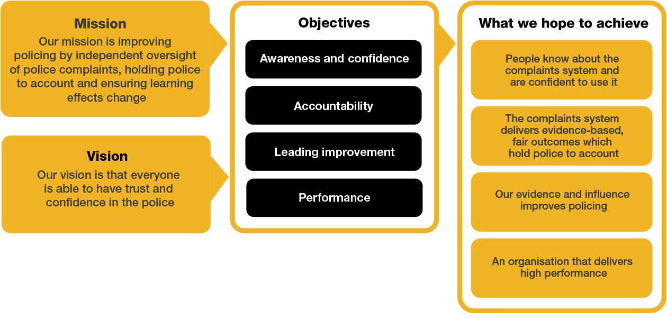

Organisational context
We work in the context of our agreed values which inform the way we do things at the IOPC. The Data Architects will need to be committed to managing in the context of these values.

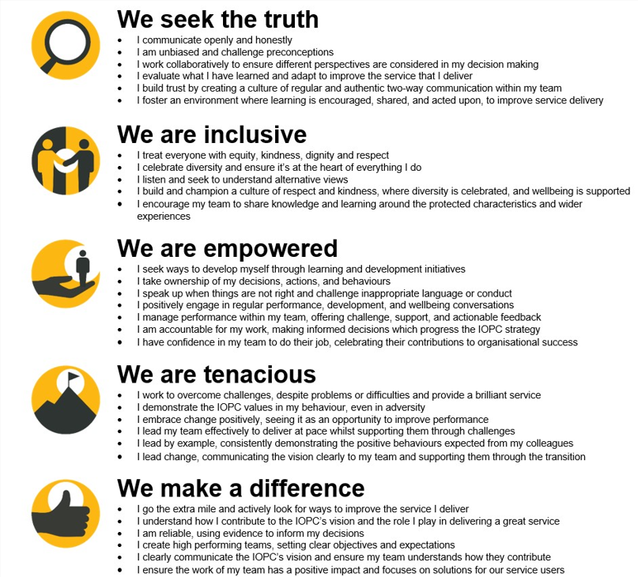

The IOPC is committed to promoting equality and valuing diversity in everything we do. Our vision is to be, and to be seen as, a leader in inclusive employment and services, demonstrating this ethos in everything that we do.
- Being a Disability Confident employer, the IOPC is dedicated to removing the barrier for disabled people to thrive in the workplace.
- Our Staff Networks are constantly working to make the IOPC the leaders of inclusive employment, from our Allyship Programme to Operation Hotton, to Welsh Language Standards and Know the Line Policy, we are constantly seeking new ways to create an environment for all to develop and thrive.


Main duties and responsibilities
- To support the wider deliverables of the Data Governance Team, and Data & Information Department
- Help to define the principles, policies, processes and specifications for data architecture, including development of conceptual, logical and physical data models.
- Assisting in the production of artefacts for data governance and assurance of data, including data glossaries, dictionaries, lineage mapping and domain data models.
- Leading on Data Design improvement workstreams across the IOPC
- Identify data that is of critical/significant importance to the IOPC, alongside other Information Management Teams, and support the design of processes to help manage that data
- Set standards for organisational data design and modelling, including advising on their application across the IOPC
- Design data architecture by dealing with specific business problems and aligning it to enterprise-wide standards and principles
- Lead the development, validation, publishing and maintenance of organisational data design, models and structures to support the knowledge requirements of the IOPC
- Support the development of strategies to drive behavioural changes across teams with data being valued and handled as a strategic asset.
- Provide training and mentorship to others around the organisation in relation to our data structures and methodologies
- Support the IOPC in defining, assuring, standardising, modelling and documenting our evolving data structures ensuring efficiency, scalability and quality. Continuously monitor and improve these structures to enhance performance.
- Maintain comprehensive documentation of models, standards and best practices for reference and future enhancements.
- Provide support to the Data Governance Lead in establishing responsibilities and roles for data ownership across the organisation
- Work with the Data Governance team to develop an organisational data catalogue, and associated glossaries and dictionaries for the IOPC
- Be an ambassador, leading conversations, and continuous improvement in data capabilities as part of our Data Strategy and improving our data literacy/culture
- Monitor the industry landscape to identify opportunities for innovationPerson specification

Person Specification

Essential
- A passion for data and the desire to create a data led culture and understanding how this can improve business performance.
- Experience of designing new data repositories, sources and products at an enterprise level
- Experience in leading on the evaluation and improvement of existing data repositories, sources and products
- Experience producing conceptual/logical data models, using industry standard tools and techniques, and agreeing definitions with business stakeholders
- Experience in setting data standards such as taxonomies, reference data, metadata and lineage
- Strong stakeholder management with the ability to translate complex business requirements into scalable, interoperable, and flexible data models.
- Ability to communicate in technical detail on topics of data lineage, data usage and data structures.
- Knowledge of basic concepts of law and regulatory guidance/standards regarding data management and trends in data policy.
- Experience of supporting substantial organisational transformation and change
- Ability to organise, prioritise and manage conflicting information and support requests.
- Ability to analyse and interpret a variety of structured and unstructured information sets to draw out the key issues or areas of interest.
- Able to work flexibly and independently, including national travel, as part of a team based in separate locations
- Advance skills in the use of M365 and SharePoint based products

Desirable
- Understanding of industry best practice Data Governance standards and methodologies
- Holding or willingness to be working towards CDMP Data Management Qualification, or similar
- Experience of data management in the Public Sector

Reasonable adjustments
The IOPC is a diverse and inclusive workplace, and we want to help you demonstrate your full potential whatever type of assessment is used. We are open to providing you with the tools you need to succeed, from extra time to formatting changes, to name a mere few. If you require any reasonable adjustments to our recruitment process, please email humanresources@policeconduct.gov.uk

Working conditions
The IOPC operates a hybrid working policy which requires all staff to work an average of 40% of their contractual hours at their office base (or another office for business reasons). Office attendance time includes in-person training, meetings with stakeholders and families, and attending events.

Preparation checklist
☐ Review the full job description
☐ Review the behaviours and the descriptors for each behaviour
☐ Review the Strengths dictionary
☐ Review the IOPC values
☐ Consider your Strengths
☐ Consider drafting example answers that cover the specific elements
☐ Prepare some questions to ask the interviewers

