Job Description
Title: Casework Manager
Reports to: Senior Casework Manager
Location: Cardiff, Sale, Birmingham, Wakefield
Grade: 10
Salary: £34,067
Contract: Fixed-Term until 31st March 2027

Purpose
As a Casework Manager, you will be welcomed into a dynamic and inclusive Oversight & Casework Team. The IOPC is on a journey to develop its culture, perspectives and ethos to support the organisation’s core outcomes, and this is your opportunity to enter into the varied world of IOPC Oversight & Casework, allowing you to develop your mindset and approaches to contribute to improving the police complaints system in England and Wales.

Our Casework Managers assess, understand, evaluate and reach decisions on reviews regarding police investigations to serious complaints. In short, they evaluate the circumstances following complaints made by members of the public after interacting with the police; weighing the available evidence, considering the relevant legislation, reports and analysis to reach a conclusion, which can range from no fault, to learning recommendations for the force/officer training, or a recommendation that disciplinary proceedings should take place.

As a Casework Manager, you will be accountable for your decisions as they affect the lives of both members of the public and police officers; the decisions you reach have the potential to make a difference to the public’s confidence in the police and policing in the UK.

The role of Casework Manager is equally challenging as it is rewarding. It is important to remain impartial and unbiased when performing the role, and ensure that our decisions are fair, balanced and supported by the legislation and available evidence. The decisions made by IOPC Casework Managers are final and can only be challenged in the courts. Therefore, the cases you complete must be of a high quality and supported by a sound rationale.

As a Casework Manager, you will be provided with in-depth bespoke and tailored training about a variety of subjects which will be relevant to your role. We invest significantly in our Casework Managers; closely supporting them to improve their knowledge and experience to effectively perform their role. The organisation has a variety of other departments, including Legal, Subject Matter Networks and an Oversight Team, who offer specialist support and guidance to Casework Managers when they are reaching their decisions.

If you are looking for an unconventional ‘desk based’ role that offers you the opportunity to develop a strong and transferrable skill set, to build your career from, be well-supported by the organisation and have a tangible positive impact on policing and the public in the UK, please consider applying

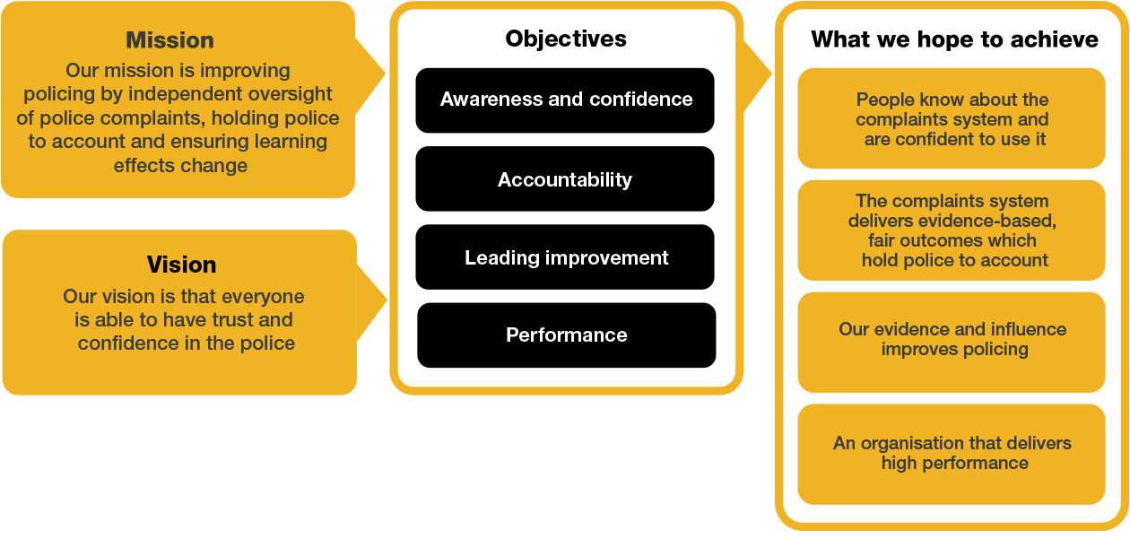
We work in the context of our agreed values which inform the way we do things at the IOPC. The Casework Manager will need to be commited to working in the context of these values.

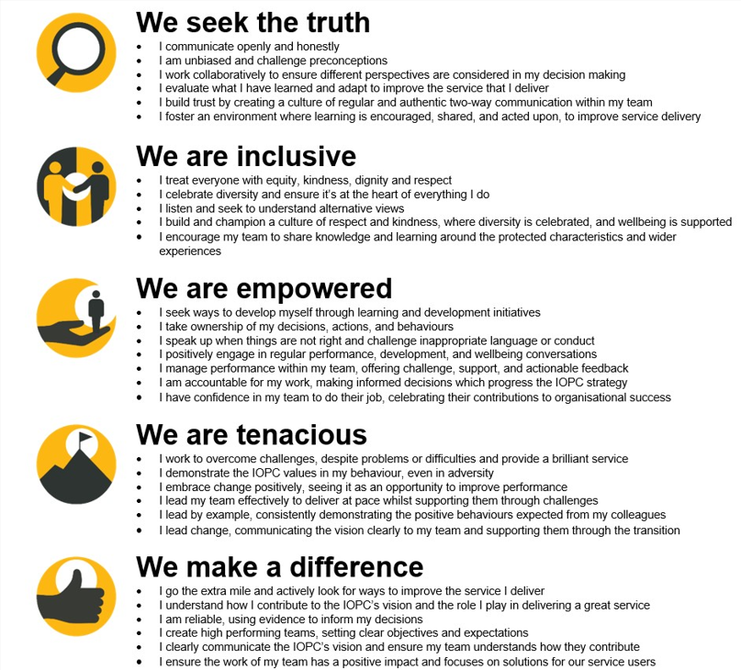
The IOPC is committed to promoting equality and valuing diversity in everything we do. Our vision is to be, and to be seen as, a leader in inclusive employment and services, demonstrating this ethos in everything that we do.
- Being a Disability Confident employer, the IOPC is dedicated to removing the barrier for disabled people to thrive in the workplace.
- Our Staff Networks are constantly working to make the IOPC the leaders of inclusive employment, from our Allyship Programme to Operation Hotton, to Welsh Language Standards and Know the Line Policy, we are constantly seeking new ways to create an environment for all to develop and thrive.


Main duties and responsibilities
This is a challenging, interesting position with a variety of work, which requires good judgement and an analytical, methodical mindset as well as the resilience to analyse the finer details of the circumstances of the complaint; which itself is often of a sensitive nature.

You will be expected to handle a wide variety of cases and subject matters, ranging from reviews following police complaint investigations, to reviewing Death and Serious Injury reports completed by the police, before communicating your assessment to a variety of interested parties and stakeholders, tailoring your communication to the audience appropriately. You may also be required to communicate your decision to other stakeholders, both internal and external.

CUSTOMER SERVICE & RELATIONSHIP MANAGEMENT

- Ensuring customer service principles are met when interacting with appellants, appropriate authorities and other interested parties and explaining the reasons for decisions taken by the organisation.
- Assess and make recommendations or decisions in accordance with the Scheme of Delegation on: investigation and other handling reviews, suspended complaint challenges, and death and serious injury local investigation reports.
- Conduct correspondence and communicate over the telephone, with members of the public and appropriate authorities.
- Ensure that each case is dealt with promptly, objectively, and in accordance with relevant legislation.
- Critically analyse evidence and information provided to the organisation.
- Assess whether the level of information provided by Appropriate Authorities is adequate.
- Obtain further information as required to assist in analysis of the information.
- Exercise your considerable levels of discretion and autonomy in reaching clear decisions based on the evidence.
- Write clear concise reports containing analysis of the evidence, explain findings and conclusions, and recommend appropriate action.
- Make, or advise others to make, learning recommendations, recommendations for disciplinary action, and directions to take disciplinary action.
- Prepare files for disclosure to the relevant parties when appropriate.
- Observe misconduct proceedings stemming from upheld reviews.
- Share learning acquired from your work with colleagues and stakeholders to improve the quality of decision making.
- Help the IOPC affect wider positive change by carrying out a range of activities such as training events and working with external stakeholders.

Person specification

Essential Experience
- Relevant experience, of complaints handling or of dealing with a direct service to the public where contentious and difficult issues have to be dealt with sensitively.
- Evidence of well-developed critical thinking skills; able to gather and use information to carry out enquiries and form sound judgements.
- Evidence of strong oral and written communication skills, backed up with good computer literacy.
- Proven ability to show initiative and contribute in a changing environment.

Reasonable adjustments
The IOPC is a diverse and inclusive workplace and we want to help you demonstrate your full potential whatever type of assessment is used. We are open to providing you with the tools you need to succeed, from extra time to formatting changes, to name a mere few. If you require any reasonable adjustments to our recruitment process, please email recruitment@policeconduct.gov.uk

Working conditions
Our recently updated Hybrid Working policy requires employees to work 40% of their contractual hours at their office base (or another office for business reasons). Office attendance time includes in-person training, meetings with stakeholders and families, and attending events. There will be a requirement to attend one of our Oversight & Casework offices (Sale, Wakefield, Birmingham and Cardiff) when business needs dictate. This is likely to be quite infrequently, and travel expenses would be paid if this is not your normal local office.

Preparation checklist
☐ Review the full job description
☐ Review the behaviours and the descriptors for each behaviour
☐ Review the Strengths dictionary
☐ Review the IOPC values
☐ Consider your Strengths
☐ Consider drafting example answers that cover the specific elements
☐ Prepare some questions to ask the interviewers

