Job description
Title: Employee Relations Specialist (Change & Transformation)
Reports to: Director of People and Change
Direct reports: None
Location: Birmingham, Canary Wharf, Cardiff, Croydon, Sale or Wakefield
Grade: 13a
Salary: £52,499 plus London Weighting Allowance of £5,130 if based in Canary Wharf or Croydon
Contract: Fixed Term Contract 12 Months

Purpose
As a Employee Relations Specialist (Change & Transformation) , you will be welcomed into a dynamic and inclusive People & Change team working to provide expert employee relations. The IOPC is on a journey to develop its culture, perspectives and ethos to support the organisation’s core outcomes and this is your opportunity to enter into the varied world of IOPC ER, allowing you to develop your mindset and approaches to contribute to improving the police complaints system in England and Wales.
The purpose of the role is to lead on providing expert employee relations on organisational change including restructures, re-organisations, and redundancies. To ensure that effective and productive consultation with staff and trade unions is conducted, as well as supporting leaders and project teams delivering change and transformation.
To be a subject matter expert with in-depth knowledge and expertise in employee relations, employment law and engaging with trade unions. Lead on managing our relationship with our trade union colleagues through change and transformation, including advising on the application of national and local agreements, collective bargaining and local dispute resolution.
Support leaders to develop effective communication and consultation plans and lead on individual consultation meetings with impacted staff while supporting the management of resulting employee relations issues, including grievances. Work with People Services teams and the Deputy Head of People to ensure that redeployment opportunities are fully explored and utilised.

Organisational Context

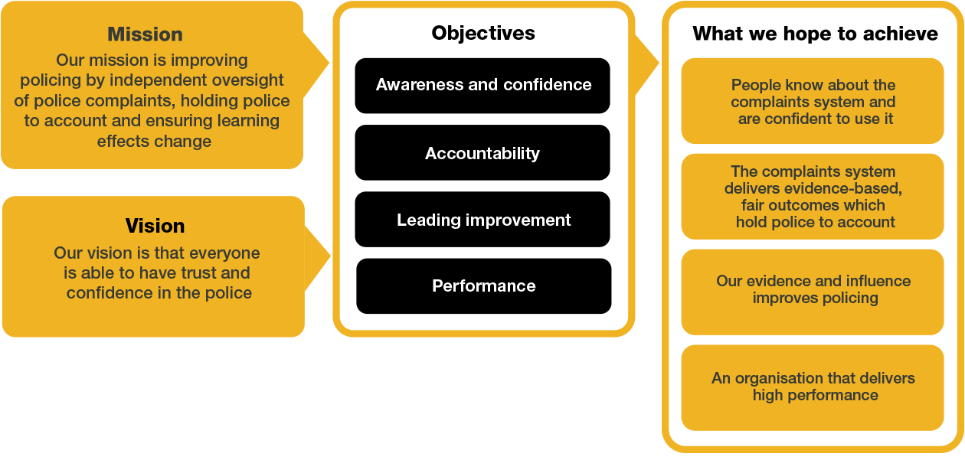

We work in the context of our agreed values which inform the way we do things at the IOPC. The Employee Relations Specialist will need to be commited to managing in the context of these values.

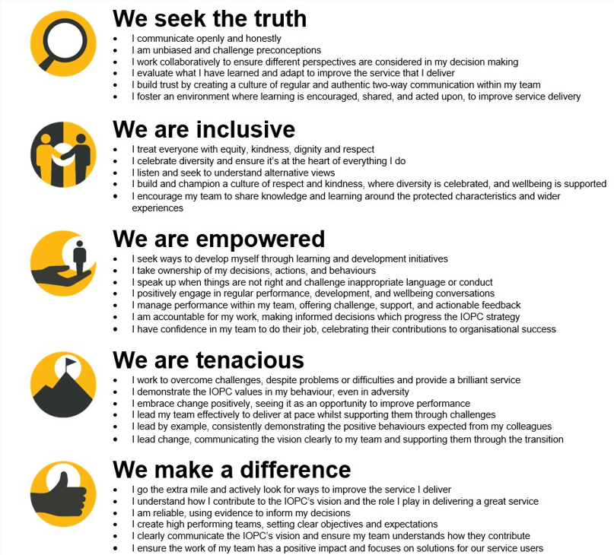

The IOPC is committed to promoting equality and valuing diversity in everything we do. Our vision is to be, and to be seen as, a leader in inclusive employment and services, demonstrating this ethos in everything that we do.
- Being a Disability Confident employer, the IOPC is dedicated to removing the barrier for disabled people to thrive in the workplace.
- Our Staff Networks are constantly working to make the IOPC the leaders of inclusive employment, from our Allyship Programme to Operation Hotton, to Welsh Language Standards and Know the Line Policy, we are constantly seeking new ways to create an environment for all to develop and thrive.


Main duties and responsibilities
Employee relations:
Provide effective process leadership to ensure that:
- Organisational change and transformation projects, such as restructures, realignments, and redundancies are effectively delivered in line with employment law, best practice and civil service governance frameworks.
- Complex casework, such as grievances raised because of change and transformation are managed promptly and effectively and seek ways to mitigate financial risk and legal recourse.
- Restructure, redeployment, and realignment activities are managed sensitively and in accordance with IOPC policy and employment legislation.
- Consultation with staff is effectively conducted and proposals offered by colleagues are given full consideration by leaders, and support management with providing a written response.
- Work alongside People Business Partners to ensure that our redeployment and realignment processes are fully exhausted to reduce exit costs.
- Ensure engagement with the civil service Recruitment and Redeployment Working Group (RRWG) is prioritised to maximise civil service redeployment opportunities.
- The People Directorate is represented through membership of the relevant boards and project groups to provide advice and influence decision making and ensure the impact on people is fully considered.
- Lead on ensuring that any regulatory redundancy notices (if applicable) are lodged with the appropriate government body in a timely manner.
- The People directorate is always represented appropriately.

People policy and communications
- Lead on the creation of new job role profiles for senior managers and engage with the job evaluation process on their behalf.
- Ensure regular communication with project trade union colleagues so that they are kept up to date with the changes.
- Engage with staff impacted by restructures and ensure that they are made aware of their rights and updated on a regular basis.
- Work effectively with change and transformation project teams to ensure that senior managers and staff receive regular communications and updates.
- Develop reports providing updates on organisational change and transformation, for management board and the People & Culture committee.

Decision Making
- Work collaboratively with the Deputy Head of People, to manage the decision-making process required to agree the proposed changes ensuring that the governance of decision making is above reproach.
- Ensure that the Home Office are suitably briefed and involved where appropriate and engagement with Capita Civil Service Compensation Scheme is managed effectively.

Liaison and project Management
- Work closely with the Deputy Head of People to ensure that change and transformation implementation plans are delivered in a timely manner.
- Lead on consultation with the recognised trade union, via the Joint Negotiating Committee.

Implementation
- Work collaboratively with the Deputy Head of People and other People Directorate colleagues to ensure that employee relations such as redundancies, redeployment and selection processes comply with HR best practice and employment legislation.
- Ensure that any necessary authorisation for redundancies, recruitment and associated processes are obtained in good time.
- Ensure that the wellbeing of colleagues is considered at every stage of the managed change.
- Develop and deliver the support required to ensure that colleagues recruited into the new structure are effectively transitioned and trained to understand the corporate requirements of the new roles.

Person specification
Qualifications:
- Chartered Institute of Personnel and Development level 7 qualification or equivalent experience.

Knowledge:
- Excellent knowledge of change management and transformation principles. • Excellent knowledge of employment law and its practical application
- Excellent knowledge of HR best practice when managing change.
- Leadership principles and practices.
- Excellent knowledge of redundancy consultation.

Experience:
- Experience of leading and advising senior managers on implementing organisational change and restructures.
- Significant experience of consulting and negotiating with trade unions.
- Significant experience of supporting staff through change.
- Significant experience of leading on providing employee relations advice in relation to redundancies, redeployment and grievances.
- Experience of leading large organisational transformational change.
- Working in a People/HR environment with responsibilities for influencing change.
- Experience of working in the civil service, public, not for profit or charity sectors, preferrably with experience of engaging with the civil service redundancy process.
- Developing processes and or policies and procedure to facilitate effective change.
- Working collaboratively with senior managers and leadership teams.
- Experience of working with multiple stakeholders.
- Experience of assessing and evaluating the outcomes of change and transformation.
Skills:
- Excellent influencing and negotiation skills.
- Excellent communication and interpersonal skills.
- Excellent analytical skills.
- Strong decision-making skills.
- The ability to problem-solve and find cost effective solutions.
- Good coaching and mentoring skills.

Other requirements:
Applicants must be willing to travel to regional locations to conduct in person meetings with staff and senior management.

Reasonable adjustments
The IOPC is a diverse and inclusive workplace and we want to help you demonstrate your full potential whatever type of assessment is used. We are open to providing you with the tools you need to succeed, from extra time to formatting changes, to name a mere few. If you require any reasonable adjustments to our recruitment process, please email recruitment@policeconduct.gov.uk

Working conditions
The IOPC operates a hybrid working policy which requires all staff to work an average of 40% of their contractual hours at their office base (or another office for business reasons). Office attendance time includes in-person training, meetings with stakeholders and families, and attending events.

Preparation checklist
☐ Review the full job description
☐ Review the behaviours and the descriptors for each behaviour
☐ Review the Strengths dictionary
☐ Review the IOPC values
☐ Consider your Strengths (if applicable)
☐ Consider drafting example answers that cover the specific elements
☐ Prepare some questions to ask the interviewers

