Job description
Title: Investigations Team Leader – Core Business x 7
Reports to: Investigations Manager – Core Business
Location: 1 x Sale
1 x Birmingham
1 x Cardiff
2 x Canary Wharf
1 x Croydon
1 x Wakefield
Grade: 13
Salary: £47,493 (plus London weighting allowance of £5,130 if based in Canary Wharf or Croydon)
Contract: Permanent

Purpose
As an Investigations Team Leader – Core Business you will be a part of a dynamic and inclusive Investigations team working to deliver and set direction of investigations.
Alongside the Investigations Team Leader – Performance and Resourcing, you will be responsible for ensuring delivery of high quality, robust and independent investigations and demonstrating our values in all aspects of your role.
You will oversee Lead Investigators, whilst also ensuring their personal and professional development, in order to achieve investigation excellence and meet quality standards. You will play a key role in quality assurance and will have responsibility for ensuring the quality of investigations and investigation products.
You will play a critical role in ensuring timely resolutions of investigations and maintaining investigative integrity.

Other Opportunities
There is potential that opportunities for Investigations Team Leaders – Performance and Resourcing department in all locations will also become available. We would ask you to review the job description for this role in addition, and if you wish to be considered for this potential opportunity as well, answer the additional sifting question on your application. If you do not wish to be considered for these potential opportunities please simply leave this question blank.

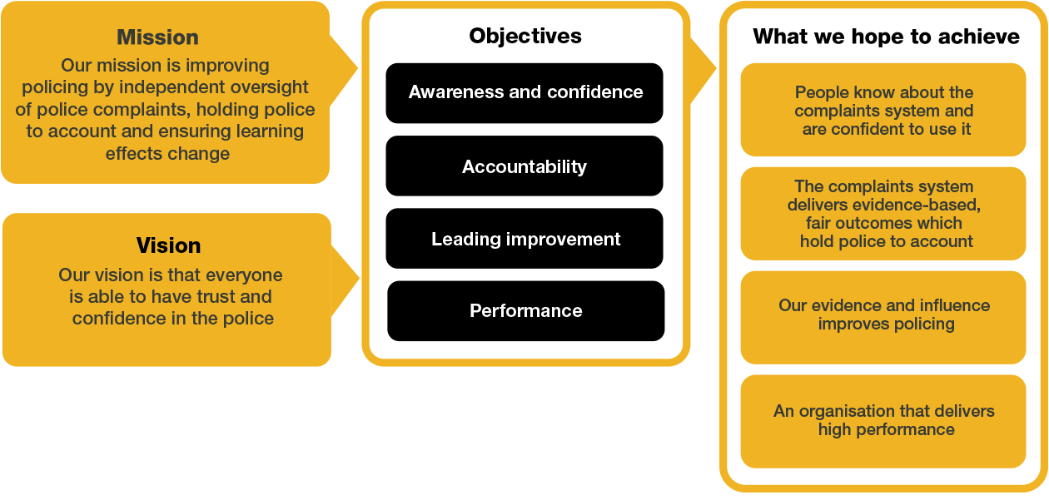
Organisational context

We work in the context of our agreed values which inform the way we do things at the IOPC. The Investigations Team Leader – Core Business will need to be commited to managing in the context of these values.

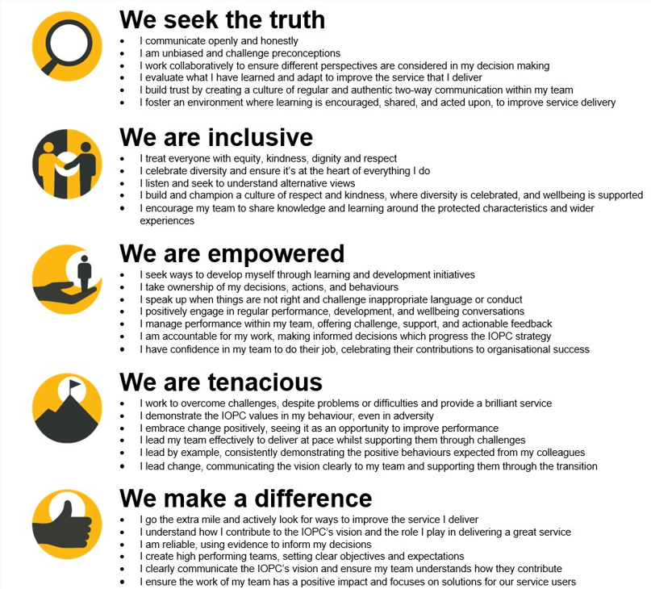

The IOPC is committed to promoting equality and valuing diversity in everything we do. Our vision is to be, and to be seen as, a leader in inclusive employment and services, demonstrating this ethos in everything that we do.
- Being a Disability Confident employer, the IOPC is dedicated to removing the barrier for disabled people to thrive in the workplace.
- Our Staff Networks are constantly working to make the IOPC the leaders of inclusive employment, from our Allyship Programme to Operation Hotton, to Welsh Language Standards and Know the Line Policy, we are constantly seeking new ways to create an environment for all to develop and thrive.


Main duties and responsibilities
General:
- Ensure consistent and high-quality investigations delivery against minimum standard and performance targets and in line with policy.
- Contribute as a member of the wider Investigations team to the management and development of the Investigations function.
- Form part of the 24-hour national on call rota which will include working unsociable hours in order to manage deployment to incident scenes to direct scene management and ensure that all necessary action is taken to preserve and recover evidence
- Develop and implement effective collaborative working with all other directorates within the IOPC to continuously improve performance and drive culture change.
- Responsible for fostering team behaviours that align with IOPC Values and Behaviours.
- Maintain professional expertise and keep up to date with relevant legislation, policy and good practice in order to strive for operational excellence.

Transformation:
- Actively participate in the IOPC Transformation programme to ensure that we do what only the IOPC can do and deliver effective, timely and high-quality investigations.
- Identify ways to improve the way in which investigations are completed and delivered.

Role specific:
Delivery:
- Provide structured supervision and DRIVE meetings to ensure Lead Investigators are confident, competent and engaged.
- Conduct case supervision and regular reviews of investigations to ensure they are progressing to a high quality and in line with the case supervision procedure.
- Perform an assurance function to ensure operational policy and procedure is followed and minimum standards are complied with.
- Ensure systems i.e. CMS are utilised effectively and ensure necessary data is recorded accurately.
- Work closely with Lead Investigators to proactively direct investigations and understand capacity requirements.
- Undertake oversight work in relation to designated forces and stakeholder groups as agreed.
- Contribute towards identified policy or oversight areas as agreed.
- Support Lead Investigators with their development, performance management and welfare in order to create a resilient workforce that can adapt to change and challenges.
- Support the Investigations Manager – Core Business with recruitment, workforce planning, identifying gaps in resource needs and supporting with recommending strategies to fill any gaps.
- Liaise with internal and external stakeholders as appropriate to retain confidence in the investigation.
- Address risks proactively to ensure investigations remain credible and transparent; taking steps to understand risk, reduce and mitigate against it, and escalate where necessary.
- Offer advice, guidance and direction where appropriate to forces, HMRC, and UKBA in matters relating to deaths, serious injury or other referrals.
- Work collaboratively with Investigations Team Leader – Performance & Resourcing to provide feedback on the performance of investigators.
- Deputise for the Investigations Manager – Core Business, where appropriate, to provide internal and external leadership across the full sphere of operational delivery activities.

Decision Making:
- Advise or act as the decision maker in delegated cases in accordance with the decision-making framework.

Cultural Competence, Equality, Diversity & Inclusion:
- Promote inclusive practice across the investigations team.
- Ensure fair case management and that investigations are conducted without prejudice or discrimination.

Person specification

Essential Experience
- Fully Accredited Investigator (Units 1 - 4) or investigative experience of an equivalent nature.
- Understanding of the police complaints system and the statutory framework within which the IOPC operates
- Understanding of the relevance of Human Rights Act 1998; IOPC obligations under the Equality Act 2010, including the Public Sector Equality Duty, and other relevant legislation to the work of the IOPC
- Involvement in promoting a culture which values diversity of experience and background and embeds effective team behaviours. Experience of prioritising and managing tasks and resources effectively to deliver quality outcomes within challenging timescales.
- Experience of carrying out effective case supervision, quality assurance and performance improvement processes.
- Experience of supporting staff, who are working in an environment with significant scrutiny, challenge and potentially emotive material, and building resilience and adaptability.
- Driving license valid in England and Wales.

Desirable:
- Experience of working in a matrix management structure.
An experienced team leader with a track record of building high performing operational teams in a complex environment.

Skills and Abilities
- Ability to adapt and adjust delivery based on unexpected developments or challenges in investigations.
- Ability to identify process improvements and training needs to enhance investigative outcomes.
- Ability to convey information effectively and negotiate and influence others.
- Evidence of excellent analytical and report writing skills; ability to reach and document clear, rational, evidence-based and independent decisions based on analysis of existing and emerging information.
- Highly developed oral, written and presentation skills.
- The ability to make informed decisions under pressure.
- Resource management abilities including understanding how to allocate resource efficiently.
- Skilled in delivering structured feedback, coaching and mentoring.

Desirable:
- An understanding of Policing in the UK.

Working conditions
The IOPC operates a hybrid working policy requiring all staff to spend, on average, 40% of their contracted hours at their designated office base (or another office where business needs apply). Office attendance may include in-person training, stakeholder and family meetings, events, and any work that cannot be carried out remotely.

Reasonable adjustments
The IOPC is a diverse and inclusive workplace and we want to help you demonstrate your full potential whatever type of assessment is used. We are open to providing you with the tools you need to succeed, from extra time to formatting changes, to name a mere few. If you require any reasonable adjustments to our recruitment process, please email recruitment@policeconduct.gov.uk

Preparation checklist
☐ Review the full job description
☐ Review the behaviours and the descriptors for each behaviour
☐ Review the Strengths dictionary
☐ Review the IOPC values
☐ Consider your Strengths (if applicable)
☐ Consider drafting example answers that cover the specific elements
☐ Prepare some questions to ask the interviewers

