

Job role profile

Title: Investigations Manager – Core Business
Reports to: Deputy Director of Investigations
Location: Birmingham
Grade: 15
Salary: £64,301 per annum
Contract: Permanent

Purpose

As an Investigations Manager – Core Business, you will be a part of a dynamic investigations team working locally and nationally on a wide range of investigations in the Investigation, Oversight and Casework directorate. You will set investigation direction, understand capacity and make decisions on cases.

Alongside the Investigations Manager - Performance and Resourcing and Investigations Manager – Core Business you will be responsible for providing strategic leadership to teams of investigators, ensuring delivery of high quality, robust and independent investigations and demonstrating our values in all aspects of your role.

You will have line management responsibilities of a team of Investigations Team Leaders - Core Business, and you will have accountability for the quality, timeliness and efficiency of investigations.
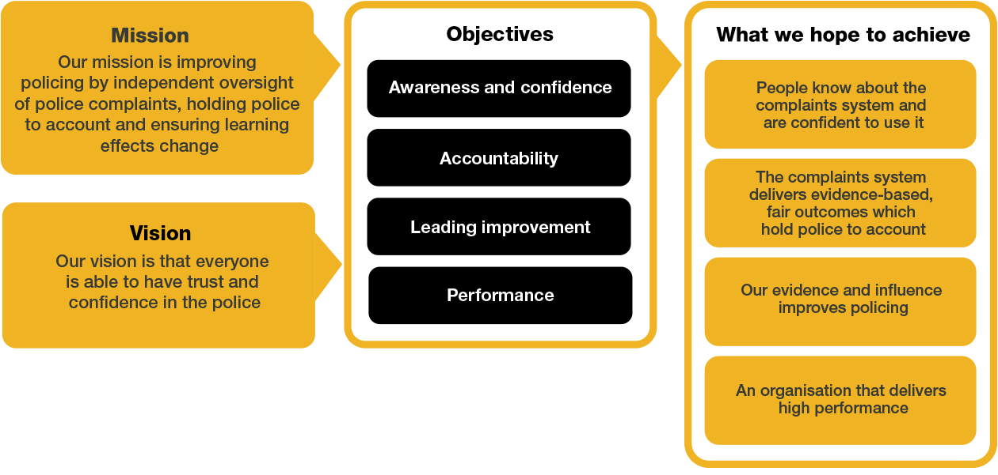

O
rganisational

C
ontext

We work in the context of our agreed values which inform the way we do things at the IOPC. As the Investigations Manager – Core Business, you will need to be committed to managing in the context of these values.
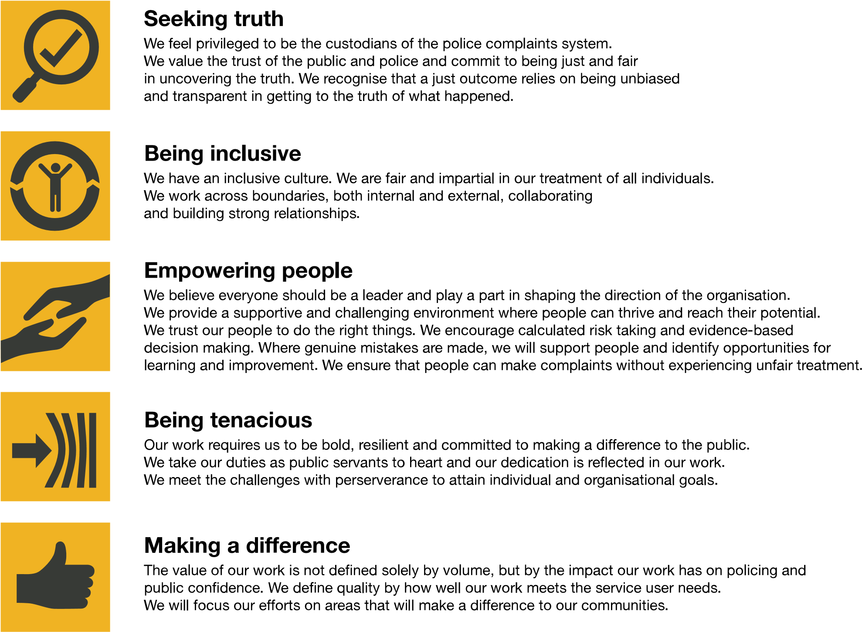
The IOPC is committed to promoting equality and valuing diversity in everything we do. Our vision is to be, and to be seen as, a leader in inclusive employment and services, demonstrating this ethos in everything that we do.
- Being a Disability Confident employer, the IOPC is dedicated to removing the barrier for disabled people to thrive in the workplace.
- Our Staff Networks are constantly working to make the IOPC the leaders of inclusive employment, from our Allyship Programme, to Welsh Language Standards and Know the Line Policy, we are constantly seeking new ways to create an environment for all to develop and thrive.


Main duties and responsibilities

Leadership and general:

- Provide strategic direction and operational leadership to investigation teams to ensure the delivery of high-quality, robust investigations.
- Ensure consistent and high-quality investigations delivery against policy and performance targets.
- Work closely with internal stakeholders to ensure the IOPCs Strategic Objectives are met including; Stakeholder Engagement Team, Oversight and Directors of Engagement.
- Contribute as a member of the wider Investigations senior management team to the development of the strategic direction and management of the Investigations function.
- Participate in the on-call function – offering advice, guidance and direction to forces, HMRC and UKBA in matters relating to deaths, serious injuries and other referrals.
- Work with the Directors/ Deputy Directors in Investigations, and other key stakeholders to ensure a coordinated and consistent Investigations function.
- Deputise for Deputy Directors of Investigations as and when requested / where appropriate to provide internal and external leadership across investigation delivery activities.
- Develop and implement effective collaborative working with all other directorates within the IOPC to continuously improve performance and drive culture change.
- Contribute to the management of the investigations team finance including budget management.

Transformation:

- Work collaboratively with colleagues to ensure that the ambitions of the IOPC are delivered
- Actively participate in the IOPC Transformation programme to ensure that we do what only the IOPC can do and deliver effective, timely and high-quality investigations.
- Identify ways to improve the way in which investigations are completed and delivered.
- Ensure investigations colleagues are kept up to date with transformation progress.

Role specific:

Delivery:

- Provide direct line management to the Investigations Team Leaders – Core Business, overseeing their performance, personal and professional development, recruitment and accreditation.
- Coach and mentor Investigations Team Leaders – Core Business to build investigation capacity and capability.
- Work closely with Investigations Team Leaders – Core Business to direct investigations and understand capacity requirements.
- Oversee workforce planning, identify gaps in resource needs and recommend strategies to fill any gaps.
- Ensure that Investigations Team Leaders – Core Business and Lead Investigators deliver efficient, well informed and timely actions for the delivery of proportionate investigation outcomes.
- Ensure that the legal team are involved at an early stage in investigations, where appropriate.
- Work collaboratively with the Investigations Manager - Performance and Resourcing and Investigations Manager - Complex to provide feedback on the performance of investigators.
- Help to ensure effective implementation of the Decision-Making Framework.
- Carefully and considerately discharge your delegated regulatory duties and responsibilities.

Corporate Responsibility:
- Minimise risk to the IOPC through ensuring all decisions and actions are consistent and align with best practice.

Decision Making:
- Lead on decision making regarding cases, escalating high risk cases to the Investigations Manager - Complex or delegating decision making for certain cases.
- Ensure the most appropriate decision-making approach is adopted based on the facts and complexity of each case.
- Lead on decision making in relation to professional development and training needs; ensuring Investigation Team Leaders – Core Business and Investigators are equipped with the skills necessary to perform their roles to the highest standard.
- Work closely with the Investigations Manager - Performance and Resourcing and the Deputy Director of Demand, Resourcing and Performance on the prioritisation of cases.

Communication & Engagement:

- Work alongside the Directors of Engagement when required on case specific force liaison.

Cultural Competence, Equality, Diversity & Inclusion:
- Lead by example in promoting and embedding cultural competence when interacting with all stakeholders.
- Ensure that a culture of inclusion is embedded across the investigations team.

Person specification

Experience
- Proven experience in leading and managing teams in complex and high-profile investigations, ideally within a regulatory, oversight or public sector context.
- Strong track record in providing strategic direction ensure the delivery of high-quality, independent and robust investigations.
- Experience of driving teams to deliver high levels of performance and continuous improvement.
- Proven experience of investigating or leading investigations.
- Demonstrated ability to oversee and direct teams, including workforce planning, resource allocation and the management of investigation priorities.
- Experience in financial management; including budgeting and cost control.
- Proven experience of investigations methodology and principles applied to complex, large and challenging investigations.
- Experience of working as part of a senior management team to develop and implement the strategic vision for a function or organisation.
- An experienced leader with a track record of building high performing operational teams in a complex environment.
- Experience of managing disclosure in complex investigations
- Experience of leading teams through significant change, engaging and motivating staff to embrace new ways of working.

Desirable:
- Experience of working in a matrix management structure.
- Driving license valid in England and Wales.

Skills and Abilities
- Excellent intellectual ability, and highly developed skillset to analyse complex legislation and apply it to appropriate cases.
- The ability to manage, motivate and develop people.
- The ability to work efficiently and effectively in a challenging environment with competing priorities.
- High levels of credibility as well as the ability to justify decisions made, including in a legal setting.
- Good judgement and ability to make high profile decisions.
- Highly developed decision-making skills.
- Evidence of excellent analytical and report writing skills; ability to reach and document clear, rational, evidence-based and independent decisions based on analysis of existing and emerging information.
- Highly developed oral, written and presentation skills.
- Excellent influencing and negotiation skills and the ability to persuade through personal credibility.
- Strong interpersonal skills, including the ability to negotiate and maintain good relationships with senior officials in all areas of public life.
- Experience of supporting staff who are working in an environment with significant scrutiny, challenge and potentially emotive material.
- Analytical thinker with the skills and ability to assess complex cases, identify key issues and develop solutions that address needs.
- Proven experience in mentoring, coaching and developing team members, fostering a culture of continuous improvement and professional growth.

Desirable:
- An understanding of Policing in the UK.

Positive Action

Positive action as detailed in the Equality Act 2010, allows us to use measures designed to help improve equality in the workplace, and create a level playing field for all, whilst still employing everyone based on merit. Our workforce profile data shows that people who identify as black, Asian and minority ethnic are under-represented at the IOPC.
For this role – should we have a situation where multiple candidates have achieved the highest score and one identifies as black, Asian or minority ethnic, by using positive action, we can select that candidate for the role, therefore improving this area of under-representation at the IOPC. We will only use positive action in this way where the highest scoring candidates have all scored equally, at the final assessment stage, and above our required threshold.

Reasonable adjustments
The IOPC is a diverse and inclusive workplace, and we want to help you demonstrate your full potential whatever type of assessment is used. We are open to providing you with the tools you need to succeed, from extra time to formatting changes, to name a mere few. If you require any reasonable adjustments to our recruitment process, please email recruitment@policeconduct.gov.uk

Working conditions
The IOPC operates a hybrid working policy which requires all staff to work an average of 40% of their contractual hours at their office base (or another office for business reasons). Office attendance time includes in-person training, meetings with stakeholders and families, and attending events.

Preparation checklist
☐ | Review the full job description
☐ | Review the behaviours and the descriptors for each behaviour
☐ | Review the Strengths dictionary
☐ | Review the IOPC values
☐ | Consider your Strengths (if applicable)
☐ | Consider drafting example answers that cover the specific elements
☐ | Prepare some questions to ask the interviewers

