Job description
Title: Senior Executive Support
Reports to: Chief of Staff
Location: Canary Wharf
Grade: 13
Salary: £47,493 plus London weighting of £4,968 per annum
Contract: Permanent

Purpose
As Senior Executive Support, you will be welcomed into a dynamic and inclusive team working work closely and providing personal support to The Director General. You will develop deep insights into the work of the organisation at a strategic level and with this, provide a high level of support and advice to the Director General, enabling them to perform at the highest level.
The IOPC is on a transformation journey and this role offers an opportunity to be at the heart of it by joining a dynamic Director General office. The Senior Executive Support, similar to the role of a Private Secretary, delivers high quality executive support to the IOPC senior leadership team and has a key role in enabling the delivery of the IOPC strategic objectives.
This newly established post forms part of a structure which allows team members to thrive in a fast-paced, high performing and collaborative environment.

You will provide direct line management to the Executive Assistant to the Director General and work together with the Chief of Staff to ensure highly effective tailored and focused executive support for the principal. This role is integral to the smooth running of the Director General office.
You will quickly establish effective working relationships across the IOPC Senior team and specifically with the Deputy Director General’s Office and the Executive Support Services Team, delivering seamless executive support to the organisation.

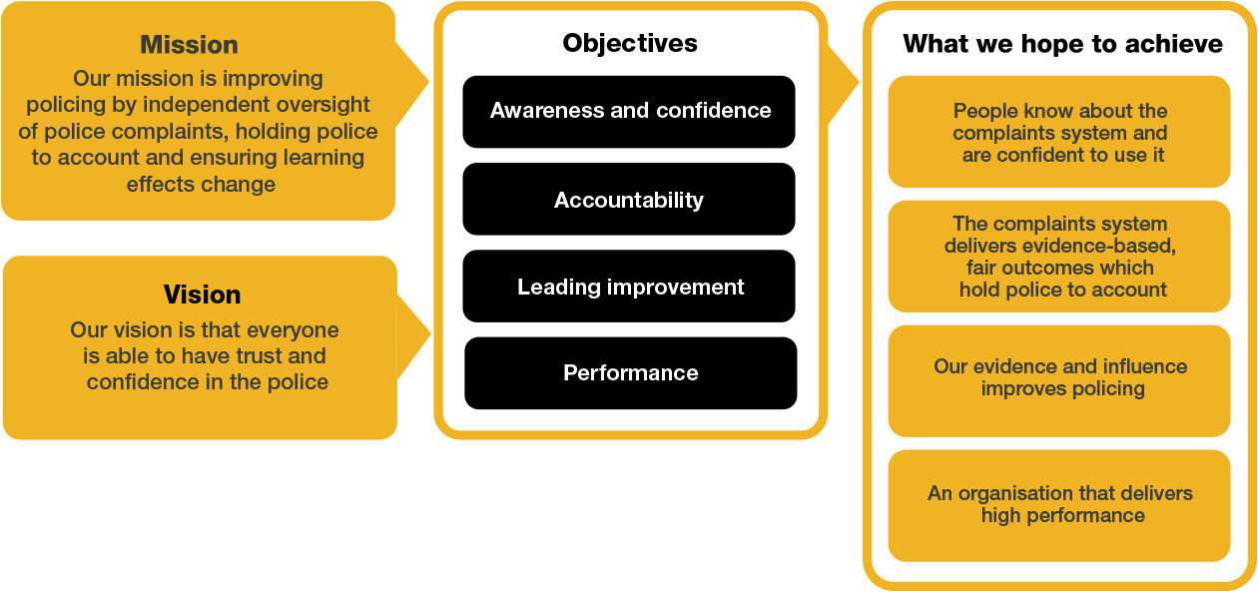

We work in the context of our agreed values which inform the way we do things at the IOPC. The Senior Executive Support will need to be commited to managing in the context of these values.

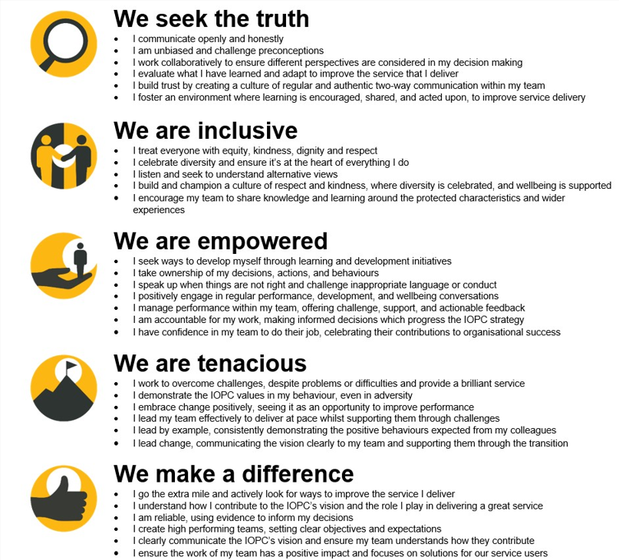
Additional Information

Political Restriction

Please note that this is a politically restricted role and will be subject to limitations set out in the IOPC code of conduct, a relevant extract from which is set out below. This post has been identified as politically restricted because:

- The post holder will act as “spokesperson” for the organisation, or have a significant degree of face-to-face contact with stakeholders, pressure groups, or other bodies or individuals who are seeking to influence the IOPC
- It would appear to the public that the post holder had some influence over the outcome of the organisation’s decisions.

If a post is politically restricted, this means that you should discuss with your line manager before taking on any political activities. Permissions will not be unreasonably withheld but consideration will need to be given to the scope and remit of the role and how this may be perceived in the context of your IOPC position. You should discuss with your line manager if you are considering becoming politically active, for example:
- Campaigning for a political party.
- Holding a political office.
- Occupying party political posts.
- Holding a particularly sensitive or high-profile unpaid roles in a political party.

The IOPC is committed to promoting equality and valuing diversity in everything we do. Our vision is to be, and to be seen as, a leader in inclusive employment and services, demonstrating this ethos in everything that we do.
- As a silver standard Stonewall employer, we continue to commit ourselves to being a LGBTQ+ employer through the work of our Pride LGBTQ+ Staff Network, creating welcoming environments for lesbian, gay, bi and queer people.
- We are pleased to share we are a signatory of the Business in the Community Race at Work Charter. The Charter is composed of five calls to action for leaders and organisations across all sectors.
- Being a Disability Confident employer, the IOPC is dedicated to removing the barrier for disabled people to thrive in the workplace.
- Our Staff Networks are constantly working to make the IOPC the leaders of inclusive employment, from our Allyship Programme to Operation Hotton, to Welsh Language Standards and Know the Line Policy, we are constantly seeking new ways to create an environment for all to develop and thrive.




Main duties and responsibilities
- To act as the point of contact to the Director General and support in all related matters pertaining to the business.
- Assisting in the development and implementation of business strategies, providing insights, and facilitating strategic meetings.
- Ensuring the Director General is fully prepared for meetings, providing briefings, action updates and stakeholder information to ensure they can achieve the meeting objectives. Attending meetings with the Director General and ensuring meetings are actioned and delivered effectively and efficiently.
- With the guidance of the Chief of Staff preparing speeches, speaking notes and briefings using authentic application of voice and tone of the speaker.
- To draft reports, briefings and communication material on behalf of the Director General (for both internal and external stakeholders).
- Draft correspondence on behalf of the Director General to external key stakeholders, ensuring clarity, professionalism, and alignment with organisational tone and values.
- Liaise with all Executive Support colleagues across the organisation to deal with high profile issues and priorities for the Director General.
- To identify areas of potential organisational risk across the business and to demonstrate initiative to make judgements on appropriate mitigating actions, including an assessment of whether risks/issues require further escalation to the Chief of Staff and where appropriate, Director General.
- To handle and lead discrete pieces of work on behalf of the Director General and Chief of Staff
- Acting decisively in urgent situations, implementing contingency plans, and maintaining communication to ensure business continuity and mitigate risks.
- Lead on solutioning high priority issues that are escalated to Director Generals, collaborating with and influencing relevant colleagues to an effective resolution.
- To provide direct line management to the Executive Assistant (G10) ensuring high quality and performance in the delivery executive support to the individual.
- Manage and protect the Director General’s time, through close working with the Executive Assistant.
- To work closely with the Two Deputy Director Generals office and Executive Support team ensuring that seamless executive support service is delivered and wider organisational objectives are achieved.
- Working closely with the Chief of Staff to brief of the DG on media and political developments that impact the IOPC.

Cultural Competence, Equality, Diversity & Inclusion:
- Be pro-active and committed to equity, diversity and inclusion.
- Demonstrate cultural competence when interacting with all stakeholders.

Person specification

Essential Experience
- Knowledge of the work of the IOPC and the wider public sector environment.
- Previous experience of providing private secretary support to a senior leader.
- Experience of preparing high level professional reports and documents for both internal and external senior audiences.
- Experience of drafting speaking notes and speeches with authentic application of voice and tone of the speaker.
- Experience of working with diverse groups, networking and building professional productive relationships.
- Line management experience, focused on delivering high performance and quality.
- Proven track record of delivery, demonstrating an analytical approach to making judgements and decisions in a fast moving and fluctuating working environment.
- Experience of project managing cross directorate/ organisational initiatives.
- Evidence of having acted with discretion to deal appropriately with confidential matters.
- Able to be Security Cleared to the appropriate level.

Skills and Abilities
- Demonstrable ability to communicate effectively, both verbally and in writing, with experience in building relationships with a diverse and challenging group of stakeholders.
- Proficiency in the use of ICT, including MS Office, Word, Excel, PowerPoint, SharePoint and MS Teams.
- Task management - ability to manage a fluctuating workload and adapt to fast moving demands.
- Trouble shooter with ability to quickly understand an issue and apply a fix.
- Demonstrable ability to quickly grasp new/complex concepts and assimilate information quickly.
- Comfortable taking decisions within a clear framework of delegation.

Reasonable adjustments
The IOPC is a diverse and inclusive workplace and we want to help you demonstrate your full potential whatever type of assessment is used. We are open to providing you with the tools you need to succeed, from extra time to formatting changes, to name a mere few. If you require any reasonable adjustments to our recruitment process, please email recruitment@policeconduct.gov.uk

Working conditions
The IOPC are currently consulting with our consultative bodies about proposed changes to our hybrid working policy which will require all staff to work 20% of their contractual hours at their office base (or another office for business reasons) from 1 September 2024 and will be increased to 40% from April 2025. Office attendance time includes in-person training, meetings with stakeholders and families, and attending events.

Preparation checklist
☐ Review the full job description
☐ Review the behaviours and the descriptors for each behaviour
☐ Review the Strengths dictionary
☐ Review the IOPC values
☐ Consider your Strengths (if applicable)
☐ Consider drafting example answers that cover the specific elements
☐ Prepare some questions to ask the interviewers

