Job Description
TITLE: Media Officer
REPORTS TO: Senior Media Officer
LOCATION: Canary Wharf or Croydon
GRADE: 12
SALARY: £41,878 plus London Weighting £5,130 per annum
CONTRACT: Permanent

Purpose
The post holder reports to a Senior Media Officer for the London and South East region and is responsible for providing advice on media and communications to IOPC senior managers and staff, implementing both proactive and reactive media plans. The post holder will be security cleared to at least BS level and the post is politically restricted.
The media deals with a number of high profile cases which often make the headlines so the environment can be fast paced and requires a quick-thinking, problem-solving approach. You will have direct and frequent contact with operational, policy, stakeholder engagement teams and senior management, and with the media and various police force press offices. You will take part in the out-of-hours duty press officer rota.
To be successful in this role, you will be confident in turning complex information into clear content that resonates with diverse audiences. You’ll be responsible for developing innovative communication plans across multiple platforms, working creatively with colleagues on digital and social media channels to reach different audiences. You’ll be working collaboratively with colleagues across the Communications and Stakeholder Engagement team.

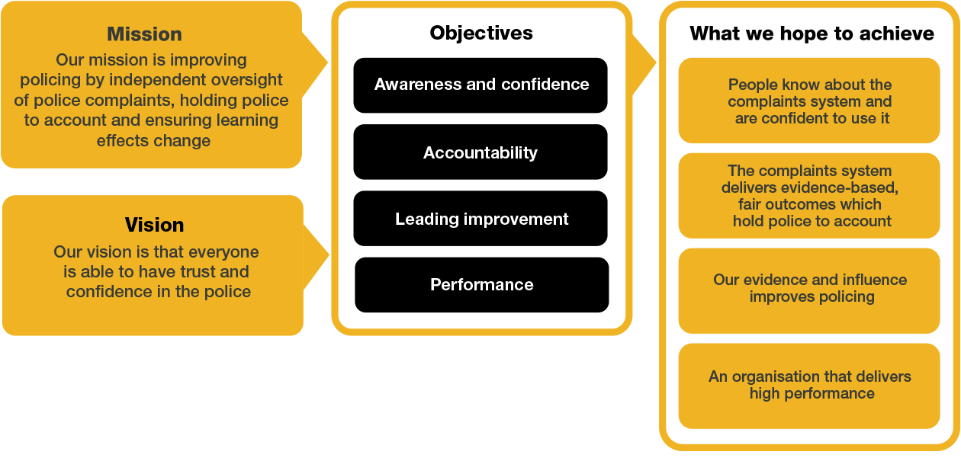
We work in the context of our agreed values which inform the way we do things at the IOPC. The Media Officer will need to be commited to operating in the context of these values.

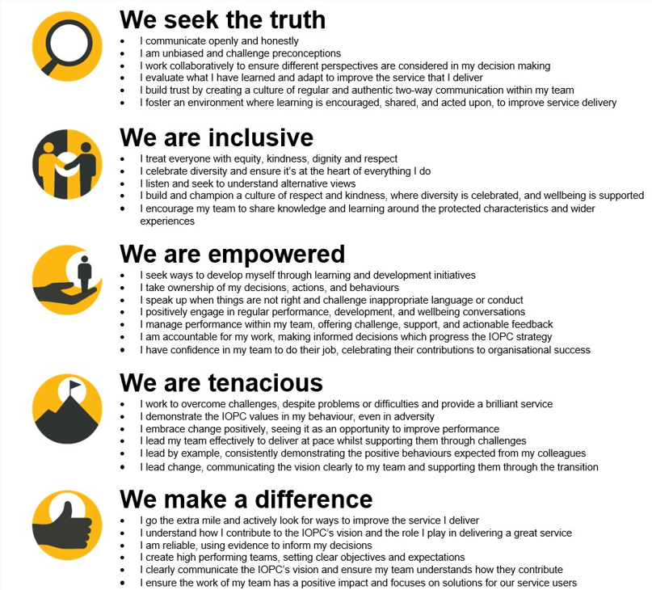
The IOPC is committed to promoting equality and valuing diversity in everything we do. Our vision is to be, and to be seen as, a leader in inclusive employment and services, demonstrating this ethos in everything that we do.
- Being a Disability Confident employer, the IOPC is dedicated to removing the barrier for disabled people to thrive in the workplace.
- Our Staff Networks are constantly working to make the IOPC the leaders of inclusive employment, from our Allyship Programme to Operation Hotton, to Welsh Language Standards and Know the Line Policy, we are constantly seeking new ways to create an environment for all to develop and thrive.


Main duties and responsibilities
- To provide a high quality proactive and reactive media relations service on IOPC investigations, including writing and distributing press releases, monitoring national and specialist media, taking the initiative to rebut inaccuracies and leading on relevant statements and briefings
- To actively seek out proactive opportunities which help explain what we do, promote our work and enhance our reputation
- To arrange interviews and provide briefings to senior managers, often at short notice
- To write and implement media handling plans for the publication of IOPC investigations, corporate reports and national policy areas, working closely with senior managers
- To liaise with Stakeholder Engagement colleagues to develop and implement integrated communications and engagement plans for controversial or significant issues
- To contribute to the strategic diary and forward planning for the communications team
- To be a committed member of the national media team and support colleagues working in other regions
- To liaise with colleagues across regions and nationally to ensure accurate, consistent and coordinated messages are disseminated to IOPC staff, stakeholders and to the public
- To contribute to the IOPC’s social media strategy by making day to day use of social media platforms to engage new and existing audiences
- To take part in the national out-of-hours duty press office rota
- To undertake any other duties as may be assigned from time to time commensurate with the level and responsibilities of the post.

Person specification

Essential
- Experience in media relations in a busy press office, including dealing, on a regular basis, with controversial issues and crisis management or experience as a journalist in a busy newsroom
- High level understanding of national and local media and their priorities, including online news and social media platforms
- Experience of being able to handle emotionally sensitive subjects within a press context
- Excellent communication, interpersonal and writing skills
- Experience in creating content across digital channels
- Proven ability to translate complex issues into clear, simple narratives
- Experience providing robust and appropriate advice to senior managers
- Ability to build and maintain strong working relationships with a variety of stakeholders, including journalists.
- Ability to work as part of a team, contributing to shared goals, supporting colleagues and fostering a positive team environment
- Strong customer and audience focus
- Strong communication skills – both written and oral
- Good negotiation and influencing skills
- Positive attitude and flexibility of approach
- Good knowledge of current affairs

Reasonable adjustments
The IOPC is a diverse and inclusive workplace and we want to help you demonstrate your full potential whatever type of assessment is used. We are open to providing you with the tools you need to succeed, from extra time to formatting changes, to name a mere few. If you require any reasonable adjustments to our recruitment process, please email recruitment@policeconduct.gov.uk

Working conditions
Our recently updated Hybrid Working policy requires employees to work 40% of their contractual hours at their office base (or another office for business reasons). Office attendance time includes in-person training, meetings with stakeholders and families, and attending events. There will be a requirement to attend one of our Oversight & Casework offices (Sale, Wakefield, Birmingham and Cardiff) when business needs dictate. This is likely to be quite infrequently, and travel expenses would be paid if this is not your normal local office.

Preparation checklist
☐ Review the full job description
☐ Review the behaviours and the descriptors for each behaviour
☐ Review the Strengths dictionary
☐ Review the IOPC values
☐ Consider your Strengths
☐ Consider drafting example answers that cover the specific elements
☐ Prepare some questions to ask the interviewers

