

Job role profile

Title: Investigations Manager – Major Investigations
Reports to: Deputy Director of Investigations
Location: Sale, Cardiff, Birmingham, Wakefield, Canary Wharf or Croydon
Grade: 15
Salary: £64,301 (London weighting of £5,130 if based in Canary Wharf or djdjdjdjdjdjdjdjdjdjd Croydon)
Contract: Permanent

Purpose

As an Investigations Manager – Major Investigations, you will be a part of a dynamic investigations team working locally and nationally on Major Investigations in the Investigation, Oversight and Casework directorate. You will direct, be the decision maker and have delivery responsibility over these cases.

You will be responsible for providing strategic leadership to teams of investigators, ensuring delivery of high quality, robust and independent investigations and demonstrating our values in all aspects of your role.

You will have accountability for the quality of investigations, timeliness and efficiency.

You will play a key role within the Operational Practitioner Group for Decision Making; you will set and embed good practice and standards in decision making, provide peer support to decision makers across the organisation and manage and mitigate organisational risk during Major Investigations.

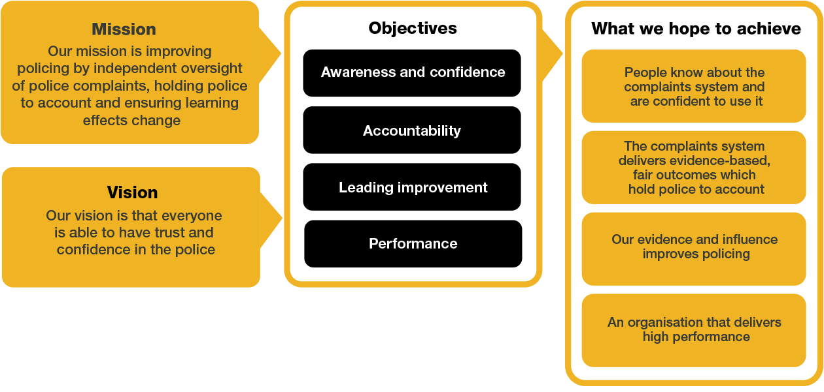

O
rganisational

C
ontext

We work in the context of our agreed values which inform the way we do things at the IOPC. As the Investigations Manager- MI, you will need to be committed to managing in the context of these values.
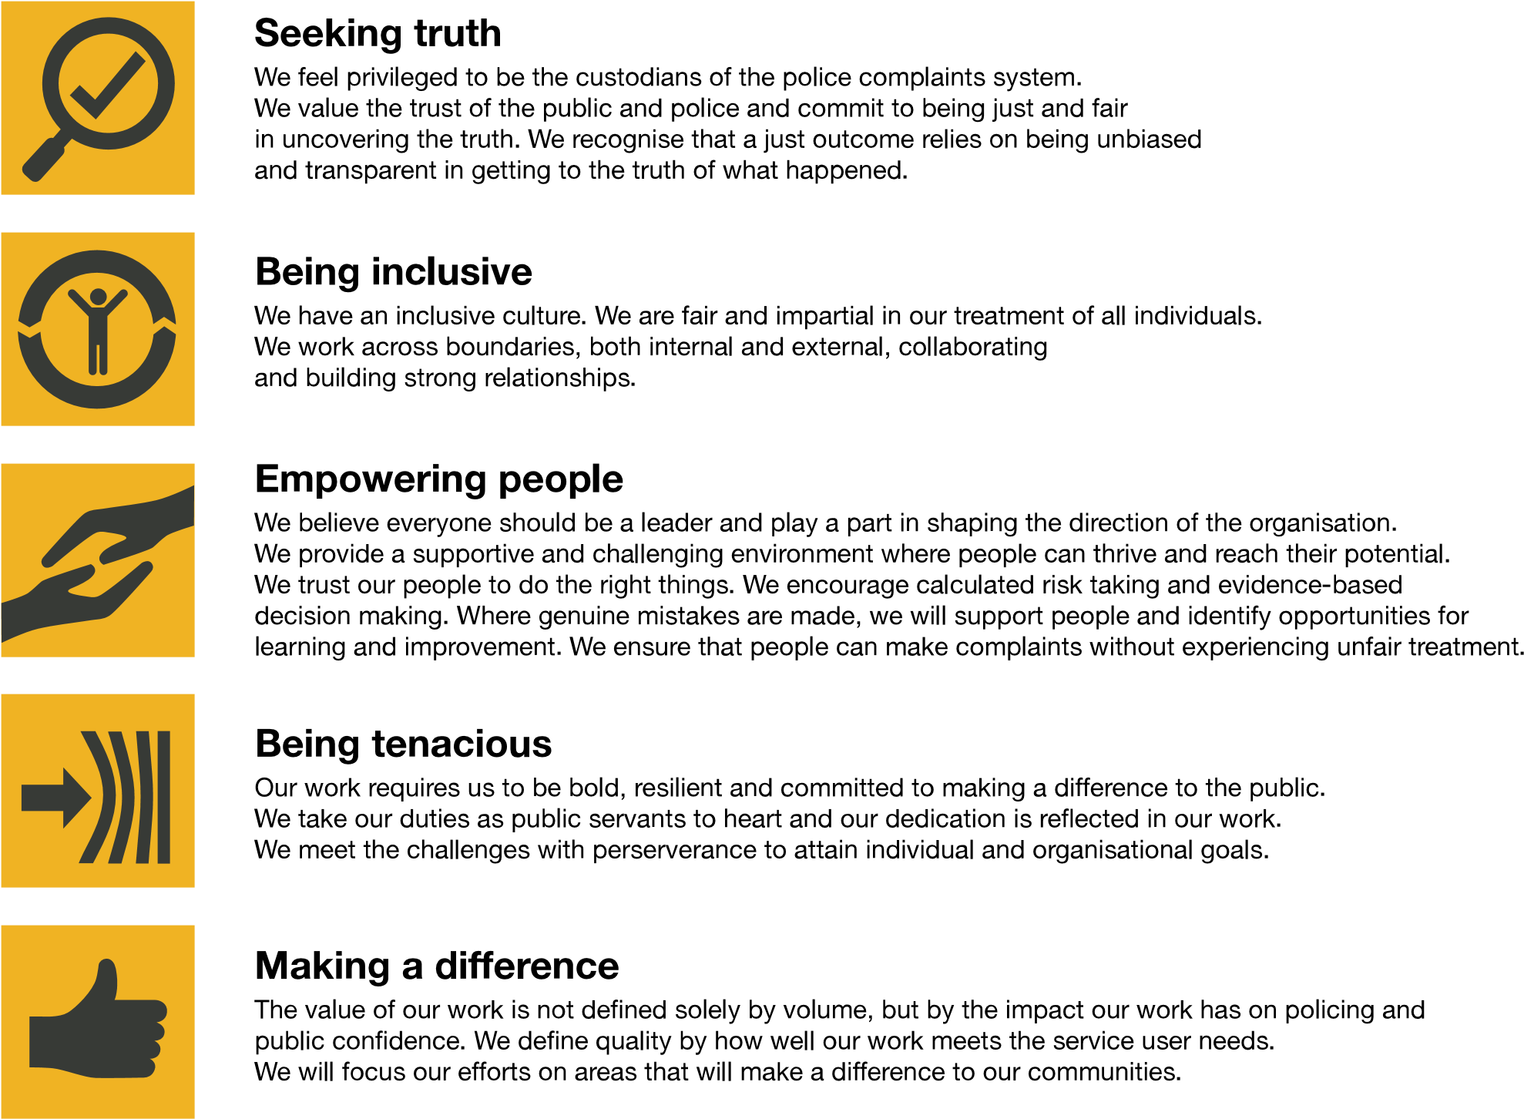
The IOPC is committed to promoting equality and valuing diversity in everything we do. Our vision is to be, and to be seen as, a leader in inclusive employment and services, demonstrating this ethos in everything that we do.
- Being a Disability Confident employer, the IOPC is dedicated to removing the barrier for disabled people to thrive in the workplace.
- Our Staff Networks are constantly working to make the IOPC the leaders of inclusive employment, from our Allyship Programme to, to Welsh Language Standards and Know the Line Policy, we are constantly seeking new ways to create an environment for all to develop and thrive.


Main duties and responsibilities

Leadership and general:

- Provide strategic direction and operational leadership to investigation teams to ensure the delivery of high-quality, robust investigations.
- Ensure consistent and high-quality investigations delivery against policy and performance targets.
- Work closely with internal stakeholders to ensure the IOPCs Strategic Objectives are met including; Stakeholder Engagement Team, Oversight and Directors of Engagement.
- Contribute as a member of the wider Investigations senior management team to the development of the strategic direction, management and recruitment of the Investigations function.
- Participate in the on-call function – offering advice, guidance and direction to forces, HMRC and UKBA in matters relating to deaths, serious injuries and other referrals.
- Work with the Directors/Deputy Directors in Investigations, and other key stakeholders to ensure a coordinated and consistent Investigations function.
- Deputise for Deputy Directors of Investigations as and when requested / where appropriate to provide internal and external leadership across investigation delivery activities.
- Develop and implement effective collaborative working with all other directorates within the IOPC to continuously improve performance and drive culture change.

Transformation:

- Work collaboratively with colleagues to ensure that the ambitions of the IOPC are delivered.
- Actively participate in the IOPC Transformation programme to ensure that we do what only the IOPC can do and deliver effective, timely and high-quality investigations.
- Identify ways to improve the way in which investigations are completed and delivered.
- Ensure investigations colleagues are kept up to date with transformation progress.

Role specific:

Delivery:

- Develop and implement guidance, training and best practices for decision making within the Operational Practitioner Group for Decision Making, maintaining consistency and integrity across cases.
- Re-visit decisions after criminal, inquest and disciplinary proceedings; providing peer review and support for other Decision Makers, and colleagues in the Investigations Core Business team.
- Work closely with Investigations Team Leader - MI to understand capacity requirements.
- Ensure that Investigations Team Leader - MI and Lead Investigators – MI deliver efficient, well informed and timely actions for the delivery of proportionate investigation outcomes.
- Attend and support at Critical Case Panel Meetings.
- Review and develop systems for ensuring decisions are robust, proportionate, consistent and fulfil the organisations public duties and objectives.
- Ensure that the legal team are involved at an early stage in investigations, where appropriate.
- Provide feedback on the performance of investigators and raise concerns as and when necessary.
- Help to ensure effective implementation of the Decision-Making Framework.
- Carefully and considerately discharge your delegated regulatory duties and responsibilities.

Major Investigations:

- Provide advice and guidance across the organisation on serious and sensitive operational matters including; managing risk, tactical decision making, critical incident management and specific technical areas of expertise in order to drive effective service deliver that withstands public scrutiny.

Corporate Responsibility:
- Minimise risk to the IOPC through ensuring all decisions and actions are consistent and align with best practice.

Decision Making:
- Lead on providing expert decision making in Major Investigations; ensuring all relevant legal, ethical and operational considerations are addressed.
- Support the Investigations Manager - Complex and Investigations Manager in Core Investigations and ACU when there is limited capacity.

Communication & Engagement:

- Implement a collaborative approach with key stakeholders who have decision-making responsibilities (Legal, Quality and Presenting Unit Teams) ensuring relevant input and perspectives.

Cultural Competence, Equality, Diversity & Inclusion:
- Demonstrate cultural awareness and sensitivity in decision making, recognising diverse backgrounds and perspectives.
- Promote an environment that values cultural competence and encourages open dialogue on diversity issues, both within the investigation teams and across the IOPC.
- Ensure that a culture of inclusion is embedded across the investigations team.

Person specification

Experience

- Proven experience in leading and managing teams in complex and high-profile investigations, ideally within a regulatory, oversight or public sector context.
- Proven experience of investigating or leading investigations.
- Experienced leader with a track record of working effectively with others.
- Experience in financial management.
- An understanding of the management and care of survivors and victims of criminality, specifically sexual abuse.
- Strong track record in providing strategic direction ensure the delivery of high-quality, independent and robust investigations.
- Experience of driving teams to deliver high levels of performance and continuous improvement.
- Demonstrated ability to oversee and direct teams, including workforce planning, resource allocation and the management of investigation priorities.
- Proven experience of investigations methodology and principles applied to complex, large and challenging investigations.
- Experience of working as part of a senior management team to develop and implement the strategic vision for a function or organisation.
- An experienced leader with a track record of building high performing operational teams in a complex environment.
- Experience of managing disclosure in complex investigations
- Experience of leading teams through significant change, engaging and motivating staff to embrace new ways of working.

Desirable:
- Experience of working in a matrix management structure.
- Driving license valid in England and Wales.
- Experience of delivering/leading major investigations or protracted and large-scale investigations.
- Experience of HOLMES as a case management system, or a robust understanding of how the HOLMES case management system operates.

Skills and Abilities
- Excellent intellectual ability, and highly developed skillset to analyse complex legislation and apply it to appropriate cases.
- The ability to motivate and develop others.
- The ability to work efficiently and effectively in a challenging environment with competing priorities.
- High levels of credibility as well as the ability to justify decisions made, including in a legal setting.
- Good judgement and ability to make high profile decisions.
- Highly developed decision-making skills.
- Evidence of excellent analytical and report writing skills; ability to reach and document clear, rational, evidence-based and independent decisions based on analysis of existing and emerging information.
- Highly developed oral, written and presentation skills.
- Excellent influencing and negotiation skills and the ability to persuade through personal credibility.
- Strong interpersonal skills, including the ability to negotiate and maintain good relationships with senior officials in all areas of public life.
- Experience of supporting staff who are working in an environment with significant scrutiny, challenge and potentially emotive material.
- Analytical thinker with the skills and ability to assess complex cases, identify key issues and develop solutions that address needs.
- Proven experience in mentoring, coaching and developing team members, fostering a culture of continuous improvement and professional growth.

Desirable:
- An understanding of Policing in the UK.

Reasonable adjustments
The IOPC is a diverse and inclusive workplace, and we want to help you demonstrate your full potential whatever type of assessment is used. We are open to providing you with the tools you need to succeed, from extra time to formatting changes, to name a mere few. If you require any reasonable adjustments to our recruitment process, please email recruitment@policeconduct.gov.uk

Working conditions
The IOPC operates a hybrid working policy which requires all staff to work an average of 40% of their contractual hours at their office base (or another office for business reasons). Office attendance time includes in-person training, meetings with stakeholders and families, and attending events.

Preparation checklist
☐ | Review the full job description
☐ | Review the behaviours and the descriptors for each behaviour
☐ | Review the Strengths dictionary
☐ | Review the IOPC values
☐ | Consider your Strengths (if applicable)
☐ | Consider drafting example answers that cover the specific elements
☐ | Prepare some questions to ask the interviewers

