Job description
Title: Insight Data Analytics Manager
Reports to: Insight & Analytics Lead
Location: Any IOPC office (Hybrid Working)
Grade: 12
Salary: £41,878 (plus London Weighting Allowance of £5,130 if based in Canary Wharf or Croydon)
Contract: Permanent

Purpose
As our Insight Data Analytics Manager, you will be welcomed into our new Digital, Data and Technology function (DDaT) within Strategy and Corporate Services. The IOPC is on a journey to develop its culture, perspectives, and ethos to support the organisation’s core outcomes, and this is your opportunity to enter the varied world of IOPC DDaT, allowing you to develop your mindset and approaches to contribute to improving the police complaints system in England and Wales.
Our new function brings together teams responsible for knowledge and information management, data analysis and reporting, Data Governance, data quality and records management as well as ICT. It operates nationally, with team members across seven sites.
You will be responsible for supporting the Insight & Analytics Lead with the delivery of our Data Strategy. Strong leadership is essential to support our ambitious group of Technical Data Analysts achieve success and nurture the team to ensure delivery of the vision and you can expect a varied and fulfilling role.
The Insight Data Analytics Manager will work closely with others from our DDaT, Business Development, and Operational functions to deliver data insight and analytics to support decision making. You will be an expert in data interpretation and need to be able to communicate meaningfully with stakeholders of varying data appreciation levels.
We are looking for someone with leadership and management experience in an analytical and insight team who has the vision and knowledge to drive improvements in both efficiency and quality through others.

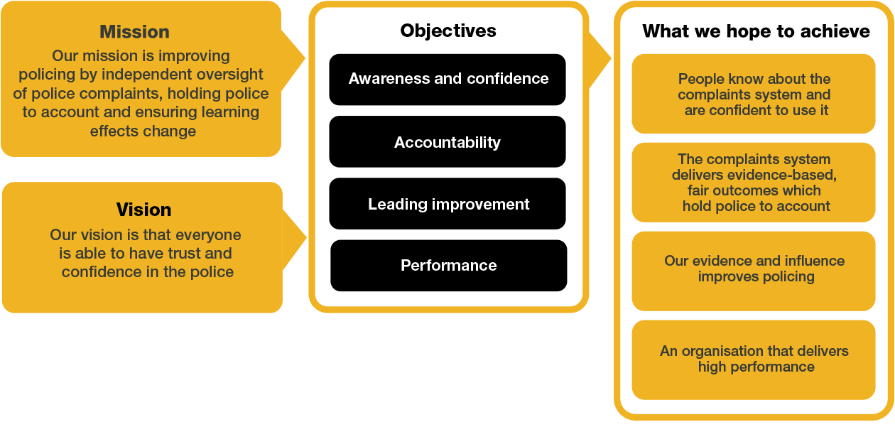
Organisational context

We work in the context of our agreed values which inform the way we do things at the IOPC. The Insight Data Analytics Manager will need to be commited to managing in the context of these values.

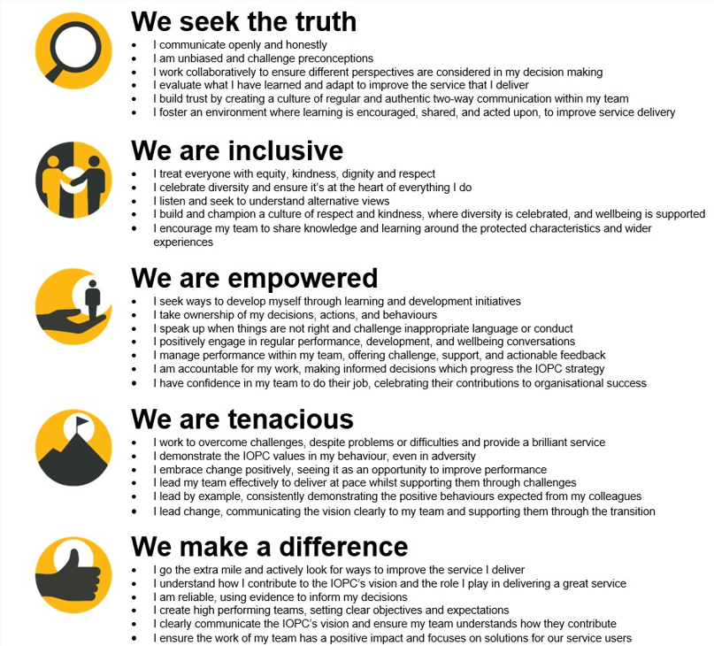

The IOPC is committed to promoting equality and valuing diversity in everything we do. Our vision is to be, and to be seen as, a leader in inclusive employment and services, demonstrating this ethos in everything that we do.
- Being a Disability Confident employer, the IOPC is dedicated to removing the barrier for disabled people to thrive in the workplace.
- Our Staff Networks are constantly working to make the IOPC the leaders of inclusive employment, from our Allyship Programme, to Welsh Language Standards and Know the Line Policy, we are constantly seeking new ways to create an environment for all to develop and thrive.


Main duties and responsibilities
- Lead the data insight enablement delivery plan and support the associated timetable of data visualisation products.

- Work collaboratively and in partnership with Product/project managers to support effective data capture and data flows design requirements to drive analytical opportunities

- Work with Data Engineers by providing clear design requirements for the management of the Enterprise Data Warehouse configuration.

- Use technology to support data insight including Power BI and other analytical tools.

- Data preparation, cleanse and validation to ensure Data Quality and integrity

- Examine, interpret and report results of analytical initiatives to internal and external stakeholders, business leaders and teams

- Be professionally curious and understand the why behind data visualisation and reports.

- Managing relationships with internal and external stakeholders and clearly delivering data visualisation and insights that are easily understood

- Liaising and coordinating the needs of technical and business stakeholders, ensuring effective business requirements gathering and interpreting them to deliver excellent customer service through data insight.

- Line management of staff and cross-team management of projects and work delivery

- Supporting staff through coaching, development and performance management, to ensure high quality and timely work delivery

- Oversee the design and delivery of data insight products and data requests processes ensuring accuracy, prioritisation, timescales, and quality standards are met

- Use knowledge of business, data and reporting structures to lead conversations and influence our data visualisation and insight architecture

- Work with others to improve information availability and reduce data management complexities, continually improving data management practices

- Own improvement of risks relating to data analysis with suggested mitigation or resolutions as appropriate.

- Supporting the Insight & Analytics Lead in delivery of our data and corporate strategies

- Maintaining project documentation and providing regular meaningful updates on progress and learning

- Be an ambassador within our DDaT function, leading conversations and continuous improvement in data capabilities and improving our data literacy/culture. Advocating data governance and data management standards and guidelines in the delivery of the Data Team’s products and services

Person specification

Essential
- Advanced Insight analytical skills and able to demonstrate skills and experience of using other data visualisation tools and techniques and use of Power BI reporting to extract meaningful analytical reporting on data.

- Proficiency in data analytical techniques including data cleaning, statistical analysis and familiarity with data querying, mining and manipulation tools and demonstratable track record on insight delivery.

- Proven experience of leading organisational insight requirements and ability to translate complex data for a variety of stakeholders, linked to performance and KPI tracking.

- Experience in planning projects and delivery in line with business priorities, using a variety of analysis and problem-solving techniques

- Integrate information from various environments and develop queries or reporting solutions to fulfil business needs

- Comprehensive knowledge and understanding of the data models within Case Management / Record Management Platforms, core data platforms and Enterprise Data Warehouse Technologies

- Experience analysing and determining root cause of recurring issues related to data accuracy and timeliness and supporting the I&A lead with business strategy development

- Strong team leadership and communication skills, both written, presentation and verbal with the ability to communicate insights to stakeholders at all levels

- Can demonstrate strong working relationships with internal partners, suppliers and end users

- Experience of working independently and at pace, including management of remote workers and requirement for national travel, as part of a team based in separate locations and demonstrating initiative

- Skilled in gathering business requirements and user-stories, including strategic organisational change and transformation level projects.

- Ability to work at a strategic level, promote organisational values and lead change and improvements in data

- Management experience and positive leadership knowledge including the ability to motivate and drive positive behaviours in others through coaching and personal development

- Experience of working in a secure environment and adhering to data principles and legislation

Desirable
- BCS Data Analyst (level 4) certification

- Masters or graduate degree in data analysis or equivalent work experience

Reasonable adjustments
The IOPC is a diverse and inclusive workplace and we want to help you demonstrate your full potential whatever type of assessment is used. We are open to providing you with the tools you need to succeed, from extra time to formatting changes, to name a mere few. If you require any reasonable adjustments to our recruitment process, please email recruitment@policeconduct.gov.uk

Working conditions
The IOPC operates a hybrid working policy which requires all staff to work an average of 40% of their contractual hours at their office base (or another office for business reasons). Office attendance time includes in-person training, meetings with stakeholders and families, and attending events.

Preparation checklist
☐ Review the full job description
☐ Review the behaviours and the descriptors for each behaviour
☐ Review the Strengths dictionary
☐ Review the IOPC values
☐ Consider your Strengths (if applicable)
☐ Consider drafting example answers that cover the specific elements
☐ Prepare some questions to ask the interviewers

