Job description
Title: Deputy Director, Digital and Data
Reports to: Director of Finance and Corporate Resources
Location: Croydon, Canary Wharf, Sale, Wakefield, Birmingham or Cardiff
Grade: 17
Salary: £81,265 per annum (plus London Weighting of £4,968 if based in Croydon or Canary Wharf)
Contract: Permanent

Purpose
The role is a key senior leadership position in the IOPC and will be leading the Digital and Data function across the IOPC. At a time when the organisation is transforming the way it delivers its core business, rationalising its technology infrastructure and aiming to exploit our own data as well as national data sets, this is a critical role at an exciting time for the IOPC.
The post reports to the Director of Finance and Corporate Resources and forms part of the Director’s Senior Leadership Team. The post holder will be the Deputy Director of the Digital and Data Profession within the IOPC and will be accountable for fostering and developing the profession across the IOPC and in line with the wider Civil Service profession model.
The postholder is responsible for collaboratively leading the development of the IOPC’s Digital and Data strategy, outlining the organisation’s ambition for how digital and data is to be used to achieve the organisation’s objectives. They will be a critical partner of our operational leaders, anticipating the challenges of investigations, oversight and casework to develop and deliver a technology roadmap that improves our productivity.
This is a high-profile role which requires a technical leader who is a strategic thinker, can work at pace, has the ability to develop a high-performance culture and can effectively manage multiple senior stakeholder relationships across the IOPC at all levels and the wider Digital profession across Government.
The successful candidate will be an exceptional leader with the proven ability to set a strong direction and convey a persuasive future vision at all levels of an organisation. They will provide the key link between the Digital and Data strategy team and the rest of the organisation. Providing leadership to the whole of the organisation to realise the benefits that are possible and planned from digital and data capabilities.
You will be responsible for developing and implementing effective processes, delivery standards and governance ensuring that day to day operations run efficiently, and results delivered – all with the end-user in mind.
You will be a digital champion, with an ability to grow digital capability and talent across the organisation. You will be able to advise with confidence how to utilise digital and technology solutions to ensure successful programme delivery.
You will have a strong focus on leading and developing your team to perform at its best, providing excellent customer service, giving constructive advice and challenge, and acting as trusted advisor.
You will have the ability to engage, influence and form strong working relationships with a broad range of stakeholders at all levels. You will have excellent communication skills with the ability to communicate a variety of messages to a range of audiences.
The post holder will be expected to gain or hold security clearance to Security Check (SC).

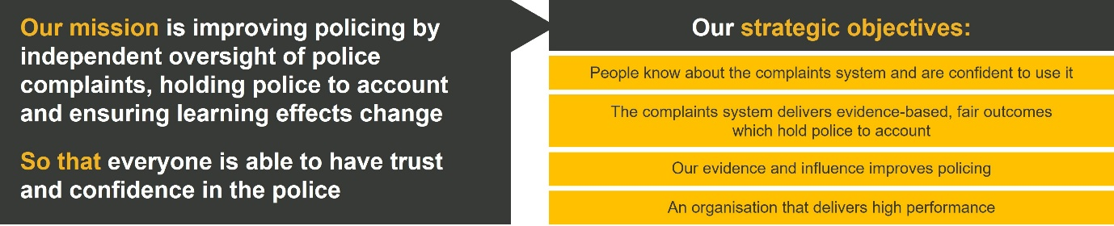
Organisational context

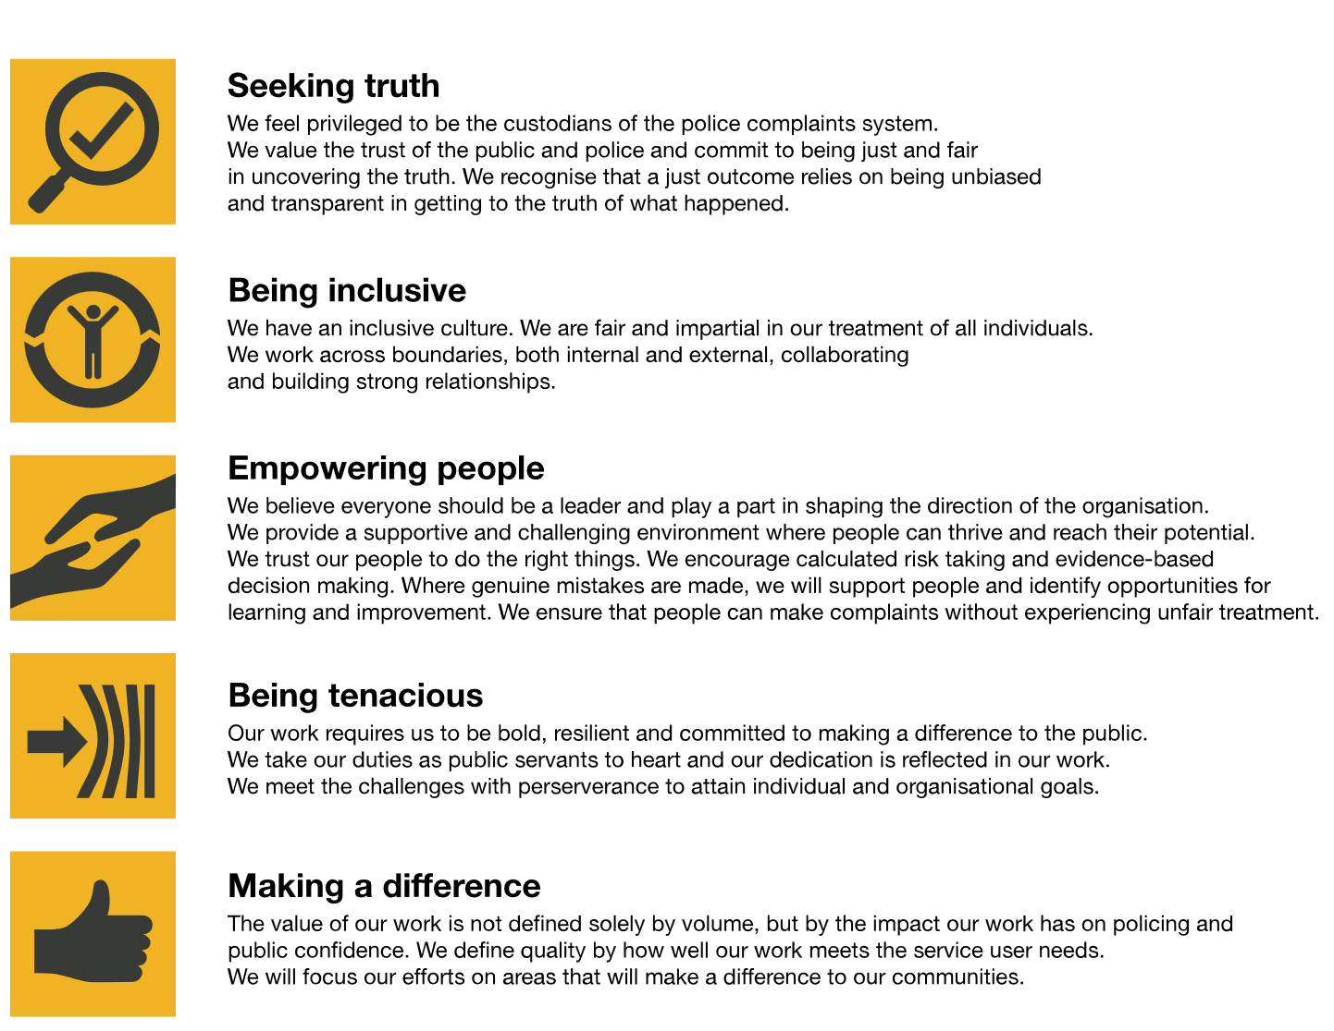
We work in the context of our agreed values which inform the way we do things at the IOPC. The post-holder will need to be commited to managing in the context of these values.

The IOPC is committed to promoting equality and valuing diversity in everything we do. Our vision is to be, and to be seen as, a leader in inclusive employment and services, demonstrating this ethos in everything that we do.
- We are pleased to share we are a signatory of the Business in the Community Race at Work Charter. The Charter is composed of five calls to action for leaders and organisations across all sectors.
- Being a Disability Confident employer, the IOPC is dedicated to removing the barrier for disabled people to thrive in the workplace.
- Our Staff Networks are constantly working to make the IOPC the leaders of inclusive employment, from our Allyship Programme to Welsh Language Standards and Know the Line Policy, we are constantly seeking new ways to create an environment for all to develop and thrive.



Main duties and responsibilities

- Development of IOPC’s digital and data strategies including achieving buy in from key stakeholders.
- Creating a roadmap of activities and ensuring the right operating model is in place to realise the strategic vision and ensuring delivery is aligned to IOPC’s priorities.
- Leadership of a senior team responsible for running other core teams and services to agreed service levels and budgets.
- As Deputy Director, Digital and Data build a skilled, flexible, diverse, and engaged workforce.
- As the organisational lead for analysis, be responsible for improving our analytical capabilities across the whole organisation.
- Championing and role modelling values and behaviours and supporting others in doing so.
- Developing and maintaining effective relationships with key internal and external stakeholders including IOPC’s senior leadership, users, our service partners/ vendors, and cross governmental peers.
- Operating strong governance, risk and service management including:
  - Reporting Key Performance Indicators (KPIs)
  - Ensuring compliance with Digital, Risk, Data, Security and Technology regulation and government control frameworks
  - Ensuring effective risk management
- Drive for efficiencies and value for money in delivering existing services, capital expenditure, and projects and ensuring effective procurement, contract management and the right workforce mix.
- Leading and supporting the IOPC’s digital and data teams, establishing a strong direction and persuasive future vision and creating a place where digital professionals want to be.
- Providing flexible support to colleagues across the IOPC in order to support effective digital service delivery and identify opportunities for fresh digital reform.
- Reducing costs and bureaucracy within IOPC through process efficiency and automation.
- Prioritising resources and focus on our technology infrastructure, architecture, and cyber capabilities, and on the digital and data controls across the organisation.
- Providing visible leadership across the digital teams and throughout the organisation

Key Contacts
- Director of Finance and Corporate Resources and SLT peers
- Director of Transformation
- Other senior leaders within the organisation
- Members of the Management Board
- Performance and Finance and Audit Risk and Assurance Committees
- Digital programme teams and associated stakeholders

Person specification

Essential
- An engaging, adaptable, and collaborative leader, with experience of managing multiple complex teams.
- Ability to build strong, inclusive, high performing teams and cross-team working relationships whilst delivering Digital and Data related activities.
- A strategic and inspirational leader who can lead effectively through uncertainty and get the best out of a diverse workforce.
- A strategic thinker with the ability to shape direction in a complex landscape and develop new and innovative ideas whilst maintaining existing service levels.
- A strategic thinker who is able to articulate how technology and AI can deliver benefits to the organisation. You will have experience of simplifying a complex technology architecture to improve our resilience, simplify our support and improve our opportunities for better use of data and knowledge.
- You will have a strong understanding of how better use of our own data, and national data sets, will enable us to generate insights into the police accountability system that magnify our impact on our strategic objective.
- An ability to manage senior stakeholders, both internally and externally, and confidence in dealing with, and influencing, senior officials, and key partners.
- An ability to produce clear and non-technical advice on complex issues, with the ability to articulate risks simply, clearly, and persuasively to senior decision makers.
- Excellent technical skills with proven experience of delivering multiple and varied end-to-end Digital and Data solutions backed up by strong domain knowledge.
- Proven commercial expertise including experience of innovative approaches to sourcing services, and of managing relationships with large suppliers.
- A ‘growth’ mind-set, combined with a pragmatic and well-disciplined approach to digital delivery.
- Experience of delivering major programmes of work - including those which involve difficult trade-offs and considerable risk.

Reasonable adjustments
The IOPC is a diverse and inclusive workplace and we want to help you demonstrate your full potential whatever type of assessment is used. We are open to providing you with the tools you need to succeed, from extra time to formatting changes, to name a mere few. If you require any reasonable adjustments to our recruitment process, please email recruitment@policeconduct.gov.uk

Working conditions
Making the IOPC a great place to work is one of our key priorities. We are pleased to offer a unique hybrid working model based on business needs, balanced with the needs of our colleagues. Our business need framework guides our decisions about when it is best to work onsite (in our offices or other appropriate locations) to complete tasks most effectively or when to work remotely, offering colleagues flexibility to work where they feel most productive and supporting work-life balance. The model also encourages staff to feel welcome at the IOPC by ensuring we have opportunities to work face-to-face as teams.
We expect people to spend at least 2 days a week in an office, and this role will require travel around all of our seven offices around England and Wales.

Preparation checklist
☐ Review the full job description
☐ Review the behaviours and the descriptors for each behaviour
☐ Review the Strengths dictionary
☐ Review the IOPC values
☐ Consider your Strengths (if applicable)
☐ Consider drafting example answers that cover the specific elements
☐ Prepare some questions to ask the interviewers

