Job description
Title: Operations Specialist Support Team (OSST) HOLMES Indexer
Reports to: OSST Indexing/Investigation Support Team Leader
Location: Sale – Investigations, Oversight & Casework
Grade: 8
Salary: £28,665
Contract: Permanent

Purpose
As a HOLMES Indexer within the IOPC, you can expect to work in a progressive and dynamic organisation with declared and strong core values. This role has opportunities to be involved in the implementation of new processes and contribute to the investigation process. The work will be fulfilling and offer opportunity for personal growth and satisfaction.

Responsible for accurately inputting, analysing and researching data on the Home Office Large Major Enquiry System (HOLMES). Ensuring compliance with the Investigation policy decisions, national guidelines and provide support and guidance to investigations staff working on HOLMES supported investigations.
Alongside other Operations Specialist Support Team members, ensure the database is fit for purpose to enable disclosure to take place, build files for court and create jury bundles. Participate in de-briefs and/or other forums to provide details of any lessons learnt during an investigation to enable discussion, in relation to IOPC HOLMES processes. To inform future policies and practises by ensuring HOLMES forms part of the IOPC’s learning and development environment.
The HOLMES Suite located at the Sale office, is purpose built to support a major investigation or an Investigation of National Significance. There is appropriate security and suitable storage for investigation material, including exhibits.

This role will particularly focus on providing support in relation to disclosure for misconduct and criminal proceedings.

As a HOLMES Indexer you may view some distressing or sensitive material gathered as part of our independent investigations.

Organisational Context

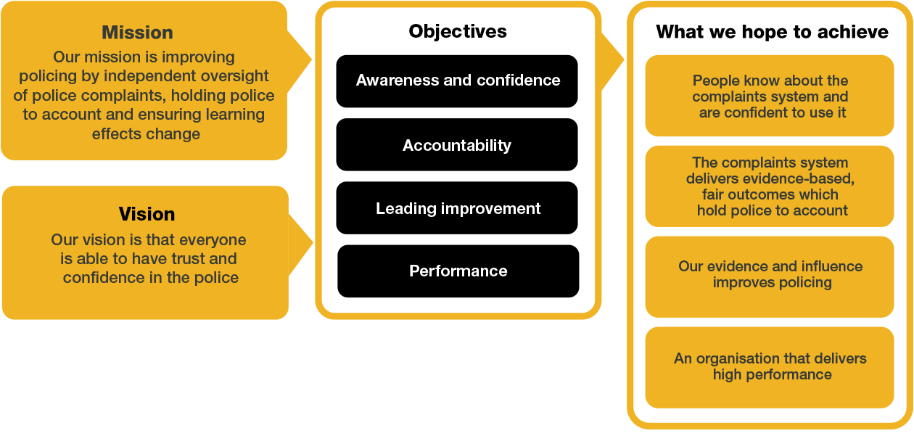

The Independent Office for Police Conduct is responsible for oversight of the police complaints system in England and Wales and has the power to carry out independent investigations into complaints, conduct, and death or serious injury matters. We also investigate allegations that Police and Crime Commissioners or their deputies may have committed criminal offences. The IOPC is also the appeal body for some complaints investigated by police forces and other bodies.

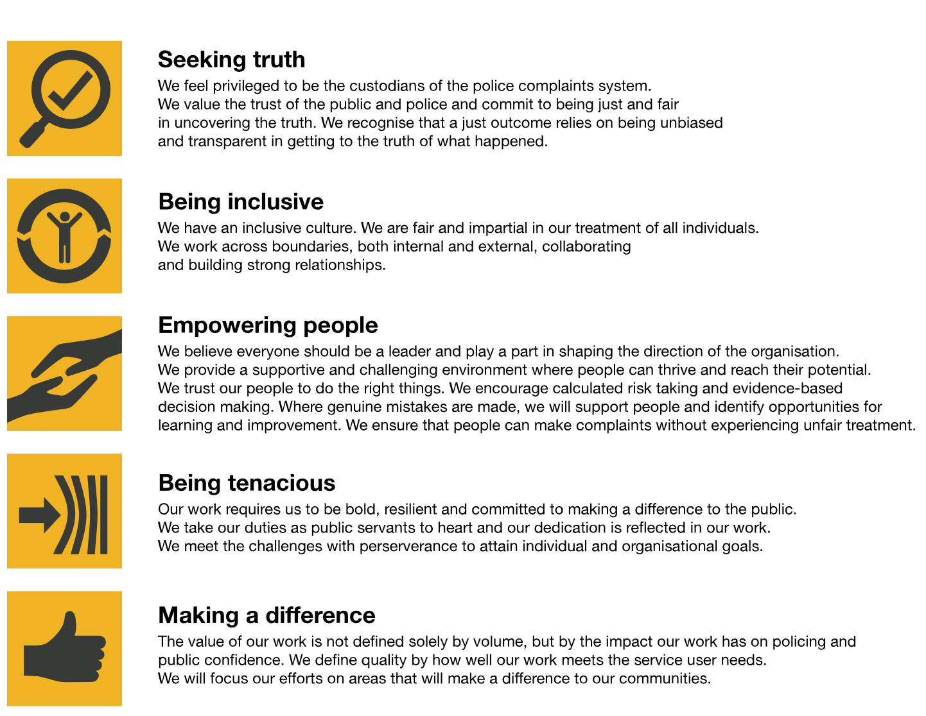
The IOPC is committed to promoting equality and valuing diversity in everything we do. Our vision is to be, and to be seen as, a leader in inclusive employment and services, demonstrating this ethos in everything that we do.

The IOPC is committed to promoting equality and valuing diversity in everything we do. Our vision is to be, and to be seen as, a leader in inclusive employment and services, demonstrating this ethos in everything that we do.
- Being a Disability Confident employer, the IOPC is dedicated to removing the barrier for disabled people to thrive in the workplace.
- Our Staff Networks are constantly working to make the IOPC the leaders of inclusive employment, from our Allyship Programme to Operation Hotton, to Welsh Language Standards and Know the Line Policy, we are constantly seeking new ways to create an environment for all to develop and thrive.


Main duties and responsibilities
To effectively support HOLMES supported Major Investigations, in relation to Police Reform Act (PRA) and Criminal Investigations. The support of the team relates to investigations managed on the Home Office Large Major Enquiry System (HOLMES).
- Assist with the maintenance and management of key information received during an IOPC investigation through maintaining a HOLMES database to support any level of IOPC investigation.
- Maintain the HOLMES database through indexing and administrative tasks in accordance with local policies.
- Undertake detailed research prior to creating any records to avoid duplication
- Accurately register all documentation entering the investigation to appropriate indexes on the HOLMES 2 database
- Raise actions, as requested by a receiver or other designated requestor to the correct index and with enough information to assist the investigator in knowing where to obtain initial information about the subject of the action. Ensuring you record the source document for the action and being mindful of disclosure requirements for any personal information within action text.
- Index all documents, as required depending on the level of investigation by: -
- creating all relevant indexes and adding all known information
- creating cross reference descriptions detailing the contents of the document to all appropriate records.
- add links to records to show associations noted within documentation to ensure the index accurately reflects all information known
- ensure information in free text fields can be traced to its original source
- To assist in the collation and dissemination of accurate and relevant information to ensure investigative resources are effectively and efficiently utilised.
- To assist in the collation of accurate and relevant data for inclusion in reports and in response to other information requests
- Whilst carrying out daily duties any records identified on the database as requiring review should be advised to the OSST HOLMES Indexer/Investigation Support Unit Team Leader or the OSST Reader/Receiver Team Leader, for assessment.
- Assist in the preservation and integrity of all HOLMES material (excluding exhibits) by following handling processes, maintaining a standard filing system that is regularly audited and following a signing out policy for any material leaving the HOLMES Suite.
- Assist the Lead investigator with preparation of Case File Documentation for CPS or Coroners Court and as required, jury bundles from HOLMES
- Assists, when appropriate, in the day to day tutoring/mentoring of new staff with the HOLMES Suite, providing on the job training, support and encouragement.
- Assist and liaise with staff members to maintain good communication and relationships with colleagues.
- Attend briefings as required

These main duties and responsibilities are intended only as a guide to the main responsibilities of the post and are not intended to restrict the scope of the post holder to perform other duties. Additional responsibilities for the post holder may be agreed on an individual basis and recorded as part of the annual performance review role requirement.
This post may be requested to temporarily deploy to other IOPC offices or locations to provide temporary support in setting up a new or ongoing major investigation. Travel and accommodation will be supplied and reasonable subsistence expenses paid according to the agreed Travel and Subsistence policy.

Person specification
Essential Experience/Skills

- Recent experience (on or after July 2024) undertaking the role of HOLMES Indexer on large and/or complex investigations
- Proven experience of researching the HOLMES database to provide information, as requested to the Director or Operations Manager
- Proven experience of working effectively in a team environment.
- Ability to work effectively under pressure,
- Experience of dealing with internal parties to complete tasks successfully.
- Experience of knowledge sharing across internal departments to enhance in-house learning
- Experience of working on own initiative and taking decisions within a framework of delegation
- Analytical skills with the capacity to absorb/organise new information to ensure well briefed on new topics.
- Comfortable taking decisions within a clear framework of delegation.
- Experience of analysing and extracting information from various sources and translating and summarising into a clear format for others
- Experience of working in an environment where a high level of attention to detail and an ability to work accurately is essential
- Sound administrative skills, ability to work under pressure and prioritise tasks.
- Experience of dealing with internal parties to complete tasks successfully.
- Strong inter-personal (written and oral) communication skills.

Desirable Experience/Skills

- Practical knowledge of Data Protection Act, Freedom of Information and Government Protected Marking Scheme.

Selection process
This vacancy is using Success Profiles. As part of the application process you will be asked to complete three sift stage questions. You will be assessed against Executive Officer Behaviours.
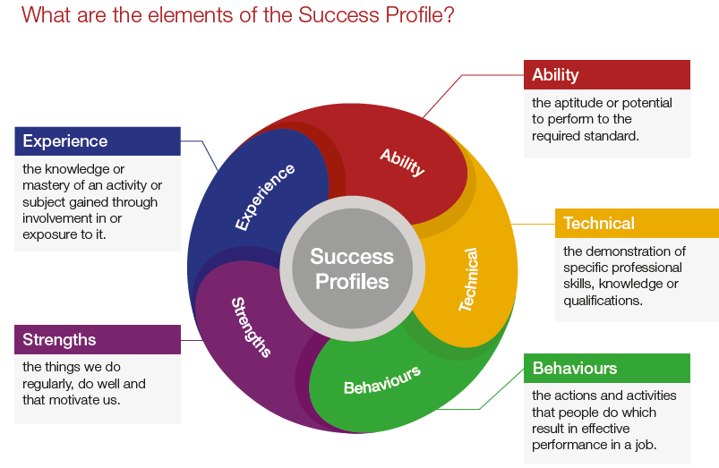
Success Profiles moves us to a tailored way of assessing, dependent on the requirements of the job. For each role we advertise, we consider what you will need to demonstrate in order to be successful. This gives us the best possible chance of finding the right person for the job, drives up performance and improves diversity and inclusivity so that we can truly reflect the communities that we serve. Not all of the elements are relevant to every role and will vary depending on the level and type of role. You should ensure you read the job description carefully to see what elements are required for the specific job you are applying for. There are separate guides to each of the elements, which will give you more information about what and how you can demonstrate specific requirements.
How the elements are assessed
You could be assessed in a number of different ways, depending on the type of role and level you are applying for. Using a range of assessment methods helps us to more accurately match people to the essential requirements of the job. For example, you may be asked to complete an application form; provide a CV and supporting statement; attend an assessment centre; or complete an online test. Often a combination of these approaches will be used, and more than one element may be tested within the same assessment method.
Details of which elements will be assessed and how we will assess you against these, are included in the job description.

Reasonable adjustments
The IOPC is a diverse and inclusive workplace and we want to help you demonstrate your full potential whatever type of assessment is used. We are open to providing you with the tools you need to succeed, from extra time to formatting changes, to name a mere few. If you require any reasonable adjustments to our recruitment process, please email recruitment@policeconduct.gov.uk

Working conditions
The IOPC operates a hybrid working policy which requires all staff to work an average of 40% of their contractual hours at their office base (or another office for business reasons). Office attendance time includes in-person training, meetings with stakeholders and families, and attending events.

Preparation checklist
☐ Review the full job description
☐ Review the behaviours and the descriptors for each behaviour
☐ Review the Strengths dictionary
☐ Review the IOPC values
☐ Consider your Strengths (if applicable)
☐ Consider drafting example answers that cover the specific elements
☐ Prepare some questions to ask the interviewers

