Job description
Title: Support Worker
Reports to: Senior Casework Manager
Location: Cardiff
Grade: Grade 8
Salary: £28,665 per annum
Contract: Permanent, full-time hours of 37 hours per week

Purpose
To provide support and assistance three days a week to an IOPC Casework Manager who is totally blind, to enable him to carry out his role. The role of the Casework Manager who requires this support involves reviewing how the police have handled complaints and other matters and deciding whether the police have handled these matters appropriately. The successful candidate will be providing the Casework Manager with support and assistance in this role, required due to his blindness. For the remaining two days of the working week, the candidate will be working within our admin hub, supporting them by completing administrative tasks.

This role will require the successful applicant to be available in-person on Mondays Tuesdays and Thursdays of each week with the set hours of 7:45am – 4:30pm.
Remaining hours can be worked flexibly either from home or in-office as preferred on the remaining Wednesday and Friday.

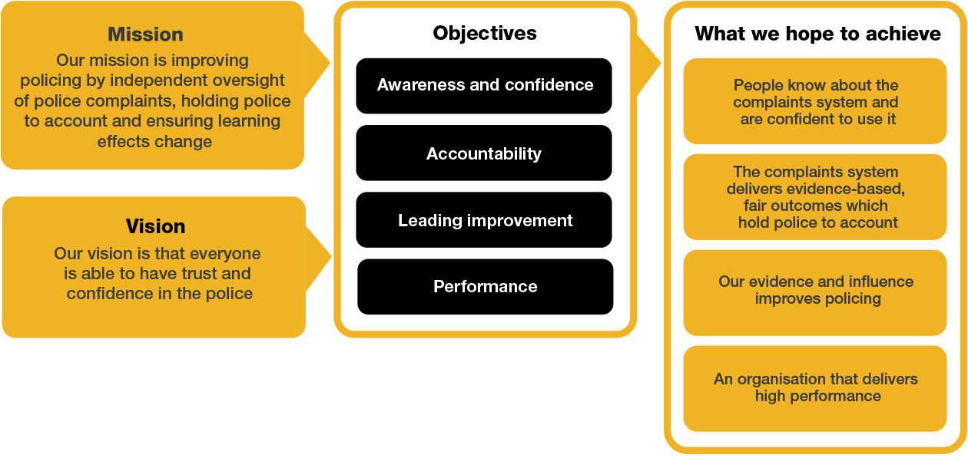
Organisational context

We work in the context of our agreed values which inform the way we do things at the IOPC. The Support Worker will need to be commited to working in the context of these values.

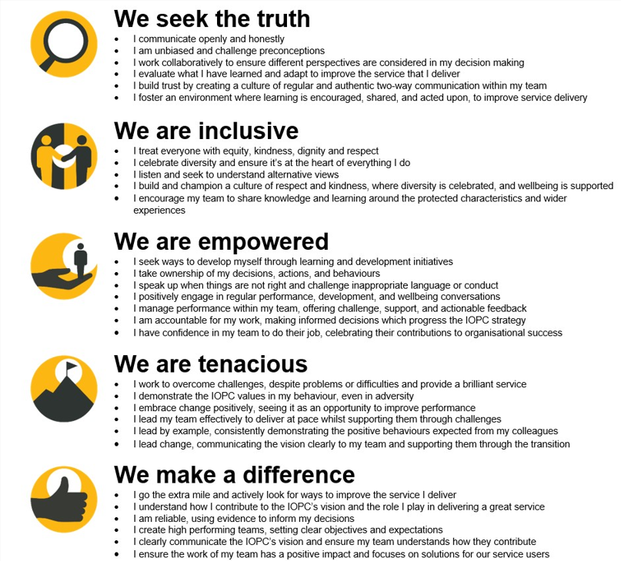
The IOPC is committed to promoting equality and valuing diversity in everything we do. Our vision is to be, and to be seen as, a leader in inclusive employment and services, demonstrating this ethos in everything that we do.
- Being a Disability Confident employer, the IOPC is dedicated to removing the barriers for disabled people to thrive in the workplace.
- Our Staff Networks are constantly working to make the IOPC the leaders of inclusive employment, from our Allyship Programme to Operation Hotton, to Welsh Language Standards and Know the Line Policy, we are constantly seeking new ways to create an environment for all to develop and thrive.


Main duties and responsibilities
Supporting the Casework Manager to access information and documentation relevant to his role, including by:
Using software to convert documents to formats which the Casework Manager can read using his computer speech software and checking the converted output for accuracy.
Accurately typing up documents or sections of documents which cannot be converted automatically, to enable the Casework Manager to read the documents.
Reading aloud documents or sections of documents as directed by the Casework Manager.
Reviewing documents to identify specific information or types of information, as instructed by the Casework Manager.
Providing accurate, detailed and impartial verbal and written descriptions of relevant visual evidence (such as CCTV, photographs and police body-worn video footage), some of which is likely to be emotionally distressing, to enable the Casework Manager to make fully informed and independent decisions.
Where necessary, entering and updating information into IOPC Case Management Systems as instructed by the Casework Manager, to a high degree of accuracy.
Assisting the Casework Manager to ensure that the visual formatting of documents which he creates and edits appears visually as intended, and that the formatting aligns with IOPC branding and communications guidelines.
Supporting the Casework Manager to access and use some parts of IOPC I.T. systems which are not compatible with his computer speech software, by reading and describing information as required and carrying out basic computer tasks, as instructed.
Providing all assistance necessary to enable the Casework Manager to access information relevant to his role, including through adapting training materials to make them accessible to the Casework Manager and supporting him during in-person and remote training, which may involve occasional travel.
Where necessary, physically guiding the Casework Manager into and around IOPC buildings, and in unfamiliar environments, to assist with his orientation. Full training on this aspect of the role will be provided. Further general information and videos on how to guide a blind person is available on This page on the website of the Royal National Institute of Blind People (RNIB).
Assisting the Casework Manager with administration required to submit claims for reimbursement of support costs to the government Access to Work scheme (full training will be provided).
When not required to provide support to the Casework Manager, undertake general Casework support tasks within the admin hub as required, including:
Referrals
- Creation of new referrals on CMS
- Forward referrals to appropriate department
- Ensure all documents and information are saved to the case and media encrypted and sent to the appropriate decision

Media
- Create and manage file parts and media for the directorate
- Copy and conversion of all media types, including BWV and CCTV.
- Downloading of media and investigation papers from cloud-based applications.
Any other reasonable duties.

Person specification

Desirable
Previous experience of supporting a disabled person, either in employment or through providing other support to enable their independence, choice and control.
An understanding and appreciation of the social model of disability.

Experience
This job would be well-suited to some people who have worked as “personal assistance” to disabled people funded by social services “direct payments”, where the disabled client is the employer. Such roles require an understanding that the client can and must make their own decisions. Experience working in administrative roles is also desirable.

Skills and Abilities
The below skills and abilities listed are essential for this role.
- Strong attention to detail and accuracy.
- Excellent written and verbal communication skills, to be able to describe visual information such as video footage in a clear, accurate and succinct manner.
- The ability to pro-actively identify problems or barriers encountered and to suggest and implement creative solutions to these challenges.
- Competent typing skills and a willingness to further develop these skills
- ICT/Microsoft Office literate.
- Knowledge of different file formats, including PDFs, image and text-based file formats.
- The ability to quickly learn to use unfamiliar software and ICT systems to achieve objectives.

Reasonable adjustments
The IOPC is a diverse and inclusive workplace, and we want to help you demonstrate your full potential whatever type of assessment is used. We are open to providing you with the tools you need to succeed, from extra time to formatting changes, to name a mere few. If you require any reasonable adjustments to our recruitment process, please email recruitment@policeconduct.gov.uk

Working conditions
For this role, the candidate will need to attend the office three days a week to provide in-person support to the Casework Manager.
The required office attendance will be on a Mondays, Tuesdays and Thursdays to align with the Casework Manager’s working days, with working hours from 07:45 to 16:30. The remainder of their contractual hours can be worked either from the office or home on Wednesdays and Fridays.
There will be an expectation for the Support Worker to coordinate their annual leave with the Casework Manager they support, to ensure continuity of service. Wherever possible, annual leave should be planned and mutually agreed in advance, taking into account the Casework Manager’s requirements and the Support Worker’s individual needs. In circumstances where annual leave cannot be aligned, the Support Worker may be required to undertake alternative duties outlined in this job description.

Preparation checklist
☐ Review the full job description
☐ Review the behaviours and the descriptors for each behaviour
☐ Review the Strengths dictionary
☐ Review the IOPC values
☐ Consider your Strengths (if applicable)
☐ Consider drafting example answers that cover the specific elements
☐ Prepare some questions to ask the interviewers

