

Title: Lead Investigator
Reports to: Investigations Team Leader – Core Business
Location: Core Investigations - Birmingham, Canary Wharf, Croydon, Cardiff,
Sale, Wakefield

Major Investigations (MI) North - Sale or Wakefield

Major Investigations (MI) South - Birmingham or Canary Wharf

Grade: 11

Salary: £37,596 (plus £4,968 London weighting allowance if based in Canary Wharf or Croydon)
Contract: Permanent

Purpose

The IOPC is an organisation steeped in history, influenced by significant figures such as Stephen Lawrence and Sir William Macpherson, overseeing the police complaints system in England and Wales and setting the standards by which the police should handle complaints. As a completely independent organisation, we seek to uphold the rights of the public and investigate the most serious matters, including deaths following police contact, to promote learning and influence change in policing.

As a Lead Investigator, you will be a part of a dynamic investigations team working locally and nationally on a wide range of investigations that are often in the public eye in the Investigation, Oversight and Casework directorate. The IOPC is on a journey to develop its culture, perspectives and ethos to support the organisations core outcomes, and this is your opportunity to enter the varied world of investigations, allowing you to develop your mindset and approaches to contribute to improving the police complaints system in England and Wales. The investigations team are tasked with upholding our values whilst establishing the facts behind a complaint and reaching conclusions to draw recommendations.

As a Lead Investigator, you will lead all aspects of an investigation, from setting out the initial terms of reference, to collecting evidence, interviewing witnesses, drawing conclusions, and writing a final report, many of which are published.
Reports also include recommendations for the police force or Police and Crime Commissioner about actions to be taken to improve practice and prevent mistakes in the future. Therefore, it is imperative that you take a ‘cultural knowledge accountability’ approach to your work, so that you produce rounded and robust outcomes. After the investigation, investigations staff are responsible for supporting criminal, disciplinary and coronial proceedings which may follow.

The nature of the work requires investigations staff to participate in an out of hours on call function for which an appropriate allowance is paid under IOPC policy.

You will need relevant experience of undertaking investigations in any sector, such as social work, the probation services, local authority enforcement or regulatory services, as well as fraud or criminal justice. This role requires highly developed analytical and report writing skills, and an ability and commitment to acting independently. The IOPC is a public service and aims to ensure that everyone receives an equal service. To make this a reality we need innovative and socially aware people to join us. The IOPC are committed to developing the mindset of a team of diverse and passionate individuals reach their career goals whilst contributing to improving policing confidence.

This role is exempt from the Rehabilitation of Offenders Act 1974; therefore, a standard Disclosure and Barring Service (DBS) check will be carried out for the successful candidate during the pre-employment process.

Organisational Context
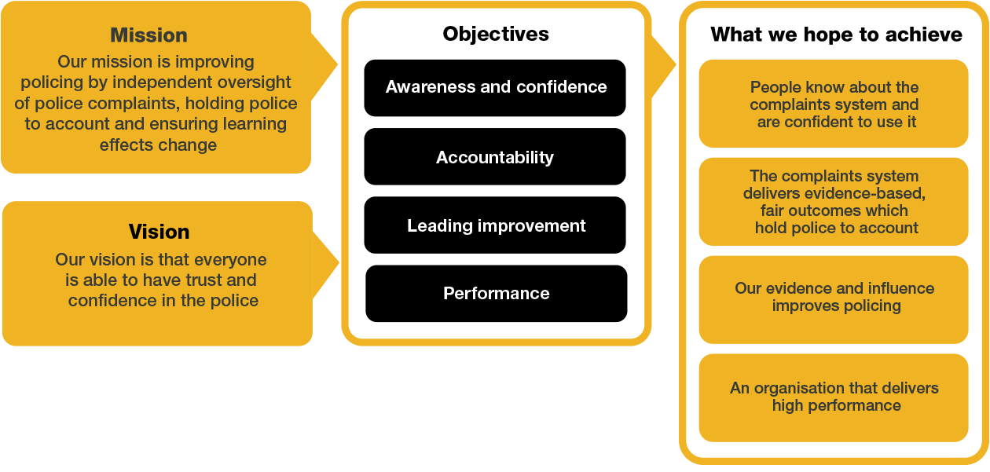

We work in the context of our agreed values which inform the way we do things at the IOPC. The Lead Investigator will need to be commited to managing in the context of these values.

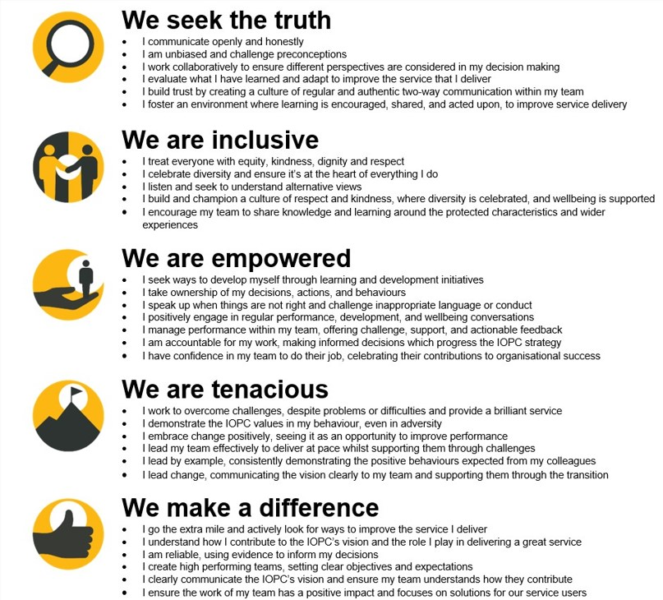

The IOPC is committed to promoting equality and valuing diversity in everything we do. Our vision is to be, and to be seen as, a leader in inclusive employment and services, demonstrating this ethos in everything that we do.

- We are pleased to share we are a signatory of the Business in the Community Race at Work Charter. The Charter is composed of five calls to action for leaders and organisations across all sectors.
- Being a Disability Confident employer, the IOPC is dedicated to removing the barrier for disabled people to thrive in the workplace.
- Our Staff Networks are constantly working to make the IOPC the leaders of inclusive employment, from our Allyship Programme to Operation Hotton, to Welsh Language Standards and Know the Line Policy, we are constantly seeking new ways to create an environment for all to develop and thrive.


Main duties and responsibilities

- Leading independent investigations into criminal and misconduct allegations in accordance with agreed IOPC guidelines.
- Conducting investigations within agreed timescales, budget, and quality standards.
- Drafting and agreeing Terms of Reference for allocated investigations.
- Undertaking investigative actions, including interviewing, and taking statements, preparing case files, and making recommendations for criminal and/or disciplinary action.
- Taking part in criminal, misconduct, and inquest proceedings where necessary.
- Reporting to your Operations Team Leader on investigation progress, areas of risk and resourcing requirements.
- Participating in the 24-hour on call facility and being prepared to work unsociable and extended hours.
- Visiting incident scenes and supervising scene management where required to ensure that all necessary action is taken to preserve and recover evidence.
- Attending post-mortems and briefing the pathologist as required.
- Writing investigation reports upon completion of the investigation for submission to the IOPC decision maker.
- Communicate effectively with complainants, bereaved families, and other internal and external stakeholders.
- Working as part of a multi-disciplinary team with decision makers, lawyers, press officers and others.
- Taking responsibility for personal development in a dynamic and constantly evolving investigative environment.
- Assisting the Directorate in achieving its key deliverables. Preparing disclosure schedules for court and inquest proceedings.
- Reviewing unpleasant material, liaising with traumatically bereaved families, robust external scrutiny of actions and decisions.

- Receive close management support/ training and have access to an extensive employee assistance program.

- Identifying potential learning for police forces to consider improving the service they provide and prevent harm to the public.

Person specification

Desirable Technical
• PiP2 qualification or equivalent investigative experience

Essential Experience
- Conducting investigative interviews, evidence gathering, analysis and presentation.
- Evidence of effective oral and written communication skills.
- Evidence of excellent analytical and report writing skills; ability to reach and document clear, rational, evidence-based, and independent decisions based on analysis of existing and emerging information.
- Experience of engaging effectively with a diverse range of people and stakeholders, and evidence of a commitment to equality and diversity within the workplace.
- Delivering a high standard of work within demanding timescales.
- Identification of operational and organisational risk.
- Working effectively in a changing environment.
- Full driving licence valid for driving in the UK

Essential Skills and Abilities
- Ability to show initiative and adapt in a changing environment.
- Writing investigation reports upon completion of the investigation for submission to the IOPC decision maker.
- Communicate effectively with complainants, bereaved families, and other internal and external stakeholders.
- Ability to recognise your development needs and be proactive in addressing them.
- Ability to prioritise and manage tasks effectively to deliver quality outcomes within demanding timescales.
- Ability to work effectively in a team with diverse ideas and people.
- Ability to communicate effectively both verbally and in writing and adapt communication styles as appropriate.

Selection process

Application
This vacancy is using Success Profiles, to find out more, please click here. You will be asked four sift questions at the application stage including an Experience and IOPC Values question. We'll also assess you against these HEO Civil Service behaviours during the application process:
- Making effective decisions
- Communicating and influencing

Stage 1: Interview – 20 to 29 October
For those successfully shortlisted, you will be invited to a technical interview conducted over MS Teams which will last approximately 30 minutes.

Stage 2: Assessment Centre – 10 November to 5 December
For those successful at stage 1, you will be invited to a two stages assessment centre which will include a formal interview, role play exercise and written exercises.

During stage 1 and 2 of the recruitment process we may assess your Experience, Behaviours, Strengths, Technical skills and Values.

Training
All successful applicants will be required to start on 11th May 2026 and will undertake a period of induction and training. As part of the training programme, you will engage in a Professionalising Investigations Programme Level 1 (PIP1) that is designed to develop your skills and knowledge as an investigator whilst working to achieve a qualification. The PIP1 programme includes formal and, on the job, learning as well as the support to build a portfolio of evidence which will provide you with the skills and knowledge to become a PIP1 investigator. You will also complete the Pearson Unit 4 accreditation relating to leading IOPC investigations. As we work to launch PIP2, you will be given the opportunity to undertake PIP2 at a later stage.

Training is mandatory and will be delivered remotely and in person. Further details of training will be provided to applicants at a later stage.

After completion of the PIP1 programme, you will be expected to engage in the revalidation programme. Revalidation ensures that your skills and knowledge are enhanced and maintained in line with the PIP requirements. Full engagement with the revalidation process is mandatory.

Reasonable adjustments

The IOPC is a diverse and inclusive workplace, and we want to help you demonstrate your full potential whatever type of assessment is used. We are open to providing you with the tools you need to succeed, from extra time to formatting changes, to name a mere few. If you require any reasonable adjustments to our recruitment process, please email recruitment@policeconduct.gov.uk.

Hybrid Working
The IOPC are currently consulting with our consultative bodies about proposed changes to our hybrid working policy which will require all staff to work 20% of their contractual hours at their office base (or another office for business reasons) from 1 September 2024 and increased to 40% from April 2025. Office attendance time includes in-person training, meetings with stakeholders and families, and attending events.

Preparation checklist

☐ | Review the full job description
☐ | Review the behaviours and the descriptors for each behaviour
☐ | Review the Strengths dictionary
☐ | Review the IOPC values
☐ | Consider your Strengths (if applicable)
☐ | Consider drafting example answers that cover the specific elements
☐ | Prepare some questions to ask the interviewers

