Job description
Title: Assurance Officer
Reports to: Data Protection Assurance and Reporting Officer
Location: Birmingham, Cardiff, Sale or Wakefield
Grade: 8
Salary: £26,010 per annum
Contract: Permanent

Purpose
As an Assurance Officer, you will be welcomed into a dynamic and inclusive Data Protection and FOI team. The IOPC is on a journey to develop its culture, perspectives and ethos to support the organisation’s core outcomes and this is your opportunity to enter into the varied world of IOPC Strategy and Corporate Services, allowing you to develop your mindset and approaches to contribute to improving the police complaints system in England and Wales.
The role will assist the Data Protection Assurance and Reporting Officer in delivering a Data Protection Assurance programme across the IOPC.
The role is based in the legal function in the Directorate of Resources and can be based in any IOPC office, with some occasional travel to other offices.

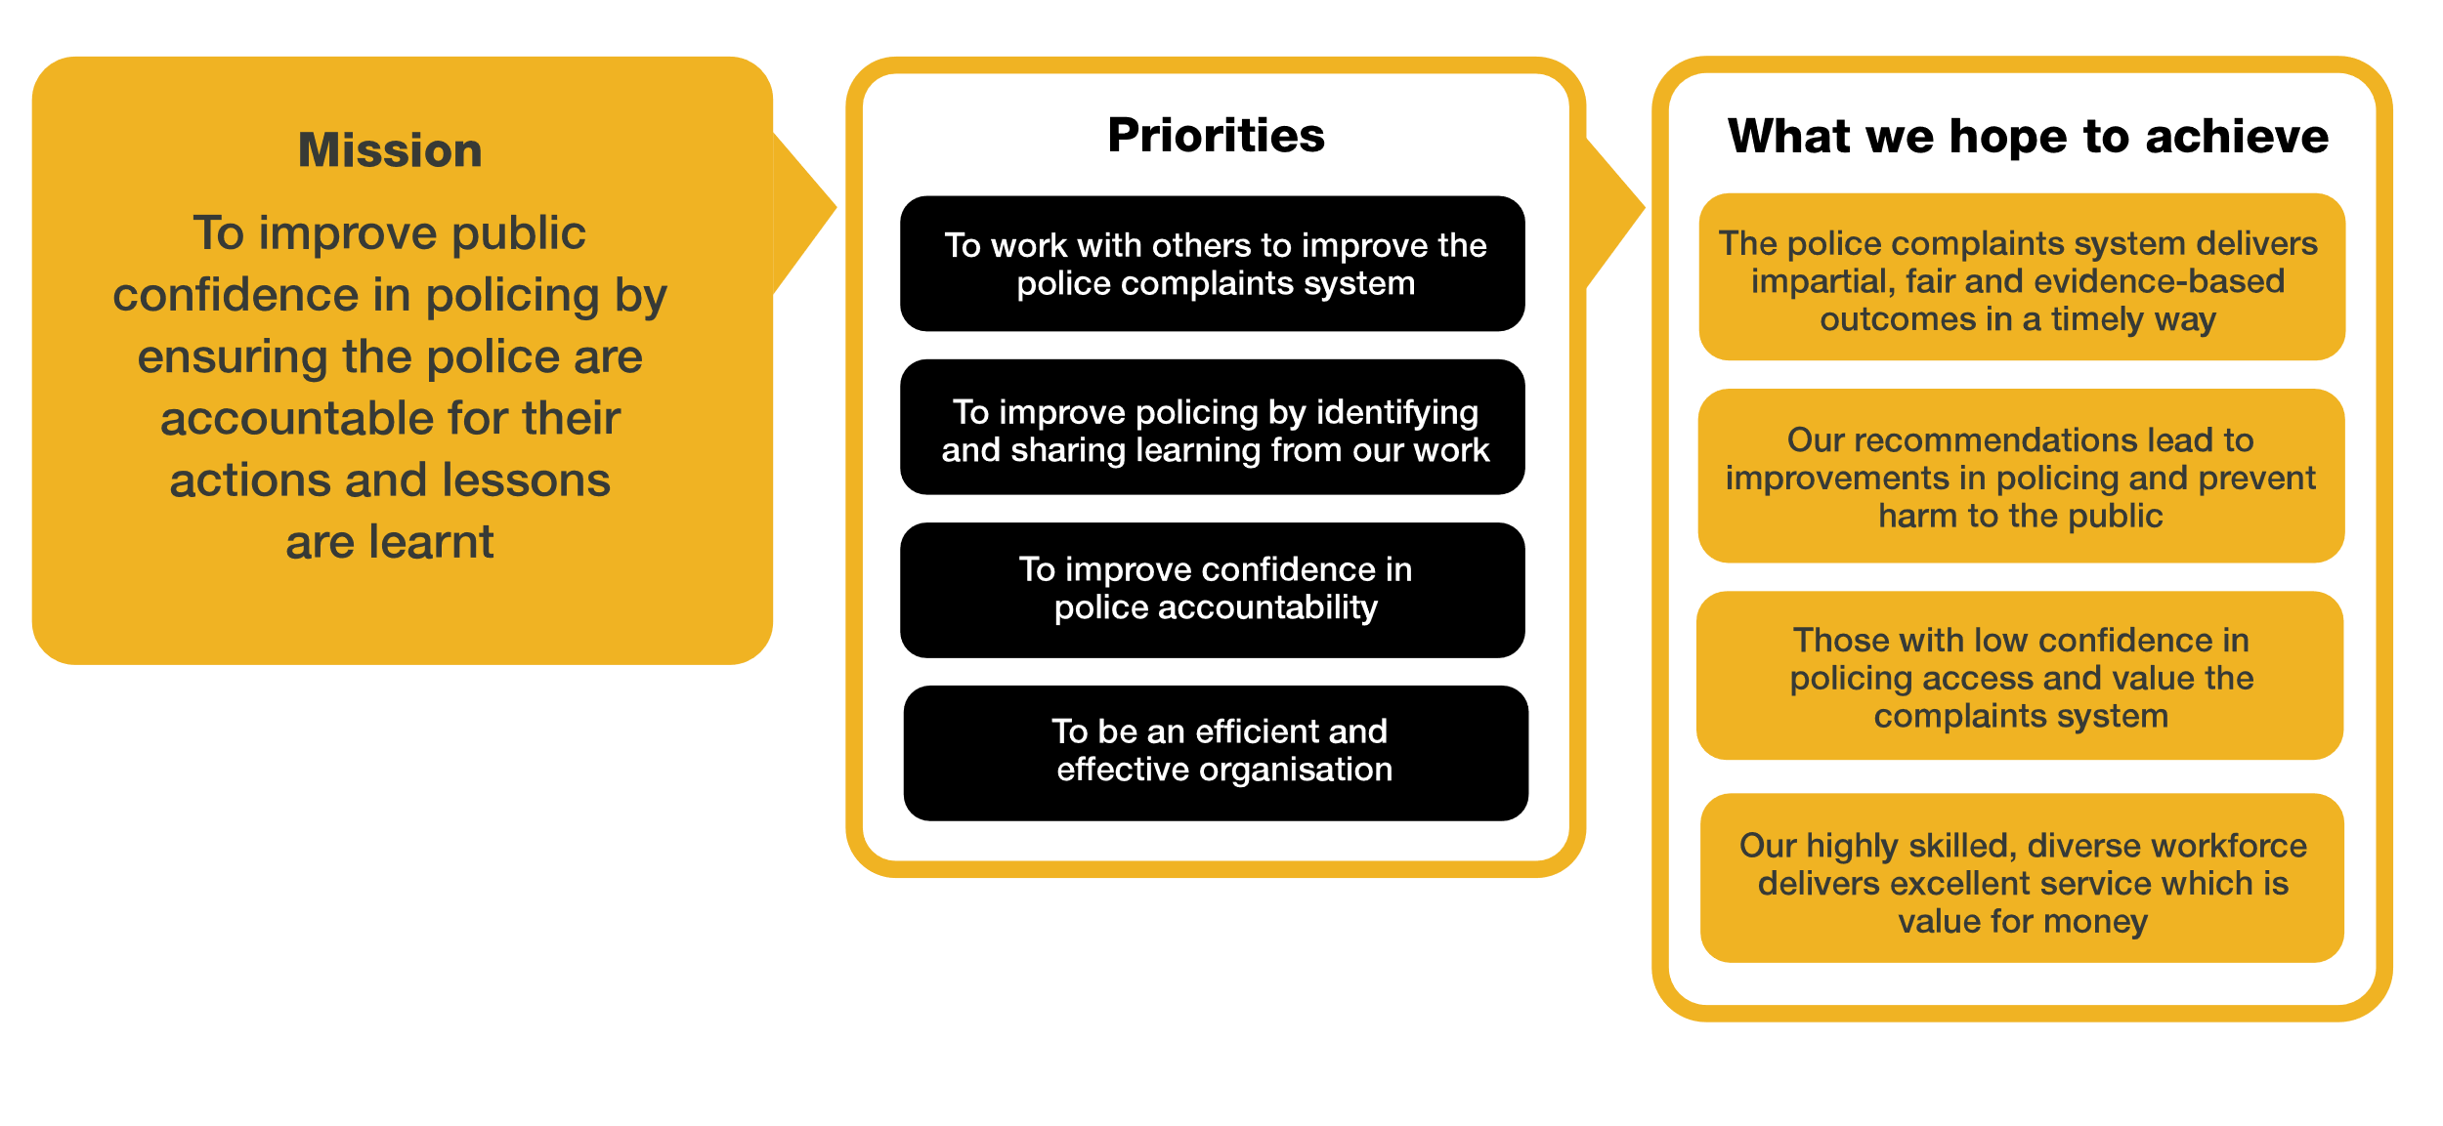
Organisational context

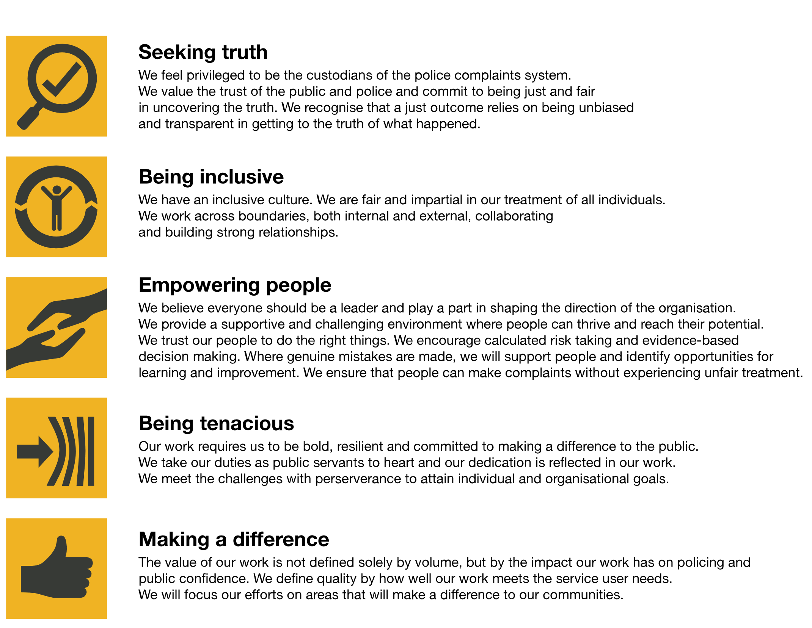
We work in the context of our agreed values which inform the way we do things at the IOPC. The Assurance Officer will need to be commited to managing in the context of these values.
The IOPC is committed to promoting equality and valuing diversity in everything we do. Our vision is to be, and to be seen as, a leader in inclusive employment and services, demonstrating this ethos in everything that we do.
- As a silver standard Stonewall employer, we continue to commit ourselves to being a LGBTQ+ employer through the work of our Pride LGBTQ+ Staff Network, creating welcoming environments for lesbian, gay, bi and queer people.
- We are pleased to share we are a signatory of the Business in the Community Race at Work Charter. The Charter is composed of five calls to action for leaders and organisations across all sectors.
- Being a Disability Confident employer, the IOPC is dedicated to removing the barrier for disabled people to thrive in the workplace.
- Our Staff Networks are constantly working to make the IOPC the leaders of inclusive employment, from our Allyship Programme to Operation Hotton, to Welsh Language Standards and Know the Line Policy, we are constantly seeking new ways to create an environment for all to develop and thrive.

Main duties and responsibilities
- To work with Information Asset Owners and the Data Protection Assurance and Reporting officer to learn more about how information assets are used in their respective areas, and identify key trends
- Attend local team meetings to share updates provided by the Data Protection Officer, or Data Protection Assurance and Reporting Officer.
- Following local team meetings provide feedback from the local teams, or pass on advice requests to the DPO or Data Protection Assurance and Reporting Officer
- Provide support to the Information Asset Owners in relation to their quarterly assurance reporting obligations e.g. reminding them of reporting timescales, directing them to where they can gather appropriate evidence, supporting with information gathering
- Acting as a conduit between the relevant business areas and the Data Protection Assurance Officer to identify when a Data Protection Impact Assessment (DPIA) might be necessary and provide appropriate administrative support within the DPIA process
- Scheduling meetings with the relevant business areas
- Support the Data Protection Assurance and Reporting Officer with coordinating internal data protection audits e.g. diary planning, evidence gathering, email communications
- Meeting support to include taking minutes and action points
- Maintain the Information Asset Register for each business area on a regular basis, as directed by the Data Protection Assurance and Reporting Officer, Data Protection Officer, or Information Asset Owners
- Review process mapping for each business area, flagging change where necessary to check that they are still accurate and reflective of current business processes, this will be done in co-ordination with the business areas
- Adhere to the IOPC data quality, records management, data protection & information management principles, to ensure information is safe, secure, and shared appropriately.
- Working closely with the other Assurance Officer to share knowledge, update on ongoing tasks and workload
- Working with the rest of the FOI & Data Protection Team to document feedback in relation to information requests received externally/internally
- Travelling to other IOPC offices/ alternative locations may be required with notice.

Person specification

Essential
- Good level of education, educated to at least GCSE standard or equivalent
- Excellent written and oral communication skills
- Ability to work under pressure and prioritise tasks, working to strict and conflicting deadlines
- Demonstrates high level of attention to detail and an ability to work accurately
- Proven experience of working effectively in a team environment
- Good Level of ICT skills and facility with IT systems and applications including MS word, Excel, and Power Point, SharePoint and experience using case management systems.
- Excellent interpersonal skills, including tact, discretion, and some experience of liaising with representatives from external agencies

Desirable
- Experience in data protection or information management.
- Previous involvement in championing or supporting behaviour change

Reasonable adjustments
The IOPC is a diverse and inclusive workplace and we want to help you demonstrate your full potential whatever type of assessment is used. We are open to providing you with the tools you need to succeed, from extra time to formatting changes, to name a mere few. If you require any reasonable adjustments to our recruitment process, please email humanresources@policeconduct.gov.uk

Working conditions
Making the IOPC a great place to work is one of our key priorities. We are pleased to offer a unique hybrid working model based on business needs, balanced with the needs of our colleagues. Our business need framework guides our decisions about when it is best to work onsite (in our offices or other appropriate locations) to complete tasks most effectively or when to work remotely, offering colleagues flexibility to work where they feel most productive and supporting work-life balance. The model also encourages staff to feel welcome at the IOPC by ensuring we have opportunities to work face-to-face as teams.

Preparation checklist
☐ Review the full job description
☐ Review the behaviours and the descriptors for each behaviour
☐ Review the Strengths dictionary
☐ Review the IOPC values
☐ Consider your Strengths (if applicable)
☐ Consider drafting example answers that cover the specific elements
☐ Prepare some questions to ask the interviewers

