**Job description**

**Title: Procurement & Contracts Manager**

**Reports to: Head of Procurement**

**Location: Birmingham, Canary Wharf, Cardiff, Croydon, Sale of Wakefield**

**(with some travel to other offices)**

**Grade: 13**

**Salary: £47,493 (plus London Weighting Allowance of £4968, if based in**

**Canary Wharf, or Croydon)**

**Contract: Permanent**

# Purpose

The post-holder is responsible for; advising managers to procure goods and services in accordance with government rules and requirements.

The post holder advises and supports internal stakeholders to manage and maximise supplier performance, ensuring internal controls are followed so that maximum operational performance and value for money are achieved.

The postholder is a procurement subject matter expert maintaining an up to date knowledge of government and statutory procurement regulations.

**Key relationships**

A member of the Corporate Services Directorate, the post-holder works with all IOPC personnel engaged in procuring or commissioning goods and services and/or managing external contracts.

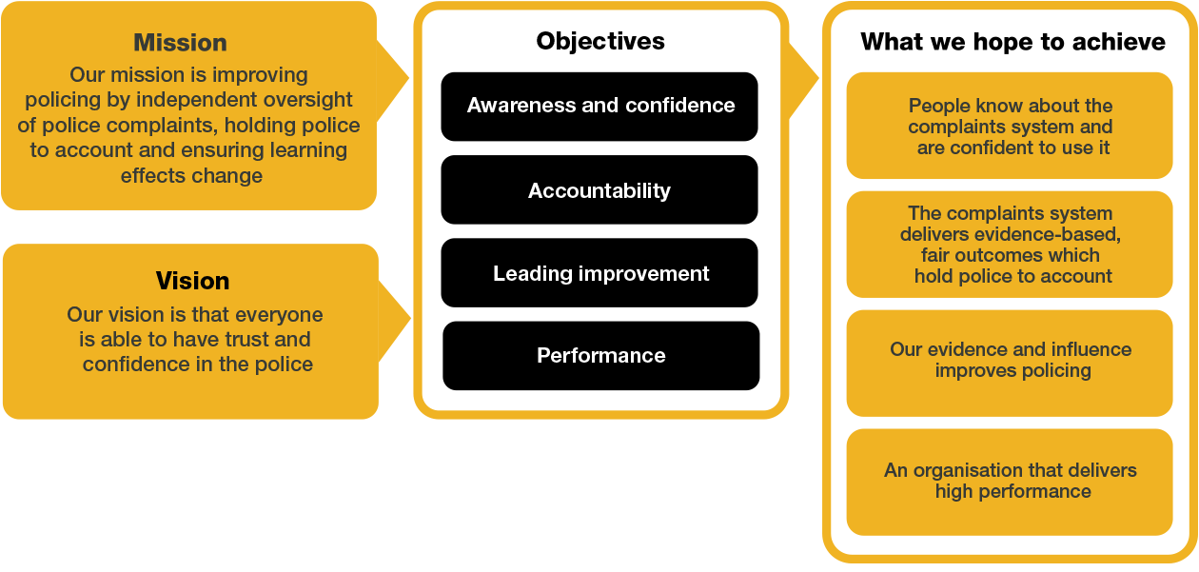Organisational context

We work in the context of our agreed values which inform the way we do things at the IOPC. The Procurement and Contracts Manager will need to be commited to working in the context of these values.

# Main duties and responsibilities

**Delegated Authority**

* The post holder has the authority to sign contracts up to £500,000 on behalf of the IOPC in accordance with the Home Office (HO) Delegation Framework,

**Procurement Projects**

* Lead on the procurement of goods and services as required ensuring compliance with Government, Home Office and IOPC procurement regulations at all times.
* Support managers in key procurement activities across the organisation and drive understanding of good procurement management across the IOPC through the proactive provision of training, coaching, information and advice.
* Develop strong and productive relationships with the Home Office Commercial Unit and maintain up to date expert knowledge of developments and best practice in public sector procurement.
* Work closely across the Procurement team to ensure compliance and best value of all supplier contracts.
* Mentor, advise and develop the Procurement Support Officer and Procurement Assistant.
* Line management responsibility may be required.
* Attend the IOPC Procurement Board.
* Ensure that the IOPC Contract Register and Procurement Pipeline is kept up to date and all contractual documents (hard copies and electronic versions) are filed;
* Assist in the development of relevant policies and guidance.

**Contract Management**

* Provide assurance that contracts are managed efficiently and effectively;
* Advise Business owners on the monitoring of supplier performance;
* Monitor contracts’ lengths to ensure that exit strategies are put in place and that retenders are commenced in a timely fashion;
* Prepare and execute IOPC contracts ensuring compliance with government frameworks contractual requirements are adhered to.
* Negotiate contractual terms and conditions with all potential suppliers prior to finalising and signing contracts;
* Work collaboratively across the IOPC to deliver set objectives and promote influence of the procurement team;
* Commission legal advice as required
* Implement realistic, cost effective, and challenging plans for the provision and development of procurement services to meet IOPC needs, ensuring maximum value for money is achieved.
* Support to Head of Procurement and managers across the IOPC on procurement activity and drive understanding of procurement rules and best practice through the provision of training, information and advice;
* Provide support and advice to staff across the IOPC on our contractual terms and conditions and also our contractual obligations on government framework contracts;
* Ensure that up to date advice and guidance about procurement is available on the IOPC Hub.
* Develop and maintain strong and productive relationships with the Home Office Commercial Directorate and other government bodies.

# Person specification

**Essential**

* Relevant professional qualification (preferably MCIPS)
* At least three years’ experience of commercial procurement and contract management
* Knowledge of public procurement regime and the law relating to procurement
* Experience of developing effective working relationships, including working with a wide variety of third party suppliers and negotiating terms of business
* Experience of managing or being involved in major procurement exercises
* Evidence of managing procurement in a devolved multi-site environment

**Desirable**

* Experience of working in the public sector or on behalf of public sector clients, ideally within a Non-Departmental Public Body (NDPB) and knowledge of the legal issues and government procedures relating to procurement and contract management

# Our Values

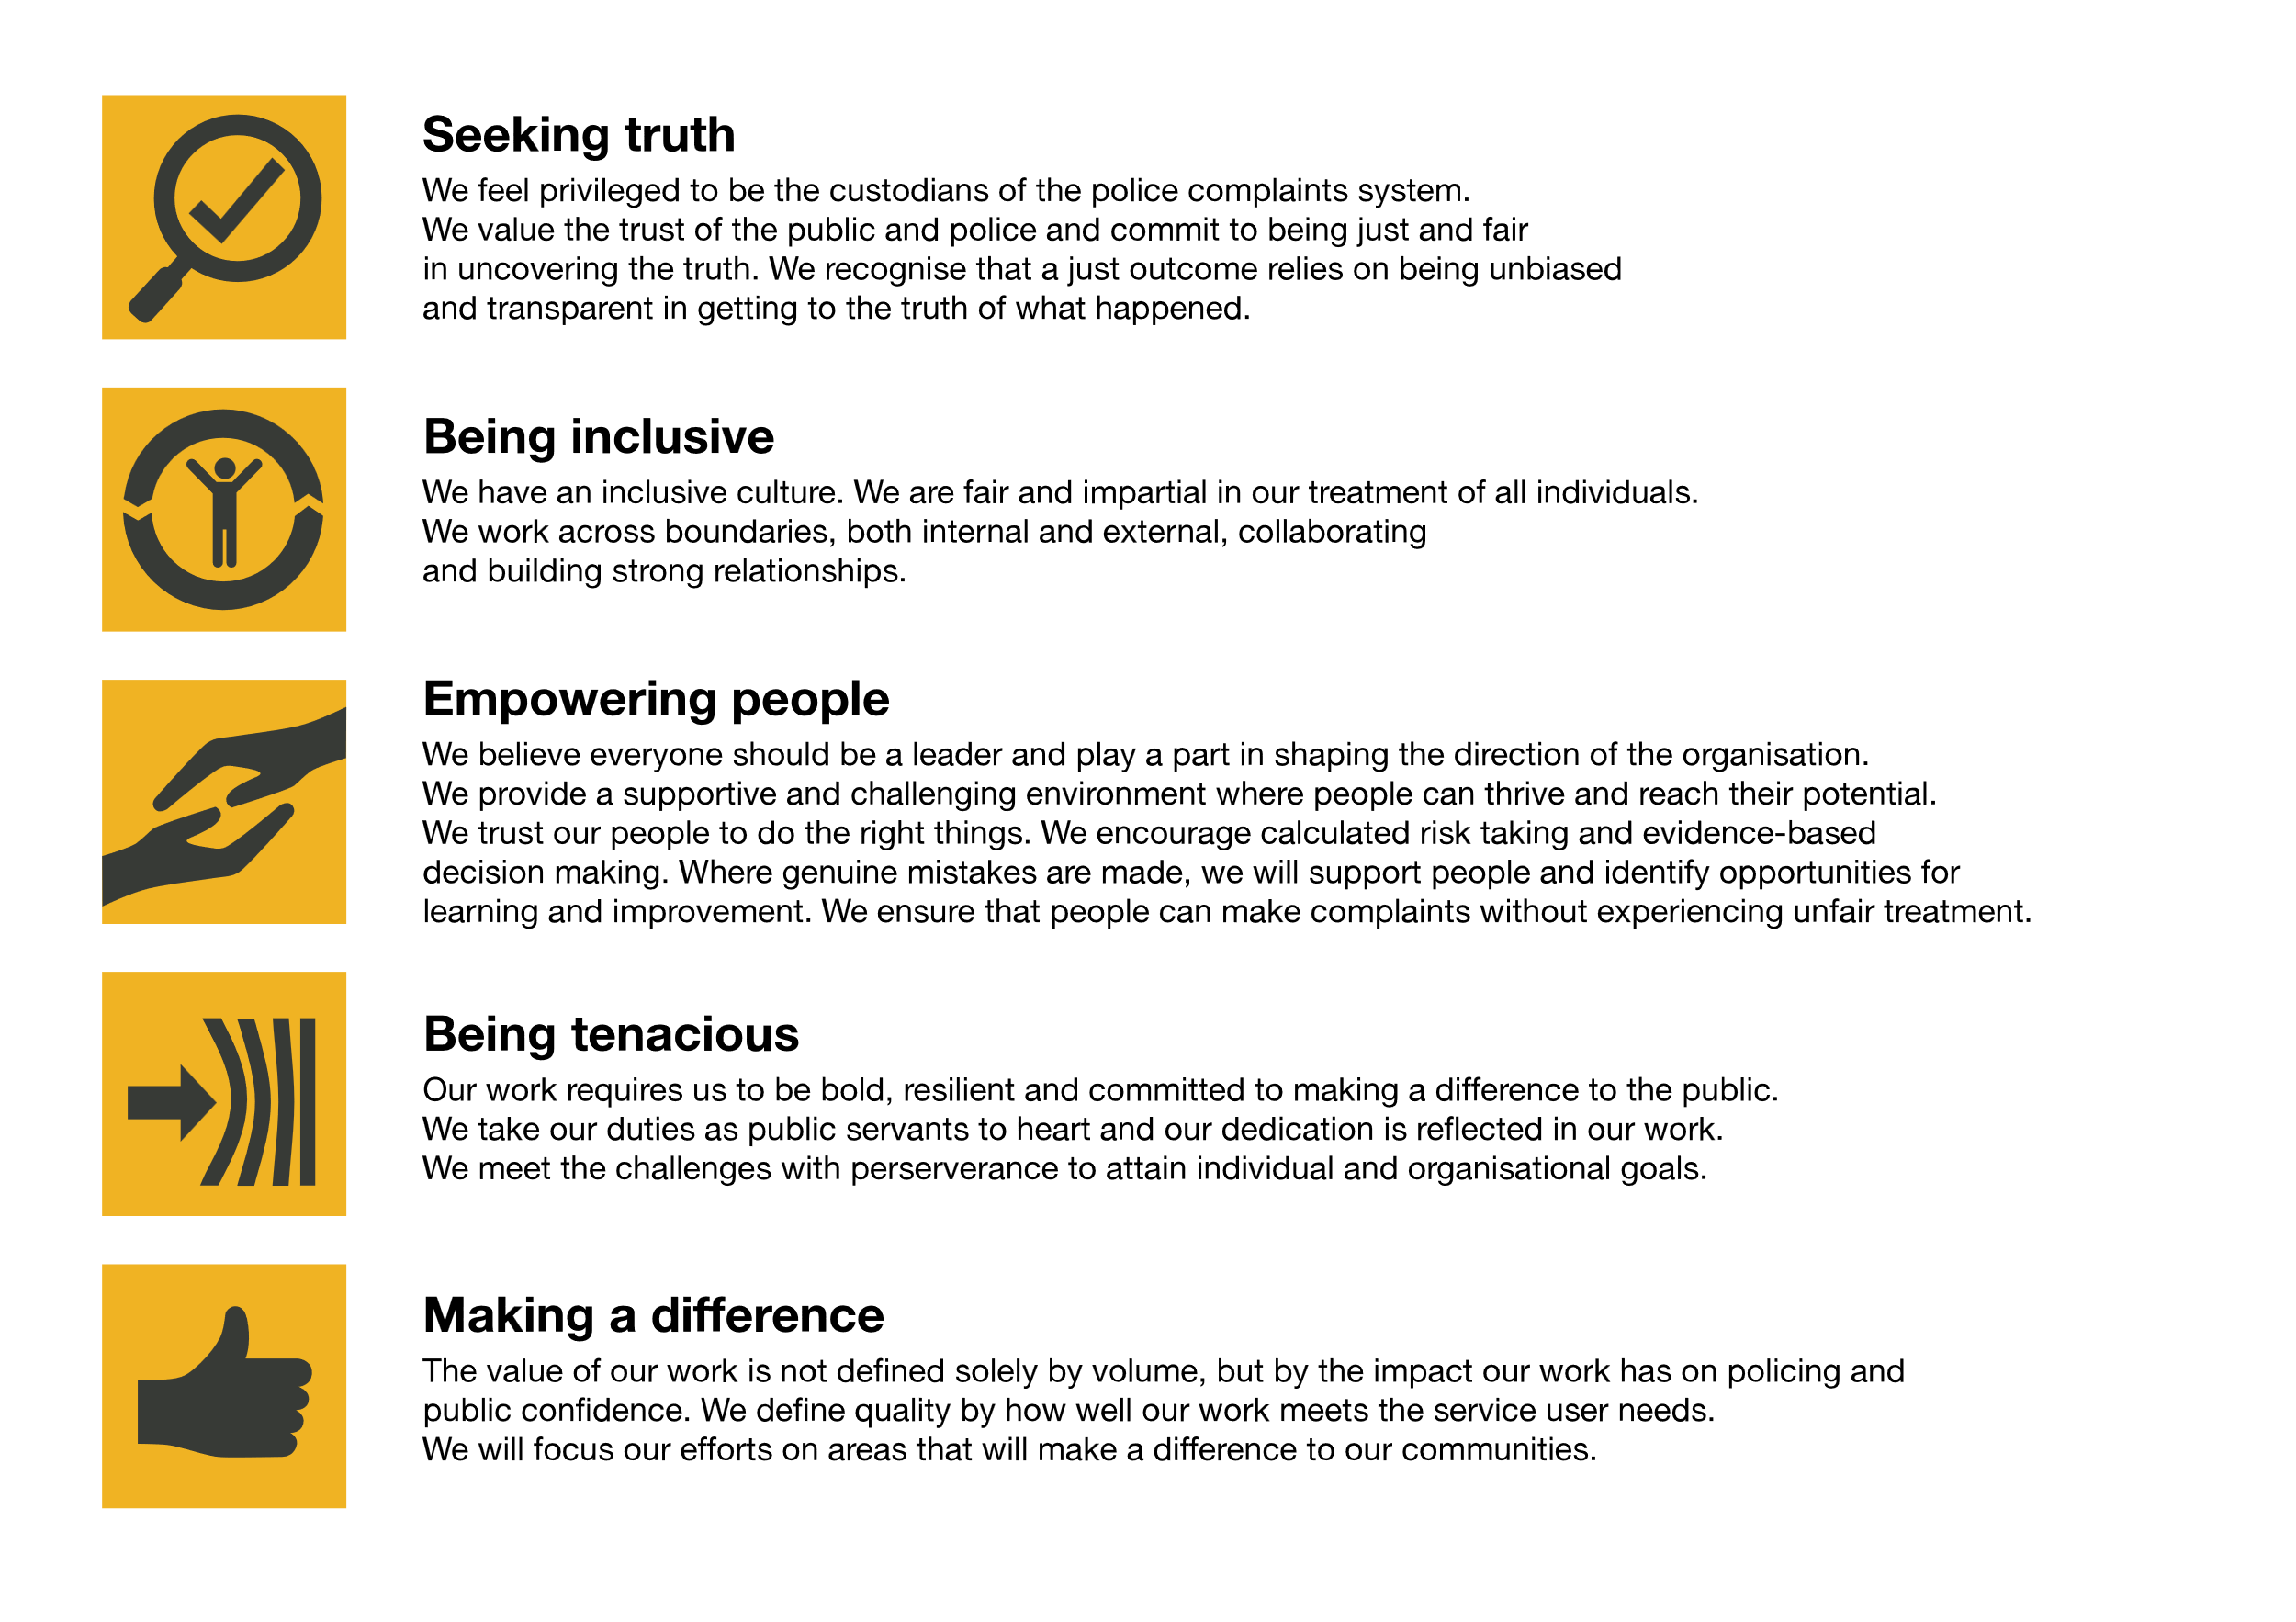

The IOPC is committed to **promoting equality and valuing diversity** in everything we do. Our vision is to be, and to be seen as, a leader in inclusive employment and services, demonstrating this ethos in everything that we do.

* As a silver standard Stonewall employer, we continue to commit ourselves to being a LGBTQ+ employer through the work of our Pride LGBTQ+ Staff Network, creating welcoming environments for lesbian, gay, bi and queer people.
* We are pleased to share we are a signatory of the Business in the Community Race at Work Charter. The Charter is composed of five [calls to action](https://race.bitc.org.uk/issues/racecharter) for leaders and organisations across all sectors.
* Being a Disability Confident employer, the IOPC is dedicated to removing the barrier for disabled people to thrive in the workplace.
* Our Staff Networks are constantly working to make the IOPC the leaders of inclusive employment, from our Allyship Programme, to [Welsh Language Standards](https://www.policeconduct.gov.uk/who-we-are/equality-and-diversity/welsh-language-standards) and Know the Line Policy, we are constantly seeking new ways to create an environment for all to develop and thrive.

## Reasonable adjustments

The IOPC is a diverse and inclusive workplace and we want to help you demonstrate your full potential whatever type of assessment is used. We are open to providing you with the tools you need to succeed. Whilst this list is not exhaustive, please see potential reasonable adjustments below that we can provide:

* Extra time for presentations or interview questions
* Formatting changes such as colours for text or background on written assignments
* Questions presented in writing during interviews

If you require any reasonable adjustments to our recruitment process, please email recruitment@policeconduct.gov.uk

## Working conditions

Making the IOPC a great place to work is one of our key priorities. We are pleased to offer a hybrid working model. The IOPC requires all staff to work 20% of their contractual hours at their office base (or another office for business reasons) from September 2024, increasing to 40% from April 2025. Office attendance time includes in-person training, meetings with stakeholders and families, as well as attending events.

Here at the IOPC, maintaining a culture that is accessible and inclusive of gender identity, sexuality, age, disability, race, sex, belief and caring responsibilities is deeply important to us. We believe that a rich, diverse workforce enables us a better understanding of each others needs, and produces more meaningful and trusting relationships, which in turn create more inclusive spaces where we all feel that we can contribute and belong.  We value our diversity, as we believe that our diversity is our strength. It allows us to identify with our communities through shared lived experiences producing better understanding and higher quality results in our work.

# What we offer

* 27.5 days paid annual leave (increasing with service to 32.5 days)
* Options to carry over, buy or sell annual leave
* Civil Service pension
* Civil Service maternity leave package
* PAM employee assistance programme
* Access to Civil Service Sports Council (CSSC) membership
* Cycle to work scheme
* Opportunity to enjoy the latest home and electronics in a more affordable way provided by Vivup
* Car Leasing Scheme
* Staff networks focused on each of the protected characteristics – run for staff, by staff:
* Age Network
* Enable Network
* Welsh Network
* Pride and LGBTQI+ Network
* Sex and Family Network
* Race, Religion and Belief Network
* Learning and development tailored to your role
* An environment with flexible working options
* A culture encouraging inclusion and diversity behaviours

## Preparation checklist

☐ Review the full job description

☐ Review the behaviours and the descriptors for each behaviour

☐ Review the Strengths dictionary

☐ Review the IOPC values

☐ Consider your Strengths

☐ Consider drafting example answers that cover the specific elements

☐ Prepare some questions to ask the interviewers