**Job description**

**Title:** Employee Relations (Engagement) Officer

**Reports to:** Director of People & Change

**Location:** Birmingham, Canary Wharf, Cardiff, Croydon, Sale or Wakefield and must be willing to travel to all IOPC locations

**Grade:** 12

**Salary:** £41,878 (plus £4968 London Allowance if applicable)

**Contract:** Permanent (this is a full-time role working 37 hours per week)

# Purpose

As the Employee Relations Engagement Officer, you will work the Director of People and Change and Head of People Services to support collaborative and effective working relationships with the IOPC recognised trade union, Joint Negotiation Committee (JNC), Staff Council, and Staff Network Groups.

You will manage and coordinate a wide range of tasks that are complex and sensitive whilst demonstrating strategic thinking, strong intellectual capability and the ability to prioritise effectively. You will review large amounts of complex and detailed information, including data such as survey outcomes, take effective decisions and ensure that work is delivered to a high standard.

You will also provide professional support to the Director of People & Change to ensure that effective forward plans are in place, aligned with the People and Workforce strategies, for the People & Culture Committee, Workforce Planning and People Impact Assurance Group, JNC and all staff groups.

In addition, you will:

* Have a key and essential role to play in supporting the Director of People & Change to ensure that high levels on engagement are maintained with staff groups and the IOPC recognised trade union.
* Plan and organise the People directorate internal communications in collaboration with colleagues in the Internal Communications team.
* Plan and organise relevant meeting agendas and ensure that the Director of People & Change is fully briefed.
* Manage and coordinate a wide range of duties related to employee relations and employee engagement that are complex and sensitive.
* Liaise and collaborate with the IOPC recognised trade union to forward plan the JNC meetings and agenda items in line with the People directorate priorities.
* Management of the Director of People & Change diary, and scheduling of cyclical and other meetings.
* Plan and schedule People directorate SMT (senior management team) and Leadership team meetings.
* Provide high level administrative support as and when required for the Director of People & Change.
* Deliver any other duties or responsibilities that are commensurate with the role of an Employee Relations (Engagement) Officer.

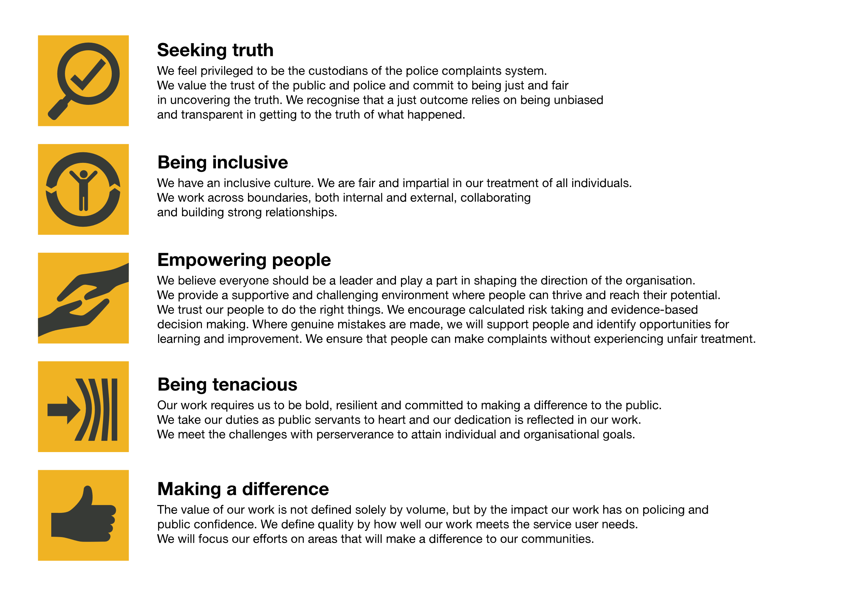

The IOPC is committed to **promoting equality and valuing diversity** in everything we do. Our vision is to be, and to be seen as, a leader in inclusive employment and services, demonstrating this ethos in everything that we do.

* As a silver standard Stonewall employer, we continue to commit ourselves to being a LGBTQ+ employer through the work of our Pride LGBTQ+ Staff Network, creating welcoming environments for lesbian, gay, bi and queer people.
* We are pleased to share we are a signatory of the Business in the Community Race at Work Charter. The Charter is composed of five [calls to action](https://race.bitc.org.uk/issues/racecharter) for leaders and organisations across all sectors.
* Being a Disability Confident employer, the IOPC is dedicated to removing the barrier for disabled people to thrive in the workplace.
* Our Staff Networks are constantly working to make the IOPC the leaders of inclusive employment, from our Allyship Programme to [Operation Hotton](https://www.policeconduct.gov.uk/recommendations/operation-hotton-recommendations-metropolitan-police-service-september-2021), to [Welsh Language Standards](https://www.policeconduct.gov.uk/who-we-are/equality-and-diversity/welsh-language-standards) and Know the Line Policy, we are constantly seeking new ways to create an environment for all to develop and thrive.

# Main duties and responsibilities

**Employee relations engagement and coordination:**

* Develop and plan the annual forward plan for the People & Culture Committee (PCC) and Workforce Planning and People Impact Assurance Group, agree with the Director of People & Change, and schedule meetings.
* Liaise with the Governance team as necessary regarding the PCC and other meetings that fall within the Governance team remit.
* Ensure that colleagues in the People directorate, and other teams if applicable, are aware of the timeline for submitting reports for meeting agenda items.
* Agree the annual forward plan for JNC, Staff Council and Staff Network meetings and fully brief the Director of People & Change.
* Regularly meet with IOPC recognised trade union to plan JNC meetings including development of the agenda and brief the People Directorate attendees.
* Take accurate notes of meetings and distribute to attendees.
* Ensure that reports and related papers are either submitted to the Governance team in a timely manner or where applicable distributed to meeting attendees.
* Support the Director of People & Change with preparing reports or presentations as applicable by undertaking analysis or research.
* Effective analysis and reporting on a range of employee surveys including pulse surveys.

**Diary management and administrative support:**

* Effectively manage the Director of People & Change diary ensuring there is capacity for meeting attendance and strategic planning and development.
* Undertake administrative and other support duties as and when required.
* Provide administrative and note taking support for the IOPC Staff Network groups including organising events to enable delivery of the group’s annual objectives.
* Support the EDI team with planning meetings, learning and development and other activities for the Staff Network group membership.

**JNC and Staff Council**

* Liaise with Staff Council members to obtain details of agenda items for discussion including:
  + Background to the request.
  + Link to the corporate objectives, if applicable.
  + If applicable, desired outcome.
* Follow up action points from meetings and ensure that responses and or updates are provided in a timely manner.
* Arrange for JNC and Staff Council to evaluate the effectiveness of meetings.
* Support Staff Council members with development of meetings and ambitions of the Council.
* Arrange learning and development activities for JNC and Staff Council members.

**Workforce Planning and People Impact Assurance Group governance:**

* Support with the development of the terms of reference for the Workforce Planning and People Impact Assurance Group.
* Create and distribute meeting agendas.
* Liaise with the Governance team as and when necessary
* Prepare reports for management board on the effectiveness of the Workforce People Impact Assurance Group for signoff by the Director of People & Change.

**People directorate communication planning:**

* Create a forward plan for People directorate internal communications and share with the Internal Communications team
* Ensure that the Internal Communications team is updated with changes to the People Directorate communication plan on a regular basis.
* Ensure that colleagues in the People directorate prepare draft communications for colleagues in Internal Communications in a timely manner.

**Cultural Competence, Equality, Diversity & Inclusion:**

* Pro-active and committed to equity, diversity and inclusion.
* Demonstrate cultural competence when interacting with all stakeholders.

# Person specification

## Qualifications:

* CIPD level 5 or a willingness to complete this qualification.

## Experience:

* Experience of working in a HR/People environment, and or an engagement role with a focus on the employee’s experiences.
* Experience of working with a range of internal stakeholders within a public sector organisation.
* Experience of identifying opportunities for continuous improvement, based on feedback, stakeholder engagement, trend analysis, etc.
* Experience of interacting and communicating with trade union colleagues.
* Experience of supporting staff groups to achieve their objectives.
* Experience of analysing and quantifying data and providing recommendations.
* Experience of working directly with and or providing support to a senior manager at Head of Service or Director level.
* Experience of organising and managing events.
* Experience of taking high quality notes of meetings and following up actions.
* Experience of drafting reports for review by senior management.
* Understanding of wider social, economic and political issues impacting public sector organisations.
* Experience of ensuring equality and diversity is an integral part of all people services.

## Skills and abilities:

* Confident communicator, with highly developed interpersonal skills and the ability to build positive working relationships with all colleagues including senior managers, employees and trade union representatives.
* Excellent planning, time management and organisational skills with the ability to prioritise work whilst remaining flexible to changing demands.
* Ability to communicate clearly, both verbally and in writing, to persuade and influence others.
* Excellent written skills with attention to detail, accuracy and ability to adapt style to audience.
* Ability to influence others in challenging circumstances.
* Ability to take accurate notes that reflect meeting discussions.
* Ability to produce reports and present quantitative and qualitative information
* Ability to analyse information, identify trends and issues and recommend and implement solutions.
* Ability to demonstrate confidentiality, empathy and sensitivity.

## Reasonable adjustments

The IOPC is a diverse and inclusive workplace, and we want to help you demonstrate your full potential whatever type of assessment is used. We are open to providing you with the tools you need to succeed, from extra time to formatting changes, to name a mere few. If you require any reasonable adjustments to our recruitment process, please email [humanresources@policeconduct.gov.uk](mailto:humanresources@policeconduct.gov.uk)

## Working conditions

The postholder will be required to work flexibly to meet the requirements of the job role, including travelling to all IOPC locations as and when required.

The usual office attendance requirement for this role is in line with the IOPC hybrid working policy (currently 20% and rising to 40% in April 2025), although from time to time it may be necessary for the post holder to attend in person meetings resulting in higher attendance levels.

The nature of this role means the post holder must be able to work 37 hours per week.