**Job description**

**Title:** Senior Transformation Programme Manager

**Reports to:** Director of Transformation

**Team Responsibilities:** Line Management will include the team of Senior Project

Managers, Project Managers and the organisational PMO

**Location:** Any IOPC office location (excluding Warrington)

**Grade:** 16

**Salary:** £71,347 per annum plus London Weighting of £4,731 if

based in Canary Wharf or Croydon

**Contract:** Secondment/FTC until 31 March 2027

# Purpose

The purpose of this senior leadership role is to lead delivery of the IOPC Transformation programme. The post holder will have primary responsibility for successful delivery of the required outcomes of the programme, including the establishment of appropriate governance and assurance, monitoring progress, managing risks and issues and ensuring the business readiness for change.

The Senior Transformation Programme (STP) Manager will lead and manage the day-to-day running of the programme, maintain oversight of the programme to ensure delivery is on track, monitoring progress, controlling investment, helping to identify and deal with issues, providing reports and managing resourcing.

The STP Manager should work effectively and collaboratively with others across the organisation, understanding their pressures and challenges, aligning priorities in order to deliver programme objectives. They will also need to develop streamlined structures and processes that are clear, focused, and easily understood to optimise clarity of accountability and supports effective delivery.

The STP Manager will need to develop a clear programme narrative, including a benefits case that can be shared with external stakeholders and staff as well as develop and implement an approach to managing transformation and effective engagement across the IOPC.

## Working conditions

The IOPC are currently consulting with our consultative bodies about proposed changes to our hybrid working policy which will require all staff to work 20% of their contractual hours at their office base (or another office for business reasons) from 1 September and increased to 40% from April next year. Office attendance time includes in-person training, meetings with stakeholders and families, and attending events.

# A screenshot of a computer screen Description automatically generatedOrganisational Context

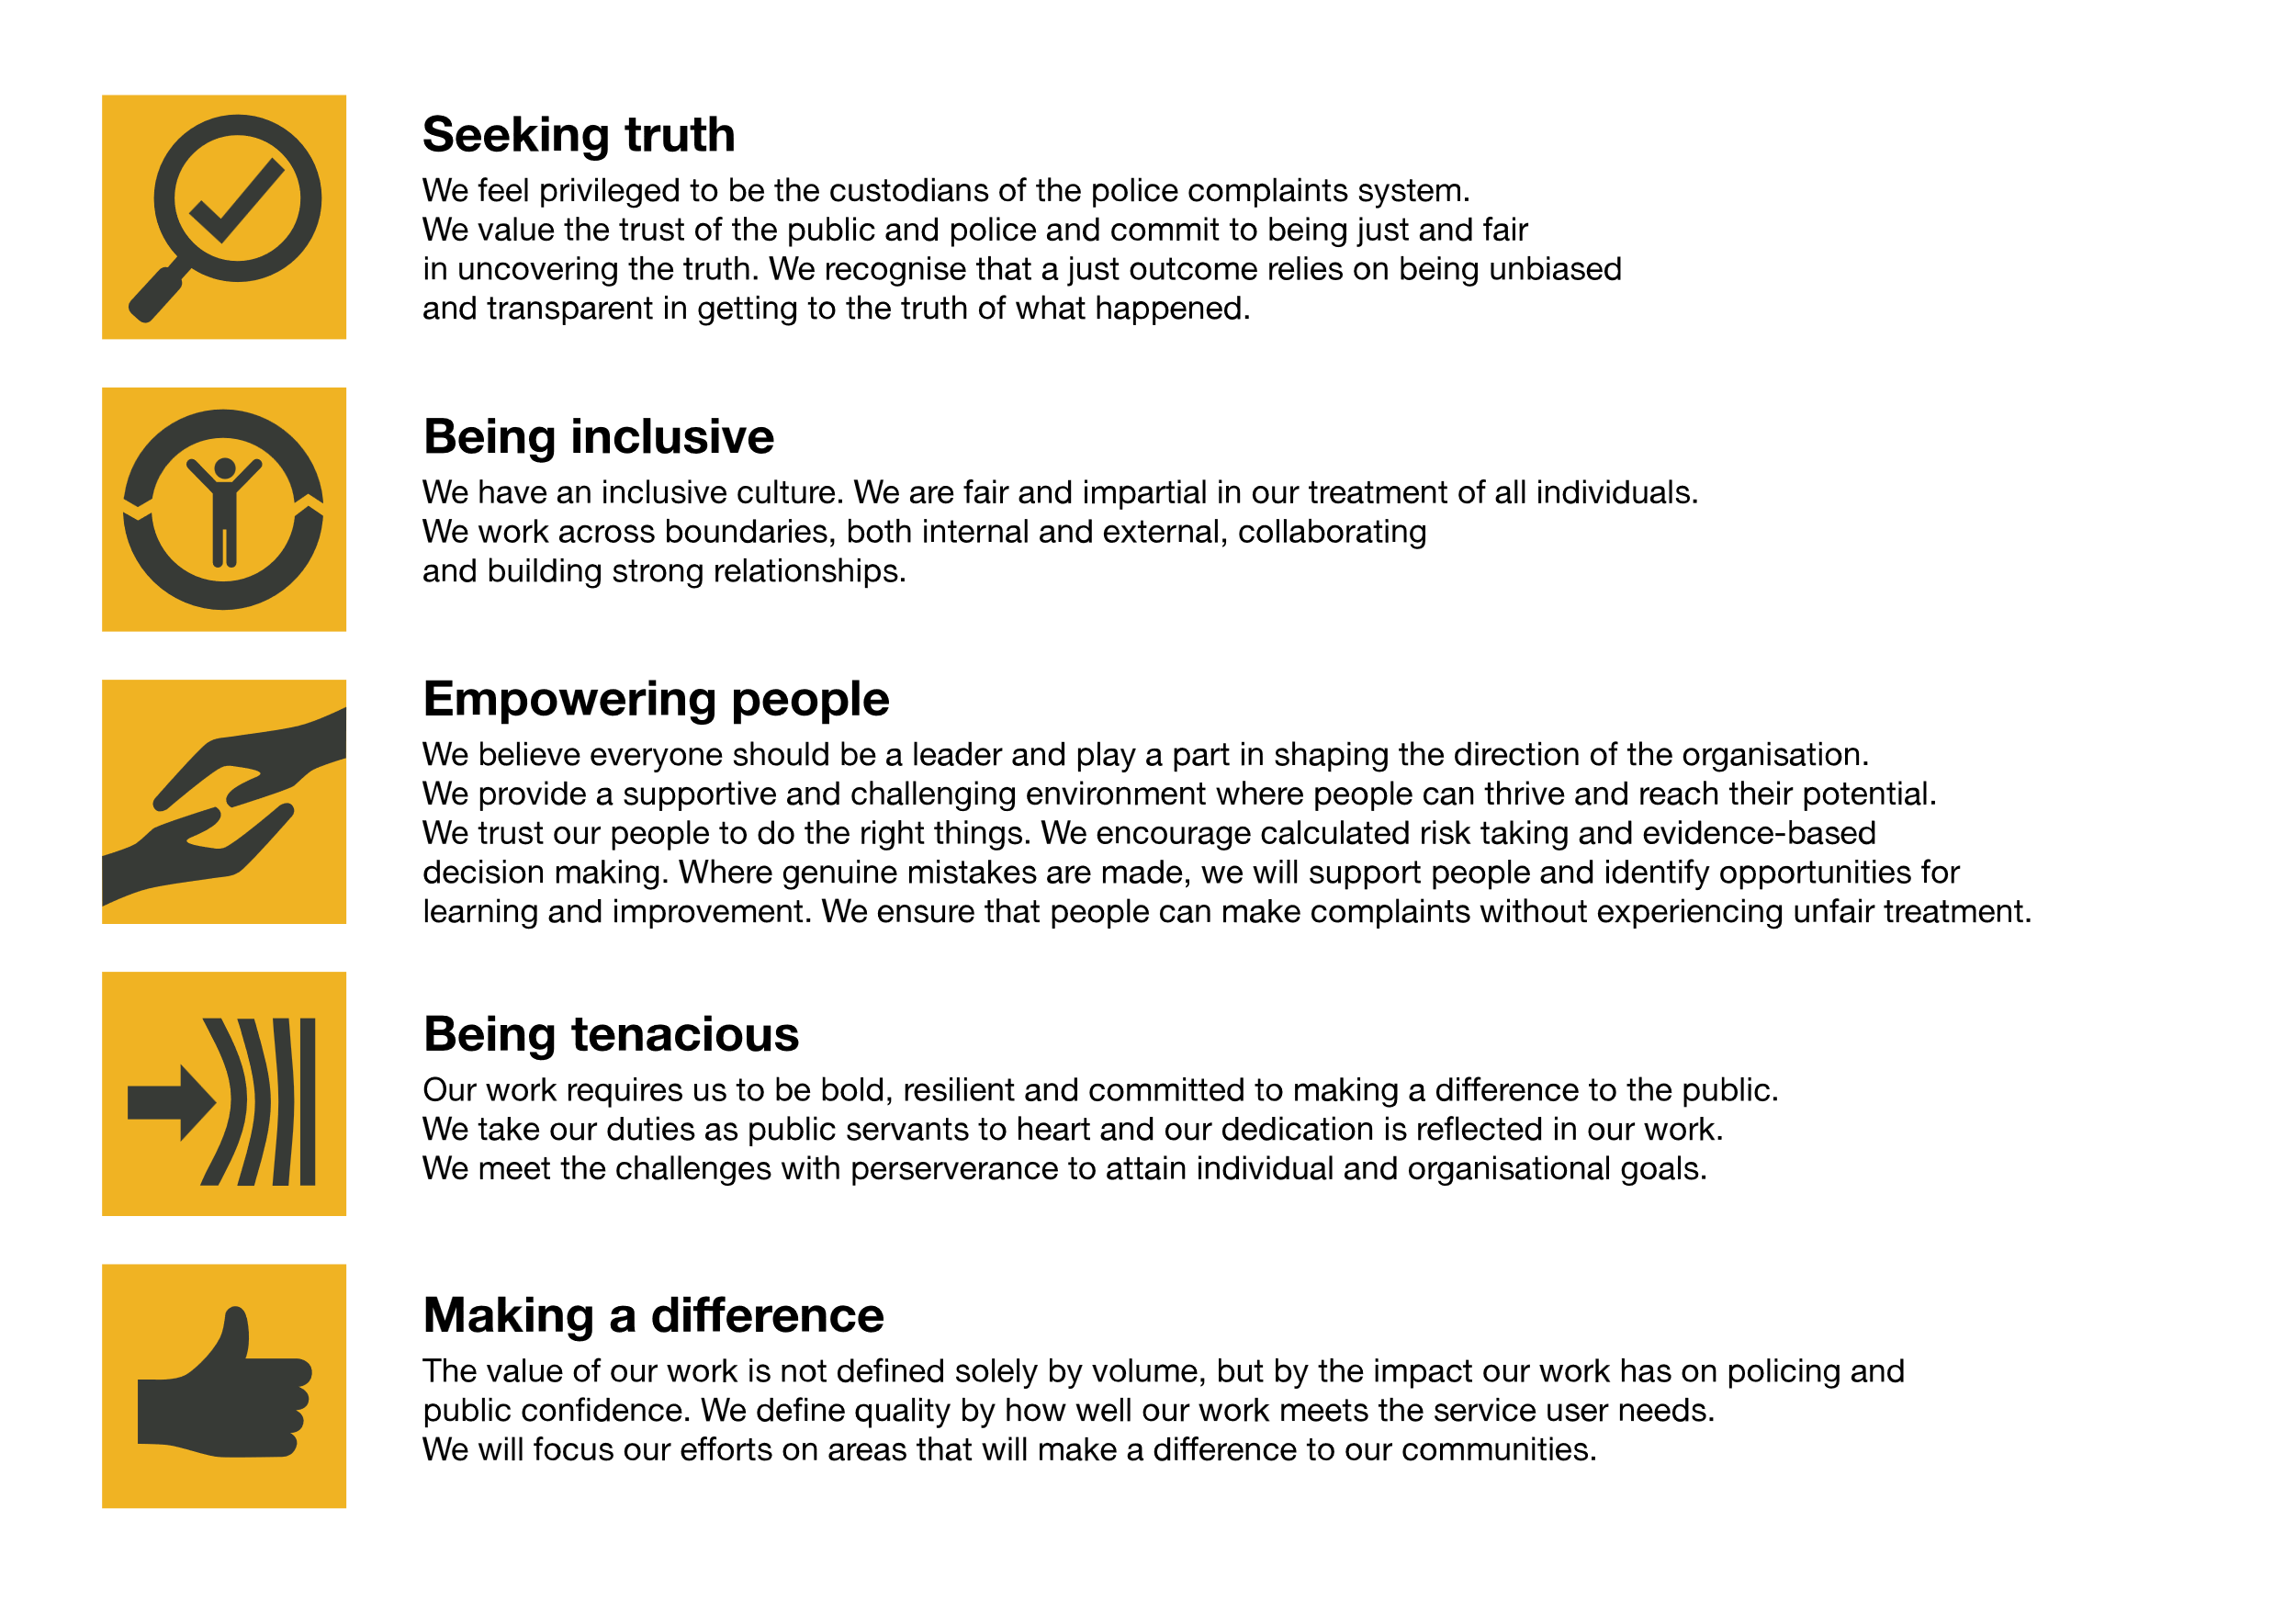We work in the context of our agreed values which inform the way we do things at the IOPC. The STP will need to be commited to managing in the context of these values.

The IOPC is committed to **promoting equality and valuing diversity** in everything we do. Our vision is to be, and to be seen as, a leader in inclusive employment and services, demonstrating this ethos in everything that we do.

* As a silver standard Stonewall employer, we continue to commit ourselves to being a LGBTQ+ employer through the work of our Pride LGBTQ+ Staff Network, creating welcoming environments for lesbian, gay, bi and queer people.
* We are pleased to share we are a signatory of the Business in the Community Race at Work Charter. The Charter is composed of five [calls to action](https://race.bitc.org.uk/issues/racecharter) for leaders and organisations across all sectors.
* Being a Disability Confident employer, the IOPC is dedicated to removing the barrier for disabled people to thrive in the workplace.
* Our Staff Networks are constantly working to make the IOPC the leaders of inclusive employment, from our Allyship Programme to [Operation Hotton](https://www.policeconduct.gov.uk/recommendations/operation-hotton-recommendations-metropolitan-police-service-september-2021), to [Welsh Language Standards](https://www.policeconduct.gov.uk/who-we-are/equality-and-diversity/welsh-language-standards) and Know the Line Policy, we are constantly seeking new ways to create an environment for all to develop and thrive.

# Main duties and responsibilities

**Leadership:**

* Functional leadership: Leading a multidisciplinary team working in a matrix environment and building strong relationships across team/business area/departmental/ boundaries with clear evidence of the ability to deliver through others. An ability to build network of influence, formal resource management and direction of teams. Able to build effective teams, flex and deploy appropriate resource, underpinned by active delegation and the development of individual and team performance.
* Leadership vision and objectives – Create an environment in which projects can succeed – working effectively together and managing dependencies. Delivering benefits and outcomes set out in business cases.
* Guidance – Provide direction and guidance on development to team and more broadly across IOPC including to SROs of key programmes.
* Resource management – Build and maintain a strong delivery-focused programme team. Provide leadership and direct larger multi-disciplinary teams to deliver successfully.

**Communication and engagement:**

* Communications and stakeholder management – Ensure stakeholder interests are identified and addressed. Segment and manage multiple stakeholder groups appropriately in complex environments. Build consensus across a large and often diverse group of stakeholders and develop strategic relationships with internal and external suppliers. Work closely with the SRO to co-manage senior stakeholders.

**Working collaboratively:**

* Strong relationship management, interpersonal, communication and influencing skills, with the ability to operate and build effective relationships at all levels within an organisation particularly at Director level and above and across business areas. Understanding stakeholders’ drivers and behaviours, utilising these to deliver on the programme’s aims.

**Programme management:**

* Business case –leading development and maintenance of Programme business case, aligning with senior stakeholders and agreeing through Programme Board / SRO / Management Board.
* Risks and issues – Accountable for ensuring strategic and operational risks and issues are identified, prioritised, assessed and mitigated. Ensure senior stakeholders are briefed, updated and where appropriate, enrolled in the management and control of key risks. Identify and engage specialists as appropriate.
* Benefits realisation – Provide strategic leadership in monitoring benefit delivery and to maximise benefits from the programme.
* Programme performance and controls – Responsible for identifying success criteria, set project controls and be accountable for performance. Monitor and control progress, engage fully with any IPA assurance and GIAA audits and respond to recommendations.
* Dependency management – Quality Assuring the dependency management process, working with senior stakeholders to resolve issues and acting as a link between the programme and business governance.

**Finance and budget:**

* Budget management – accountable for a delegated budget to deliver the programme. Managing within agreed tolerances. Ensuring projects and programmes within the programme are operating within budget and agreed tolerances.

**Other**

* Actively promote the IOPC values.

# Key Contacts

* Director of Transformation
* SROs (Senior Responsible Officer) for the key programmes of change
* Executive Director of Investigations and Oversight, Executive Director of Strategy, Comms and Engagement
* Director General

# Person specification

## Essential Experience and Skills

* Delivery: A high degree of personal resilience, tenacity and focus on outcomes. Able to navigate often complex and demanding regulatory, commercial and political landscapes, all the time maintaining a dynamism with a focus on achieving measurable and impactful results delivering excellent customer value. Able to contribute strategically across IOPC as part of the corporate leadership network as well as deliver vertically on functional objectives**.**
* A Project Delivery Professional – substantial senior level programme and project management experience in major change or transformation programmes.
* Demonstrable experience of managing a portfolio of projects from start to finish.
* Delivering within a structured environment and capable of deriving innovative and creative solutions to problems.
* Successfully leading a virtual ‘team’ from across functional or organisational boundaries to deliver high quality outputs.
* Experience of substantial stakeholder management in a complex organisational environment.
* Be someone who effectively plans, prioritises, and manages the delivery of complex projects or activities to achieve long-term strategic objectives.
* An experienced change leader, capable of creating and delivering strategic plans, coordinating and meeting demands from multiple stakeholders.
* Demonstrable experience of managing teams with an ability to motivate and lead a team effectively, setting clear objectives to manage performance and strategic direction.
* Strong leadership style, with self-awareness and the ability to influence, motivate and lead effectively across an organisation with a diverse set of stakeholders.
* Demonstrable commitment to learning and using established project management methodologies to enable successful delivery.

## Desirable Experience

* Delivered programmes within a regulatory or public sector environment.

## Essential Technical

* Technical PPM: A deep understanding and experience of Complex Programme Delivery through the end to end project lifecycle, from strategy, through initiation to delivery with a proven track record of managing large- scale, high value, complex property investment projects and programmes with a focus on new build and refurbishment commercial office projects. This should be on a national level, within a highly complex multi-client environment, driven by a culture of excellence in customer service.
* Educated to degree level in a relevant discipline (e.g. Project Management) or able to demonstrate significant knowledge experience at a comparable level.
* One or more of the following:
* Managing Successful Programmes Practitioner
* Managing Successful Programmes Advanced Practitioner
* P3O Practitioner
* APM Chartered Professional Qualification
* Major Projects Leadership Academy
* Practitioner level in the Government Project Delivery Accreditation

## Reasonable adjustments

The IOPC is a diverse and inclusive workplace, and we want to help you demonstrate your full potential whatever type of assessment is used. We are open to providing you with the tools you need to succeed, from extra time to formatting changes, to name a mere few. If you require any reasonable adjustments to our recruitment process, please email [recruitment@policeconduct.gov.uk](mailto:recruitment@policeconduct.gov.uk)

## Preparation checklist

☐ Review the full job description

☐ Review the behaviours and the descriptors for each behaviour

☐ Review the Strengths dictionary

☐ Review the IOPC values

☐ Consider your Strengths (if applicable)

☐ Consider drafting example answers that cover the specific elements

☐ Prepare some questions to ask the interviewers