**Job description**

**Title:** Casework Administrator

**Reports to: Administration Hub Manager**

**Location:** Sale

**Grade:** Grade 7

**Salary:** £26,765

**Contract:** 12 month Fixed Term Contract

# Purpose

As a Casework Manager, you will be welcomed into a dynamic and inclusive directorate. The IOPC is on a journey to develop its culture, perspectives and ethos to support the organisation’s core outcomes and this is your opportunity to enter into the varied world of IOPC Business Admin, allowing you to develop your mindset and approaches to contribute to improving the police complaints system in England and Wales.

The role assists the organisation by preparing cases, liaising with stakeholders and providing all aspects of administrative support.

**BACKGROUND**

The Administration Hub can be the first contact point for members of the public and other agencies in regard to Appeals/Reviews and Police Referrals. The Administration Hub receives referrals about serious matters from Appropriate Authorities and Appeals or Reviews from members of the public who made a complaint and are dissatisfied with the Appropriate Authorities handling of their complaint. The Administration Hub will collate all relevant information and direct cases and correspondence to the correct internal department.

Information may be received via telephone, e-mail or post. Generally, the administration team conduct a preliminary examination of the information received, input this information, prepare the case file and then refer it to the appropriate person. The Administration Hub receives new work daily and therefore the work of the team is fast paced and reactive.

In completing some of these tasks the post holder may view some distressing or sensitive material

# A screenshot of a computer screen Description automatically generatedOrganisational context

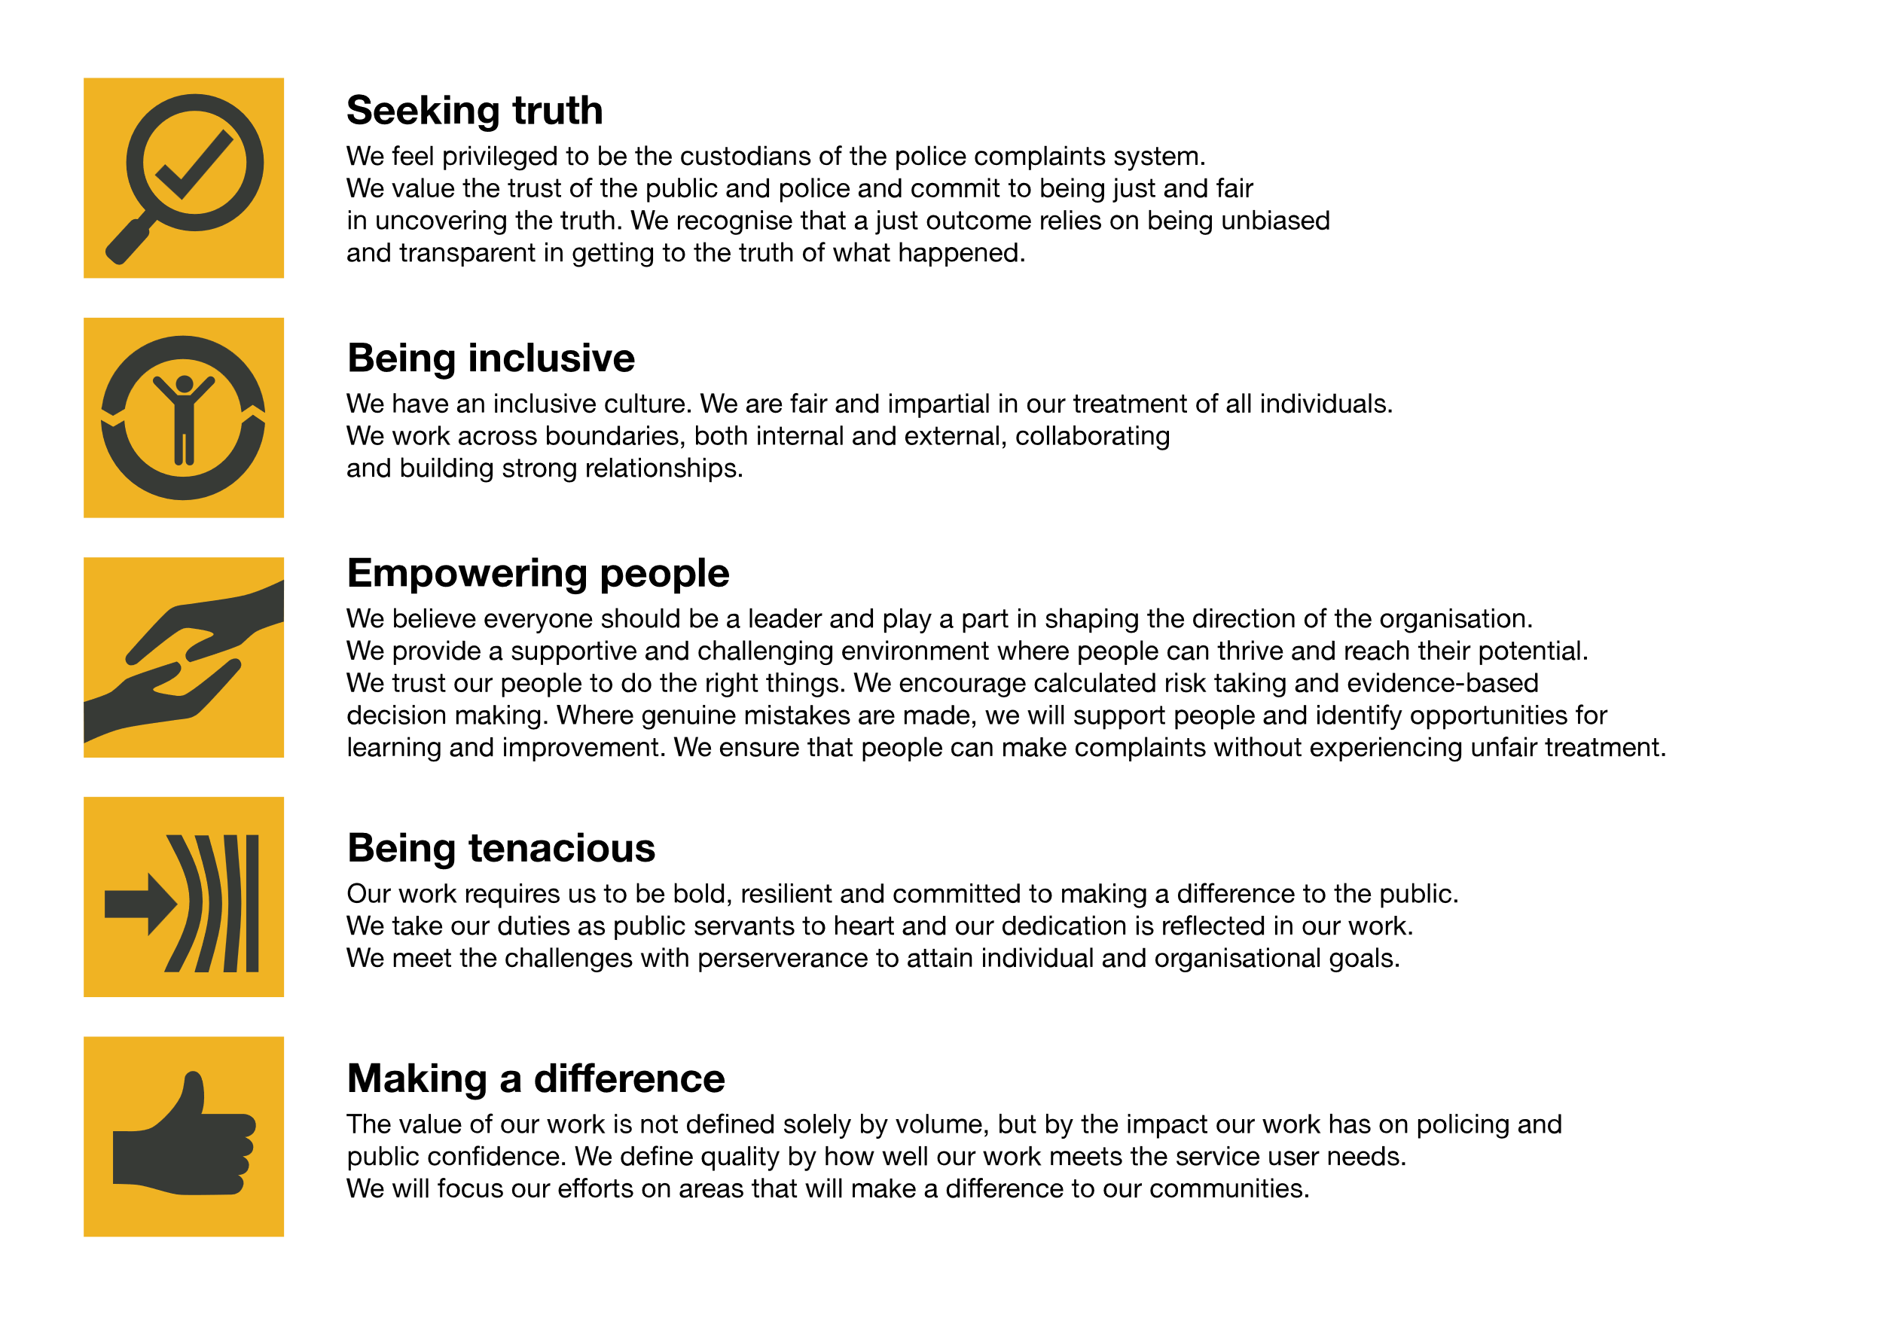We work in the context of our agreed values which inform the way we do things at the IOPC. The Casework Administrator will need to be commited to managing in the context of these values.

The IOPC is committed to **promoting equality and valuing diversity** in everything we do. Our vision is to be, and to be seen as, a leader in inclusive employment and services, demonstrating this ethos in everything that we do.

* As a silver standard Stonewall employer, we continue to commit ourselves to being a LGBTQ+ employer through the work of our Pride LGBTQ+ Staff Network, creating welcoming environments for lesbian, gay, bi and queer people.
* We are pleased to share we are a signatory of the Business in the Community Race at Work Charter. The Charter is composed of five [calls to action](https://race.bitc.org.uk/issues/racecharter) for leaders and organisations across all sectors.
* Being a Disability Confident employer, the IOPC is dedicated to removing the barrier for disabled people to thrive in the workplace.
* Our Staff Networks are constantly working to make the IOPC the leaders of inclusive employment, from our Allyship Programme to [Operation Hotton](https://www.policeconduct.gov.uk/recommendations/operation-hotton-recommendations-metropolitan-police-service-september-2021), to [Welsh Language Standards](https://www.policeconduct.gov.uk/who-we-are/equality-and-diversity/welsh-language-standards) and Know the Line Policy, we are constantly seeking new ways to create an environment for all to develop and thrive.

# Main duties and responsibilities

**1. General Duties**

* Opening all post sorting and scanning it
* Search and retrieval of files / miscellaneous post etc.
* Contact point for the Appropriate Authorities who are requesting an update on an allocation of an appeal/review or a referral.
* Contact point for members of the public prior to allocation of Appeals & Reviews, advising on allocation times, appeal rights, and how to submit appeals and further information.
* Filing and photocopying duties
* Maintaining Perito case files prior to allocation to a decision maker.
* Triage of post items and emails
* Create and manage file parts and media for the directorate
* Copy and encryption of all media types, including BWV and CCTV.
* Downloading of media and investigation papers from cloud based applications.
* Updating Sharepoint with relevant documents and ensuring templates and passwords are kept up to date
* Travel bookings/car hire for colleagues as requested

**2. Referrals**

* Creation of new referrals on Perito
* Forward referrals to appropriate department
* Ensure all documents and information are saved to the case and media encrypted and sent to the appropriate decision

**3. Appeals & Reviews**

* Creation of new Appeals/Reviews on Perito
* Update Appeal & Review spreadsheets
* Send and save acknowledgement letters for Appeals or Reviews and email the appropriate force
* Deal with Appeal or Review queries from members of the public, police forces and other policing bodies.
* Checking Appeal/Review documentation and assess who the appropriate Appeal/Review body is, and deciding whether it has been received in time and whether it requests a validity assessment.
* Communicating in writing and verbally with forces/police bodies and members of the public regarding appeals
* Acting as single point of contact (SPOC) for certain appellants dealing specifically with the setting up of their appeals/reviews ensuring they are provided with a consistent service
* Printing WFH documents for Casework Managers.
* Contact police forces to obtain background information.
* Review background papers for cases and ensuring all key documents and media listed in the Investigators report have been requested from the police force.
* Processing translation requests both verbally and written (appeal related).
* Chasing Death and Serious Injury reports from appropriate authorities and ensuring case files complete for Casework Managers to work.
* Prepare closed Appeals and Reviews for filing and archiving.

**4. Other Police Reform Act work**

* Log new applications from Appropriate Authorities
* Ensure all documents and information is saved to the case
* Acknowledge receipt of applications to the Appropriate Authority
* Updating and maintaining allocation spreadsheets, including allocating for Senior Casework Managers.

# Person specification

## Essential Experience

* Good secondary school level education, including English and Maths to GCSE grade C or equivalent
* IT literate including competency in Microsoft Office and electronic databases in particular having good Microsoft Excel skills in order to collate, store and present data.
* Ability to work on own initiative
* Must have high integrity with an ability to act with discretion and to deal appropriately with confidential matters (this post requires Security Clearance)
* Ability to deal appropriately with a wide range of people at all levels, both within and outside the IOPC
* A flexible approach to work, including the ability to work to tight deadlines and to deal with changing priorities.
* Good oral and written communication skills
* Must be proactive in approach to work
* The ability to deal with high profile, sensitive matters, which sometimes can be of an upsetting nature.

## Desirable Experience

* Some knowledge of the work of the IOPC and key legislation which governs its operation
* Good oral and written communication skills in Welsh.
* Knowledge and experience of dealing with digital media, including encryption.

## Reasonable adjustments

The IOPC is a diverse and inclusive workplace and we want to help you demonstrate your full potential whatever type of assessment is used. We are open to providing you with the tools you need to succeed, from extra time to formatting changes, to name a mere few. If you require any reasonable adjustments to our recruitment process, please email [recruitment@policeconduct.gov.uk](mailto:recruitment@policeconduct.gov.uk)

## Working conditions

The IOPC are currently consulting with our consultative bodies about proposed changes to our hybrid working policy which will require all staff to work 20% of their contractual hours at their office base (or another office for business reasons) from 1 September and increased to 40% from April next year. Office attendance time includes in-person training, meetings with stakeholders and families, and attending events.

## Preparation checklist

☐ Review the full job description

☐ Review the behaviours and the descriptors for each behaviour

☐ Review the Strengths dictionary

☐ Review the IOPC values

☐ Consider your Strengths (if applicable)

☐ Consider drafting example answers that cover the specific elements

☐ Prepare some questions to ask the interviewers