**Job description**

**Title:** Talent & OD Consultant

**Reports to:** L&D Business Partner (Talent & OD)

**Location:** Any IOPC Office: Sale, Birmingham, Cardiff, Warrington, Wakefield, Croydon or Canary Wharf

**Grade:** 12

**Salary:** £41,878 (Plus London Weighting of £4,968 if based in Croydon or Canary Wharf)

**Contract:** Permanent

# Purpose

The purpose of this role is to play a pivotal role in designing and deliver key

interventions related to organisational and talent development activity, working

across the IOPC on key strategic areas. The postholder will provide support to staff

and management, and work collaboratively with managers in partnership with

learning and development colleagues.

The postholder will primarily ensure that management and staff have the skills

needed to demonstrate the IOPC values and behaviours and drive high standards of

performance. Outcomes will be focused on the achievement of an organisational

culture where staff feel valued, supported, and involved, and enabled to deliver their

job roles effectively.

The post holder will support the L&D Business Partner (Talent & OD) to ensure our

strategies, policies and projects support wider IOPC strategy and contribute to

business outcomes. They will be responsible for providing advice and support to a

range of internal stakeholders, including managers and staff, and will always act as a

role model by demonstrating IOPC values.

The postholder will be required to undertake any other duties that are commensurate

with the role of a Talent & OD Consultant.

# A screenshot of a computer screen Description automatically generatedOrganisational Context

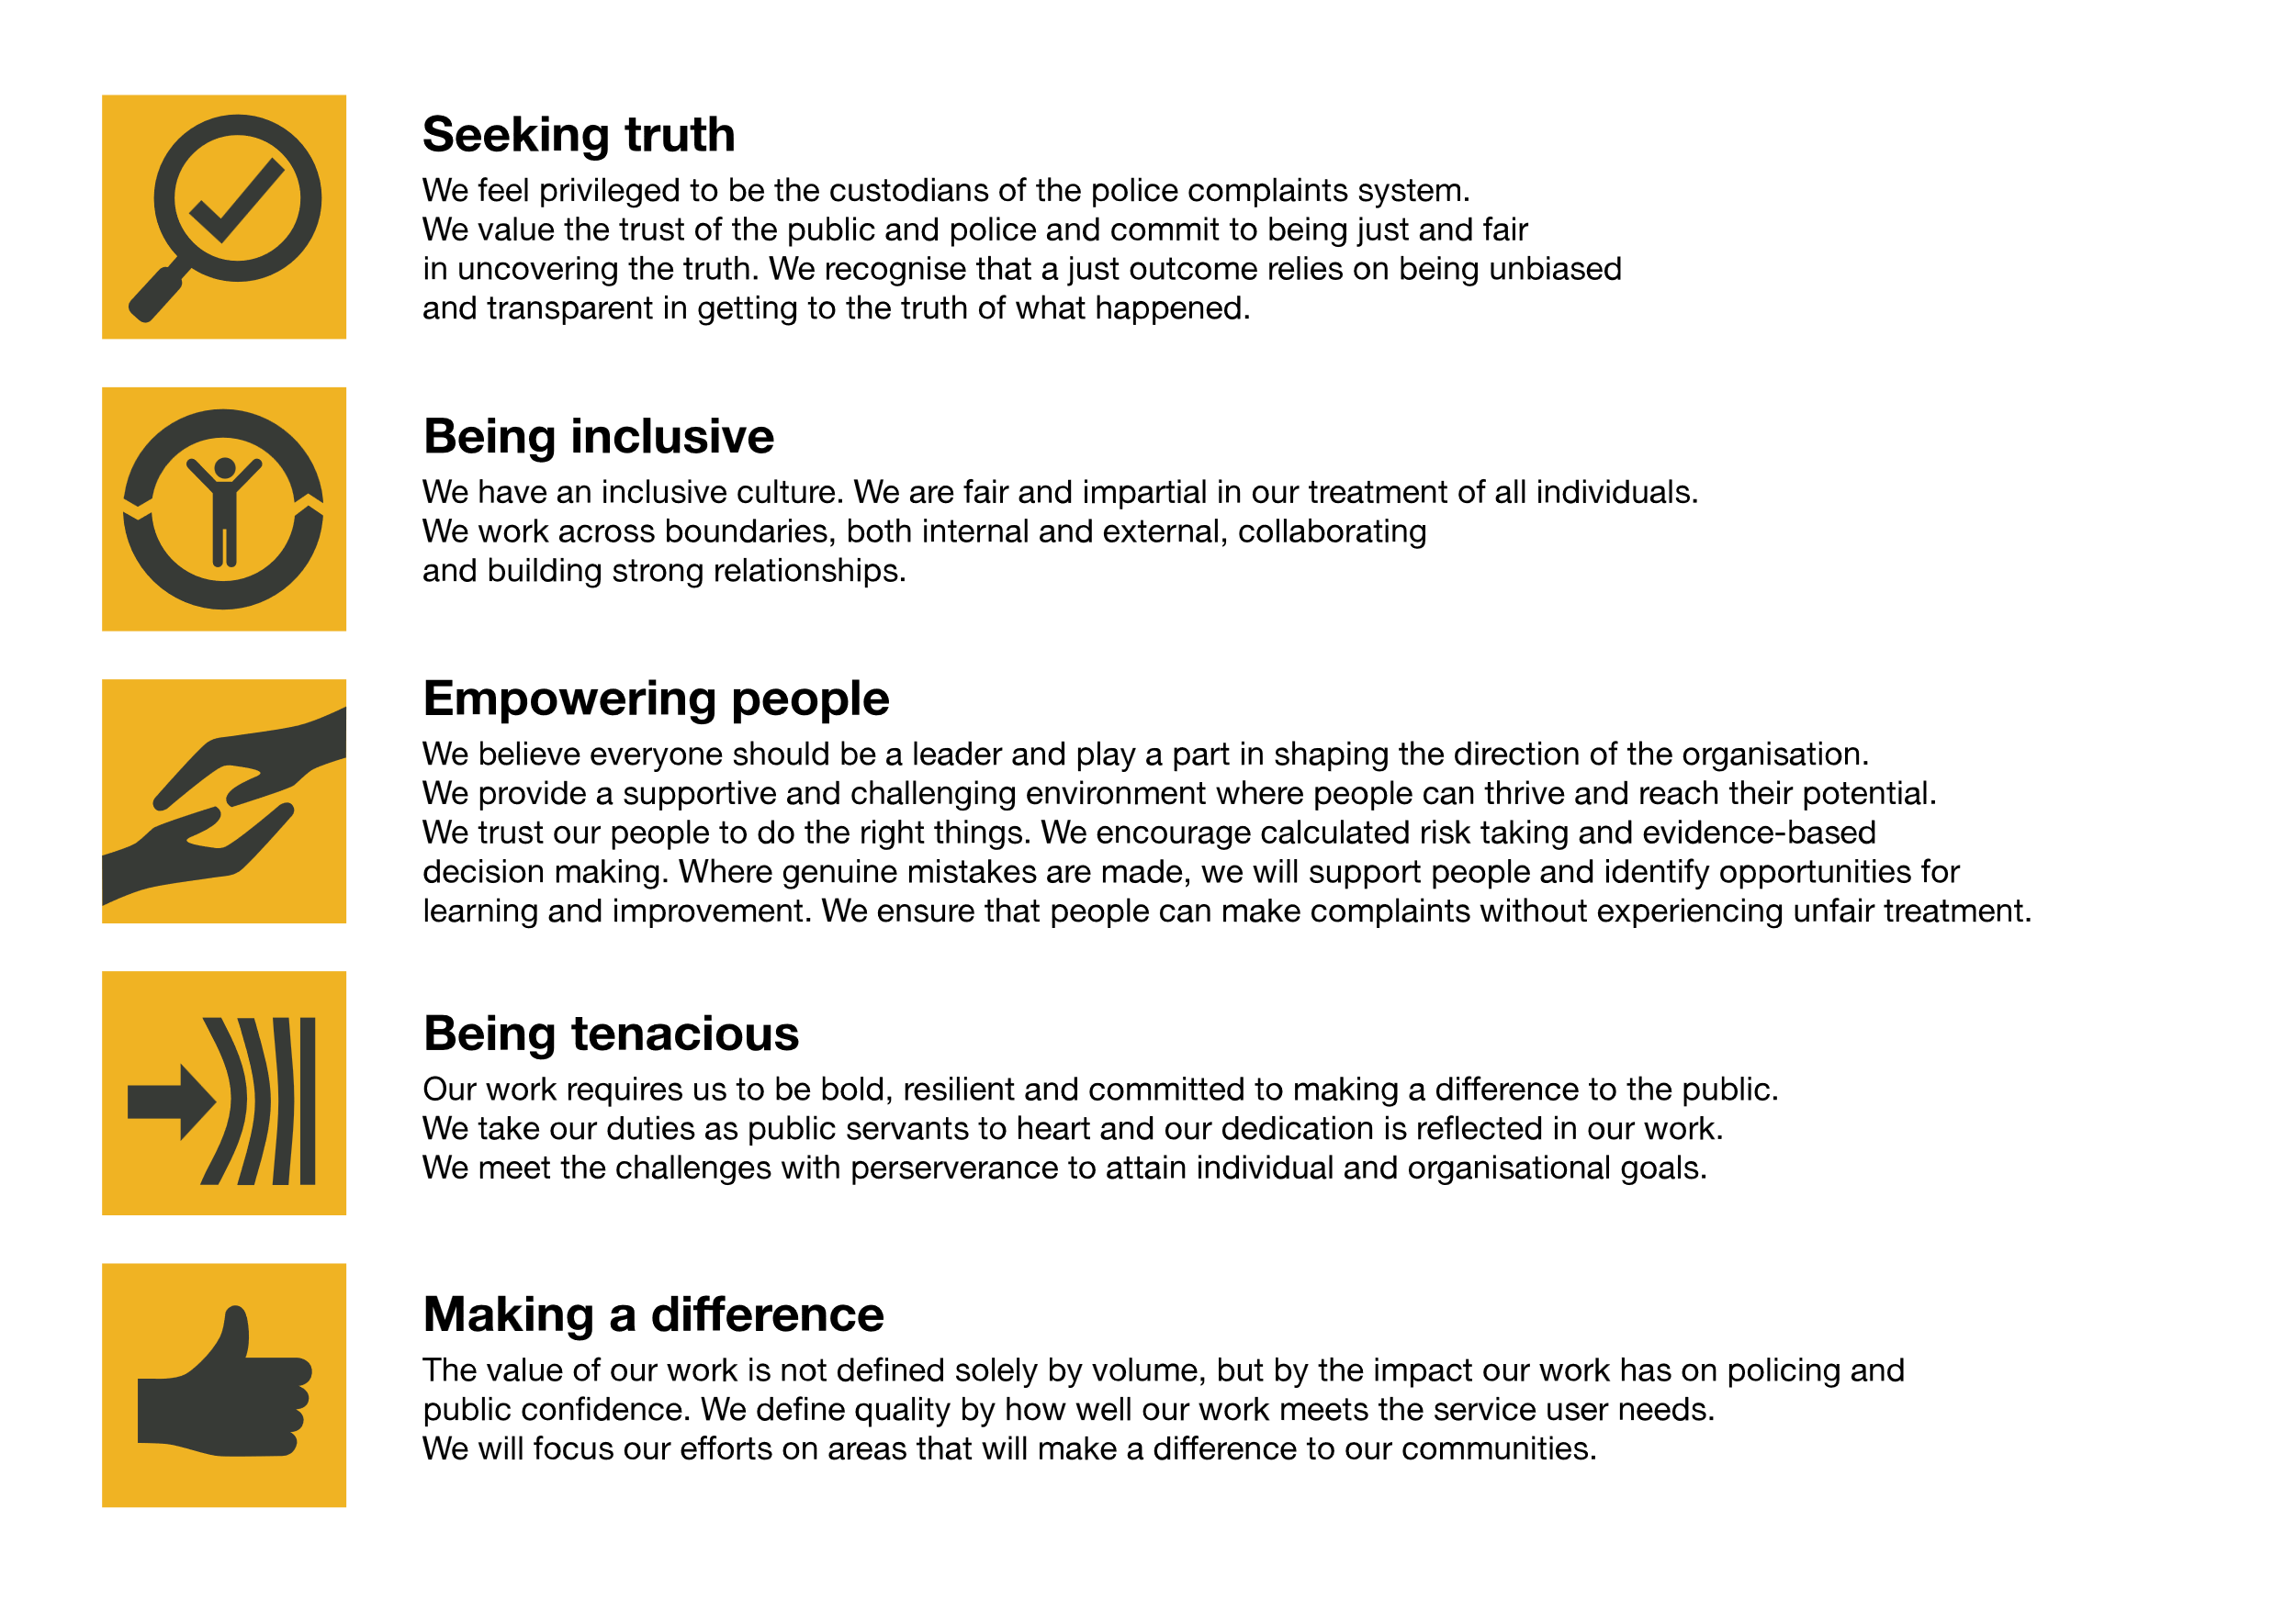We work in the context of our agreed values which inform the way we do things at the IOPC. The Talent & OD Consultant will need to be commited to managing in the context of these values.

The IOPC is committed to **promoting equality and valuing diversity** in everything we do. Our vision is to be, and to be seen as, a leader in inclusive employment and services, demonstrating this ethos in everything that we do.

* As a silver standard Stonewall employer, we continue to commit ourselves to being a LGBTQ+ employer through the work of our Pride LGBTQ+ Staff Network, creating welcoming environments for lesbian, gay, bi and queer people.
* We are pleased to share we are a signatory of the Business in the Community Race at Work Charter. The Charter is composed of five [calls to action](https://race.bitc.org.uk/issues/racecharter) for leaders and organisations across all sectors.
* Being a Disability Confident employer, the IOPC is dedicated to removing the barrier for disabled people to thrive in the workplace.
* Our Staff Networks are constantly working to make the IOPC the leaders of inclusive employment, from our Allyship Programme to [Operation Hotton](https://www.policeconduct.gov.uk/recommendations/operation-hotton-recommendations-metropolitan-police-service-september-2021), to [Welsh Language Standards](https://www.policeconduct.gov.uk/who-we-are/equality-and-diversity/welsh-language-standards) and Know the Line Policy, we are constantly seeking new ways to create an environment for all to develop and thrive.

# 

# Main duties and responsibilities

* Understand the strategic direction of the organisation and provide support,

expert advice, and guidance for implementing Talent and OD interventions

which align with our priorities and improve organisational effectiveness.

* Responsible for the design, coordination and delivery of talent and OD

activities for roles and programmes across the business, looking for

opportunity to expand and maximise what is available, evaluating them and

identifying areas for improvement

Develop and lead programmes of Talent and OD initiatives for the

organisation.

* Responsible for the promotion and compliance of corporate Organisational

Development and Talent practice.

* Lead specific internship/apprenticeship programmes to provide excellent

quality development opportunities for IOPC colleagues.

* Lead coaching and mentoring programmes.
* Support the design of leadership development programmes.
* Responsible for the identification, design, and implementation of a range of

tools and techniques to encourage all colleagues to take responsibility for

their own development.

* Responsible for identification of talent and OD opportunities and making

recommendations for changes, process reviews and updating information to

improve engagement, communication and quality of the directorate and

organisations outputs.

* Contribute to the financial and strategic planning in relation to apprenticeships

and the apprenticeship levy, providing expert advice which enables the L&D

Business Partner (Talent & OD) to make effective and efficient decisions.

* Design and deliver training and/or presentations or facilitate talent/OD events

including having responsibility for the procurement of services by external

providers and liaison with internal and external stakeholders.

* Responsible for ensuring all aspects of talent management and cultural

change are focused on diversity and inclusiveness.

* Support the creation of a learning environment in line with the digital learning

policy for all talent and OD initiatives.

* Develop and maintain appropriate induction processes.
* Understand the possible career pathways within the business and be able to

advise staff and managers about progression opportunities, demonstrating

your knowledge of talent development.

* Identify and assess the ability and potential of our staff, creating development

assessment frameworks which determine our high potential colleagues and

provide feedback on performance and coach them for success.

* Support managers to utilise assessment frameworks which identify talent and

potential within the business and be able to provide high quality advice on

supporting them to progress and to achieve their best.

* Engage with internal networks to implement talent and OD products

successfully.

* Support managers to identify gaps, opportunities and barriers in structure,

people, process or culture that are impacting on the delivery of organisational

or team goals.

* Develop strong relationships with key stakeholders across the business taking

ownership for the appropriate solutions that are devised, communicated, and

delivered.

* Forge strong links with People Business Partners to gather information and

insight about arising themes and issues to identify appropriate solutions and

deliver them promptly.

* Responsible for the delivery of our performance review process, designing

tools and guidance for specific areas of the business.

* Lead the delivery of psychometric testing through third party providers,

negotiating contracts and identifying appropriate solutions in relation to

individual, team and organisational development, and deliver feedback inhouse to individuals or groups.

* Coach colleagues from across the organisation to improve performance which

enable the organisation to better meet our objectives, including holding oneto-one and group meetings with staff to provide high quality guided learning

and opportunities share experiences and solve problems.

* Produce and maintain management information and metrics, assisting with

talent analytics to enable demonstration of ROI and the value of our talent and

OD interventions.

* Act as a key contact for our third-party suppliers, proactively coordinating

required activity and maintaining relationships.

* Mentor and coach Talent & OD Advisors and apprentices supporting them to

flourish in their roles.

* Monitor and act to ensure compliance against organisational policy or

government led regulations e.g. apprenticeship procedures, GDPR and

conduct robust Equality Impact Assessments and Data Protection Impact

Assessments.

* Alongside the L&D team, conduct skills gap analysis determining individual

and group needs.

* Responsible for developing and maintaining specialist expertise within a

specific talent or OD area, maintaining your knowledge of best practice, and

staying ahead of key trends to ensure the provision of high standard talent

management.

* Prepare and present board level reports as required.
* Maintain close cooperation with the Civil Service HR & OD, implementing any

changes that meet our needs.

# Person specification

## Essential Experience

• Experience in coaching or mentoring colleagues successfully.

• Experience of analysing information and using it to make recommendations

which improve organisational performance.

• Experience of collaborating with a wide range of stakeholders to understand

business issues, and organisational needs.

• Experience of managing a high workload within a rapidly changing

environment.

• Organised, self-motivated and capable of working autonomously.

• Confident communication with the ability to influence and engage staff.

• Experience of writing reports, guidance, and policies.

• Evidence of commitment to continuing professional development for self and

others.

• Experience of designing and delivering talent inventions or projects.

• Experience of designing and implementing OD inventions or projects.

**Desirable:**

• Professional experience of organisational development in a public sector, or legislative context.

## Qualifications

* CIPD Level 5 qualification in OD or equivalent/higher qualification/experience.

## Knowledge

• Knowledge of organisational development and talent management practices

and theories.

• Knowledge of leadership and management development theories and

practical application in the workplace.

• Knowledge of the learning methodologies.

• Understanding of apprenticeships and/or other career development

programmes such as internships.

## Skills and Abilities

• Excellent communication skills, including oral, written and presentation.

• Excellent organisational and prioritisation skills.

• Good analytical skills

• The ability to influence.

• The ability to work in an environment with competing priorities and demands.

• The ability to motivate self and others.

## Reasonable adjustments

The IOPC is a diverse and inclusive workplace and we want to help you demonstrate your full potential whatever type of assessment is used. We are open to providing you with the tools you need to succeed, from extra time to formatting changes, to name a mere few. If you require any reasonable adjustments to our recruitment process, please email [recruitment@policeconduct.gov.uk](mailto:recruitment@policeconduct.gov.uk)

## Working conditions

The IOPC are currently consulting with our consultative bodies about proposed changes to our hybrid working policy which will require all staff to work 20% of their contractual hours at their office base (or another office for business reasons) from 1 September and increased to 40% from April next year. Office attendance time includes in-person training, meetings with stakeholders and families, and attending events.

## Preparation checklist

☐ Review the full job description

☐ Review the behaviours and the descriptors for each behaviour

☐ Review the Strengths dictionary

☐ Review the IOPC values

☐ Consider your Strengths (if applicable)

☐ Consider drafting example answers that cover the specific elements

☐ Prepare some questions to ask the interviewers