**Job description**

**Title:** Health and Safety Officer

**Reports to:** Health and Safety Manager

**Location:** Any IOPC Office: Croydon, Canary Wharf, Birmingham, Wakefield, Sale, Cardiff

**Grade:** 11

**Salary:** £36,150 (Plus London Weighting Allowance of £4,731 if based in Canary Wharf or Croydon)

**Contract:** Permanent

# Purpose

As a Health and Safety Officer, you will be welcomed into a dynamic and inclusive team team working to ensure the IOPC’s health and safety policy is implemented effectively, driving a positive health and safety culture. The IOPC is on a journey to develop its culture, perspectives and ethos to support the organisation’s core outcomes and this is your opportunity to enter into the varied world of IOPC Health and Safety, allowing you to develop your mindset and approaches to contribute to improving the police complaints system in England and Wales.

You will implement the health and safety policy, driving positive health and safety culture, monitoring compliance with health and safety systems and procedures, developing and delivering health and safety training and making any required updates to health and safety documentation in order to maintain accuracy. Deputising for the Health and Safety Manager as required during periods of leave.

This is a national role and will require travel to various offices. The role is agile, with a requirement to attend any of our offices 40% of the week and option to work from home for 60%.

# Organisational context

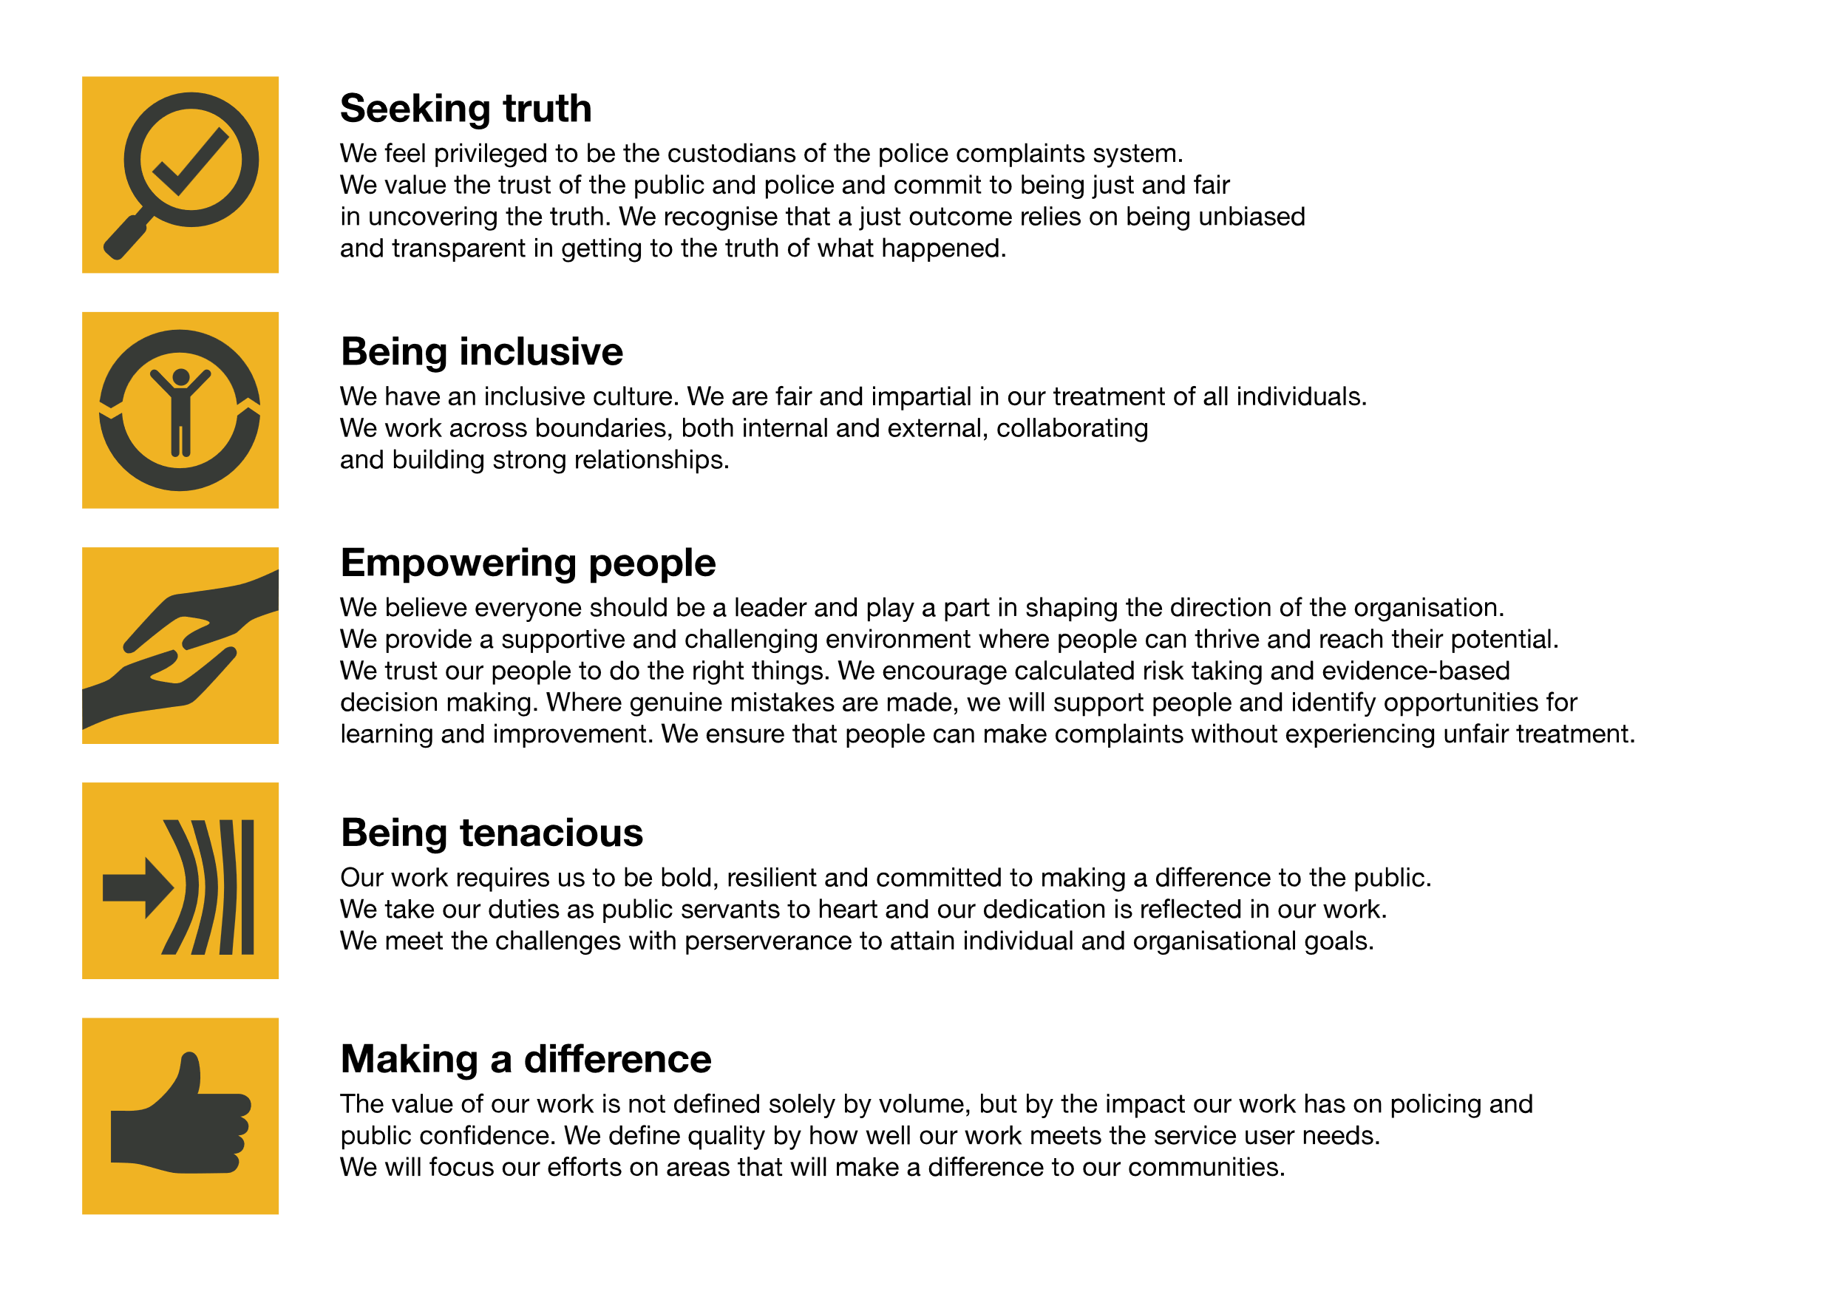We work in the context of our agreed values which inform the way we do things at the IOPC. The Health and Safety Officer will need to be commited to managing in the context of these values.

The IOPC is committed to **promoting equality and valuing diversity** in everything we do. Our vision is to be, and to be seen as, a leader in inclusive employment and services, demonstrating this ethos in everything that we do.

* As a silver standard Stonewall employer, we continue to commit ourselves to being a LGBTQ+ employer through the work of our Pride LGBTQ+ Staff Network, creating welcoming environments for lesbian, gay, bi and queer people.
* We are pleased to share we are a signatory of the Business in the Community Race at Work Charter. The Charter is composed of five [calls to action](https://race.bitc.org.uk/issues/racecharter) for leaders and organisations across all sectors.
* Being a Disability Confident employer, the IOPC is dedicated to removing the barrier for disabled people to thrive in the workplace.
* Our Staff Networks are constantly working to make the IOPC the leaders of inclusive employment, from our Allyship Programme to [Operation Hotton](https://www.policeconduct.gov.uk/recommendations/operation-hotton-recommendations-metropolitan-police-service-september-2021), to [Welsh Language Standards](https://www.policeconduct.gov.uk/who-we-are/equality-and-diversity/welsh-language-standards) and Know the Line Policy, we are constantly seeking new ways to create an environment for all to develop and thrive.

# Main duties and responsibilities

* Organise and participate in H&S Committee meetings
* Research and engagement with suitable suppliers for procurement of products and services
* Responsible for maintaining health and safety administration and systems
* Managing the administration of voluntary health and safety roles including; first aid, fire wardens, DSE assessors, risk assessment champions
* Liaison with various departments to ensure the undertaking of health and safety processes, systems and paperwork – including; risk assessments, defibrillator checks, FM premise inspections. Escalation of non-compliance to the Health and Safety Manager
* Draft and update guidance documents and policies as required to keep in line with system changes/upgrades and legislative changes
* Undertake health and safety premise inspections and tracking of corrective actions
* Creation of health and safety internal communications to improve engagement
* Undertake project work to instil new processes and/or drive engagement with current health and safety initiatives
* First point of contact for health and safety queries. Escalate to Health and Safety Manager for more complex matters as required.
* Provide health and safety advice and guidance to the organisation, support Managers, and attend departmental team meetings across the organisation to give health and safety updates and inputs.
* Undertake DSE Assessments as required
* Undertake risk assessments as required
* Undertake accident investigations. Escalate any RIDDOR reportable accidents to the Health and Safety Manager for investigation
* Develop and deliver health and safety training sessions as required
* Ensure compliance with statutory obligations and best practice

# Person specification

## Essential Experience

* Health and safety qualification – NEBOSH Certificate or equivalent as a minimum
* Proven experience of improving health and safety culture within a large organisation
* Previous experience working autonomously with little supervision
* Confident to develop and deliver training both in-person and virtually
* Excellent customer service and communication skills with the ability to influence and engage others
* Experience providing health and safety advice and support at all levels of the organisation
* Ability to prioritise changing work demands
* Computer literate with the ability to maintain systems
* Excellent attention to detail and able to produce clear reports based on data and statistics
* Experience of undertaking inspections and making recommendations
* The candidate will hold or be working towards NEBOSH diploma
* Confident driving between multiple sites

## Desirable

* Understanding of Civil Service procurement rules

## Reasonable adjustments

The IOPC is a diverse and inclusive workplace and we want to help you demonstrate your full potential whatever type of assessment is used. We are open to providing you with the tools you need to succeed, from extra time to formatting changes, to name a mere few. If you require any reasonable adjustments to our recruitment process, please email [recruitment@policeconduct.gov.uk](mailto:recruitment@policeconduct.gov.uk)

## Working conditions

The IOPC are currently consulting with our consultative bodies about proposed changes to our hybrid working policy which will require all staff to work 20% of their contractual hours at their office base (or another office for business reasons) from 1 September and increased to 40% from April next year. Office attendance time includes in-person training, meetings with stakeholders and families, and attending events.

## Preparation checklist

☐ Review the full job description

☐ Review the behaviours and the descriptors for each behaviour

☐ Review the Strengths dictionary

☐ Review the IOPC values

☐ Consider your Strengths (if applicable)

☐ Consider drafting example answers that cover the specific elements

☐ Prepare some questions to ask the interviewers