Job description
Title: Presenting Case Manager
Reports to: Head of Presenting
Location: Canary Wharf
Grade: 12
Salary: £40,075 plus £4,731 London Weighting Allowance
Contract: Permanent

Purpose
As a Presenting Case Manager, you will be welcomed into a dynamic and inclusive Legal Services team working to ensure the smooth preparation of cases for misconduct hearings. The IOPC is on a journey to develop its culture, perspectives and ethos to support the organisation’s core outcomes and this is your opportunity to enter into the varied world of IOPC Legal Services, allowing you to develop your mindset and approaches to contribute to improving the police complaints system in England and Wales.
The Presenting Case Manager within the IOPC can expect to work in a progressive and dynamic organisation with declared and strong core values. The work will be fulfilling and offer considerable opportunities for personal growth and satisfaction.
To ensure smooth preparation of cases for misconduct hearings, including disclosure in compliance with the Police (Conduct) Regulations 2020 and Home Office Guidance in relation to disclosure in misconduct proceedings with reference to the Code of Practice as set out in The Criminal Procedures and Investigation Act 1996 (as amended by the Criminal Justices Act 2003), the Disclosure Manual, The Disclosure Protocol, the Attorney General’s Guidelines and Common Law Disclosure Guidelines.
Assist the Operational Team with any queries in relation to ascertaining the relevance of material, its evidential value, sensitivity and ability to undermine the case or assist the defence (the disclosure test). Reviewing the DMR to identify any deficiencies; identify any material that is subject LPP or otherwise sensitive and taking the necessary steps.
Preparing disclosure schedules and disclosure bundles for misconduct hearings.
Preparing cases for misconduct hearings along with the presenting lawyers and the hearings unit at the Appropriate Authority.
Attending misconduct hearings with the presenting lawyers to assist.
Participate in project work and other research as necessary to further the work of the team.

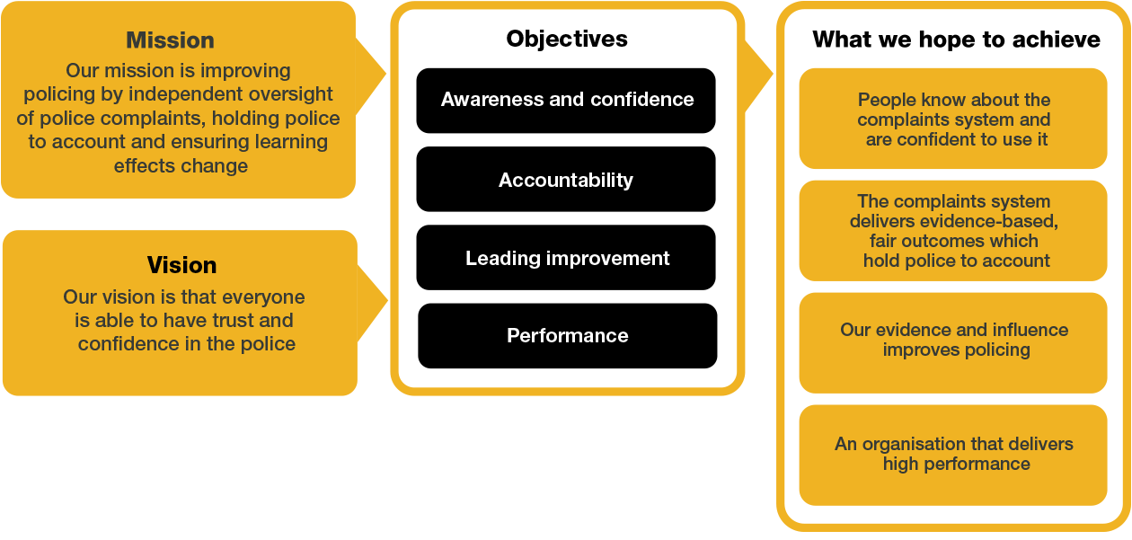
Organisational Context

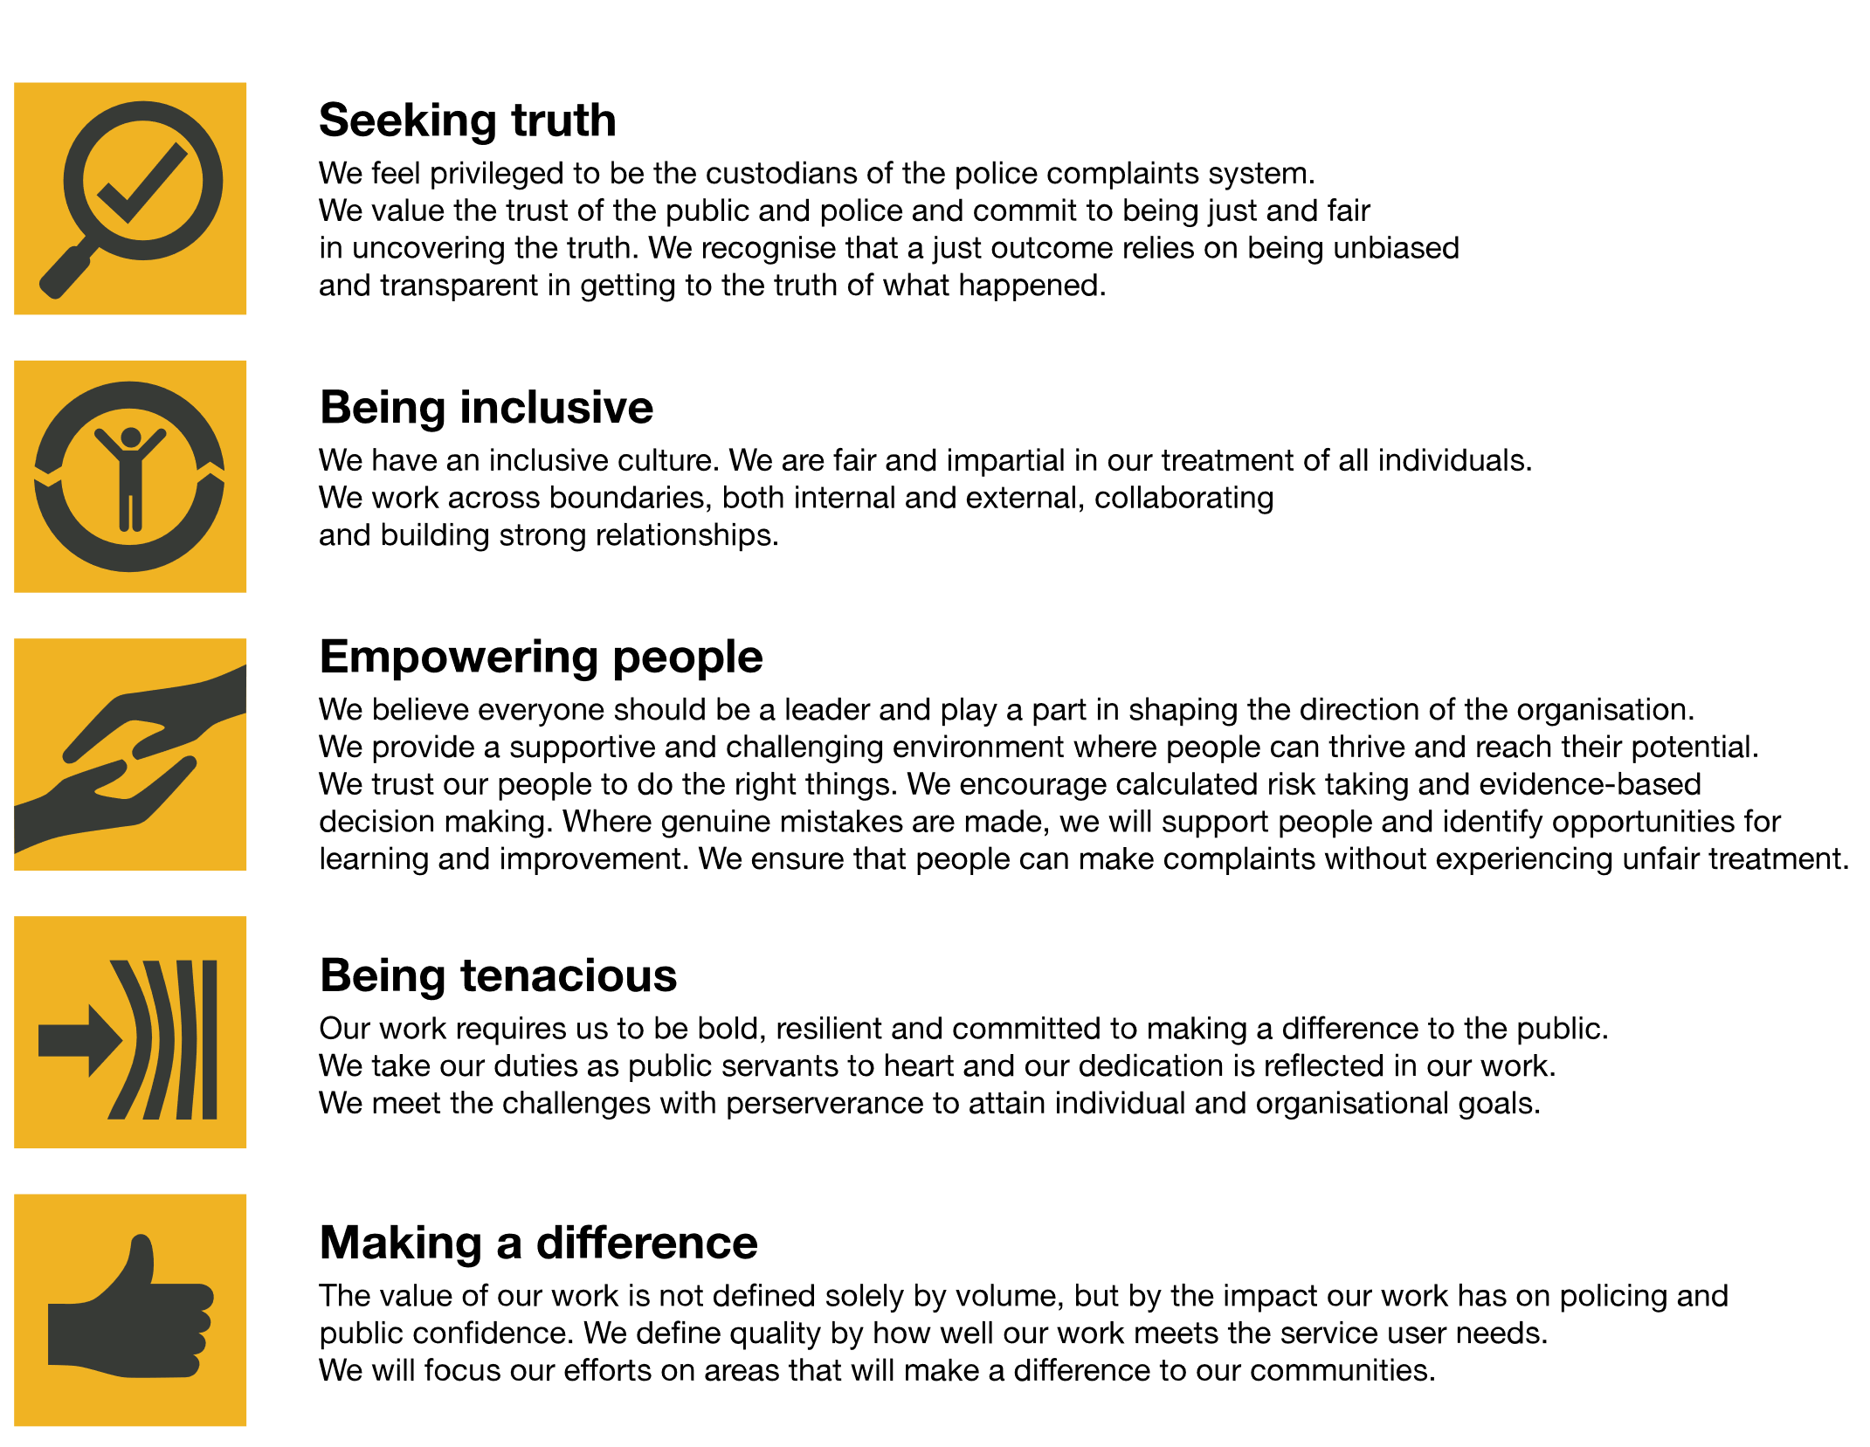
We work in the context of our agreed values which inform the way we do things at the IOPC. The Presenting Case Manager will need to be commited to managing in the context of these values.
The IOPC is committed to promoting equality and valuing diversity in everything we do. Our vision is to be, and to be seen as, a leader in inclusive employment and services, demonstrating this ethos in everything that we do.
- As a silver standard Stonewall employer, we continue to commit ourselves to being a LGBTQ+ employer through the work of our Pride LGBTQ+ Staff Network, creating welcoming environments for lesbian, gay, bi and queer people.
- We are pleased to share we are a signatory of the Business in the Community Race at Work Charter. The Charter is composed of five calls to action for leaders and organisations across all sectors.
- Being a Disability Confident employer, the IOPC is dedicated to removing the barrier for disabled people to thrive in the workplace.
- Our Staff Networks are constantly working to make the IOPC the leaders of inclusive employment, from our Allyship Programme to Welsh Language Standards and Know the Line Policy, we are constantly seeking new ways to create an environment for all to develop and thrive.

Main duties and responsibilities
- Support Presenting Lawyers in their preparation of cases, ensuring that all actions are taken in a timely manner.
- Carry own caseload and prepare cases under the supervision of Presenting Lawyers.
- Operate within the Police (Conduct) Regulations 2020 and agreed working practices with force PSDs in arranging misconduct hearings.
- Tasks include:
- Attend conferences with clients and counsel in preparation for presenting the case and provide instructions where necessary
- Liaising with the investigator to ensure full compliance with disclosure obligations.
- Correspondence with Legally Qualified Chairs, Appropriate Authorities and parties to the proceedings around the facilitation and logistics of hearings
- Serving draft regulation notices and disclosure for subject officers on the Appropriate Authority
- Reviewing defence responses and considering whether further disclosure is required
- Handling requests for further disclosure from the defence team
- Make logistical arrangements for misconduct hearings with the Appropriate Authority
- Preparing and serving witness lists and hearing bundles
- Attend hearings with counsel or the Presenting Lawyer.
- Engaging with the Head of the Presenting Unit and senior clients in relation to concerns about high-risk cases
- Post holder must be prepared to travel to hearings and other IOPC offices as necessary.
- Monitor and report misconduct outcomes.
- Participate in projects necessary to further the work of the Presenting Unit.
- Undertake other duties commensurate with the level and remit of the post as may time to time be allocated by the Head of Legal Services or the Head of the Presenting Unit.
- The post holder will be cleared to SC level.
- Ensure that necessary care for victims and witnesses is provided in an ethical and empathic manner and in accordance with legislation, policies and procedures.
- Keep up to date with and understand and apply of all changes to recent legislation and case law.
- Identify actions taken, lesson learned and good practice, sharing details with appropriate personnel.
- Attend and/or lead briefings as required.

In relation to disclosure:
- Provide advice and guidance to operational colleagues to assist in ensuring
- that the investigations disclosure obligations are complied with.
- Co-ordination and prioritisation of tasks to achieve on time, and to agreed quality standards.
- Assessing the accuracy and completeness and quality of work submitted.
- To inspect, view, listen to or search all relevant material that has been retained by the investigator.
- Assess all material retained within the investigation to ascertain their relevancy, evidential value, sensitivity and ability to undermine the case or assist the defence.
- Identify deficiencies and problems with continuity or other evidence related matters, inform t the presenting team and operational clients and ensure best evidence is obtained.
- Identify any material that is subject to Public Interest Immunity, completing the relevant forms.
- Liaise with the presenting legal team and the Appropriate Authority at case conferences and discuss disclosure, public interest immunity issues and possible defence arguments, as necessary.
- Ensure the presenting lawyers are appraised of all relevant material in the investigation.
- Deal expeditiously with requests by presenting counsel for further information on material which may lead to Disclosure.
- Keep records of all key decisions taken and be prepared to account for them later.
- Produce disclosure schedules
- Ongoing review of material as the case develops and/or on receipt of a Regulation 31 notice (defence statement).

These main duties and responsibilities are intended only as a guide to the main responsibilities of the post and are not intended to restrict the scope of the post holder to perform other duties. Additional responsibilities for the post holder may be agreed on an individual basis and recorded as part of the annual performance review role requirement.

Person specification

Essential
- Considerable experience of undertaking the role of Disclosure Manager in a criminal investigation.
- Proven experience using of using IOPC databases to produce disclosure
- Proven experience as a case builder who has completed files of evidence for criminal trials at the Magistrates and Crown Courts and/or police misconduct proceedings
- A sound knowledge and understanding of the Police (Conduct) Regulations 2020; Home Office Guidance; Criminal Procedures Investigations Act 1996 and relevant amendments to disclosure requirements.
- Evidence of planning skills and balancing priorities across a team.
- Proven experience of working effectively in a team environment.
- Ability to work effectively under pressure, and to manage the welfare of team members.
- Experience of dealing with internal and external parties to complete tasks successfully.
- Experience of working on own initiative, taking decisions within a framework of delegation for oneself and team members.
- Proven experience of having worked with multiple time demands and deadlines, exercising judgement on time management.
- Analytical skills with the capacity to absorb/organise new information to ensure well briefed on new topics.
- Comfortable taking decisions within a clear framework of delegation.

Desirable
- Knowledge of Common Law Disclosure Guidelines.
- High level administrative experience in a complex/and/or devolved organisation.
- Experience of managing the administrative requirements in relation to reviewing investigations.
- Excellent analytical skills, sound judgement and self-confidence.
- Experience of working on own initiative, taking decisions within a framework of delegation for oneself and team members.

Positive Action
At the IOPC, we are committed to building a workforce which reflects the diversity of the communities in which we serve. A more inclusive workforce enables us to be a more effective and efficient organisation, better understand and respond to the needs of our communities.
Positive action as detailed in the Equality Act 2010, allows us to use measures designed to help improve equality in the workplace, and create a level playing field for all, whilst still employing everyone based on merit. Our workforce profile data shows that people who identify as black, Asian and minority ethnic are under-represented at the IOPC.
For this role – should we have a situation where multiple candidates have achieved the highest score and one identifies as black, Asian or minority ethnic, by using positive action, we can select that candidate for the role, therefore improving this area of under-representation at the IOPC. We will only use positive action in this way where the highest scoring candidates have all scored equally, at the final assessment stage, and above our required threshold.

Emotional Consideration
In performing this role, you will be required to access distressing material whilst on operational work which will likely be impactful, traumatic and challenging. Given the nature of the work, it is also possible that you will have contact with individuals who are experiencing extreme distress. The IOPC recognises this and offers all staff a range of wellbeing provisions, including TRiM (Trauma Risk Management) peer-to-peer support, a dedicated Wellbeing Advisor, and access to free confidential counselling. All staff are strongly encouraged to proactively access and engage with the support available. If you would like to speak about this element of the role with somebody already doing similar work at the IOPC, please contact campaigns@policeconduct.gov.uk and this can be arranged.

Reasonable adjustments
The IOPC is a diverse and inclusive workplace and we want to help you demonstrate your full potential whatever type of assessment is used. We are open to providing you with the tools you need to succeed, from extra time to formatting changes, to name a mere few. If you require any reasonable adjustments to our recruitment process, please email campaigns@policeconduct.gov.uk

Working conditions
Making the IOPC a great place to work is one of our key priorities. We are pleased to offer a unique hybrid working model based on business needs, balanced with the needs of our colleagues. Our business need framework guides our decisions about when it is best to work onsite (in our offices or other appropriate locations) to complete tasks most effectively or when to work remotely, offering colleagues flexibility to work where they feel most productive and supporting work-life balance. The model also encourages staff to feel welcome at the IOPC by ensuring we have opportunities to work face-to-face as teams.
Here at the IOPC, maintaining a culture that is accessible and inclusive of gender identity, sexuality, age, disability, race, sex, belief and caring responsibilities is deeply important to us. We believe that a rich, diverse workforce enables us a better understanding of each others needs, and produces more meaningful and trusting relationships, which in turn create more inclusive spaces where we all feel that we can contribute and belong. We value our diversity, as we believe that our diversity is our strength. It allows us to identify with our communities through shared lived experiences producing better understanding and higher quality results in our work.

What we offer
- 27.5 days paid annual leave (increasing with service to 32.5 days)
- Options to carry over, buy or sell annual leave
- Civil Service pension
- PAM employee assistance programme
- Access to Civil Service Sports Council (CSSC) membership
- Cycle to work scheme
- Opportunity to enjoy the latest home and electronics in a more affordable way provided by Vivup
- Car Leasing Scheme
- Staff networks focused on each of the protected characteristics – run for staff, by staff:
- Age Network
- Enable Network
- Welsh Network
- Pride and LGBTQI+ Network
- Sex and Family Network
- Race, Religion and Belief Network
- Learning and development tailored to your role
- An environment with flexible working options
- A culture encouraging inclusion and diversity behaviours

Preparation checklist
☐ Review the full job description
☐ Review the behaviours and the descriptors for each behaviour
☐ Review the Strengths dictionary
☐ Review the IOPC values
☐ Consider your Strengths (if applicable)
☐ Consider drafting example answers that cover the specific elements
☐ Prepare some questions to ask the interviewers

