**JOB DESCRIPTION**

**TITLE:** ICT Information and Desktop Support Officer

**REPORTS TO:** Lead ICT Information and Desktop Support Officer

**LOCATION:** Canary Wharf

**GRADE:** 10

**SALARY:** £31,110 plus London Weighting £4527

**CONTRACT:** Permanent

**PURPOSE**

As an ICT Information and Desktop Support Officer you will be welcomed into a dynamic and inclusive ICT team working to provide operational service support to ICT services and security teams. The IOPC is on a journey to develop its culture, perspectives and ethos to support the organisations core outcomes and this is your opportunity to enter into the varied world of IOPC ICT, allowing you to develop your mindset and approaches to contribute to improving the police complaints system in England and Wales.

The ICT services team needs an Information and Desktop support officer responsible for providing support to IOPC supporting prevailing BAU & project rollout work. Also, to support the administration of various processes including; starters, movers & leavers, ICT service requests, IMACS, information asset management, document libraries, ICT system access control, digital media management, incident reporting and day to day support of tickets coming into the ICT Support Centre.

This role will need to work closely with internal stakeholders, including but not limited to People (HR), FM and Finance and Investigation Support Units, all of whom are also involved in key processes. Being part of the desktop support team, this role will require travel to the designated office and other offices based on a business need. The need can come from escalations from the Service Desk team for hands on end-user support and project related activities. The role also collaborative working with other members of the broader ICT team and in particular the IOPC outsourced suppliers.

# ORGANISATIONAL CONTEXT

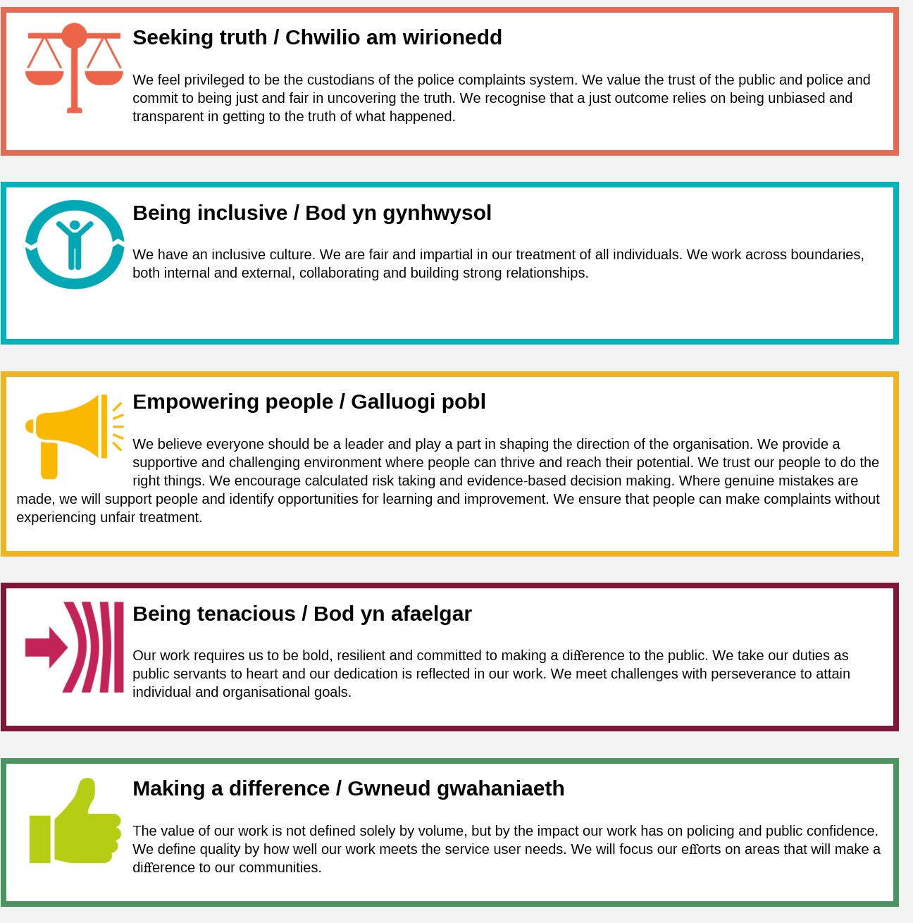We work in the context of our agreed values which inform the way we do things at the IOPC. The ICT Information and Desktop Support Officer will need to be commited to working in the context of these values.

The IOPC is committed to **promoting equality and valuing diversity** in everything we do. Our vision is to be, and to be seen as, a leader in inclusive employment and services; demonstrating this ethos in everything that we do.

* As a silver standard Stonewall employer, we continue to commit ourselves to being a LGBTQ+ employer through the work of our Pride LGBTQ+ Staff Network, creating welcoming environments for lesbian, gay, bi and queer people.
* We are pleased to share we are a signatory of the Business in the Community Race at Work Charter. The Charter is composed of five [calls to action](https://race.bitc.org.uk/issues/racecharter) for leaders and organisations across all sectors.
* Being a Disability Confident employer, the IOPC is dedicated to removing the barrier for disabled people to thrive in the workplace.
* Our Staff Networks are constantly working to make the IOPC the leaders of inclusive employment, from our Allyship Programme to [Operation Hotton](https://www.policeconduct.gov.uk/recommendations/operation-hotton-recommendations-metropolitan-police-service-september-2021), to [Welsh Language Standards](https://www.policeconduct.gov.uk/who-we-are/equality-and-diversity/welsh-language-standards) and Know the Line Policy, we are constantly seeking new ways to create an environment for all to develop and thrive.

**MAIN DUTIES AND RESPONSIBILITIES**

* To be part of a team responsible for maintaining a rigorous service delivery management regime in relation to the IOPC’s ICT supplier(s), maintaining control over service demand, ICT provision and ensuring the supplier meets the required and contracted levels and standards.
* Analysing current processes and procedures and developing new procedures based on CSI (Continual Service Improvement).
* Contribute to policies, processes and procedures.
* Reporting faults within the ITSM tool.
* Undertaking Installations, Moves, and Changes (IMACS) related to desktop equipment. Action ICT service requests, ensuring compliance with agreed governance processes
* Work with IOPC’s outsourced ICT providers to ensure that incidents are resolved promptly, problems accurately reported and diagnosed and that ICT services are efficiently delivered. Managing local “break-fix arrangements” through swap-out and stock maintenance
* To support refresh and change projects related to the desktop environment including user acceptance testing and cutover activities
* Working with the IOPC’s outsourced ICT providers, their service desk and resolver groups, raising/approving requests on 3rd party supplier ITSM portals.
* To maintain document libraries used to ensure that the ICT problem, incident, CMDB and Commodity catalogues and ICT assets are tracked and verified.
* To administer service requests and starters leavers and mover process as it applies to providing access to corporate applications, file stores and mailboxes
* To undertake other activities needed from time to time to provide resilience across the team and to provide data input and reporting to others in the wider ICT team
* To be involved in ICT procurement – determining requirements for day-to-day ordering, requesting quotes, raising requisitions.
* Negotiating with suppliers on costs, ensuring integrated and efficient services.
* Negotiating with staff of all levels, planning for future activities, for themselves and for other members of the team.
* Strong customer focus and experience of building good working relationships with stakeholders and end users
* Managing service change, ensuring continuity whilst implementing complex key technical changes.
* Providing hands-on support to local users in their use of the IOPC standard desktop/laptop and end devices such as scanners, plotters, printers, local telephony, Wi-Fi networking, fixed and soft-phone telephony and video conferencing as well as specialist equipment used for Major Investigations.
* Being a SPOC for your designated office and taking ownership of incidents/requests/project work require at that site.
* Be willing to travel for ICT projects.
* Ensure new end user requirements or requests are captured and either escalated to the Business Relationship Managers or fed into the appropriate processes such as Service Improvement board / Technical Design Authority etc.

**ESSENTIAL CRITERIA**

* Demonstrable knowledge of Citrix XenApp thin client
* Microsoft Office 365 cloud services
* Microsoft Azure cloud services
* InTune/Endpoint management
* Experience supporting various end user devices utilising appropriate management tools such as Microsoft Active Directory & Mobile Device Management systems
* Willingness to work towards the principles of ITILV3/V4 and corresponding ICT service management
* Experience of working with outsourced IT service delivery teams and awareness of ITIL incident and asset management principles
* Experience of working in a secure environment
* Knowledge of shared WiFi, VPN, LAN and WAN technologies
* Experience of managing a range of enquiries from internal stakeholders
* Demonstrable experience in the management of detailed records in relation to actions taken

**DESIRABLE CRITERIA**

* Some familiarity with the ICT project lifecycle
* PM qualification or experience – PRINCE Foundation useful
* Experience of managing hardware related faults
* Experience of working with outsourced IT service delivery teams and awareness of ITIL incident and asset management principles
* Working knowledge of one or more of the IOPC’s corporate applications such as SharePoint or HP Records Manager
* Knowledge of ITSM tools such as Freshservice/Service Now.
* Reporting and trending experience in ITSM tools.
* Experience/knowledge of automating tasks/processes

**Reasonable adjustments**

The IOPC is a diverse and inclusive workplace and we want to help you demonstrate your full potential whatever type of assessment is used. We are open to providing you with the tools you need to succeed, from extra time to formatting changes, to name a mere few. If you require any reasonable adjustments to our recruitment process, please email [humanresources@policeconduct.gov.uk](mailto:humanresources@policeconduct.gov.uk).

**Working Conditions**

Making the IOPC a great place to work is one of key priorities. We are pleased to offer a unique hybrid working model based on business needs balanced with the needs of our colleagues. Our business need framework guides our decisions about when it is best to work onsite (in our offices or other appropriate locations) to complete tasks most effectively or when to work remotely, offering colleagues flexibility to work where they feel most productive and supporting work-life balance. The model also encourages staff to feel welcome at the IOPC by ensuring we have opportunities to work face-to-face as teams. We will adhere to government guidelines particularly where we are encouraged to work from home where possible.

When the government encourages us to work from home, your first day will be conducted remotely with equipment delivered to your home address prior to your first working day. Only when safe to do so and when the government allows office working to be more regular can you expect to be greeted in your local office on your first day to meet your line manager. There will also be occasions to meet your team in person throughout the year.

**Preparation checklist**

Review the full job description ☐

Review the behaviours and the descriptors for each behaviour☐

Review the Strengths dictionary ☐

Review the IOPC values ☐

Consider your Strengths (if applicable) ☐

Consider drafting example answers that cover the specific elements ☐

Prepare some questions to ask the interviewers ☐