**Job description**

**Title: Executive Support Team Manager**

**Reports to: Deputy Chief of Staff**

**Location: Any of the following IOPC Offices: Canary Wharf, Croydon, Cardiff, Sale, Wakefield or Birmingham**

**Grade: Grade 12**

**Salary: £41,878 (Plus London Weighting allowance of £4,968 if based in Canary Wharf or Croydon)**

**Contract: Permanent**

# Purpose

The IOPC is on a transformation journey and this role offers an opportunity to be at the heart of it by joining a dynamic Executive Support Services Team (ESS). The Executive Support Services Team delivers high quality executive support to the IOPC senior leadership team and has a key role in enabling the delivery of the IOPC strategic objectives.

This newly established team forms part of a matrix management structure which allows team members to thrive in a fast-paced, high performing and collaborative environment.

As the Executive Support Services Team Manager, you will manage a team of Executive Support Officers and lead the planning, organising, delegation and allocation of tasks and duties. You will monitor outputs to ensure that the team are delivering a responsive, efficient, and effective shared service that meets the needs of the business.

You will build effective working relationships with the IOPC Senior team and matrix manage Personal Assistants to ensure their administration and support needs are being met and work is fairly distributed.

As manager, you will coach and mentor team members to ensure that they grow in confidence and ability, so that the services delivered are high quality, right the first time, and continuously improved.

# A screenshot of a computer screen Description automatically generatedOrganisational Context

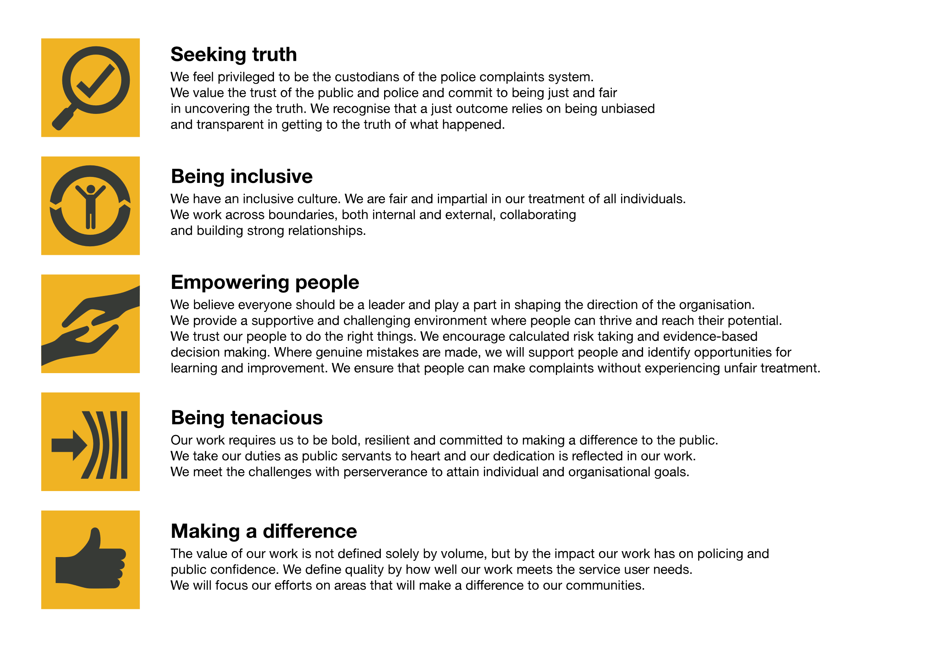We work in the context of our agreed values which inform the way we do things at the IOPC. The e Executive Support Services Team Manager will need to be commited to managing in the context of these values.

The IOPC is committed to **promoting equality and valuing diversity** in everything we do. Our vision is to be, and to be seen as, a leader in inclusive employment and services, demonstrating this ethos in everything that we do.

* As a silver standard Stonewall employer, we continue to commit ourselves to being a LGBTQ+ employer through the work of our Pride LGBTQ+ Staff Network, creating welcoming environments for lesbian, gay, bi and queer people.
* We are pleased to share we are a signatory of the Business in the Community Race at Work Charter. The Charter is composed of five [calls to action](https://race.bitc.org.uk/issues/racecharter) for leaders and organisations across all sectors.
* Being a Disability Confident employer, the IOPC is dedicated to removing the barrier for disabled people to thrive in the workplace.
* Our Staff Networks are constantly working to make the IOPC the leaders of inclusive employment, from our Allyship Programme to [Operation Hotton](https://www.policeconduct.gov.uk/recommendations/operation-hotton-recommendations-metropolitan-police-service-september-2021), to [Welsh Language Standards](https://www.policeconduct.gov.uk/who-we-are/equality-and-diversity/welsh-language-standards) and Know the Line Policy, we are constantly seeking new ways to create an environment for all to develop and thrive.

# Main duties and responsibilities

**Leadership & Management**

• Act as role model for ESS team members, coaching and supporting development to ensure high performance.

• Lead and manage the delivery of executive support services, managing workflow and assignment of tasks to ensure timely, high-quality support.

• Lead the development and introduction of new ESS standards and processes, focused on delivering and excellent service user experience.

• Monitor and evaluate performance against standards and service user expectations.

• Establish a matrix management arrangement with Directors and Executive Assistants, to ensure team working and collaboration in the delivery of executive support.

**Information Management**

• Directly respond to sensitive enquiries with high levels of discretion and ensure appropriate handling of sensitive information.

• Ensure team compliance with the IOPC data quality, records management, data protection & information management principles, to ensure information is safe, secure and shared appropriately.

• Arrange for collation of corporate information on request, to support production of management reports and documents.

• Working with data protection team to co-ordinate FOI requests, ensuring they are logged, allocated and responded to within appropriate timescales.

**Business and Project Support:**

• Directly respond to and field complex support queries where appropriate.

• Act as the gate keeper for acceptance of new executive support work, ensuring appropriate tasks are carried out by the most appropriate person/team within the wider business. Usual executive support tasks delivered by the ESS team will include:

o Basic finance tasks, Including raising POs and processing invoices.

o Support starters and leavers processes for the senior team. This may include administration relating to recruitment, onboarding ICT assets and training.

o Administration support to specific projects and to leaders with SRO responsibilities.

o Support with diary management, correspondence and ad-hoc meeting requests for senior leaders without a Personal Assistant.

o Meeting and secretariat support including agendas, minutes, actions and preparatory documents.

o Internal and external event organisation, including venue bookings, travel, catering.

**Cultural Competence, Equality, Diversity & Inclusion:**

• Be pro-active and committed to equity, diversity and inclusion.

• Demonstrate cultural competence when interacting with all stakeholders.

# Person specification

## Experience & Qualifications

• Management Qualification and/or equivalent qualification or experience.

• Proven experience of managing remote and diverse teams.

• Previous experience of working in a senior executive support environment, with exposure to complex and sensitive work.

• Extensive experience of working with IT systems and applications including MS Office (word, Excel, and Power Point) SharePoint, Outlook and Teams.

• Experience of developing standards of performance, and processes to ensure a quality customer focused service is delivered.

• Experience of developing key performance indicators to monitor and measure the performance of the team.

## Skills and Abilities

• Strong inter-personal (written and oral) communication skills.

• Prioritising to ensure key objectives of the role are consistently achieved.

• Comfortable taking decisions within a clear framework of delegation.

• Strong leadership and management skills.

• Excellent customer service skills.

• The ability to build effective working relationships with a range of stakeholders.

• Ability to prioritise competing and changing work priorities for self and team.

• Highly developed planning and prioritisation skills.

• Effective and clear communications using a range of media.

• Good analytical skills and the ability to understand and present complex information to audiences of differing abilities.

• Excellent organisational ability and attention to detail.

• Proficiency in the use of ICT, including MS Office, Word, Excel, PowerPoint, SharePoint and MS Teams.

## Reasonable adjustments

The IOPC is a diverse and inclusive workplace and we want to help you demonstrate your full potential whatever type of assessment is used. We are open to providing you with the tools you need to succeed, from extra time to formatting changes, to name a mere few. If you require any reasonable adjustments to our recruitment process, please email [recruitment@policeconduct.gov.uk](mailto:recruitment@policeconduct.gov.uk)

## Working conditions

The IOPC are currently consulting with our consultative bodies about proposed changes to our hybrid working policy which will require all staff to work 20% of their contractual hours at their office base (or another office for business reasons) from 1 September and increased to 40% from April next year. Office attendance time includes in-person training, meetings with stakeholders and families, and attending events.

## Preparation checklist

☐ Review the full job description

☐ Review the behaviours and the descriptors for each behaviour

☐ Review the Strengths dictionary

☐ Review the IOPC values

☐ Consider your Strengths (if applicable)

☐ Consider drafting example answers that cover the specific elements

☐ Prepare some questions to ask the interviewers