**Job description**

**Title: Lead Investigator**

**Reports to: Operations Team Leader**

**Location: Croydon**

**Grade: 11**

**Salary: £33,783 (plus £4,438 London weighting allowance)**

**Contract: Permanent**

# Purpose

As a Lead Investigator, you will be welcomed into a dynamic and inclusive investigations team working locally and nationally on a wide range of IOPC investigations. The IOPC is on a journey to develop its culture, perspectives and ethos to support the organisations core outcomes and this is your opportunity to enter into the varied world of investigations, allowing you to develop your mindset and approaches to contribute to improving the police complaints system in England and Wales.

The IOPC is an organisation steeped in history, influenced by significant figures such as Stephen Lawrence and Sir William Macpherson, overseeing the police complaints system in England and Wales and setting the standards by which the police should handle complaints. As a completely independent organisation, we seek to uphold the rights of the public and investigate the most serious matters, including deaths following police contact, to promote learning and influence change in policing. The investigations teams are tasked with upholding our values whilst establishing the facts behind a complaint and reaching conclusions to draw recommendations.

As a Lead Investigator, you’ll lead all aspects of an investigation, from setting out the initial terms of reference, to collecting evidence, interviewing witnesses, drawing conclusions and writing a final report, many of which are published. This means you’ll need relevant experience of undertaking investigations in any sector, such as social work, the probation services, local authority enforcement or regulatory services, as well as fraud or criminal justice.

The IOPC is a public service and aims to ensure that everyone receives an equal service. To make this a reality we need innovative and socially aware people to join us. You can find out about all of our unique roles here, from Trainee Investigator to Operations Manager. The IOPC are committed to developing the mindset of a team of diverse and passionate individuals reach their career goals whilst contributing to improving policing confidence.

This role is exempt from the Rehabilitation of Offenders Act 1974, therefore a standard Disclosure and Barring Service (DBS) check will be carried out for the successful candidate during the pre-employment process.

# Job Specific

Although the role will be fall under Croydon investigations, there will be scope for Hybrid working in other regions whereby the IOPC will pay for necessary travel to and from Croydon for job specific duties such as on-call, which will be a requirement for one week on a rolling rota every six weeks.

# Main duties and responsibilities

* Leading independent investigations into criminal and misconduct allegations in accordance with agreed IOPC guidelines.
* Conducting investigations within agreed timescales, budget and quality standards.
* Drafting and agreeing Terms of Reference for allocated investigations.
* Undertaking investigative actions, including interviewing and taking statements, preparing case files and making recommendations for criminal and/or disciplinary action.
* Taking part in criminal, misconduct and inquest proceedings where necessary.
* Reporting to your Operations Team Leader on investigation progress, areas of risk and resourcing requirements.
* Participating in the 24-hour on call facility and being prepared to work unsociable and extended hours.
* Visiting incident scenes and supervising scene management where required to ensure that all necessary action is taken to preserve and recover evidence.
* Attending post-mortems and briefing the pathologist as required.
* Writing investigation reports upon completion of the investigation for submission to the IOPC decision maker.
* Communicate effectively with complainants, bereaved families and other internal and external stakeholders.
* Working as part of a multi-disciplinary team with decision makers, lawyers, press officers and others.
* Taking responsibility for personal development in a dynamic and constantly evolving investigative environment.
* Assisting the Directorate in achieving its key deliverables. Preparing disclosure schedules for court and inquest proceedings.
* Reviewing unpleasant material, liaising with traumatically bereaved families, robust external scrutiny of actions and decisions.
* Receive close management support/ training and have access to an extensive employee assistance program.
* Identifying potential learning for police forces to consider improving the service they provide and prevent harm to the public.

# Person specification

## Desirable

* PiP2 qualification or equivalent investigative experience

## Experience

* Conducting investigative interviews, evidence gathering, analysis and presentation.
* Evidence of effective oral and written communication skills.
* Evidence of excellent analytical and report writing skills; ability to reach and document clear, rational, evidence-based and independent decisions based on analysis of existing and emerging information.
* Experience of engaging effectively with a diverse range of people and stakeholders, and evidence of a commitment to equality and diversity within the workplace.
* Delivering a high standard of work within demanding timescales.
* Identification of operational and organisational risk.
* Working effectively in a changing environment.
* Full driving licence valid for driving in the UK

## Skills and abilities

* Ability to show initiative and adapt in a changing environment.
* Writing investigation reports upon completion of the investigation for submission to the IOPC decision maker.
* Communicate effectively with complainants, bereaved families and other internal and external stakeholders.
* Ability to recognise your development needs and be proactive in addressing them.
* Ability to prioritise and manage tasks effectively to deliver quality outcomes within demanding timescales.
* Ability to work effectively in a team with diverse ideas and people.
* Ability to communicate effectively both verbally and in writing and adapt communication styles as appropriate.

## Training

The IOPC will provide:

* Investigative training, structured to individual’s needs and experience.
* Primarily focussed and tailored to reflect relevant IOPC legislation.
* Continued personal development training.
* Bespoke development opportunities.
* The opportunity to gain a recognised BTEC investigators qualification

## Working conditions

Making the IOPC a great place to work is one of our key priorities. We are pleased to offer a unique hybrid working model based on business needs, balanced with the needs of our colleagues. Our business need framework guides our decisions about when it is best to work onsite (in our offices or other appropriate locations) to complete tasks most effectively or when to work remotely, offering colleagues flexibility to work where they feel most productive and supporting work-life balance. The model also encourages staff to feel welcome at the IOPC by ensuring we have opportunities to work face-to-face as teams.

## Hybrid Working

Whereby an individual, or team, works part of their time in the office and part of their time working from home, or some other suitably secure agreed location.

The IOPC will provide the standard equipment needed to undertake your work. The equipment issued to you will vary dependent on your job role. The IOPC will provide Laptops which are Wi-Fi enabled and where colleagues opt to work remotely, they will be responsible for accessing a secure Wi-Fi or cabled internet connection.

Where it is not possible to access a secure internet connection, hybrid working will not be possible. The IOPC does not contribute to the cost of installing or maintaining a secure internet connection.

You will be able to work remotely throughout the UK, with a requirement to attend the Croydon office once a week unless business needs direct otherwise.

See Hybrid Policy: <https://policeconduct.sharepoint.com/sites/thehub/news/news_stories/Pages/ns12082022_hybridpolicyandguidance.aspx>

# Organisational context

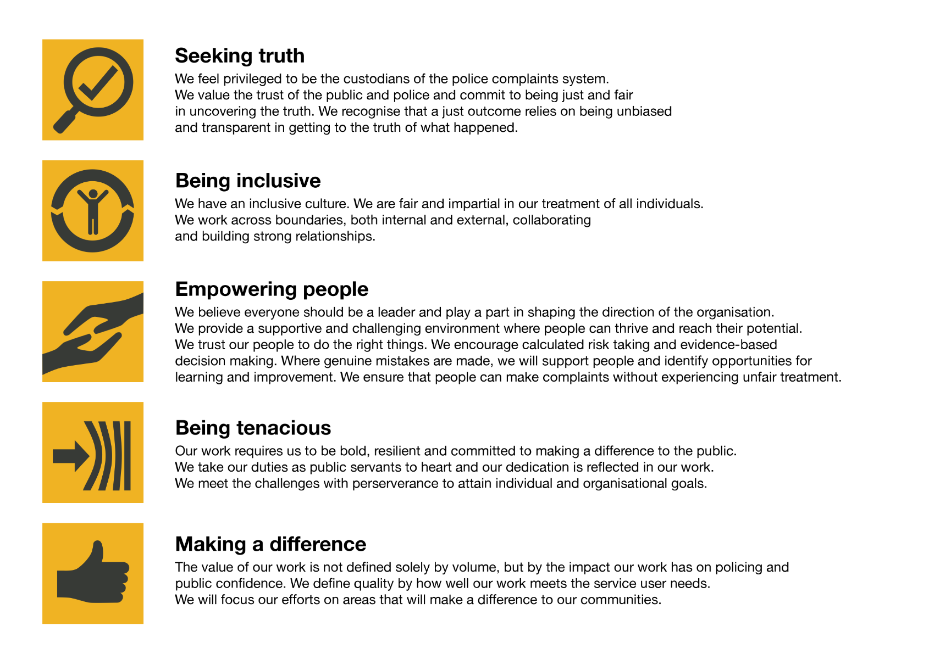We work in the context of our agreed values which inform the way we do things at the IOPC. The Lead Investigator will need to be commited to managing in the context of these values.

The IOPC is committed to **promoting equality and valuing diversity** in everything we do. Our vision is to be, and to be seen as, a leader in inclusive employment and services, demonstrating this ethos in everything that we do.

* As a silver standard Stonewall employer, we continue to commit ourselves to being a LGBTQ+ employer through the work of our Pride LGBTQ+ Staff Network, creating welcoming environments for lesbian, gay, bi and queer people.
* We are pleased to share we are a signatory of the Business in the Community Race at Work Charter. The Charter is composed of five [calls to action](https://race.bitc.org.uk/issues/racecharter) for leaders and organisations across all sectors.
* Being a Disability Confident employer, the IOPC is dedicated to removing the barrier for disabled people to thrive in the workplace.
* Our Staff Networks are constantly working to make the IOPC the leaders of inclusive employment, from our Allyship Programme, to [Welsh Language Standards](https://www.policeconduct.gov.uk/who-we-are/equality-and-diversity/welsh-language-standards) and Know the Line Policy, we are constantly seeking new ways to create an environment for all to develop and thrive.

The IOPC is a diverse and inclusive workplace and we want to help you demonstrate your full potential whatever type of assessment is used. We are open to providing you with the tools you need to succeed, from extra time to formatting changes, to name a mere few. If you require any reasonable adjustments to our recruitment process, please email [campaigns@policeconduct.gov.uk](mailto:campaigns@policeconduct.gov.uk)

## Preparation checklist

☐ Review the full job description

☐ Review the behaviours and the descriptors for each behaviour

☐ Review the Strengths dictionary

☐ Review the IOPC values

☐ Consider your Strengths (if applicable)

☐ Consider drafting example answers that cover the specific elements

☐ Prepare some questions to ask the interviewers

**Selection process**

This vacancy is using [**Success Profiles**](https://www.gov.uk/government/publications/success-profiles?_ga=2.156185915.1692943174.1578577916-319911383.1576576754). As part of the application process you will be asked to complete a written statement of suitability (of up to a maximum of two pages of A4) explaining how you consider your personal experience, behaviours and values provide evidence of your suitability for the role, with particular reference to the:

* **Experience** set out in the criteria of the ***person specification,***
* **Values** of ***being tenacious*** and ***seeking truth***
* **Behaviour** of ***making effective decisions***

During the selection process, we will also assess you against the following Behaviour:

* **Communicating and Influencing**

If successful at application stage, you will be invited to a telephone interview with further steps to be confirmed if successful following this stage.

Please note that your application for this role will purely be assessed against the information you provide in your statement of suitability. Other information provided at application stage, such as work history, will not be considered as part of the marking criteria. We ask that you ensure you provide sufficient details to demonstrate your suitability for the role within your statement of suitability.

Should your application be successful and you are invited to a telephone interview, the interviewers will use your statement of suitability as part of the interview. This further demonstrates the importance of providing an extensive insight of your knowledge, skills and experience during your statement to help you meet the success profiles you will be measured against.