**Job description**

**Title: Executive Support to the Director General**

**Reports to: Chief of Staff**

**Location: Canary Wharf (with frequent national travel)**

**Grade: 11**

**Salary: £42,564 (base salary of £37,596 plus £4,968 London Weighting Allowance)**

**Contract: Permanent**

# Purpose

As an Executive Support to the Director General, you will be welcomed into a dynamic and inclusive team providing high level confidential support to the Director General’s office. The IOPC is on a journey to develop its culture, perspectives and ethos to support the organisation’s core outcomes and this is your opportunity to enter into the varied world of IOPC Executive Support, allowing you to develop your mindset and approaches to contribute to improving the police complaints system in England and Wales.

**In this role you will:**

Provide high level confidential support to the Director General and Chief of Staff by providing a full secretariat and administrative service.

Contribute and support to the work of the Director General’s Office, ensuring that it operates efficient and effective administrative systems and tasks are completed in a timely manner.

Work collaboratively with management board members, and other leaders to support the one ‘IOPC’ approach.

# A screenshot of a computer screen Description automatically generatedOrganisational context

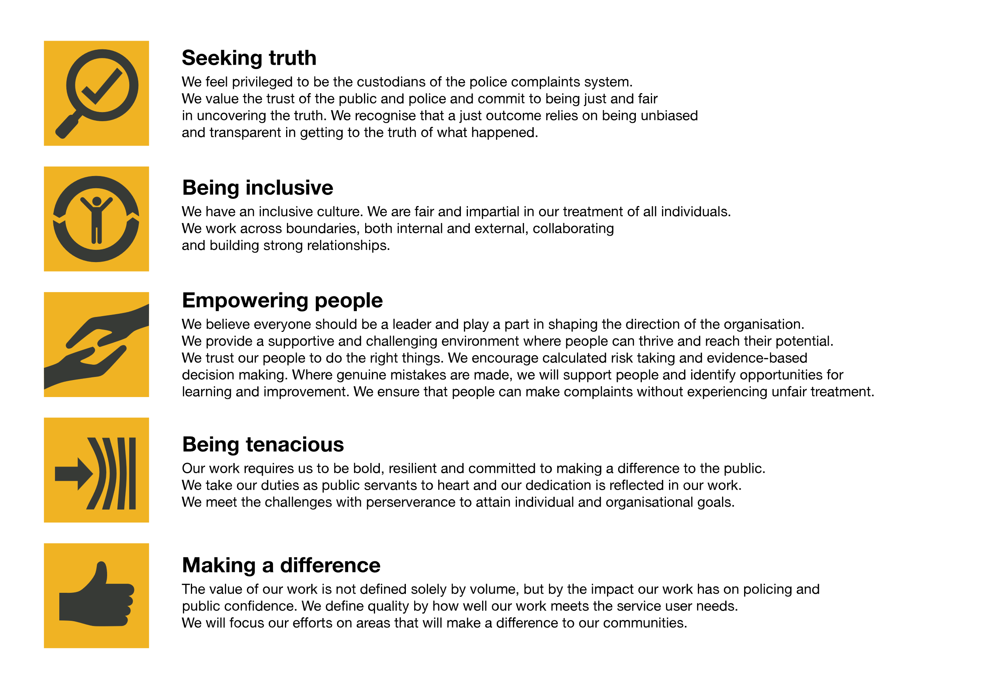We work in the context of our agreed values which inform the way we do things at the IOPC. The Executive Support to the Director General will need to be commited to managing in the context of these values.

The IOPC is committed to **promoting equality and valuing diversity** in everything we do. Our vision is to be, and to be seen as, a leader in inclusive employment and services, demonstrating this ethos in everything that we do.

* As a silver standard Stonewall employer, we continue to commit ourselves to being a LGBTQ+ employer through the work of our Pride LGBTQ+ Staff Network, creating welcoming environments for lesbian, gay, bi and queer people.
* We are pleased to share we are a signatory of the Business in the Community Race at Work Charter. The Charter is composed of five [calls to action](https://race.bitc.org.uk/issues/racecharter) for leaders and organisations across all sectors.
* Being a Disability Confident employer, the IOPC is dedicated to removing the barrier for disabled people to thrive in the workplace.
* Our Staff Networks are constantly working to make the IOPC the leaders of inclusive employment, from our Allyship Programme to [Operation Hotton](https://www.policeconduct.gov.uk/recommendations/operation-hotton-recommendations-metropolitan-police-service-september-2021), to [Welsh Language Standards](https://www.policeconduct.gov.uk/who-we-are/equality-and-diversity/welsh-language-standards) and Know the Line Policy, we are constantly seeking new ways to create an environment for all to develop and thrive.

# Main duties and responsibilities

1. To act as a first point of contact for the office of the Director General

2. To proactively manage and coordinate the diary of the Director General and Chief of Staff by prioritising and arranging internal and external meetings, as directed, and as and when necessary.

3. Undertake specific projects on behalf of the Director General and provide all necessary support for activities.

4. Plan and organise travel and accommodation as and when required for the Director General and Chief of Staff.

5. To liaise with key stakeholders on behalf of the Director General and Chief of Staff.

6. Maintain effective digital filing, records and data storage including emails and retrieval systems in compliance with organisational policy and ensuring the needs of the Director General and Chief of Staff are met.

7. Organise and forward plan the work of the Director General’s office.

8. Support the work of the Deputy Chief of Staff by gathering and collating information from across the organisation to facilitate the production of briefings and reports for the Director General Office.

9. To provide full secretarial support by signposting as appropriate and dealing with correspondence and calls, as directed by the Chief of Staff.

10.Draft letters and responses to a high standard, collate agendas, minute meetings, follow up actions and other administrative tasks as required to support the Director General’s office.

11.To plan and manage key organisational events as directed by the Chief of Staff.

12.To contribute to the development of the Director General’s office by creating efficient working systems and processes to enable a professional working environment.

13.Always demonstrate a “can-do” attitude with commitment to the equality, diversity and inclusion aims and strategy of the IOPC, as well as the values and behaviours.

14.To undertake any other duties that are commensurate with the effective running of the Director General office.

# Person specification

## Essential Experience

• Experience of providing high-level administrative support in a senior role.

• Experience of providing support to a Director General / Chief Executive or similarly high-level job role.

• Excellent, administrative skills including the ability to identify administrative needs and develop and maintain appropriate systems to meet them.

• Experience of managing and planning projects, conferences, and events.

## Essential Skills

• Ability to work collaboratively with colleagues and a range of stakeholders.

• Ability to convey information to people clearly and simply.

• High level of attention to details.

• Ability to forward plan and manage a complex and busy diary.

• Ability to take accurate minutes, including being able to interpret and sum up complex discussions concisely.

• Ability to draft routine correspondence and reports.

• Ability to maintain accuracy and attention to detail.

• Good negotiation skills.

• Excellent interpersonal and communication skills including diplomacy.

• Excellent time management skills with the ability to manage multiple priorities and deadlines.

• Excellent knowledge of Microsoft Office.

• Able to focus for long periods of time and prioritise and work under frequent pressure with tight and challenging deadlines.

## Knowledge and Qualifications

**Qualifications:**

• Evidence of continuing personal and professional development.

**Knowledge:**

• Good understanding of administrative and secretarial practices.

• Knowledge of office management processes and procedures.

## Reasonable adjustments

The IOPC is a diverse and inclusive workplace and we want to help you demonstrate your full potential whatever type of assessment is used. We are open to providing you with the tools you need to succeed, from extra time to formatting changes, to name a mere few. If you require any reasonable adjustments to our recruitment process, please email [recruitment@policeconduct.gov.uk](mailto:recruitment@policeconduct.gov.uk)

## Working conditions

## • The postholder must be able to spend the majority (60 – 80%) of their contractual hours working in-person, in Canary Wharf due to nature of the job role.

## • The postholder must be able to work flexibly to meet the demands of the job role. This means at times longer days including early starts and late finish.

## • The postholder must be able and willing to travel all IOPC locations, and external stakeholder locations, as and when required

## Preparation checklist

☐ Review the full job description

☐ Review the behaviours and the descriptors for each behaviour

☐ Review the Strengths dictionary

☐ Review the IOPC values

☐ Consider your Strengths (if applicable)

☐ Consider drafting example answers that cover the specific elements

☐ Prepare some questions to ask the interviewers