**Job description**

**Title: Internal Communications Officer**

**Reports to: Internal Communications Manager**

**Location: Birmingham, Canary Wharf, Cardiff, Croydon, Sale or Wakefield**

**Grade: 10**

**Salary: £32,600 per annum (plus £4731 London Weighting, if applicable)**

**Contract: Permanent**

# Purpose

As an Internal Communications Officer you will be welcomed into a dynamic and inclusive Strategy and Impact directorate. The IOPC is on a journey to develop its culture, perspectives and ethos to support the organisation’s core outcomes and this is your opportunity to enter into the varied world of IOPC Internal Communications, allowing you to develop your mindset and approaches to contribute to improving the police complaints system in England and Wales.

The Internal Communications Officer will support the development and deployment of internal communications strategies aimed at engaging a geographically dispersed and diverse workforce. They will deploy change communications and engagement strategies and opportunities at a time of considerable change for the organisation through our Transformation Programme and work with colleagues across the business on staff engagement initiatives.

# Organisational context

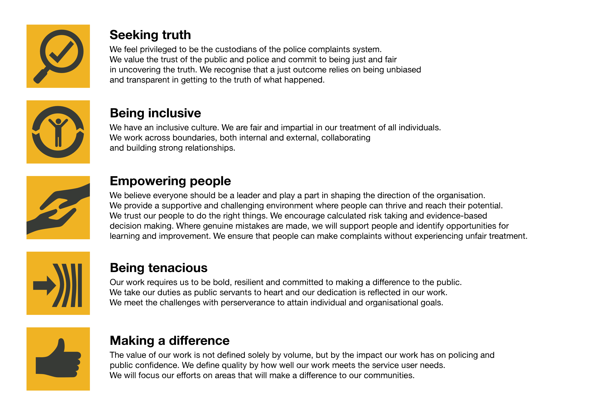We work in the context of our agreed values which inform the way we do things at the IOPC. The Internal Communications Officer will need to be commited to managing in the context of these values.

The IOPC is committed to **promoting equality and valuing diversity** in everything we do. Our vision is to be, and to be seen as, a leader in inclusive employment and services, demonstrating this ethos in everything that we do.

* As a silver standard Stonewall employer, we continue to commit ourselves to being a LGBTQ+ employer through the work of our Pride LGBTQ+ Staff Network, creating welcoming environments for lesbian, gay, bi and queer people.
* We are pleased to share we are a signatory of the Business in the Community Race at Work Charter. The Charter is composed of five [calls to action](https://race.bitc.org.uk/issues/racecharter) for leaders and organisations across all sectors.
* Being a Disability Confident employer, the IOPC is dedicated to removing the barrier for disabled people to thrive in the workplace.
* Our Staff Networks are constantly working to make the IOPC the leaders of inclusive employment, from our Allyship Programme to [Operation Hotton](https://www.policeconduct.gov.uk/recommendations/operation-hotton-recommendations-metropolitan-police-service-september-2021), to [Welsh Language Standards](https://www.policeconduct.gov.uk/who-we-are/equality-and-diversity/welsh-language-standards) and Know the Line Policy, we are constantly seeking new ways to create an environment for all to develop and thrive.

# Main duties and responsibilities

* Deliver the internal communications strategy to support the corporate strategy for the IOPC – include the Transformation Programme and business as usual activity.
* Write clear, persuasive and creative copy for a variety of internal and external audiences.
* Edit copy provided by non-communications colleagues according to plain English and house style principles.
* Use a range of channels to deploy internal communications across the IOPC to build effective networks across the IOPC’s offices in England and Wales.
* Provide internal communications advice to colleagues at all levels to ensure that key messages are communicated effectively to all staff using a range of channels.
* Evaluate the success of internal communications campaigns.
* Ensure that internal and external communications are aligned - to support staff to be effective ambassadors for the IOPC.
* Manage and monitor the internal communications channels to keep them up-to-date and collect their data and analytics to inform internal communication decisions.
* Provide administrative support to the team.

# Person specification

## Essential Experience

* Experience in an internal communications/communications role within a large organisation.
* Experience of developing and implementing internal communications plans that engage staff.
* Experience of using a range of communications channels, including online and digital platforms.
* Experience of drafting clear, concise targeted messages.
* Ability to work under pressure to tight deadlines and juggle a range of priorities.
* Strong written and verbal communications skills, combined with an attention to detail.
* Excellent interpersonal skills and the ability to deal confidently with people at all levels using persuasive skills when necessary.
* A flexible, proactive and creative approach.
* Ability to handle sensitive material with tact and diplomacy.

## Reasonable adjustments

The IOPC is a diverse and inclusive workplace and we want to help you demonstrate your full potential whatever type of assessment is used. We are open to providing you with the tools you need to succeed, from extra time to formatting changes, to name a mere few. If you require any reasonable adjustments to our recruitment process, please email [humanresources@policeconduct.gov.uk](mailto:humanresources@policeconduct.gov.uk)

## Working conditions

Making the IOPC a great place to work is one of our key priorities. We are pleased to offer a unique hybrid working model based on business needs, balanced with the needs of our colleagues. Our business need framework guides our decisions about when it is best to work onsite (in our offices or other appropriate locations) to complete tasks most effectively or when to work remotely, offering colleagues flexibility to work where they feel most productive and supporting work-life balance. The model also encourages staff to feel welcome at the IOPC by ensuring we have opportunities to work face-to-face as teams.

## Preparation checklist

☐ Review the full job description

☐ Review the behaviours and the descriptors for each behaviour

☐ Review the Strengths dictionary

☐ Review the IOPC values

☐ Consider your Strengths

☐ Consider drafting example answers that cover the specific elements

☐ Prepare some questions to ask the interviewers