**Job description**

**Title: Facilities Coordinator**

**Reports to: Head of Estates and Facilities Management**

**Location: Birmingham**

**Grade: 11**

**Salary: £37,596**

**Contract: Permanent**

# Purpose

The role will report to the Head of Estates and FM and will oversee the co-ordination and delivery of facilities services to the IOPC offices. This will involve overseeing the operation of FM processes and software (helpdesk/room booking/record keeping) and security systems (including follow up and resolution of all issues and incidents as appropriate), local facilities related procurement, financial record keeping and day to day provision of goods & services.

In addition the role will provide day to day line management of the office facilities management team, oversee building maintenance and cleaning (including contract management) and assist with H&S and security compliance, including: induction, training, briefings, monitoring reports and risks assessments, plus local hard copy / case file record keeping / archiving, office moves & relocations.

The role will also be responsible for assisting with FM budget management and taking a leading role in FM Projects as they arise. The role will also assist with Business Continuity Planning and delivery and providing some support to other teams within the Resources Directorate when required.

The role will manage the FM team in their office.

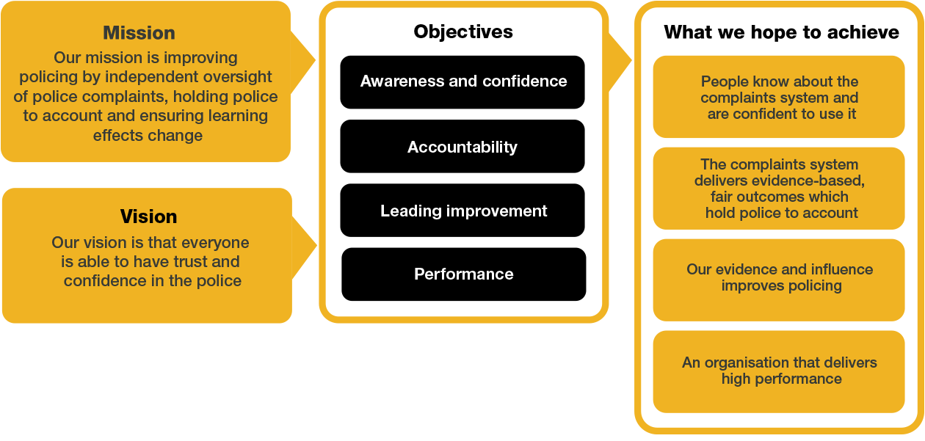Organisational context

We work in the context of our agreed values which inform the way we do things at the IOPC. The Facilities Coordinator will need to be commited to managing in the context of these values.

# Main duties and responsibilities

1. Managing and setting up processes as required to ensure that the offices operate efficiently.
2. To oversee the management all FM services at the office and line manage the onsite FM team.
3. To oversee day to day operation of FM Helpdesk and ensure that local FM staff process and resolve calls promptly, that customers are kept updated and any significant issues are reported upwards to the Head of Estates and FM
4. Manage all relevant external contractors including where relevant HOPG/MOJ FM service delivery contracts. To arrange attendance, progress works and manage delivery, ensuring high levels of service delivery at all times. Escort and supervise external contractors as required.
5. Oversee the processing of FM invoices ensuring processes and documentation are completed within guidelines and targets. To maintain accurate information on spreadsheets to be submitted to Head of Estates and FM.
6. Manage the specific office budget including regular monthly meetings with Finance team to review progress, reforecast and agree any under/overspends, variances and actuals as required with the Head Estates and FM
7. Collate and monitor local data required for IOPC’s sustainability reporting, leading on local environmental issues
8. Responsibility for day to day office security and provide guidance to onsite teams as required. Ensuring staff are aware of opening and locking up and emergency procedures and out of hour processes. Ensure day to day operation and monitoring of the security systems, following up incidents and producing reports as required.
9. Assist with the development and implementation of business continuity and disaster recovery in conjunction with Head of Estates and FM
10. Arrange repair of office equipment (such as printers, photocopiers etc.) engaging with suppliers and engineers and resolving problems as they occur.
11. Assist with the sourcing and tendering/procurement of suppliers for FM consumables/equipment/services, ensuring best value and compliance with procurement procedures. Arrange local contract review meetings and follow up on any relevant issues, escalating issues to Head of Estates and FM where requiired
12. Working with the Head of Estates and FM to provide the full range of FM support services.
13. Ensure that FM staff raise purchase orders, and record financial transactions as required and within financial/procurement guidelines.
14. Lead office building projects to include: liaising with external contractors, drafting and agreeing construction project plans Health and Safety info. Engaging with managers and staff in office to ensure minimum disruption to office.
15. Provide support to Health & Safety Manager in the delivery of Health & Safety compliance across the organisation.
16. Provide FM support in designated FM Projects.
17. Any other Facilities Management tasks as required including ad-hoc cover at other locations where necessary and adhoc guidance on FM relevant policy reviews

NB: This post will require:

* Some manual handling
* Some out of hours working will be necessary
* Some travel between IOPC offices

# Person specification

1. Management of FM projects, works and installations.
2. Experience of working busy medium/large organisation in a facilities environment.
3. Experience of dealing with staff at all levels verbally and in writing both internally and externally
4. Experience of managing staff
5. Awareness of public sector procurement processes.
6. Experience of managing contracts for goods and services and renegotiating as required.
7. Experience of supervising Evacuation Wardens & First Aiders
8. Experience of producing spreadsheets/financial information and contributing to the budget setting/monitoring process
9. Experience of organising and supervising internal office moves and reorganisations.
10. Experience of overseeing the maintenance of a broad range of office equipment.
11. Experience of overseeing the maintenance of buildings and plant.
12. Ability to work on own initiative and as part of a team.
13. Experience of implementing H&S Policy.
14. IOSH (Managing safely) qualified or prepared to work towards.

DESIRABLE EXPERIENCE

1. BIFM Level 4, or working towards this.

# Our Values

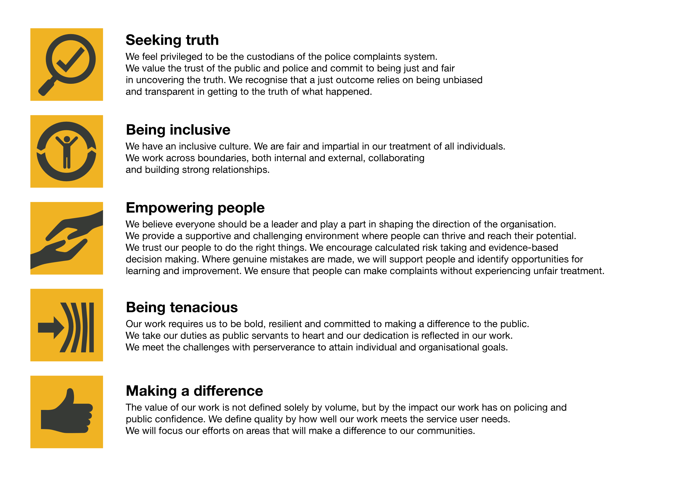

The IOPC is committed to **promoting equality and valuing diversity** in everything we do. Our vision is to be, and to be seen as, a leader in inclusive employment and services, demonstrating this ethos in everything that we do.

* As a silver standard Stonewall employer, we continue to commit ourselves to being a LGBTQ+ employer through the work of our Pride LGBTQ+ Staff Network, creating welcoming environments for lesbian, gay, bi and queer people.
* We are pleased to share we are a signatory of the Business in the Community Race at Work Charter. The Charter is composed of five [calls to action](https://race.bitc.org.uk/issues/racecharter) for leaders and organisations across all sectors.
* Being a Disability Confident employer, the IOPC is dedicated to removing the barrier for disabled people to thrive in the workplace.
* Our Staff Networks are constantly working to make the IOPC the leaders of inclusive employment, from our Allyship Programme, to [Welsh Language Standards](https://www.policeconduct.gov.uk/who-we-are/equality-and-diversity/welsh-language-standards) and Know the Line Policy, we are constantly seeking new ways to create an environment for all to develop and thrive.

## Reasonable adjustments

The IOPC is a diverse and inclusive workplace and we want to help you demonstrate your full potential whatever type of assessment is used. We are open to providing you with the tools you need to succeed. Whilst this list is not exhaustive, please see potential reasonable adjustments below that we can provide:

* Extra time for presentations or interview questions
* Formatting changes such as colours for text or background on written assignments
* Questions presented in writing during interviews

If you require any reasonable adjustments to our recruitment process, please email recruitment@policeconduct.gov.uk

## Working conditions

Making the IOPC a great place to work is one of our key priorities. This role currently offers the opportunity to work 4 days in the office and 1 day from home.

Here at the IOPC, maintaining a culture that is accessible and inclusive of gender identity, sexuality, age, disability, race, sex, belief and caring responsibilities is deeply important to us. We believe that a rich, diverse workforce enables us a better understanding of each others needs, and produces more meaningful and trusting relationships, which in turn create more inclusive spaces where we all feel that we can contribute and belong.  We value our diversity, as we believe that our diversity is our strength. It allows us to identify with our communities through shared lived experiences producing better understanding and higher quality results in our work.

# What we offer

* 27.5 days paid annual leave (increasing with service to 32.5 days)
* Options to carry over, buy or sell annual leave
* Civil Service pension
* Civil Service maternity leave package
* PAM employee assistance programme
* Access to Civil Service Sports Council (CSSC) membership
* Cycle to work scheme
* Opportunity to enjoy the latest home and electronics in a more affordable way provided by Vivup
* Car Leasing Scheme
* Staff networks focused on each of the protected characteristics – run for staff, by staff:
* Age Network
* Enable Network
* Welsh Network
* Pride and LGBTQI+ Network
* Sex and Family Network
* Race, Religion and Belief Network
* Learning and development tailored to your role
* An environment with flexible working options
* A culture encouraging inclusion and diversity behaviours

## Preparation checklist

☐ Review the full job description

☐ Review the behaviours and the descriptors for each behaviour

☐ Review the Strengths dictionary

☐ Review the IOPC values

☐ Consider your Strengths

☐ Consider drafting example answers that cover the specific elements

☐ Prepare some questions to ask the interviewers