**Job description**

**Title:**  Record Manager – Archiving Lead

**Reports to:** Record Manager Lead

**Location:** Warrington

**Grade:** 12

**Salary:** £41,878 per annum

**Contract:** Full time Permanent

# Purpose

As the IOPC Archive Lead, you will be welcomed into a dynamic and inclusive records management team leading the archiving strand of our Record Management processes. This role is suitable for experienced managers who specialise in the archiving stages of the data lifecycle. The role is suited to those with experience of delivering Public Records Act responsibilities and leading transfers to archiving repositories, including The National Archives. The role overseas the delivery of our busy and complex archiving functions; relating to the Hillsborough Stadium Disaster of 1989 and our wider IOPC information and data archiving requirements. You will be part of the Data and Information function within our DDaT services.

You will lead the delivery of the IOPC archiving requirements supported by the Archivist team. You will lead all aspects of your team’s effectiveness through delivery planning and scheduling of work and undertaking quality assurance, as well overseeing cataloguing and sensitivity review work. You will lead on engagement with off site Archiving, including applications to Advisory Panels and agreeing transfer processes.

As a Public Records Act Officer within the IOPC you can expect to work in a progressive and dynamic organisation with declared and strong core values. These values influence our plans, service delivery and engagement with complainants, the police and all our stakeholders.

**Role Description**

To work within IOPC Data and Information function to enable the effective data management for archiving of;

* IOPC investigations and materials in relation to our role overseeing the Police complaints process.
* Material relating to the Hillsborough Stadium Disaster of 1989

**Role Description**

To lead the work within IOPC managing the archiving aspects of the data lifecycle. The post holder be the general manager of archive material, conducting and delegating the functions needed for the PRA requirements for our business including the Hillsborough legacy activity.

# Organisational context

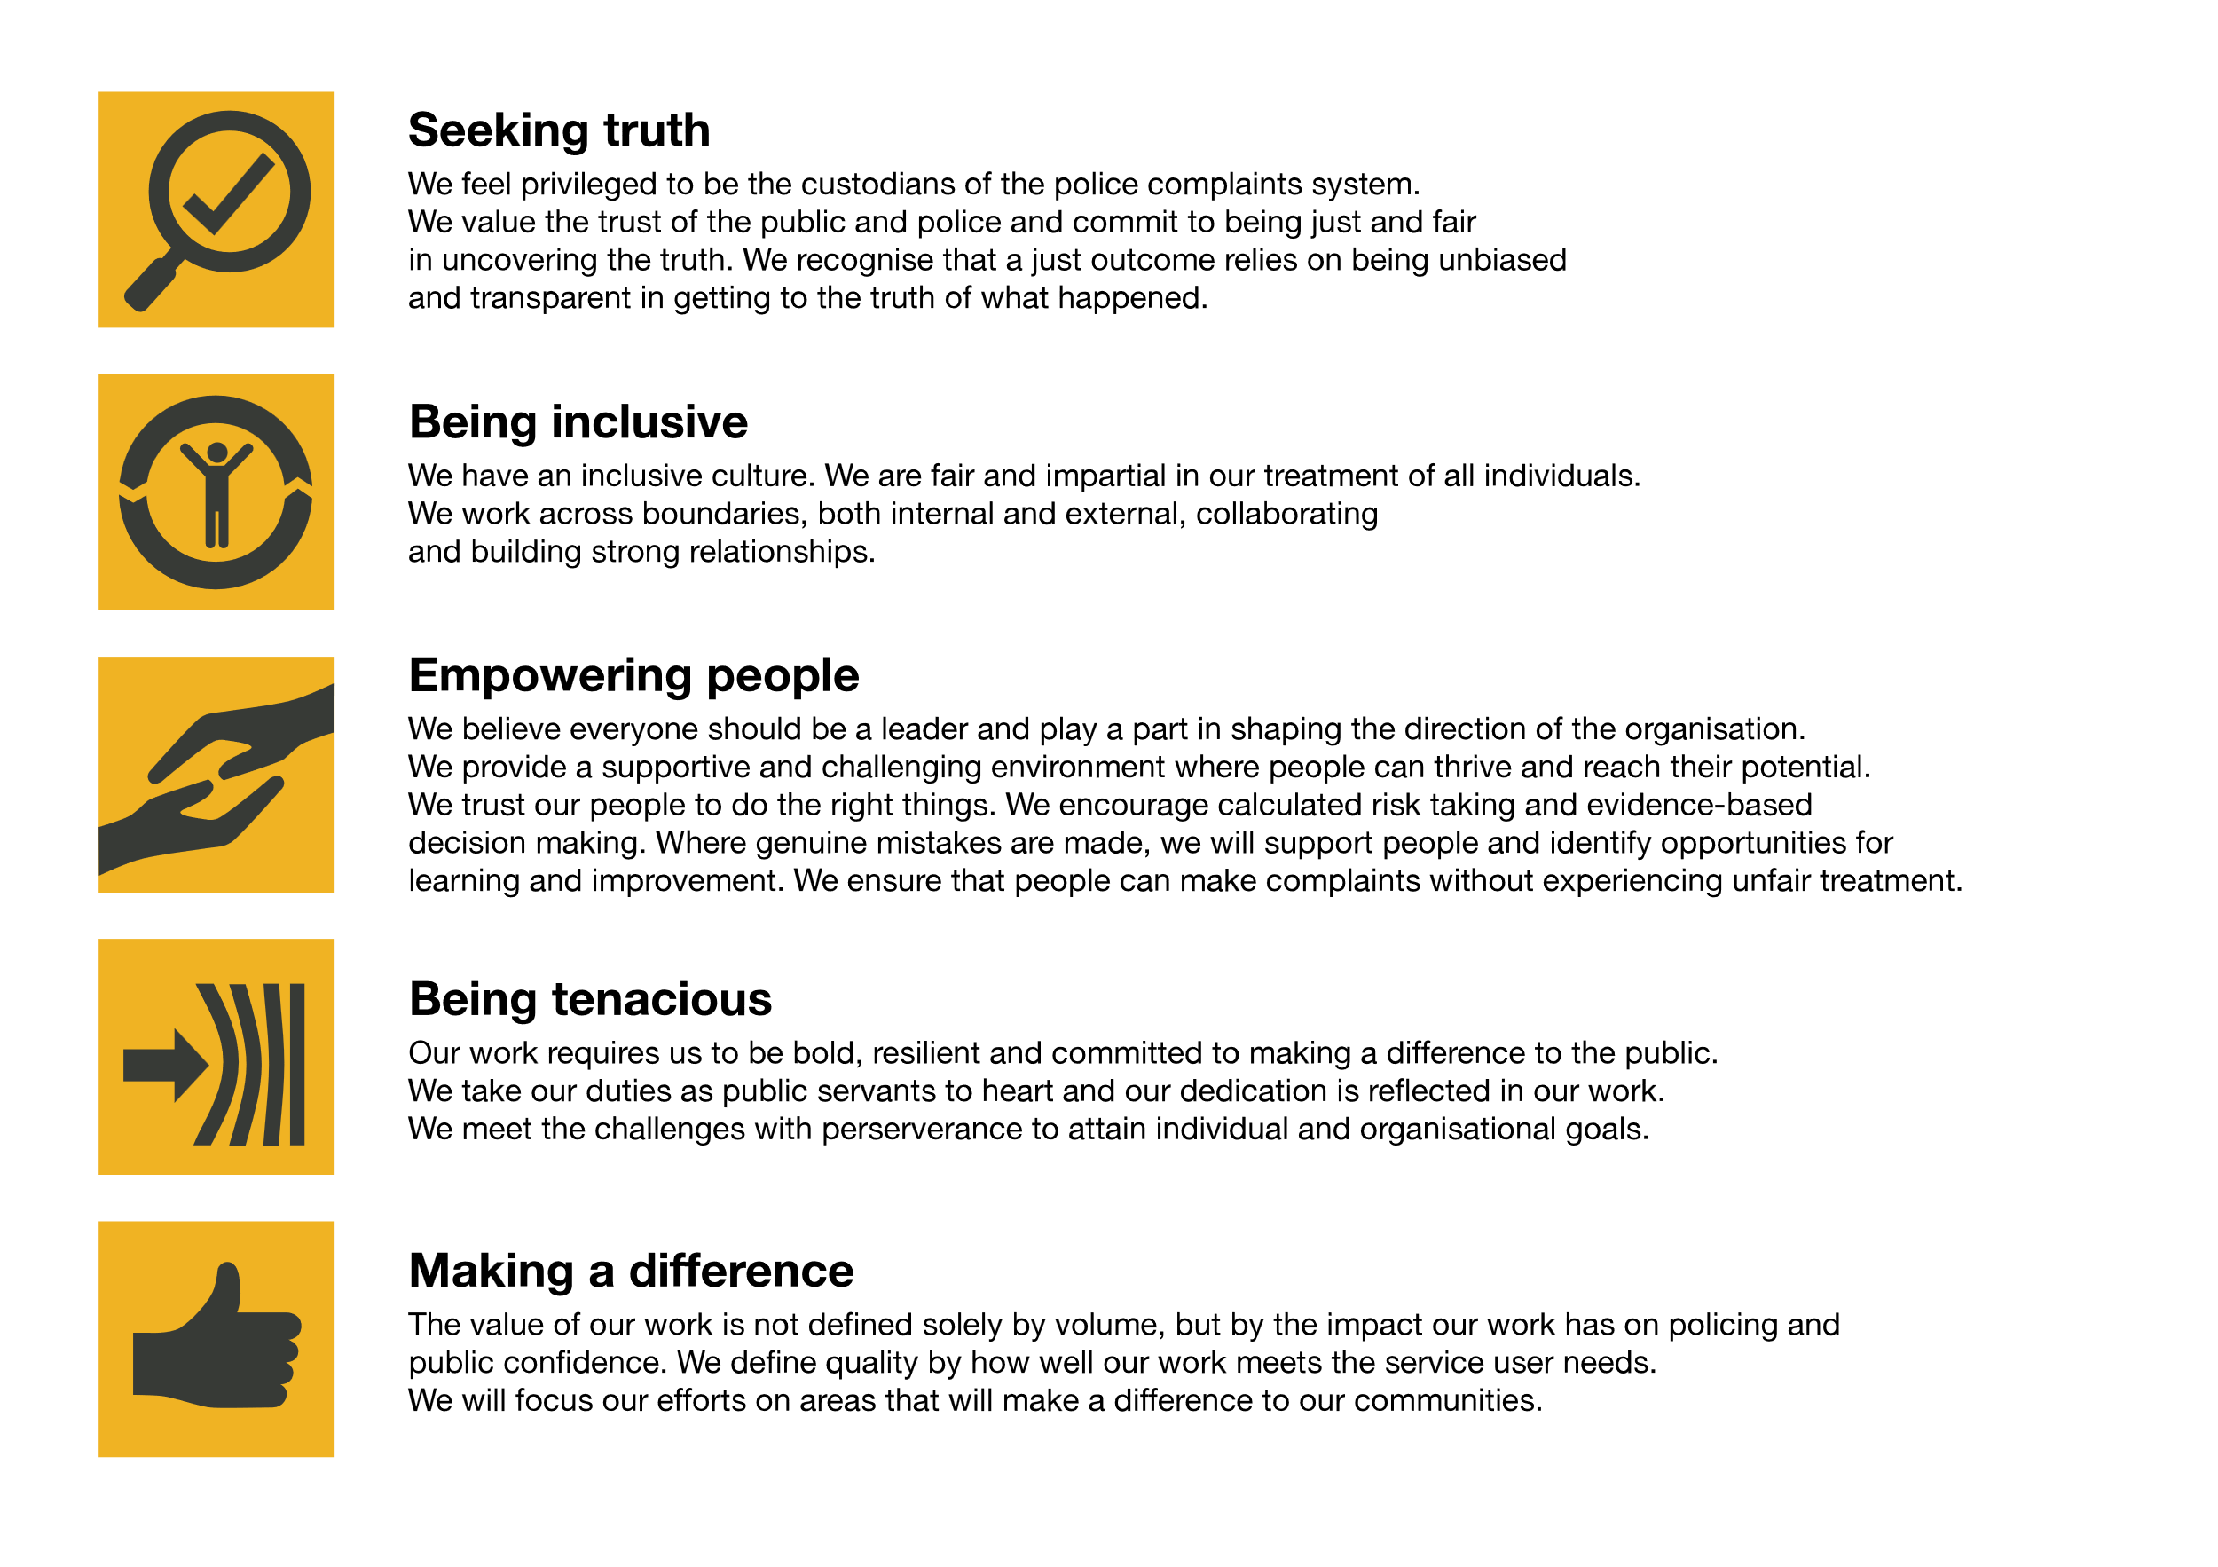We work in the context of our agreed values which inform the way we do things at the IOPC. The Archive Lead will need to be commited to managing in the context of these values.

The IOPC is committed to **promoting equality and valuing diversity** in everything we do. Our vision is to be, and to be seen as, a leader in inclusive employment and services, demonstrating this ethos in everything that we do.

* As a silver standard Stonewall employer, we continue to commit ourselves to being a LGBTQ+ employer through the work of our Pride LGBTQ+ Staff Network, creating welcoming environments for lesbian, gay, bi and queer people.
* We are pleased to share we are a signatory of the Business in the Community Race at Work Charter. The Charter is composed of five [calls to action](https://race.bitc.org.uk/issues/racecharter) for leaders and organisations across all sectors.
* Being a Disability Confident employer, the IOPC is dedicated to removing the barrier for disabled people to thrive in the workplace.
* Our Staff Networks are constantly working to make the IOPC the leaders of inclusive employment, from our Allyship Program to [Welsh Language Standards](https://www.policeconduct.gov.uk/who-we-are/equality-and-diversity/welsh-language-standards) and Know the Line Policy, we are constantly seeking new ways to create an environment for all to develop and thrive.

# Main duties and responsibilities

* To lead the Archiving team to all aspects of the archiving requirements of the data lifecycle. Including delivery of cataloguing, sensitivity review, redaction processes for physical and digital files, file preparation and transfer processes to meet the Public Records Act standards and IOPC delivery schedules
* To lead the archivist team including allocating and quality assuring their work to deliver and efficient and effective service.
* To deliver the IOPC requirements for preservation of digital and physical materials requirements within archiving including specialist advice on preservation and digitisation where appropriate
* To develop and deliver in training awareness for the IOPC teams in relevant processes related to the Public Records Act
* To ensure a wide range of stakeholders can easily navigate the IOPC generated archives by developing detailed indexes and descriptions against agreed naming conventions, with clear glossary and taxonomy.
* Lead in the development of policies relating to the archiving management of records in addition to internal policies such as Salvage Recovery Plans and Business Continuity plans.
* To ensure at all times that information contained within the collection is managed lawfully under the terms of the Data Protection 2018 and Freedom of Information Acts.
* To work cooperatively, communicate and consult with appropriate colleagues within the IOPC investigations directorate and build effective working relationships.
* Any other relevant duties appropriate to the grade as may be required.
* All duties and responsibilities should be carried out in accordance with agreed IOPC policies and procedures.

# Person specification

## Essential

* Extensive Experience of leading Organisational compliance with the Public Records Act, including cataloguing standards, developing or leading sensitivity reviews, redaction, file preparation and preservation.
* A minimum of 1 year archiving management level employment, post graduate experience or equivalent.
* Supervisory experience of leading team delivery of the development and embedding of archiving requirements of data lifecycle management including transfer processes to TNA or similar.
* Knowledge of relevant legislation, standards and procedures in relation to collections management, including the Public Records Act, and Copyright Act
* Experience of managing archival collections to recognised environmental standards and managing and performing tasks to ensure the preservation of collections
* Experience of project management including archive digitisation projects.
* Experience of working to tight deadlines and adjusting working practices accordingly.
* Experience of driving compliance of Data Protection and Freedom of Information requirements.
* Experience of working with discretion, confidentiality and sensitivity
* Postgraduate degree level, in Archive and Records Management or equivalent experience.

## Desirable

* Experience of working in an investigation and inquiry archiving environment
* Experience of working in a public sector archiving environment
* Experience of working directly with The National Archives
* Experience of use of HOLMES

## Reasonable adjustments

The IOPC is a diverse and inclusive workplace and we want to help you demonstrate your full potential whatever type of assessment is used. We are open to providing you with the tools you need to succeed, from extra time to formatting changes, to name a mere few. If you require any reasonable adjustments to our recruitment process, please email [recruitment@policeconduct.gov.uk](mailto:recruitment@policeconduct.gov.uk)

## Working conditions

The IOPC are currently consulting with our consultative bodies about proposed changes to our hybrid working policy which will require all staff to work 20% of their contractual hours at their office base (or another office for business reasons) from 1 September 2024 and will be increased to 40% from April 2025. Office attendance time includes in-person training, meetings with stakeholders and families, and attending events.

The model also encourages staff to feel welcome at the IOPC by ensuring we have opportunities to work face-to-face as teams.

## Preparation checklist

☐ Review the full job description

☐ Review the behaviours and the descriptors for each behaviour

☐ Review the Strengths dictionary

☐ Review the IOPC values

☐ Consider your Strengths (if applicable)

☐ Consider drafting example answers that cover the specific elements

☐ Prepare some questions to ask the interviewers