Job description
Title: Head of Finance
Reports to: Director of Finance and Corporate Services
Location: Any IOPC Office: Sale, Birmingham, Croydon, Canary Wharf, Wakefield, Warrington, Cardiff
Grade: 16
Salary: £71,347 plus London Weighting allowance of £4,731 if based in Croydon or Canary Wharf.
Contract: Permanent

Purpose
The IOPC is undertaking a major efficiency and productivity programme, enabled by new IT systems and in support of an ambitious five-year strategy. This in the context of rising demand and complexity of operational work and a challenging financial climate which means the IOPC must deliver more with fewer resources. Success of the programme relies on delivery of a new medium term financial strategy and delivery of financial benefits as well as delivery of ambitious new ICT and Data strategies.

As a Head of Finance, you will be welcomed into a dynamic and inclusive Finance Directorate working to ensure IOPC’s assets, funding, and cash flows are maximised, consistent with overall business objectives. The IOPC is on a journey to develop its culture, perspectives and ethos to support the organisation’s core outcomes and this is your opportunity to enter into the varied world of IOPC Finance, allowing you to develop your mindset and approaches to contribute to improving the police complaints system in England and Wales.

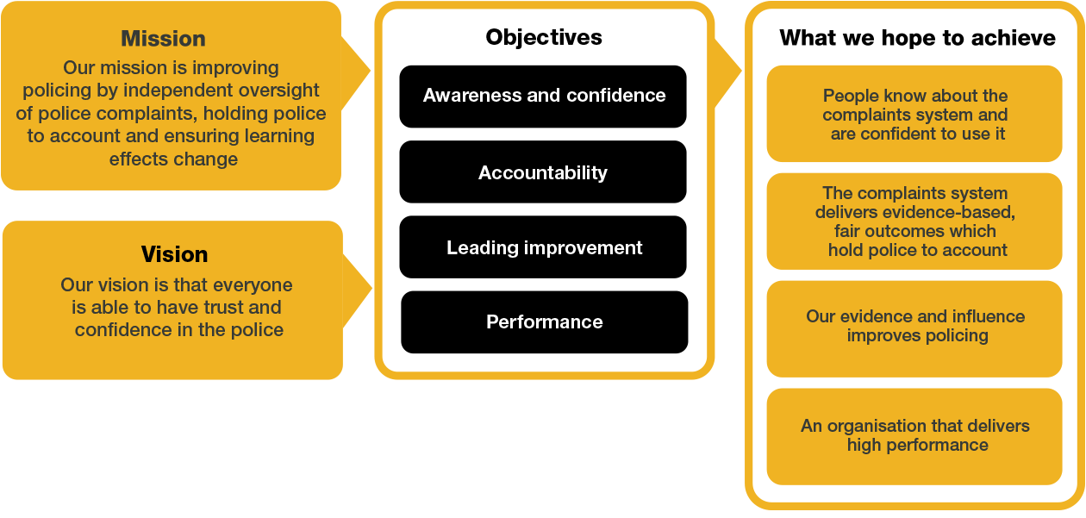
Organisational Context

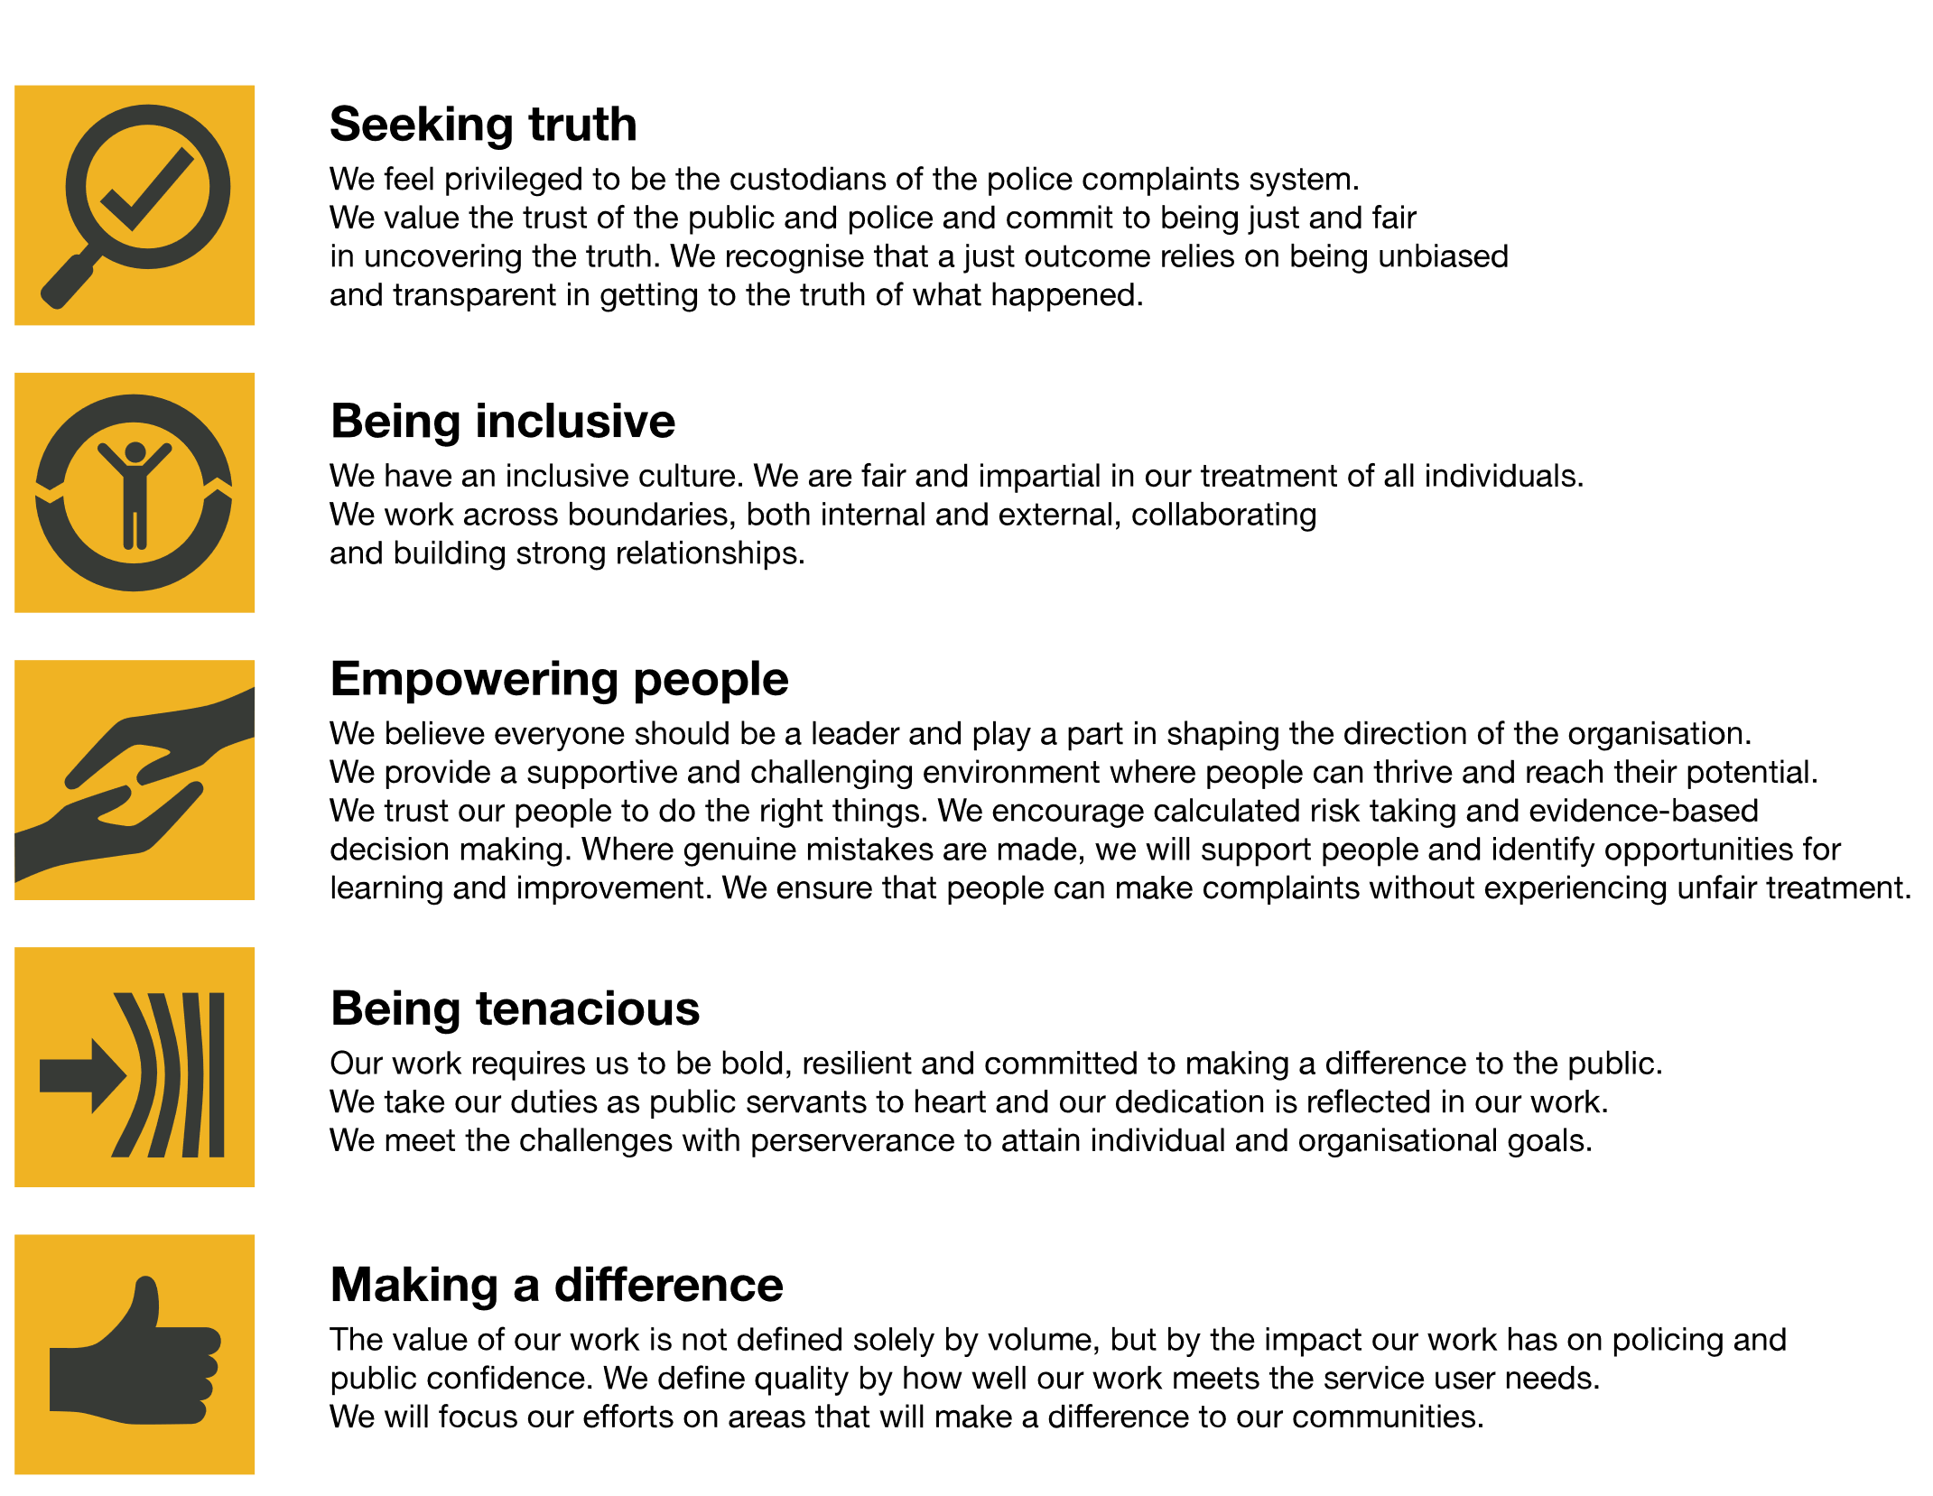
We work in the context of our agreed values which inform the way we do things at the IOPC. The Head of Finance will need to be commited to managing in the context of these values.
The IOPC is committed to promoting equality and valuing diversity in everything we do. Our vision is to be, and to be seen as, a leader in inclusive employment and services, demonstrating this ethos in everything that we do.
- As a silver standard Stonewall employer, we continue to commit ourselves to being a LGBTQ+ employer through the work of our Pride LGBTQ+ Staff Network, creating welcoming environments for lesbian, gay, bi and queer people.
- We are pleased to share we are a signatory of the Business in the Community Race at Work Charter. The Charter is composed of five calls to action for leaders and organisations across all sectors.
- Being a Disability Confident employer, the IOPC is dedicated to removing the barrier for disabled people to thrive in the workplace.
- Our Staff Networks are constantly working to make the IOPC the leaders of inclusive employment, from our Allyship Programme to Welsh Language Standards and Know the Line Policy, we are constantly seeking new ways to create an environment for all to develop and thrive.

Main duties and responsibilities
- Lead Finance function at senior level working closely with the team and functions across the IOPC.
- Prepare and implement plans for the provision and development of financial services to ensure IOPC’s assets, funding, and cash flows are maximised, consistent with overall business objectives.
- Work with colleagues to articulate and provide advice on the financial considerations with regards to change initiatives to deliver shared objectives and to support the IOPC to provide value for money services.
- Develop and maintain external relationships, working with senior stakeholders to ensure financial transparency of IOPC operations and to demonstrate adherence to best practice.
- Accountability for overseeing the delivery of financial reports in line with agreed requirements, ensuring the finance function consistently adds value to IOPC.
- Establish, develop, and monitor internal policies relating to financial systems and budgets, internalising controls on expenditure as set out by Cabinet Office and HMT.
- Assume responsibility for overseeing IOPC financial systems, engaging budget managers and other relevant stakeholders to drive understanding of financial considerations and management, and to contribute to high quality decision making across the IOPC.
- Provide leadership, management, and direction for a team of staff within the finance function to develop expertise and ensure compliance and effective delivery of services.
- Lead and oversee the development of annual financial accounting activity, working with budget holders and senior leaders to produce statutory accounts and contribute to the annual business planning process.
- Act as the lead technical expert and point of escalation for complex financial matters, providing high level technical advice and professional judgement to minimise financial risk for IOPC.
- Work with auditors to arrange and coordinate internal and external audits, meeting with the National Audit Office to provide IOPC annual accounts.
- Assume accountability for overseeing the delivery of financial reports in line with agreed requirements, ensuring the finance function consistently adds value to IOPC.
- Co-ordinate the response to requests from the Home Office and other central government departments where necessary
- Working closely with the Director of Finance and Corporate Services, to ensure that the statutory accounts are accurately prepared liaising with the Auditors as necessary.
- Provide appropriate assurances to the Director General in their role as Accounting Officer.

Key Contacts

- All staff across the Finance Directorate
- Director of Finance and Corporate Services
- Peers across Strategy and Corporate Services
- Risk and Audit Manager
- Head of Procurement
- Home Office Business Partners

Person specification
Qualifications

Essential
- An ACA or CIPFA qualified accountant or any equivalent accounting qualification

Desirable
- A Prince2 or MSP qualification

Essential

- Experience of leading finance function at senior level, ideally in a public sector organisation
- Sound understanding of public finance structures, preferably including relations between central government and Non-Departmental Public Bodies
- Demonstrable experience of supporting equality diversity and inclusion

Skills and Abilities
- Ability to think and act strategically, developing practical, innovative, and creative solutions to the management of strategic and complex problems.
- Ability to work collaboratively and at pace.
- Highly developed oral, written and presentation skills.
- Able to build effective relationships quickly and to influence and negotiate as needed

Positive Action
At the IOPC, we are committed to building a workforce which reflects the diversity of the communities in which we serve. A more inclusive workforce enables us to be a more effective and efficient organisation, better understand and respond to the needs of our communities.
Positive action as detailed in the Equality Act 2010, allows us to use measures designed to help improve equality in the workplace, and create a level playing field for all, whilst still employing everyone based on merit. Our workforce profile data shows that people who identify as black, Asian and minority ethnic are under-represented at the IOPC.
For this role – should we have a situation where multiple candidates have achieved the highest score and one identifies as black, Asian or minority ethnic, by using positive action, we can select that candidate for the role, therefore improving this area of under-representation at the IOPC. We will only use positive action in this way where the highest scoring candidates have all scored equally, at the final assessment stage, and above our required threshold.

Reasonable adjustments
The IOPC is a diverse and inclusive workplace and we want to help you demonstrate your full potential whatever type of assessment is used. We are open to providing you with the tools you need to succeed, from extra time to formatting changes, to name a mere few. If you require any reasonable adjustments to our recruitment process, please email campaigns@policeconduct.gov.uk

Working conditions
Making the IOPC a great place to work is one of our key priorities. We are pleased to offer a unique hybrid working model based on business needs, balanced with the needs of our colleagues. Our business need framework guides our decisions about when it is best to work onsite (in our offices or other appropriate locations) to complete tasks most effectively or when to work remotely, offering colleagues flexibility to work where they feel most productive and supporting work-life balance. The model also encourages staff to feel welcome at the IOPC by ensuring we have opportunities to work face-to-face as teams.
Here at the IOPC, maintaining a culture that is accessible and inclusive of gender identity, sexuality, age, disability, race, sex, belief and caring responsibilities is deeply important to us. We believe that a rich, diverse workforce enables us a better understanding of each others needs, and produces more meaningful and trusting relationships, which in turn create more inclusive spaces where we all feel that we can contribute and belong. We value our diversity, as we believe that our diversity is our strength. It allows us to identify with our communities through shared lived experiences producing better understanding and higher quality results in our work.

What we offer
- 27.5 days paid annual leave (increasing with service to 32.5 days)
- Options to carry over, buy or sell annual leave
- Civil Service pension
- PAM employee assistance programme
- Access to Civil Service Sports Council (CSSC) membership
- Cycle to work scheme
- Opportunity to enjoy the latest home and electronics in a more affordable way provided by our employee benefits scheme Vivup
- Car Leasing Scheme
- Staff networks focused on each of the protected characteristics – run for staff, by staff:
- Age Network
- Enable Network
- Welsh Network
- Pride and LGBTQI+ Network
- Sex and Family Network
- Race, Religion and Belief Network
- Learning and development tailored to your role
- An environment with flexible working options
- A culture encouraging inclusion and diversity behaviours

Preparation checklist
☐ Review the full job description
☐ Review the behaviours and the descriptors for each behaviour
☐ Review the Strengths dictionary
☐ Review the IOPC values
☐ Consider your Strengths (if applicable)
☐ Consider drafting example answers that cover the specific elements
☐ Prepare some questions to ask the interviewers

