Job description
Title: People Business Partner
Reports to: Deputy Head of People
Location: Birmingham, Cardiff, Canary Wharf, Croydon, Sale, Wakefield
Grade: 13A
Salary: £52,499 plus London Weighting £4,968 per annum if based in Canary Wharf or Croydon
Contract: Family Leave – 12 Month Contract

Purpose
As a People Business Partner, you will be welcomed into a dynamic and inclusive People & Change team working in partnership with senior managers and line managers to build strong and influential working relationships The IOPC is on a journey to develop its culture, perspectives and ethos to support the organisation’s core outcomes and this is your opportunity to enter into the varied world of IOPC People & Change, allowing you to develop your mindset and approaches to contribute to improving the police complaints system in England and Wales.
As People Business Partner you will adopt a proactive and responsive approach to the changing needs of the business. You will be integral to understanding the core business, bring insight, add value, and challenge the status quo, to ensure that management are supported to deliver their business objectives.
You will work alongside stakeholders to implement and embed the strategic People agenda for the business area of responsibility. To provide HR / employee relations expertise to the organisation and address all associated people matters in accordance with best practice, internal compliance, and legal requirements.
As People Business Partner you will maximise workforce effectiveness across your designated business area of responsibility, by coaching and mentoring managers to manage their people. To work in partnership with business leaders to ensure operational goals are achieved through effective people management and to maximise workforce performance through proactive support and advice to line managers. You will deliver the people strategy in area of responsibility and ensure that workforce planning is undertaken so that the business has the right people with the right skills in the right jobs.

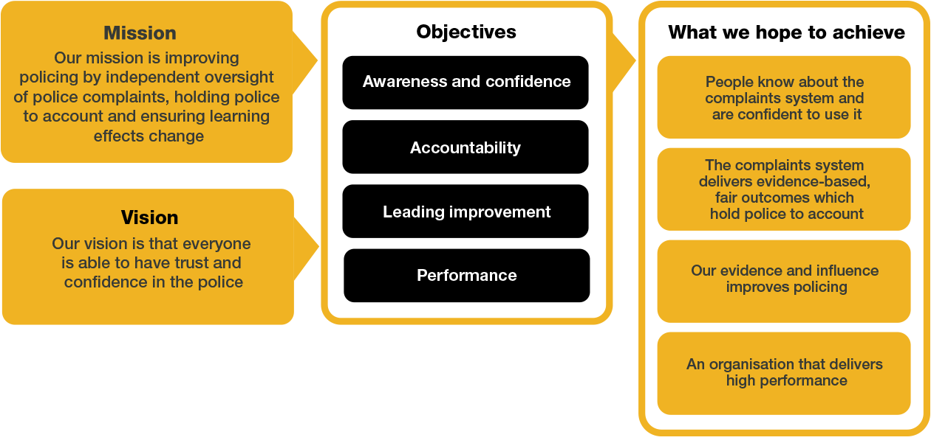
Organisational Context

We work in the context of our agreed values which inform the way we do things at the IOPC. The People Business Partner will need to be commited to managing in the context of these values.

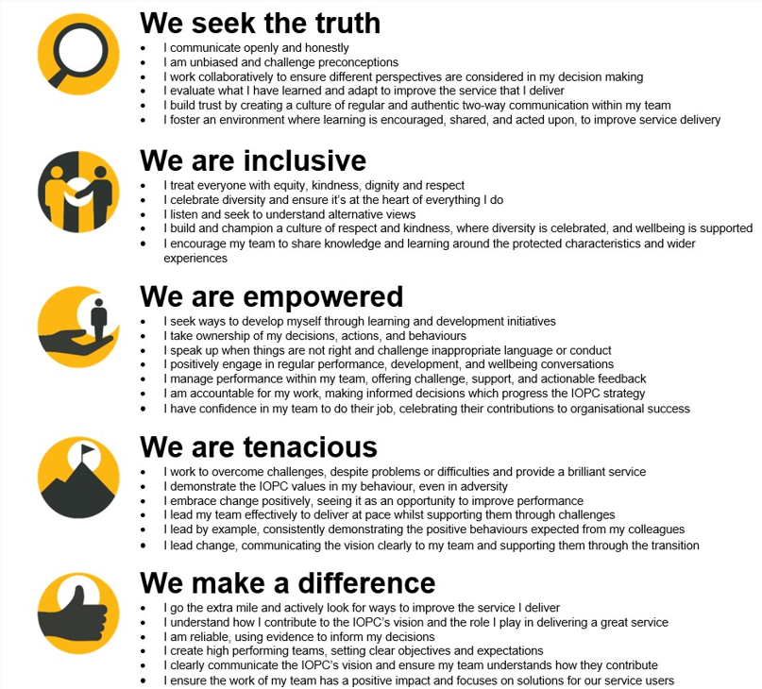

The IOPC is committed to promoting equality and valuing diversity in everything we do. Our vision is to be, and to be seen as, a leader in inclusive employment and services, demonstrating this ethos in everything that we do.
- We are pleased to share we are a signatory of the Business in the Community Race at Work Charter. The Charter is composed of five calls to action for leaders and organisations across all sectors.
- Being a Disability Confident employer, the IOPC is dedicated to removing the barrier for disabled people to thrive in the workplace.
- Our Staff Networks are constantly working to make the IOPC the leaders of inclusive employment, from our Allyship Programme to Operation Hotton, to Welsh Language Standards and Know the Line Policy, we are constantly seeking new ways to create an environment for all to develop and thrive.



Main duties and responsibilities
- Contributing to developing and implementing the people strategy as a member of the People Directorate Senior Management Team.
- Adopting a strategic approach to partnering directors, senior leadership teams and managers in designing future workforce requirements, assessing capability, succession planning, and supporting the implementation of diversity and inclusion initiatives.
- Supporting change, including restructuring, organisational design, and transformation activities, by proactively planning, advising, implementing and evaluating initiatives, and consulting fully with recognised union and employee representatives.
- Supporting directors and senior leadership teams to identify and plan employee engagement and retention interventions, driving increased capability.
- Establishing a performance culture, coaching, and feeding back to managers to improve their capability and accountability.
- Leading, managing, motivating, and coaching a team of People Business Partners and other colleagues as directed, identifying opportunities for their development and improvement.
- Leading on people related projects and initiatives, collaborating with the wider organisation and other departments within the People team.
- Promoting and embedding equality and diversity as an integral part of organisational practice and culture.
- Working with the Wellbeing Advisor to identify and embed wellbeing principles and processes throughout the organisation.
- Developing and updating people related policies, taking into account case law and best practice, acting as a source of expert guidance for the organisation and identifying opportunities for continuous improvement.
- Managing a wide range of complex employee relations casework in an effective, pragmatic, and timely manner, providing support and advice to managers, assessing risk, and applying legal and occupational health advice.
- Embedding the principles and practice of restorative practice in order to drive culture change throughout the organisation.
- Dealing with Employment Tribunal claims through to conclusion.
- Exploring solutions for disposal of employee relations cases and submitting business cases for authorisation by the Home Office and Cabinet office for severance schemes as required.
- Supporting investigations into staff related matters, advising on the process and legalities.
- Planning and overseeing recruitment within designated business areas, mapping timescales, and identifying risks and issues.
- Working closely with the recruitment team to develop best practice and increase efficiency in hiring high calibre staff.
- Providing advice and guidance on job design and participating in job evaluation panels.
- Work in collaboration with the Information asset owner to review and sign off freedom of information and subject access requests, escalating items where relevant.
- Foster close working relationships with the wider People directorate, identifying improvements around linked systems and policies etc, and working in collaboration to implement changes.

Person specification
Qualifications:
- Educated to degree level, or equivalent experience, with a postgraduate qualification in Human Resources or a related discipline.
- CIPD level 7 qualification.

Knowledge:
- Comprehensive knowledge of employment legislation and its practical application in the workplace.
- Extensive knowledge of people best practice.
- Knowledge of workforce and succession planning.
- Knowledge of change management methodologies and delivering change effectively.
Experience:
- Significant experience of business partnering in a dynamic multi-functional environment.
- Experience of applying employment law pragmatically in handling complex employee relations, resourcing, change management and performance management matters.
- Proven track record of providing credible, expert people advice to leadership teams and managers in a complex environment.
- Experience of negotiating and consulting with recognised trade unions and or staff representative bodies.
- Track record of designing, delivering and implementing tailored people related solutions, policies and procedures.
- Able to work across multiple sites, including travelling and occasional overnight stays.

Desirable:

- Experience of working in the public, not for profit or charity sector.

Skills:
- Strategic awareness and the ability to apply this to operational challenges to positively impact business results.
- Ability to confidently manage and influence a diverse and challenging range of senior stakeholders.
- Ability to identify and assess risks, mitigating these where possible and reaching balanced decisions.
- Ability to lead, motivate, coach, and manage a team of people practitioners.
- Excellent communicator, with strong coaching and influencing skills.
- Ability to analyse data and apply analytics to improve business delivery.
- Strong commercial awareness, with the ability to balance commercial success with organisational values.
- Strong IT skills, with the ability to input, report and interpret data from HRIS and recruitment / applicant tracking systems.

Reasonable adjustments
The IOPC is a diverse and inclusive workplace and we want to help you demonstrate your full potential whatever type of assessment is used. We are open to providing you with the tools you need to succeed, from extra time to formatting changes, to name a mere few. If you require any reasonable adjustments to our recruitment process, please email recruitment@policeconduct.gov.uk

Working conditions
The IOPC are currently consulting with our consultative bodies about proposed changes to our hybrid working policy which will require all staff to work 20% of their contractual hours at their office base (or another office for business reasons) from 1 September 2024 and will be increased to 40% from April 2025. Office attendance time includes in-person training, meetings with stakeholders and families, and attending events.

Preparation checklist
☐ Review the full job description
☐ Review the behaviours and the descriptors for each behaviour
☐ Review the Strengths dictionary
☐ Review the IOPC values
☐ Consider your Strengths (if applicable)
☐ Consider drafting example answers that cover the specific elements
☐ Prepare some questions to ask the interviewers

