Job description
Title: Health and Safety Manager
Reports to: Head of People Services
Location: This role can be based in any of the following offices: Birmingham,
Cardiff, Canary Wharf, Croydon, Sale or Wakefield and is in line with
the requirement to work 40% of time within an office/external
meetings
Grade: 13
Salary: £47,493 plus London Weighting of £4968 if based in Canary Wharf
or Croydon
Contract: Fixed term contract until 24 August 2026 (covering family leave)

Purpose
As a Health and Safety Manager you will be welcomed into a dynamic and inclusive People team working to provide support and guidance on a range of Health and Safety (H&S) protocols. The IOPC is on a journey to develop its culture, perspectives and ethos to support the organisations core outcomes and this is your opportunity to enter into the varied world of IOPC H&S, allowing you to develop your mindset and approaches to contribute to improving the police complaints system in England and Wales.

The primary purpose of this role is to provide detailed advice and guidance to the H&S Forum and People Impact and Workforce Planning Assurance Board and work with staff members to oversee the implementation of Health and Safety legislative and best practice requirements throughout the IOPC. You will also Line Manage and support the Health and Safety Advisor. The role will also involve maintaining the health and safety management system, preparation of suitable training materials and the delivery of staff training sessions and implementation of the Annual Plan and H&S Communication Strategy.
The IOPC currently has seven offices in Cardiff, Croydon, Birmingham, London, Sale, Wakefield and Warrington. This role will be part of the People Directorate and will involve collaborative working with a variety of stakeholders including, Estates/FM staff, Operation’s staff, Committee members, and a range of other staff at all sites. There may be required interaction with external suppliers and The HSE. Therefore, this will give you the opportunity to occasionally travel to build these relationships.

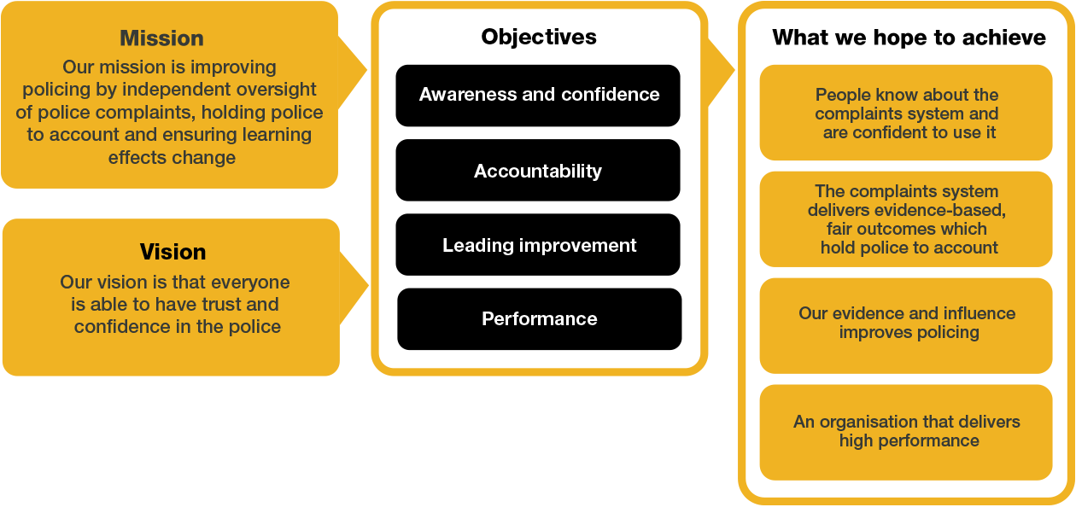
Organisational context

We work in the context of our agreed values which inform the way we do things at the IOPC. The postholder will need to be commited to managing in the context of these values.

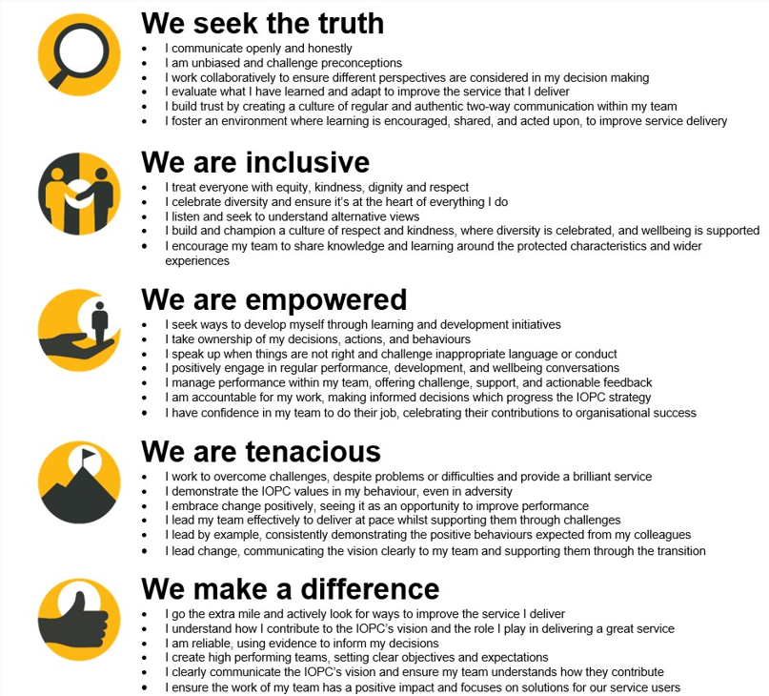

The IOPC is committed to promoting equality and valuing diversity in everything we do. Our vision is to be, and to be seen as, a leader in inclusive employment and services, demonstrating this ethos in everything that we do.
- As a silver standard Stonewall employer, we continue to commit ourselves to being a LGBTQ+ employer through the work of our Pride LGBTQ+ Staff Network, creating welcoming environments for lesbian, gay, bi and queer people.
- We are pleased to share we are a signatory of the Business in the Community Race at Work Charter. The Charter is composed of five calls to action for leaders and organisations across all sectors.
- Being a Disability Confident employer, the IOPC is dedicated to removing the barrier for disabled people to thrive in the workplace.
- Our Staff Networks are constantly working to make the IOPC the leaders of inclusive employment, from our Allyship Programme to Operation Hotton, to Welsh Language Standards and Know the Line Policy, we are constantly seeking new ways to create an environment for all to develop and thrive.




Main duties and responsibilities
- As the competent person for health and safety, provide specialist advice and guidance to the Director General and the Senior Management team on relevant legislation and implementation of the IOPC's Health and Safety Policy, annual plan and communication strategy.
- Advise and support all staff on health & safety issues
- To support the Head of People Services (PS) by developing systems to manage and report information on Health & Safety management and performance which will allow senior managers to manage safely
- Act as the competent Fire safety manager for the IOPC, (under the Regulatory Reform (fire safety) Order, 2005)
- Develop and implement the IOPC's health and safety policies, associated documents and supporting guidance to comply with health and safety legislation.
- Support the Head of PS in the monitoring and audit of health and safety management within the IOPC
- Monitor reports of accidents and incidents and near miss events to identify trends, investigating accidents, incidents and near miss events, as appropriate, providing reports and recommendations for corrective actions and preventative measures
- Manage the investigation of incidents ensuring that appropriate procedures are followed and take the necessary corrective and preventative action
- Liaise with health and safety enforcement authorities (HSE, Local Authority and Fire and Rescue Services) and our Trade Unions on health & safety matters. as required
- To ensure that there is a comprehensive programme of training and development for health and safety across the IOPC, including the provision of e-learning platforms
- Ensure the provision of Health and Safety reps/ appointed persons across the organisation receive adequate training, and support first-aiders, DSE assessors and evacuation wardens
- Draft quarterly H&S reports to the Workforce Planning and People Impact Assurance Group and Health and Safety Forum.
- Draft and deliver the annual health and safety report to Health & Safety Forum, Management Board and Staff Council
- Attend various committees and boards as an advisor on health and safety matters, including acting as the officer in attendance at the H&S Executive Forum.
- Support the Head of PS by undertaking programmes of monitoring, auditing and performance measurement sufficient to assure the Director General, Unitary Board and Management Board that health and safety management arrangements are appropriate, robust and compliant
- Ensure the IOPC’s health & safety policy and procedures comply with legal requirements, codes of practice and good practice guidance established by the HSE and other relevant bodies
- Work with the Head of PS advising on emerging issues and legislative changes that may have a significant impact on the IOPC
- To act as the IOPC’s main contact with health & safety enforcement agencies and be responsible for complying with statutory reporting requirements for Reporting of diseases and dangerous occurrences regulations 2013
- To assess the health and safety implications of capital and refurbishment projects, encouraging and facilitating the elimination and control of risks by design
- Advising the FM teams on the requirements of Construction, Design & Management Regulations (CDM) 2015
- To ensure that all the IOPC’s regional offices are compliant with statutory compliance and regulatory legislation
- To undertake the H&S Audit programme of the IOPC
- To monitor and continuously improve the health and safety management system
- Monitor the Departmental H&S Risk Registers in conjunction with the senior managers of each department
- Ensure that office risk assessments are kept up to date
- Maintain our fleet management system, risk assessment application and personal safety application
- Plan an execute engagement events for health and safety awareness day and health and safety awareness week
- Engage with staff networks and deliver H&S inputs upon request or following organisational learning
- Develop the suite of H&S Toolbox Talks
- Maintain and update as necessary, the H&S information published on the intranet (Hub)
- To liaise with the legal teams regarding actual and potential liability claims
- To maintain professional CPD to ensure competence
- Ensure robust risk assessments are in place for the IOPC. These include General office, first aid, fire risk assessments, young persons, lone working and new and expectant mothers
- Undertake the provision of occupational hygiene monitoring when required.
- Work with the internal communications team to deliver required H&S messages, campaigns and raise awareness of health and safety across the organisation
- Undertake ill health risk assessments as required
- Oversee and support the DSE Assessors in undertaking assessments and providing required equipment
- Support the People Partnering team in advising on required equipment for reasonable adjustments
- Undertake Line Manager responsibilities for the Health and Safety Advisor
- Assist the procurement team in renewal of any H&S contracts and the sourcing of new suppliers/equipment where necessary.

NB: This post will require:
- Some out of hours working may be necessary
- Travel between IOPC offices

Person specification

Essential Experience
- Experience of delivering H&S advisory and assurance at a tactical level.
- Experience of various health and safety management systems within a UK context.
- Experience of dealing with staff at all levels verbally and in writing both internally and externally
- Ability to communicate effectively with a broad range of staff
- Experience of delivering tailored training and preparing training support materials
- Experience of health and safety management in a large organisation, preferably in a multidisciplinary environment and multi-site organisation
- Experience of leading a health and safety audit
- Experience in developing and implementing effective reporting systems.
- Project management skills
- Experience of drafting policy
- Experience of strategy formulation

Essential Technical
- NEBOSH National/International Diploma or equivalent
- Grad IOSH or higher
- Fire Safety qualification or equivalent experience
- Lead H&S auditor qualification or track record of auditing in a large organisation.
- Proven excellent written and presentational skills

Desirable Technical
- Train the trainer qualification
- Line Management experience
- Postgraduate Certificate in Occupational Health and Safety management
- Chartered membership of IOSH

Reasonable adjustments
The IOPC is a diverse and inclusive workplace and we want to help you demonstrate your full potential whatever type of assessment is used. We are open to providing you with the tools you need to succeed, from extra time to formatting changes, to name a mere few. If you require any reasonable adjustments to our recruitment process, please email recruitment@policeconduct.gov.uk

Working conditions
The IOPC are currently consulting with our consultative bodies about proposed changes to our hybrid working policy which will require all staff to work 20% of their contractual hours at their office base (or another office for business reasons) from 1 September 2024 and will be increased to 40% from April 2025. Office attendance time includes in-person training, meetings with stakeholders and families, and attending events.

Preparation checklist
☐ Review the full job description
☐ Review the behaviours and the descriptors for each behaviour
☐ Review the Strengths dictionary
☐ Review the IOPC values
☐ Consider your Strengths (if applicable)
☐ Consider drafting example answers that cover the specific elements
☐ Prepare some questions to ask the interviewers

