Job description
Title: Information Rights Officer
Reports to: Data Protection Officer
Location: Birmingham, Sale, Cardiff, Wakefield
Grade: 10
Salary: £34,067
Contract: Fixed-term for 12 months

Purpose
As an Information Rights Officer, you will be welcomed into a dynamic and inclusive Data Protection team. The IOPC is on a journey to develop its culture, perspectives and ethos to support the organisation’s core outcomes, and this is your opportunity to enter into the varied world of IOPC data protection, allowing you to develop your mindset and approaches to contribute to improving the police complaints system in England and Wales.
An IOPC Information Rights Officer is part of a wider team that processes freedom of information requests and subject access requests.
The role is primarily, but not solely, concerned with the compliance of information access requests. The role holder will process subject access requests for the IOPC and must liaise with internal and external stakeholders, at all levels of the business, who have a vested interest in the proposed disclosure in order to provide accurate and timely responses that are compliant with legislation. In addition to this they will be involved in quality assuring correspondence, disseminating best practice, training staff and maintaining records as part of a team charged with responsibility for co-ordinating and assuring the IOPC’s compliance with Information Rights legislation.
The role is based in the Data Protection and Freedom of Information Team within the Legal Directorate. The job is based in Sale, Birmingham, Cardiff or Wakefield but may involve some travel to the other IOPC’s offices and elsewhere in England and Wales from time to time.

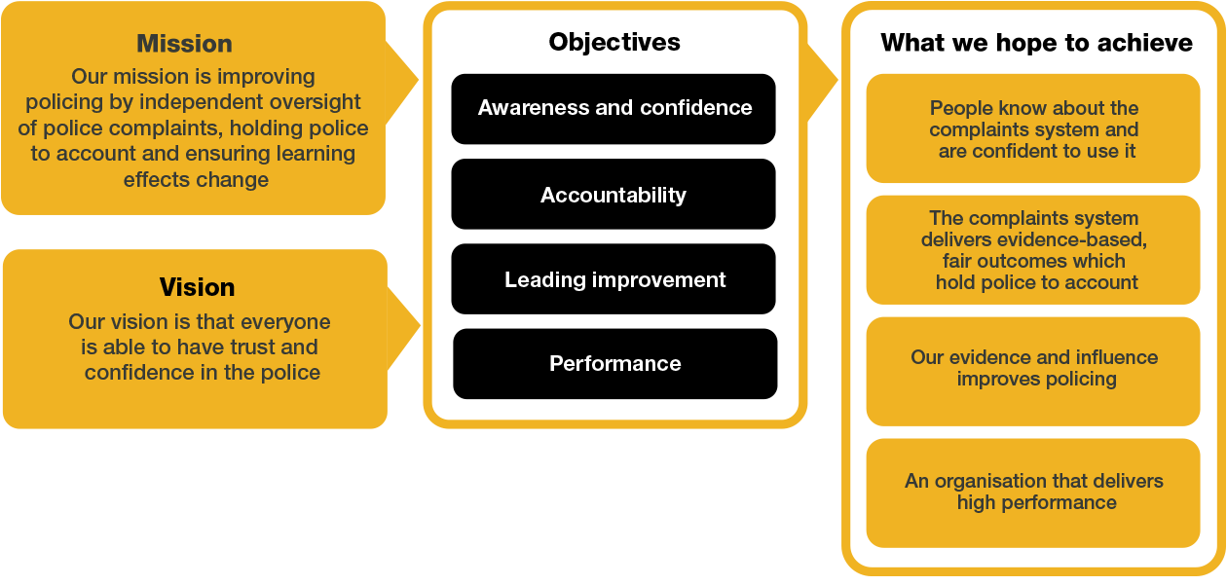
Organisational Context

We work in the context of our agreed values which inform the way we do things at the IOPC. The Information Rights Officer will need to be commited to managing in the context of these values.

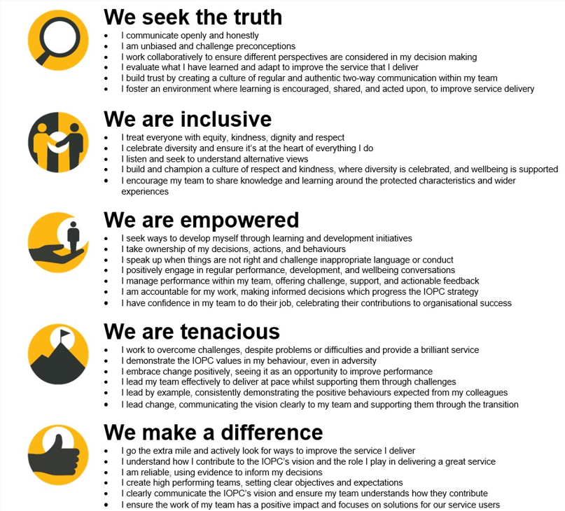

The IOPC is committed to promoting equality and valuing diversity in everything we do. Our vision is to be, and to be seen as, a leader in inclusive employment and services, demonstrating this ethos in everything that we do.
- As a silver standard Stonewall employer, we continue to commit ourselves to being a LGBTQ+ employer through the work of our Pride LGBTQ+ Staff Network, creating welcoming environments for lesbian, gay, bi, trans and queer people.
- We are pleased to share we are a signatory of the Business in the Community Race at Work Charter. The Charter is composed of five calls to action for leaders and organisations across all sectors.
- Being a Disability Confident employer, the IOPC is dedicated to removing the barrier for disabled people to thrive in the workplace.
- Our Staff Networks are constantly working to make the IOPC the leaders of inclusive employment, from our Allyship Programme to Operation Hotton, to Welsh Language Standards and Know the Line Policy, we are constantly seeking new ways to create an environment for all to develop and thrive.




Main duties and responsibilities
- Acting as first point of contact for the processing of all subject access requests. Ensuring responses are accurate, compliant and timely.
- Providing high quality advice and support on the application of information rights law through the scoping and draft redacting of subject access request and FOI request responses.
- Providing advice on whether information should be disclosed or refused in compliance with the relevant legislation. With the knowledge and understanding of when to defer to legal for clarification, further understanding, internal and external consultation and guidance in relation to other legislation which may apply to the IOPC’s disclosure.
- Understanding, interpreting and applying any relevant tribunal and Information Commissioner’s Office (ICO) cases and guidance to subject access request and FOI request responses.
- Assessing requests and correspondence to identify the relevant IOPC internal and external stakeholders that may be affected by disclosure
- Working with IAOs and other interested parties, at all levels, so as to identify and understand their concerns about disclosure or exemption application and to provide expert advice on any applicable exemptions from disclosure.
- Responding to requests ensuring that all correspondence and associated disclosures are timely, accurate and compliant with legislation, regulations and policies.
- Providing ongoing advice, training and guidance to the IOPC as whole where required.
- Support the IOPC internal review officers in responding to FOIA and DPA complaints.
- Support the Senior FOI/DPA Advisor and others in undertake internal reviews of responses to subject access requests.
- Provide supporting material to enable representations to information tribunals in respect of FOI cases and the courts in relation to DPA cases.
- Liaising with the Senior FOI/DPA Advisor or the DPO where a disclosure relates to sensitive matters.
- Provide supporting material in regard to requests that potentially attract the exemption under section 36 FOIA.
- Liaising with external stakeholders from where the material originates so as to ensure that their concerns about disclosure are taken into account.
- Ensuring accurate records are kept of requests, responses, disclosures and exemptions and associated correspondence in accordance with FOIA and DPA.
- Support the production of and updating of guidance on the Intranet and support material used by the IOPC in order to promote best practice, in light of the evolving business and legal landscape.
- Support the provision information rights training across the organisation.
- Updating and improving processes within the IOPC to deliver a better information rights service.
- Keeping up to date with statute law, case law and practice relating to information rights legislation, including participating in in-house seminars, and external events. Facilitate knowledge transfer and dissemination to various staff including other FOI & DPA staff.
- Carrying out such other duties and responsibilities of a wider FOI and DPA nature as are required from time to time.

Person specification

Essential Experience
- Professional qualification, equivalent qualification or demonstrable working experience in a similar role
- Proven ability to draft redact documents, and prepare disclosure schedules for proposed disclosures in accordance with Article 15 UK GDPR
- Ability to make evidence-based decisions taking into account the legislation that binds us for example the UK GDPR, the DPA, FOIA, and the PRA
- Good analytical skills in order to assess information disclosures
- Excellent attention to detail.
- Ability to influence colleagues at all levels across the whole organisation.
- Good working knowledge and experience of records management, complaints processes, archive and retention principles and their supporting systems.
- Proven ability to provide advice to both internal and external stakeholders on a variety of complex issues (including legal issues), with a keen awareness of sensitivities.
- Excellent organisational skills and the ability to work under pressure to tight deadlines.
- Ability to work effectively both independently and as part of a team.
- Proven ability to show initiative and contribute in a changing environment.

Essential Technical
- Theoretical and practical understanding of the Freedom of Information Act and Data Protection law
- A working knowledge of IT applications and systems, with knowledge of redaction tools an advantage.

Desirable Technical
- A knowledge of other pertinent legislation i.e. the Human Rights Act, Police Reform Act, Regulation of Investigatory Powers Act and Police Reform and Social Responsibility Act are desirable.

This job outline is intended to indicate the broad range of responsibilities and requirements of the post. It is neither exhaustive nor exclusive but while some variations can be expected in particular duties, the outline is considered to provide a reasonable general description of the post.

Reasonable adjustments
The IOPC is a diverse and inclusive workplace and we want to help you demonstrate your full potential whatever type of assessment is used. We are open to providing you with the tools you need to succeed, from extra time to formatting changes, to name a mere few. If you require any reasonable adjustments to our recruitment process, please email recruitment@policeconduct.gov.uk

Working conditions
The IOPC are currently consulting with our consultative bodies about proposed changes to our hybrid working policy which will require all staff to work 20% of their contractual hours at their office base (or another office for business reasons) from 1 September 2024 and will be increased to 40% from April 2025. Office attendance time includes in-person training, meetings with stakeholders and families, and attending events.

Preparation checklist
☐ Review the full job description
☐ Review the behaviours and the descriptors for each behaviour
☐ Review the Strengths dictionary
☐ Review the IOPC values
☐ Consider your Strengths
☐ Consider drafting example answers that cover the specific elements
☐ Prepare some questions to ask the interviewers

