**JOB DESCRIPTION**

**TITLE:**  People Systems Technical Lead

**REPORTS TO:** Senior People Systems and Information Manager

**LOCATION:** Birmingham, Canary Wharf, Cardiff, Croydon, Sale or Wakefield

**GRADE:** 13

**SALARY:**  £46,335 (plus London Weighting Allowance of £4731, if based in Canary Wharf or Croydon)

**CONTRACT:** Permanent

**PURPOSE**

This role will lead on the work to develop systems and system functionality that supports the work of the People team at the IOPC, implementing the new system which benefits the entire organisation through people management.

The post holder will act with confidence as the “system owner” for MyIOPC, ResourceLink, TribePad (ATS) and other people management applications, to ensure our systems are fully imbedded into the organisation. We are looking for someone with a strong attention to detail, who can implement and communicate change to various stakeholders.

You will be working collaboratively with internal and external stakeholders to produce a seamless systems experience by acting on technical requirements and objectives of the organisation, so if you are someone with relevant systems experience who can build relationships with a variety pf people, we would encourage you to apply.

# 

# ORGANISATIONAL CONTEXT

We work in the context of our agreed values which inform the way we do things at the IOPC. The People Systems Technical Lead will need to be commited to working in the context of these values.

**MAIN DUTIES AND RESPONSIBILITIES**

**Systems Development**

* Work with the Senior People Systems and Information Manager to define the People Directorate Systems Roadmap.
* Work with People Directorate functional leads to understand user requirements.
* Work with system users and owners to understand their user experience, consider, and validate feedback, and produce functional specification documents for consideration within People Systems & Information Management Strategy.
* Lead on translating agreed functional requirements into technical design specifications including workflow, system integration, and user experience, supported by detailed and agreed change documentation.
* Proactively work within IOPC technical and business change management process such as CAB and TDA to ensure that system enhancements, functional changes and system upgrades are communicated and approved.
* Manage the handover of new and / or enhanced business processes to end users to support the embedding of the business processes.

**Systems Management**

* Manage and maintain all People systems (ResourceLink, MyIOPC, TribePad ATS, Time Management, and e-Davis) in terms of access control, configuration, system development in line with agreed Acceptance into Service and People Systems Service Delivery standards.
* Oversee system performance and user satisfaction data to ensure excellent user experience
* Work with system suppliers, ICT colleagues and other stakeholders to plan and implement system upgrades including general release and functional upgrades.
* Work with suppliers to develop system capabilities to future-proof the application.
* Work with suppliers to ensure successful resolution of defects that have been escalated by the People Systems Team.

**ResourceLink /MyIOPC**

* Act as the technical lead for ResourceLink / MyView with overall responsibility for ensuring that the functionality meets the changing needs of the organisation.
* Attend ResourceLink user groups and work with other ResourceLink customers to influence the development of improved functionality
* Maintain up to date knowledge of the product’s development
* Lead on the development and implementation of MyView system functionality including but not limited to system testing, workflow, reporting, system integration and sign-off.
* Manage system configuration including the ongoing maintenance of system security, user profiles as well as updates to configuration to support the introduction of new system capability.
* Manage and maintain an accurate establishment, overseeing organisational restructure projects to ensure system continuity is maintained in a timely manner
* Develop systems capabilities to deliver a suite of easily accessible management reports aligned to user security privileges, organisational structure, and appropriate datasets.
* Provide a point of contact for ResourceLink/MyIOPC system expertise and technical knowledge.
* Support the Senior People Systems Manager in managing the contractual relationship with Zellis

**TribePad ATS**

* Act as the technical lead for the TribePad ATS with overall responsibility for ensuring that the functionality meets the needs of the Talent Acquisition Team and the wider organisation.
* Attend TribePad user groups and work with other customers to influence the development of improved functionality, user experience and reporting.
* Maintain up to date knowledge of the product’s development including management reporting.
* Lead on the development, implementation, and continued maintenance of TribePad Onboarding Module.
* Lead on the development, implementation, and continued maintenance of ATS integration products such as ResourceLink ATR, New Starter, and Mover’s workflows.
* Manage system configuration including the ongoing maintenance of system security, user profiles as well as updates to configuration to support the introduction of new system capability.
* Provide a point of contact for TribePad system expertise and technical knowledge.

**People Systems integration**

* Work with stakeholders to design, develop, implement, and maintain most effective technical solutions for efficient data transfer in support of system integration and performance reporting.
* Provide technical expertise to design and deliver effective integration using SQL / XML across all People systems to maximise and drive efficiency opportunities.
* Produce and maintain a People system relationship chart and work with the IOPC System Architect to ensure that People systems are fully documented and have agreed service delivery specifications.
* Act as a point of contact for IOPC wide projects which may impact on People Systems, for example Single Sign On, revised security protocols or improved access to mobile capability.
* Work with ICT colleagues to agree and implement approach for delivering technical integration between ResourceLink and Microsoft Azure Active Directory and MS 365 Apps.

**Data**

* Oversee the management and maintenance of data quality to achieve a recognised ‘single version of the truth’ for all People directorate electronic data
* Work with ICT colleagues to develop a standard approach to carrying out future data migration activities recognising industry best practice, existing business processes and standards.
* Produce technical plans and deliver solutions for the management and maintenance of system legacy data that aligns to IOPC Records Management Policy and data protection legislation.
* Ensure that the technical configuration of people systems is consistent with the requirements of the IOPC data retention policy so that any over retention risks are mitigated.
* Design, build and maintain business reporting products such as MI Dashboards utilising applications such as Power BI, Power Automate and other Power Apps in line with IOPC data governance standards.

**People Management**

* Maintain own professional skills and capabilities by keeping abreast of current and emerging technologies, trends, supplier outlook and use these skills to develop the IOPC People Systems Team.

**PERSON SPECIFICATION**

**KNOWLEDGE, EXPERIENCE and QUALIFICATIONS**

The **essential** requirements are:

**For this role you will require:**

* Proven experience and capability of managing, developing people management systems such as ResourceLink, ATS in a People Management environment.
* Proven experience and capability of supporting and maintaining ResourceLink Payroll module.
* Considerable experience within a HRIS function of successfully designing and configuring HR systems to support business policy and process.
* Proven experience and capability of delivering business reporting using the RRS business reporting suite.
* Proven experience of developing SQL and XML to support integration and single / two-way interfaces.
* Advanced database management knowledge and experience including setup, maintenance, reporting, customisation and / or configuration.
* Proven ability of working with stakeholders to successfully deliver change initiatives.
* Consultancy and Project Management skills.
* Ability to communicate with individuals at all levels of the organisation.
* Proven ability to prioritise and manage workload effectively whilst maintaining high standards.
* Ability to work with minimum supervision in a fast-moving and demanding environment.
* Proven ability of managing and developing a team in a systems environment.
* Excellent general IT skills including Excel, Word, Outlook and databases.
* Attention to detail and a high level of accuracy and consistency under pressure
* A customer focused approach using drive and initiative to provide an excellent service.

The **desirable** requirements are:

* Further education qualification in HR or other relevant field such as Business Information Systems or clearly demonstrable experience in working in this field.
* Proven experience of successfully using MS 365 Apps such as Power BI and Power Automate.
* Proven experience of working with e-Davis system.
* Previous payroll and pension’s administration experience.

**Selection process**

This vacancy is using [**Success Profiles**](https://www.gov.uk/government/publications/success-profiles?_ga=2.156185915.1692943174.1578577916-319911383.1576576754). As part of the application process, you will be asked to complete a statement of suitability and three shortlisting questions.

The Level 3 Behaviours being assessed during the recruitment process are:

* Changing and Improving
* Communicating and Influencing
* Working Together
* Developing Self and Others
* Managing a Quality Service
* Delivering at Pace

For successful candidates who reach the assessment stage, we will provide further details of what will be assessed.

**What is Success Profiles?**

Success Profiles moves us to a tailored way of assessing, dependent on the requirements of the job. For each role we advertise, we consider what you will need to demonstrate in order to be successful. This gives us the best possible chance of finding the right person for the job, drives up performance and improves diversity and inclusivity so that we can truly reflect the communities that we serve.

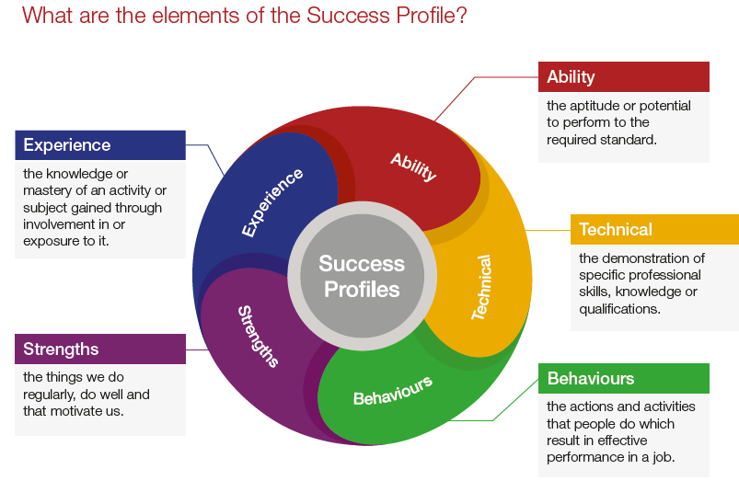Not all of the elements are relevant to every role, and will vary depending on the level and type of role. You should ensure you read the job description carefully to see what elements are required for the specific job you are applying for. There are separate guides to each of the elements, which will give you more information about what and how you can demonstrate specific requirements.

**How the elements are assessed**

You could be assessed in a number of different ways, depending on the type of role and level you are applying for. Using a range of assessment methods helps us to more accurately match people to the essential requirements of the job. For example, you may be asked to complete an application form; provide a CV and supporting statement; attend an assessment centre; or complete an online test. Often a combination of these approaches will be used and more than one element may be tested within the same assessment method.

Details of which elements will be assessed and how we will assess you against these, are included in the job description.

**Reasonable adjustments**

The IOPC is a diverse and inclusive workplace and we want to help you demonstrate your full potential whatever type of assessment is used. If you require any reasonable adjustments to our recruitment process please let the recruiting manager know.

**Preparation checklist**

Review the full job description ☐

Review the behaviours and the descriptors for each behaviour☐

Review the Strengths dictionary ☐

Review the IOPC values ☐

Consider your Strengths ☐

Consider drafting example answers that cover the specific elements ☐

Prepare some questions to ask the interviewers ☐