**Job description**

**Title:** Intelligence Analyst

**Reports to:** Intelligence Manager

**Location:** Canary Wharf orSale

**Grade:** 11

**Salary:** £36,150 plus £4,731 London Weighting if applicable – pro rata

**Contract:** Part-time (21hrs) - Permanent

# Purpose

As an Intelligence Analyst you will be welcomed into a dynamic and inclusive team. The IOPC is on a journey to develop its culture, perspectives and ethos to support the organisation’s core outcomes, and this is your opportunity to enter into the varied world of IOPC, allowing you to develop your mindset and approaches to contribute to improving the police complaints system in England and Wales.

You will be responsible for providing detailed and complex investigative analysis to the Operations Directorate, providing an objective structured view of that material in the form of charts, diagrams and appropriate reports. The analysis will include conclusions, inferences, information gaps, identification of risks and making recommendations regarding alternative courses of action.

Working in conjunction with colleagues in the Investigations team, you will identify pertinent lines of enquiry and provide focus to the investigation. You will support investigations conducted by Investigators and Lead Investigators.

You will be driving the tactical and strategic objectives of the investigations by the collation, research and analysis of intelligence and information from a variety of internal and external sources.

Taking responsibility for highly sensitive material relating to the investigation, you will ensure the security and confidentiality of that material at all times and that all analysis is undertaken in compliance with relevant policy and legislation and in accordance with national standards of good practice.

You will prepare analytical evidence for potential use in misconduct or criminal proceedings. This may involve liaison with crown prosecution staff, barristers and court chambers staff and attending court as a witness, if required.

This is a challenging but rewarding role and key to the investigations we undertake. 

# Organisational context

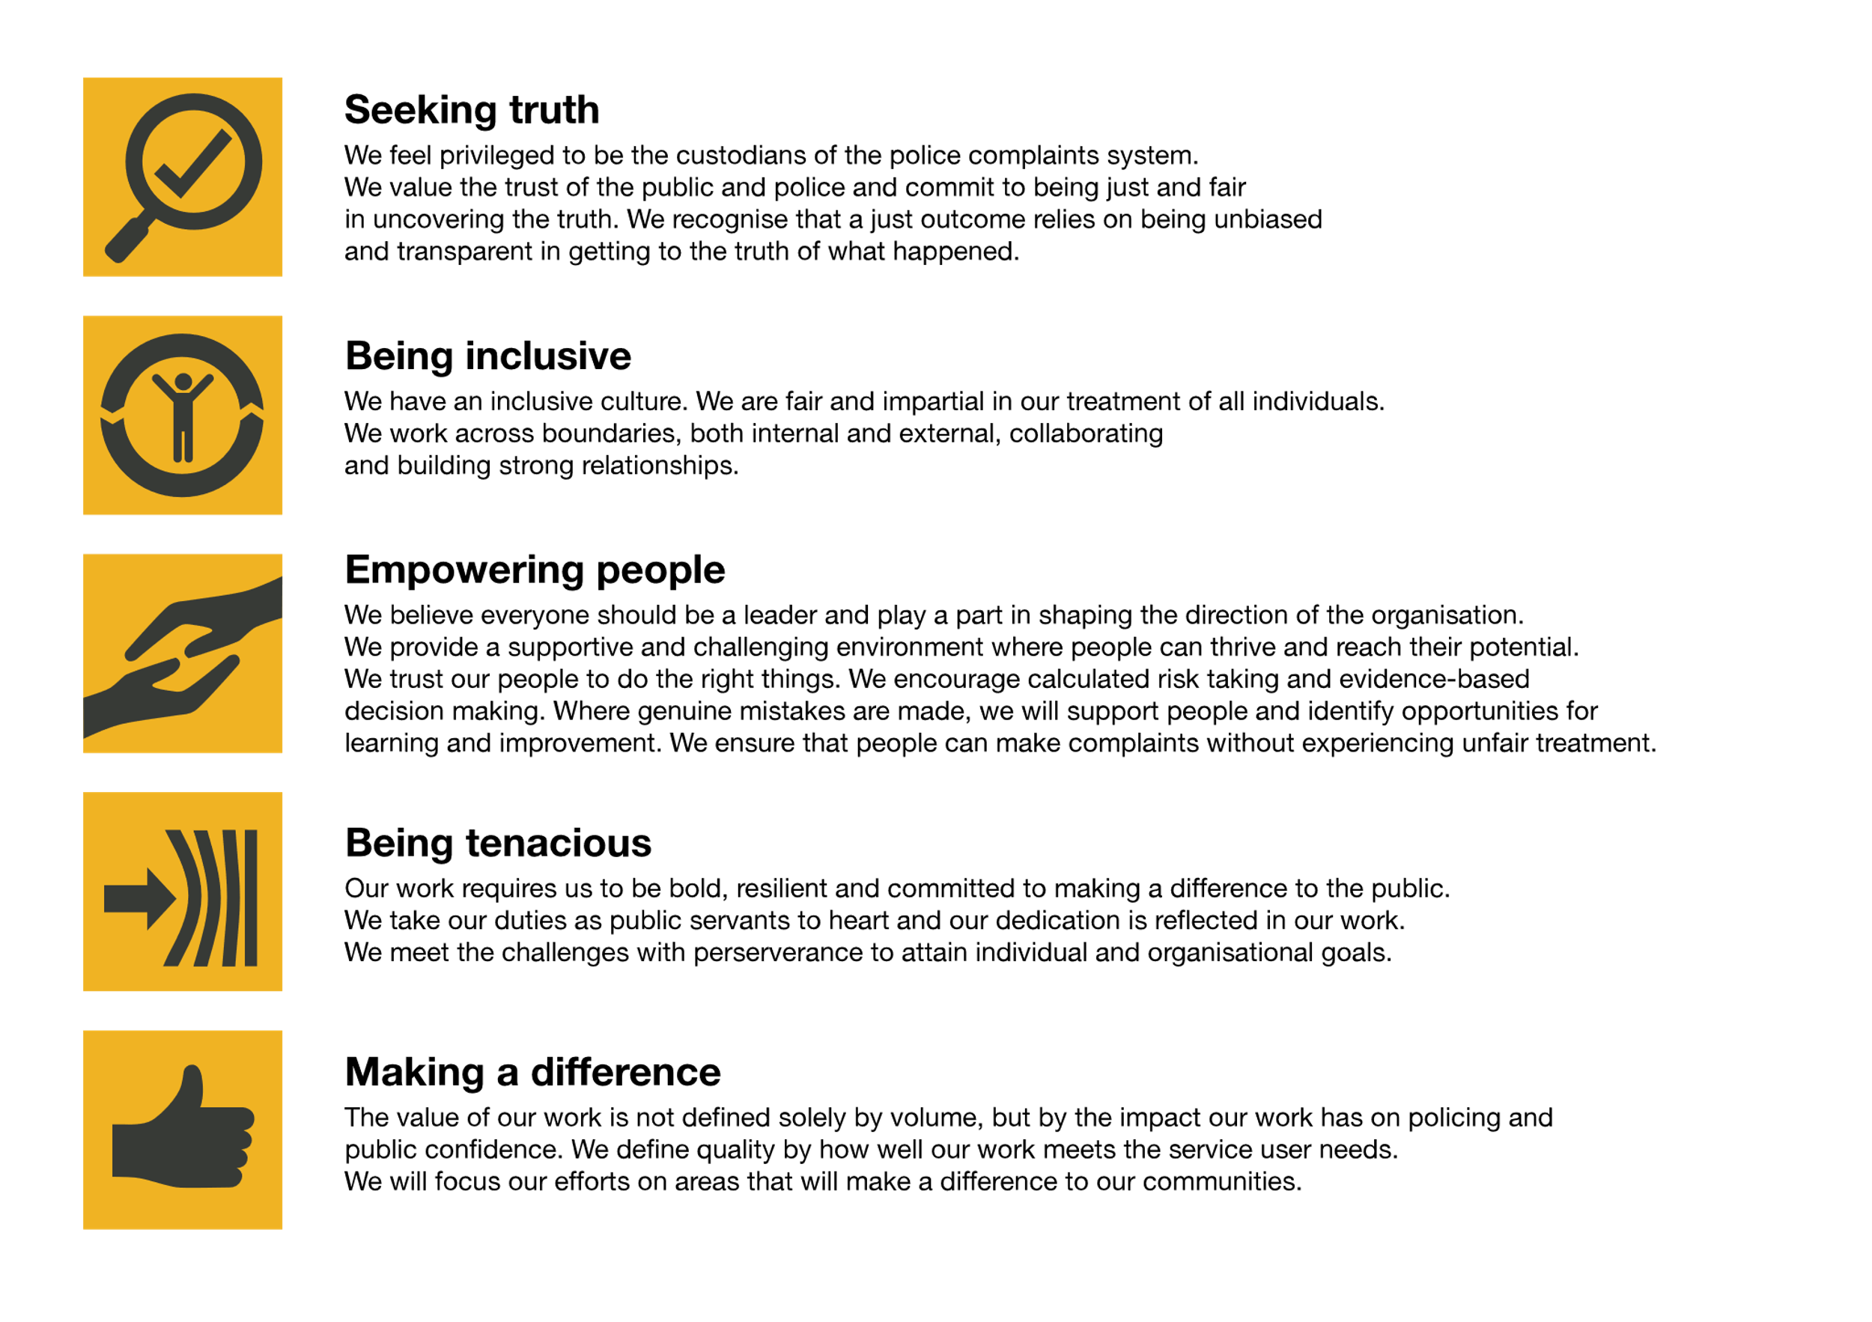We work in the context of our agreed values which inform the way we do things at the IOPC. The Intelligence Analyst will need to be commited to managing in the context of these values.

The IOPC is committed to **promoting equality and valuing diversity** in everything we do. Our vision is to be, and to be seen as, a leader in inclusive employment and services, demonstrating this ethos in everything that we do.

* As a silver standard Stonewall employer, we continue to commit ourselves to being a LGBTQ+ employer through the work of our Pride LGBTQ+ Staff Network, creating welcoming environments for lesbian, gay, bi and queer people.
* We are pleased to share we are a signatory of the Business in the Community Race at Work Charter. The Charter is composed of five [calls to action](https://race.bitc.org.uk/issues/racecharter) for leaders and organisations across all sectors.
* Being a Disability Confident employer, the IOPC is dedicated to removing the barrier for disabled people to thrive in the workplace.
* Our Staff Networks are constantly working to make the IOPC the leaders of inclusive employment, from our Allyship Programme to [Operation Hotton](https://www.policeconduct.gov.uk/recommendations/operation-hotton-recommendations-metropolitan-police-service-september-2021), to [Welsh Language Standards](https://www.policeconduct.gov.uk/who-we-are/equality-and-diversity/welsh-language-standards) and Know the Line Policy, we are constantly seeking new ways to create an environment for all to develop and thrive.

# Main duties and responsibilities

* Provide operational investigative analysis to Operations Directorate Investigators. Develop inferences and hypotheses and identify gaps and inconsistencies within the material through undertaking complex analysis.
* Analyse data collated from various sources to identify patterns and trends. Proactively identify lines of research and intelligence development. Identify risks and consider alternative courses of action.
* Produce appropriate NIM analytical products for the Investigators as appropriate.
* Proactively communicate findings to the Investigators and liaise with them to identify where analysis and investigation research support can add value to the investigation.
* Provide briefings, updates and reports for meetings when required both verbally and in written form. Provide operational briefings to investigators.
* Take responsibility for highly sensitive material relating to the investigation, ensuring the security and confidentiality of that material at all times. Ensure that all analysis is undertaken in compliance with all relevant policy and legislation e.g. CPIA, RIPA, IPA, DPA, HRA and according to national standards of good practice.
* Prepare analytical evidence for potential use in misconduct or criminal proceedings. This may involve liaison with crown prosecution staff, barristers and court chambers staff and attending court as a witness, if required.
* Have a working knowledge of Professional Standards Departmental procedures and misconduct and grievance procedures within law enforcement.
* Maintain standards of professional practice and keep abreast of changes in legislation, policies, and procedures within the police and intelligence environment.
* Carry out such other duties which are consistent with the nature, responsibilities and grading of the post.

# Person specification

## Essential

* Fully trained, accredited and experienced analyst.
* Prepared to maintain standards of professional practice and to keep abreast of changes in legislation, policies, and procedures within the operational and intelligence environments.
* Extensive working knowledge of RIPA, IPA CPIA, HRA and other relevant legislation to support investigation file build preparation where sensitive material exists.

## Desirable

* Knowledge of intelligence processes
* Working knowledge of HOLMES 2
* Relevant degree/qualification.

## Experience

* Extensive experience of conducting strategic and/or operational analysis with particular experience of analysing data from various sources and clearly presenting it to others in written and verbal formats.
* Proven technical experience and success in developing and producing analytical charts and assessments.
* Experience utilising Microsoft applications, particularly Excel.
* Evidence of well-developed critical thinking skills, a capacity to conduct enquiries, obtain information and to use sound judgement to develop this information into tactical or strategic advice.
* Practical experience of sensitive evidence/intelligence gathering techniques and capabilities and the processes which exist to manage disclosure of that material.
* Ensures intelligence is evaluated and disseminated correctly and that sources of intelligence are protected accordingly.
* Proven experience in successfully maintaining working relationships with internal and external parties.
* Evidence of strong written and verbal communication skills.

## Skills and Abilities

* Strong experience in the use of Microsoft Excel.
* Strong experience of research and analytical tasks; including obtaining, collating and analysing information and the associated clerical/administrative tasks.
* Experience of assessing a wide range of materials and data and preparing and delivering reports.

## Reasonable adjustments

The IOPC is a diverse and inclusive workplace, and we want to help you demonstrate your full potential whatever type of assessment is used. We are open to providing you with the tools you need to succeed, from extra time to formatting changes, to name a mere few. If you require any reasonable adjustments to our recruitment process, please email [humanresources@policeconduct.gov.uk](mailto:humanresources@policeconduct.gov.uk)

## Working conditions

Making the IOPC a great place to work is one of our key priorities. We are pleased to offer a unique hybrid working model based on business needs, balanced with the needs of our colleagues. Our business need framework guides our decisions about when it is best to work onsite (in our offices or other appropriate locations) to complete tasks most effectively or when to work remotely, offering colleagues flexibility to work where they feel most productive and supporting work-life balance. The model also encourages staff to feel welcome at the IOPC by ensuring we have opportunities to work face-to-face as teams.

## Preparation checklist

☐ Review the full job description

☐ Review the behaviours and the descriptors for each behaviour

☐ Review the Strengths dictionary

☐ Review the IOPC values

☐ Consider your Strengths (if applicable)

☐ Consider drafting example answers that cover the specific elements

☐ Prepare some questions to ask the interviewers