Job description
Title: Customer Contact Centre Advisor – Welsh Language Essential
Reports to: Customer Contact Centre Manager
Location: Sale (Manchester)
Grade: 8
Salary: £28,665
Contract: Permanent

Purpose
As a Customer Contact Advisor, you will be welcomed into a dynamic and inclusive Investigations, Oversight and Casework team as the first point of contact to the organisation, presenting a professional image providing accurate advice and information to a range of external customers and stakeholders. The IOPC is on a journey to develop its culture, perspectives and ethos to support the organisation’s core outcomes, and this is your opportunity to enter into the varied world of Investigations, Oversight and Casework, allowing you to develop your mindset and approaches to contribute to improving the police complaints system in England and Wales.
Working as part of the Customer Contact Centre you will have a spectrum of responsibilities that encompass all elements of the contact centre. This will include providing a responsive telephone information service, responding to correspondence and complaints received from a range of external parties, including members of the public, police forces, MPs, solicitors and other agencies. You will be required to use Welsh language skills.
You will be expected to support the delivery of excellent customer service, providing the best possible experience with the approach of ‘getting it right first time’ to manage customer expectation and to reduce avoidable contact. The complexity of enquiry or complaint will vary as will the demand of work at any one time. You will work within a defined framework and fulfil individual targets to maximise contribution to team and directorate performance.

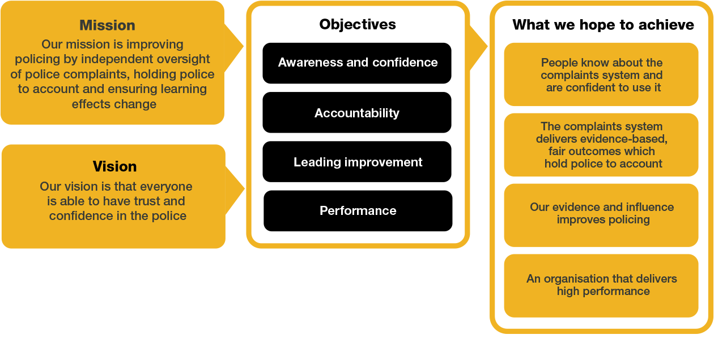
Organisational Context

We work in the context of our agreed values which inform the way we do things at the IOPC. The Customer Contact Centre Advisor will need to be commited to managing in the context of these values.

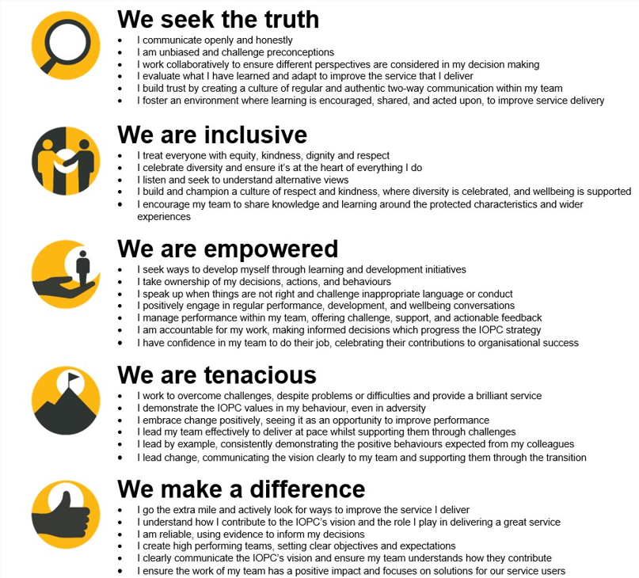

The IOPC is committed to promoting equality and valuing diversity in everything we do. Our vision is to be, and to be seen as, a leader in inclusive employment and services, demonstrating this ethos in everything that we do.
- As a silver standard Stonewall employer, we continue to commit ourselves to being a LGBTQ+ employer through the work of our Pride LGBTQ+ Staff Network, creating welcoming environments for lesbian, gay, bi and queer people.
- We are pleased to share we are a signatory of the Business in the Community Race at Work Charter. The Charter is composed of five calls to action for leaders and organisations across all sectors.
- Being a Disability Confident employer, the IOPC is dedicated to removing the barrier for disabled people to thrive in the workplace.
- Our Staff Networks are constantly working to make the IOPC the leaders of inclusive employment, from our Allyship Programme to Operation Hotton, to Welsh Language Standards and Know the Line Policy, we are constantly seeking new ways to create an environment for all to develop and thrive.




Main duties and responsibilities
- Provide a responsive service in Welsh and English to a range of customer of queries and complaints ensuring prompt resolution of issues received by phone/email/letter/online form.
- Process direct complaints received from members of the public to the appropriate police force or authority with minimal handling and representation.
- Be alert to and identify high profile matters and matters of public interest, and direct complaints that it may be appropriate not to forward to the force because of exceptional circumstances and draw these to the attention of the Customer Contact Centre Manager.
- Establish customer needs and provide appropriate information - which may range from advising on the role of the IOPC, the process for making a complaint or appeal to more general requests for information or signposting to other agencies
- Respond to comebacks, complaints, MPs’ letters and other correspondence.
- Take ownership of calls, queries and complaints, seeking to resolve issues to reduce subsequent contact providing the best possible experience for the customer
- Where appropriate, liaise with internal and external stakeholders regarding complaints and information received and recognising where information is significantly complex or sensitive and handling the information as appropriate.
- Identify and collate trends data information on potentially high-profile issues
- Deal with customers that can often be angry, distressed, and sometimes challenging but remaining courteous and have the ability to see things from the customer point of view to ensure a consistent and fair service is provided to all
- Alongside signposting complainants to advocacy and advice services where they can receive assistance in making a complaint, the post holder may need to take down the details of complaints and appeals over the phone in accordance with the IOPC Reasonable Adjustment policy. This relates particularly to callers that may have an access or communication needs.
- Keep up to date with organisational issues and events, including press releases, report releases, changes to organisational practices to ensure knowledge is current in order to provide appropriate advice.
- Resolve queries first time to reduce subsequent contact providing the best possible experience for the customer.
- Record accurate enquiry and complaint information on relevant case and customer relationship management systems.
- Process and respond to Report Line contacts from serving Police Officers.
- Deal with whistleblowing allegations and liaise with the internal department regarding any whistleblowing.
- Any other duties suitable to the grade, which may include administrative support, assisting more senior staff with face-to-face interactions with member of the public, switchboard cover, post.
- Train and assist new members of the team where appropriate.
- Considering the validity of reviews received out of time and communicating the decision to the service user and force, using clear guidance and standard template letters. Identifying any unusual, contentious or difficult cases and seeking appropriate advice to enable a sound decision to be taken.

Person specification

Essential
- Evidence of strong oral and written communication skills
- Evidence of strong oral and written communication skills using the Welsh language
- Confidence and ability to communicate with people at all levels
- Ability to be patient, resilient, sensitive and diplomatic when dealing with the public and stakeholders
- A capacity to conduct enquiries, obtain information and to use sound judgement to reach conclusions

Experience
- Proven relevant experience of working in a customer focused advice or information handling environment
- Experience of dealing with challenging people over the phone
- Experience of responding to customers using the Welsh language, both verbally and in writing
- Experience of responding to customer queries and complaints in writing

Skills and Abilities
- Good organisational skills and ability to manage own workload
- Good IT skills, including Microsoft Office and database systems

Reasonable adjustments
The IOPC is a diverse and inclusive workplace and we want to help you demonstrate your full potential whatever type of assessment is used. We are open to providing you with the tools you need to succeed, from extra time to formatting changes, to name a mere few. If you require any reasonable adjustments to our recruitment process, please email recruitment@policeconduct.gov.uk

Working conditions
The IOPC are currently consulting with our consultative bodies about proposed changes to our hybrid working policy which will require all staff to work 20% of their contractual hours at their office base (or another office for business reasons) from 1 September 2024 and will be increased to 40% from April 2025. Office attendance time includes in-person training, meetings with stakeholders and families, and attending events.

Preparation checklist
☐ Review the full job description
☐ Review the behaviours and the descriptors for each behaviour
☐ Review the Strengths dictionary
☐ Review the IOPC values
☐ Consider your Strengths (if applicable)
☐ Consider drafting example answers that cover the specific elements
☐ Prepare some questions to ask the interviewers

