Job description
Title: Data Governance Officer
Reports to: Data Governance Lead
Location: Any IOPC office
Grade: 10
Salary: £31,110 (Plus London Weighting allowance of £4,527 if based in Croydon or Canary Wharf)
Contract: Permanent

Purpose
As a Data Governance Officer, you will be welcomed into our new Digital, Data and Technology function within Strategy and Corporate Services. The IOPC is on a journey to develop its culture, perspectives, and ethos to support the organisation’s core outcomes, and this is your opportunity to enter the varied world of IOPC Strategy and Impact, allowing you to develop your mindset and approaches to contribute to improving the police complaints system in England and Wales.
Our new function and brings together teams responsible for knowledge and information management, data analysis and reporting, Data Governance, data quality and records management as well as ICT. It operates nationally with team members across seven sites
You will be responsible for supporting the Data Governance Lead with the delivery of organisational priorities within the IOPC Data Governance Framework as set out in the Data Strategy. We want you to embed a culture of excellent data management into the organisation, we are looking for someone who is passionate about data and the importance of data completeness and quality, to support our developing data teams and changing organisation.

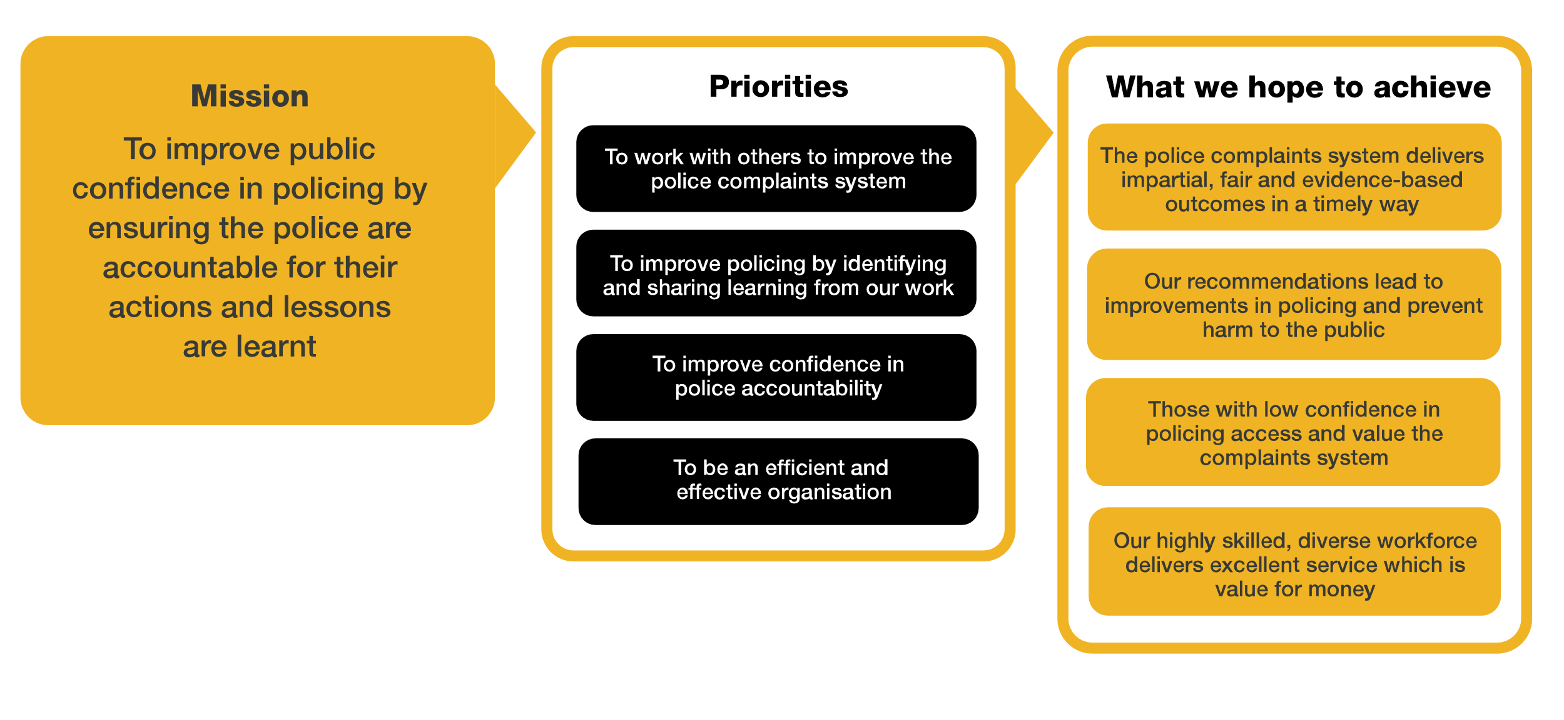
Organisational context

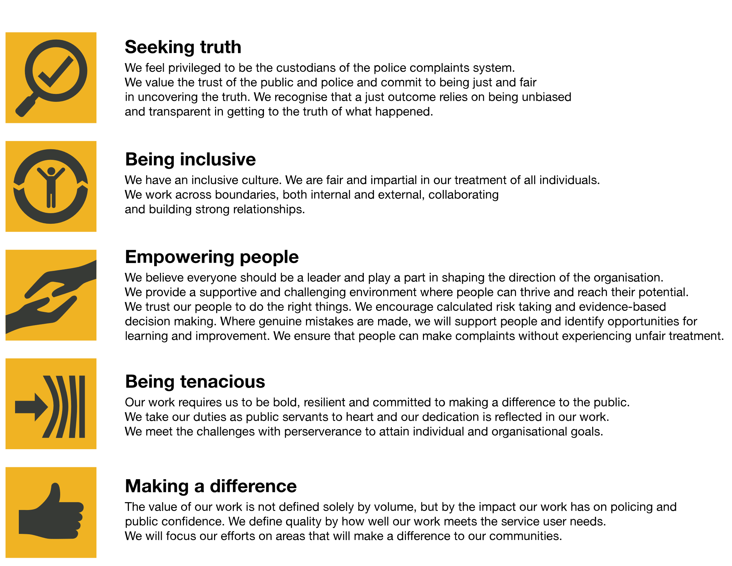
We work in the context of our agreed values which inform the way we do things at the IOPC. The Data Governance Officer will need to be commited to managing in the context of these values.
The IOPC is committed to promoting equality and valuing diversity in everything we do. Our vision is to be a leader in inclusive employment and services, demonstrating this ethos in everything that we do.
- As a silver standard Stonewall employer, we continue to commit ourselves to being a LGBTQ+ employer through the work of our Pride LGBTQ+ Staff Network, creating welcoming environments for lesbian, gay, bi, and queer people.
- We are pleased to share we are a signatory of the Business in the Community Race at Work Charter. The Charter is composed of five calls to action for leaders and organisations across all sectors.
- Being a Disability Confident employer, the IOPC is dedicated to removing the barrier for disabled people to thrive in the workplace.
- Our Staff Networks are constantly working to make the IOPC the leaders of inclusive employment, from our Allyship Programme to Operation Hotton, to Welsh Language Standards and Know the Line Policy, we are constantly seeking new ways to create an environment for all to develop and thrive.

Main duties and responsibilities
- Be an ambassador for Data Governance in the IOPC.
- Engage in discussions with various teams across the IOPC to identify issues with data and information management and feed them into the IOPC Data Strategy Deliverables.
- Understand individual team requirements and ensure this is considered in the creation of the Data Governance Framework by reporting into the Data Governance Lead.
- Support with the delivery of an enterprise-wide Data Governance Programme aligned to technical, legislative, and regulatory requirements
- Work with various teams across the IOPC to identify issues or concerns relating to the management of data. Work with the Data Governance Team, and other Information Management Teams to resolve these issues.
- Support with the design and help deliver a Data Governance programme to define, master, and enhance data. Working to ensure it meets the needs of the business and analytical teams
- Support the wider Data Governance Team the design and implementation of the Data Dictionary, Glossary and Product Catalogue, sharing the proposals with the relevant teams in the IOPC and assisting with leading sessions to populate the appropriate information.
- Responsible for the day-to-day maintenance of Data Governance tools (e.g., Data Dictionary, Glossary and Product Catalogue), keeping them accurate and up to date.
- Support with the implementation of new Data Governance technology or tools
- Review and update Data Governance policies on an annual basis
- Support other information management teams (e.g., corporate Records Management, KIM) with delivery of best practice data management in IOPC systems and repositories
- Support with the development of an organisations taxonomy model and conducting discovery sessions with system users.
- Support with the implementation of the IOPC Data Ownership model including identification of data domains, creating the framework, conducting working groups and discovery workshops, and when in place supporting IOPC Data Owners with their roles and responsibilities.
- Work with various teams across the IOPC to identify issues or concerns relating to the management of data. Work with the Data Governance Team, and other Information Management Teams to resolve these issues.
- Work with the Learning, Talent, and Development team to develop formal training and guidance for the IOPC’s information management systems.

- Work with the Knowledge Team and the Quality and Service Improvement team to uphold data management standards and to develop a good data culture in the organisation.
- Work with operational staff to improve data management across the organisation.
- Work directly with colleagues in ICT; Business Relationship Managers, Business Intelligence Team, and Application Solutions Architect, to be a conduit for data improvements, between technical developments and required culture and process change.
- Help teams identify smarter ways of managing data, including tools and processes, supporting the IOPC Data Governance Framework

Person specification

Experience
- Experience of data management
- Using evidence to make decisions.
- Working with case management systems and reporting systems.
- Demonstrable evidence of strong analytical and communication skills both written and verbal.
- Building strong working relationships with internal stakeholders and end users.
- Some experience of process improvement and development would be desirable
- Some experience of solving problems through data analysis and data exploration would be desirable

Skills and Abilities
- You will be able to effectively communicate with internal stakeholders, in both written and verbal formats
- You will have demonstrable experience in analysing data
- Able to give and take constructive feedback and share learning with colleagues
- You are committed, independent, reliable and solution focussed
- Competent in the use of Microsoft Office.
- Ability to work through periods change and support organisation wide projects
- You will have knowledge of Data Governance and information management
- Able to prioritise and manage own tasks effectively.

Reasonable adjustments
The IOPC is a diverse and inclusive workplace, and we want to help you demonstrate your full potential whatever type of assessment is used. We are open to providing you with the tools you need to succeed, from extra time to formatting changes, to name a mere few. If you require any reasonable adjustments to our recruitment process, please email humanresources@policeconduct.gov.uk

Working conditions
Making the IOPC a great place to work is one of our key priorities. We are pleased to offer a unique hybrid working model based on business needs, balanced with the needs of our colleagues. Our business need framework guides our decisions about when it is best to work onsite (in our offices or other appropriate locations) to complete tasks most effectively or when to work remotely, offering colleagues flexibility to work where they feel most productive and supporting work-life balance. The model also encourages staff to feel welcome at the IOPC by ensuring we have opportunities to work face-to-face as teams.

Preparation checklist
☐ Review the full job description
☐ Review the behaviours and the descriptors for each behaviour
☐ Review the Strengths dictionary
☐ Review the IOPC values
☐ Consider your Strengths (if applicable)
☐ Consider drafting example answers that cover the specific elements
☐ Prepare questions to ask the interviewers

