**Job description**

**Title: Governance Officer**

**Reports to: Head of Governance**

**Location: Canary Wharf**

**Grade: 13**

**Salary: £47,493 (plus London Weighting Allowance of £4968)**

**Contract: Permanent**

# Purpose

As a Governance Officer, you will be welcomed into a dynamic and inclusive Governance team. The IOPC is on a journey to develop its culture, perspectives and ethos to support the organisation’s core outcomes and this is your opportunity to enter into the varied world of IOPC Governance allowing you to develop your mindset and approaches to contribute to improving the police complaints system in England and Wales.

* The Governance Officer will play a pivotal role in supporting the Head of Governance in ensuring effective governance, compliance, and ethical standards within the IOPC.
* The postholder is responsible for supporting IOPC board and committee members ensuring that they have access to reports, research and information related to the business of the IOPC as and when required.
* To support the Head of Governance to develop and deliver a high-quality governance service focusing on compliance with relevant legislative/regulatory requirements, and collaboration with internal and external stakeholders.
* Supporting the Head of Governance to ensure that high standards of governance are maintained, and decisions made by board and committee members are aligned with the organisations business strategy and objectives.
* Undertaking research to inform governance arrangements, as well as board and committee reports.
* The postholder will also provide governance and compliance advice to the Unitary Board and all committees, as well as the executive team. The postholder will ensure effective and efficient functioning of the Unitary Board, and its committees.

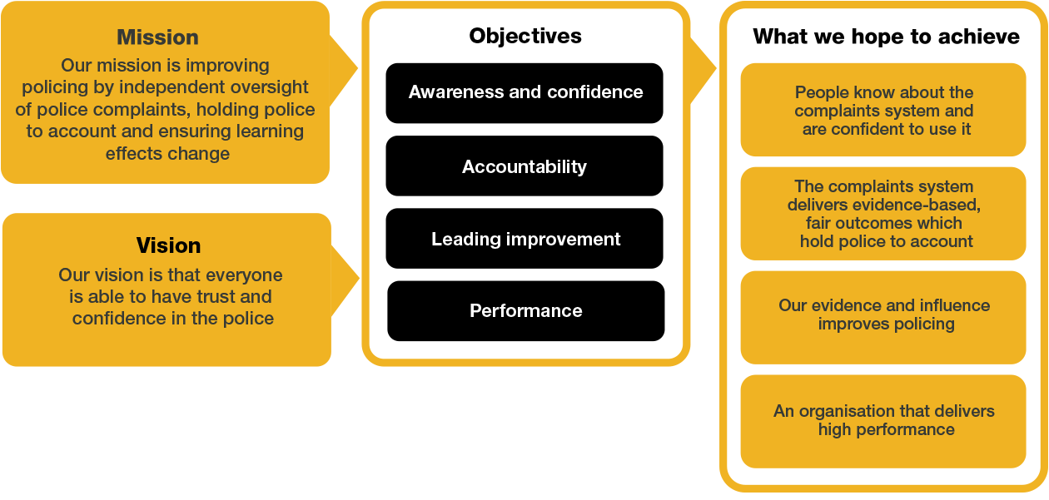Organisational context

We work in the context of our agreed values which inform the way we do things at the IOPC. The Governance Officer will need to be commited to working in the context of these values.

# Main duties and responsibilities

**Governance:**

1. To provide a high level of governance advice to board and committee members to support the furtherance of IOPC business.
2. To ensure that all boards and committees are provided with a comprehensive and efficient governance support services to enable them to discharge their roles.
3. Ensure governance process and procedures are adhered to in the implementation of the IOPC’s decision making process.
4. Develop policies, procedures, and processes to ensure compliance with governance arrangements and legislative requirements.
5. Monitor and identify new and emerging governance requirements/best practices/areas for improvement and determine potential impact for the IOPC.
6. Support the development of board and committee forward plans and take responsibility for ensuring report authors submit their papers and or reports in a timely manner.

**Research and communication:**

1. Under the direction of the Head of Governance ensure the intranet and internet pages are updated with relevant and up to date board and committee information.
2. Regularly update board and committee members with internal communications so that they are kept up to date.
3. Undertake research as directed by the Head of Governance to inform effective and efficient governance.

**Support:**

1. Develop, and support the delivery of board and committee member induction and orientation programmes into the IOPC.
2. To identify any training and personal development requirements and to assist the Head of Governance in the allocation of work and the provision of training and guidance to meet those assessed needs.
3. Prepare and distribute meeting agendas and papers in a timely manner, and support with the drafting of meeting minutes.

**Finance:**

1. Undertake monthly budget management and monitoring, ensuring accurate forecasts are provided to the Head of Governance.
2. Processing of invoices as and when required.

**General:**

1. To assist and support with general enquiries from board and committee members.
2. To assist and support the Head of Governance in maintaining a secure system for the management and retention of documents and for public access to relevant reports, decisions and background papers which is compliant with statutory governance requirements.
3. Assist the Head of Governance in developing and implementing operational plans and priorities for the governance team in accordance with the IOPC’s strategic objectives.
4. Always demonstrate high commitment to the equality, diversity and inclusion aims and strategy of the IOPC, as well as the values and behaviours.
5. To undertake any other duties that are commensurate with the role of a Governance Officer.

# Person specification

**Qualifications:**

* Educated to degree level or equivalent qualification, or experience.
* Evidence of continuing personal and professional development.

**Knowledge:**

* Understanding of the impact of governance regulatory frameworks and statutory regulations and how that affects the way an organisation functions.
* Good understanding of research methodologies and presenting findings in logical and clear manner.

**Experience:**

* Proven use of office systems, with advanced use of Microsoft Office, i.e. MS Word, PowerPoint, Outlook, and Excel.
* Experience in providing robust administrative support to, board and committee members, and senior leadership teams.
* Sound judgement and logical approach to decision making with the ability to determine and implement solutions.

**Skills:**

* Excellent written and verbal communication skills including presentation and report writing skills.
* Good analytical skills.
* Excellent inter-personal skills and the ability to communicate and work effectively with a wide range of people from different backgrounds at all levels of seniority.
* Proven standard of word processing skills, with a high standard of presentation and accuracy.
* The ability to plan and organise own workload and work autonomously.
* The ability to be innovative, objective as well as logical in resolving problems. The ability to maintain a high level of performance and meeting of deadlines even when faced with conflicting priorities of others.
* The ability to present complex information in a clear and logical manner.
* Ability to learn from mistakes as a positive learning opportunity and encourage others to do the same.
* The ability to prioritise and balance a range of competing tasks to deliver to agreed timescales.
* Professional and flexible attitude to work.

**Additional information:**

* The postholder must be able to work flexibly to meet the demands of the job role.
* The postholder must be able and willing to travel all IOPC locations, as and when required.

# Our Values

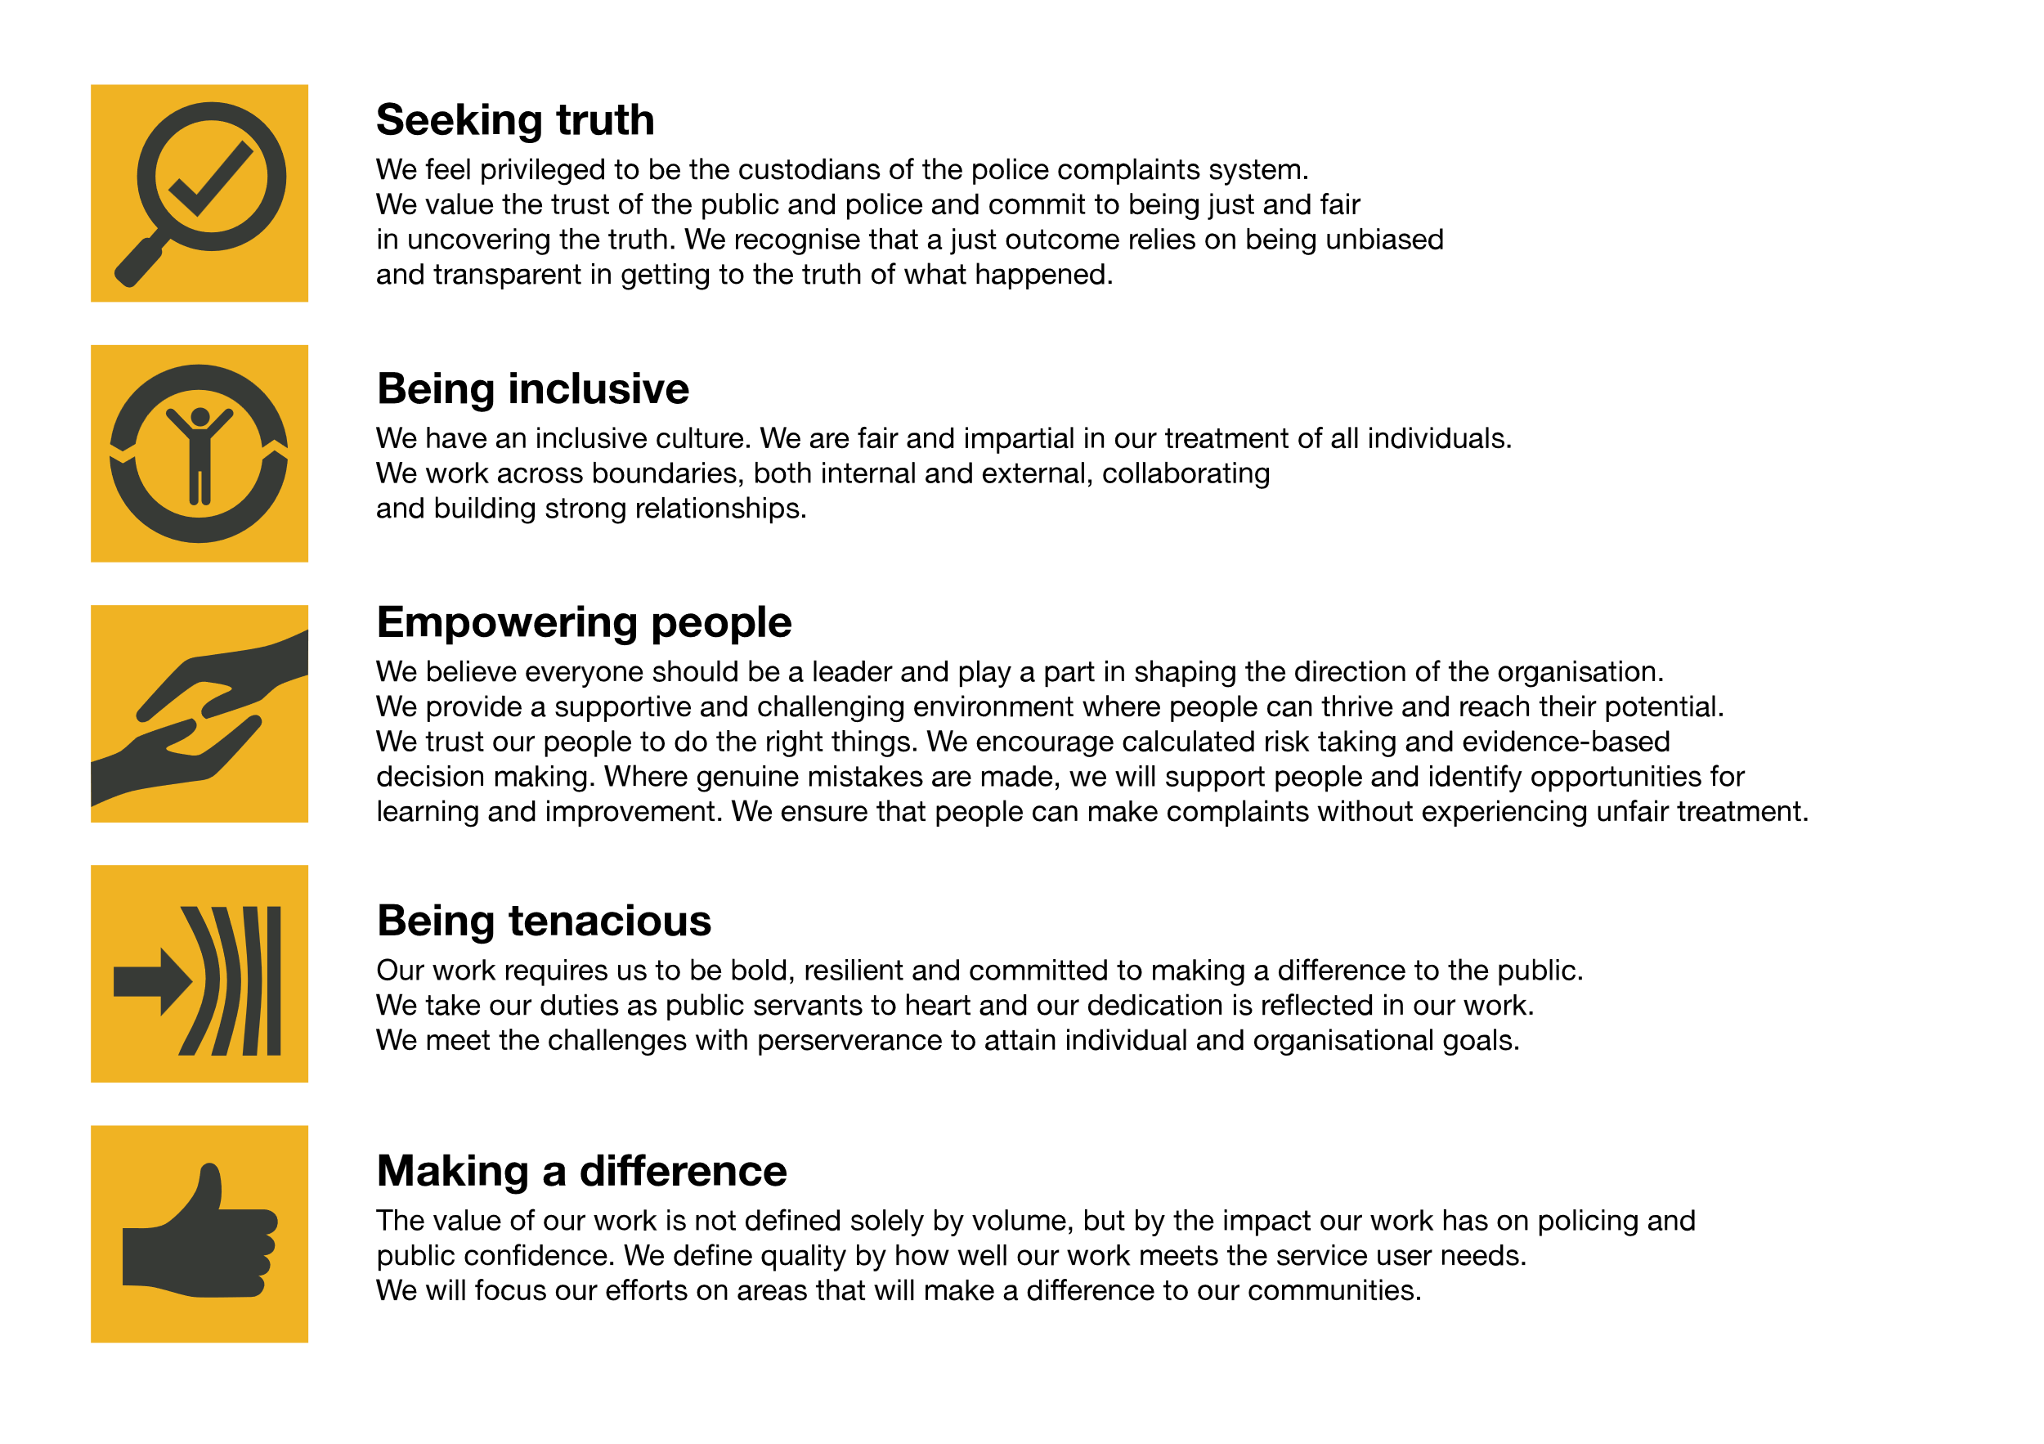

The IOPC is committed to **promoting equality and valuing diversity** in everything we do. Our vision is to be, and to be seen as, a leader in inclusive employment and services, demonstrating this ethos in everything that we do.

* As a silver standard Stonewall employer, we continue to commit ourselves to being a LGBTQ+ employer through the work of our Pride LGBTQ+ Staff Network, creating welcoming environments for lesbian, gay, bi and queer people.
* We are pleased to share we are a signatory of the Business in the Community Race at Work Charter. The Charter is composed of five [calls to action](https://race.bitc.org.uk/issues/racecharter) for leaders and organisations across all sectors.
* Being a Disability Confident employer, the IOPC is dedicated to removing the barrier for disabled people to thrive in the workplace.
* Our Staff Networks are constantly working to make the IOPC the leaders of inclusive employment, from our Allyship Programme, to [Welsh Language Standards](https://www.policeconduct.gov.uk/who-we-are/equality-and-diversity/welsh-language-standards) and Know the Line Policy, we are constantly seeking new ways to create an environment for all to develop and thrive.

## Reasonable adjustments

The IOPC is a diverse and inclusive workplace and we want to help you demonstrate your full potential whatever type of assessment is used. We are open to providing you with the tools you need to succeed. Whilst this list is not exhaustive, please see potential reasonable adjustments below that we can provide:

* Extra time for presentations or interview questions
* Formatting changes such as colours for text or background on written assignments
* Questions presented in writing during interviews

If you require any reasonable adjustments to our recruitment process, please email recruitment@policeconduct.gov.uk

## Working conditions

Making the IOPC a great place to work is one of our key priorities. We are pleased to offer a hybrid working model. The IOPC requires all staff to work 20% of their contractual hours at their office base (or another office for business reasons) from September 2024, increasing to 40% from April 2025. Office attendance time includes in-person training, meetings with stakeholders and families, as well as attending events.

Here at the IOPC, maintaining a culture that is accessible and inclusive of gender identity, sexuality, age, disability, race, sex, belief and caring responsibilities is deeply important to us. We believe that a rich, diverse workforce enables us a better understanding of each others needs, and produces more meaningful and trusting relationships, which in turn create more inclusive spaces where we all feel that we can contribute and belong.  We value our diversity, as we believe that our diversity is our strength. It allows us to identify with our communities through shared lived experiences producing better understanding and higher quality results in our work.

# What we offer

* 27.5 days paid annual leave (increasing with service to 32.5 days)
* Options to carry over, buy or sell annual leave
* Civil Service pension
* Civil Service maternity leave package
* PAM employee assistance programme
* Access to Civil Service Sports Council (CSSC) membership
* Cycle to work scheme
* Opportunity to enjoy the latest home and electronics in a more affordable way provided by Vivup
* Car Leasing Scheme
* Staff networks focused on each of the protected characteristics – run for staff, by staff:
* Age Network
* Enable Network
* Welsh Network
* Pride and LGBTQI+ Network
* Sex and Family Network
* Race, Religion and Belief Network
* Learning and development tailored to your role
* An environment with flexible working options
* A culture encouraging inclusion and diversity behaviours

## Preparation checklist

☐ Review the full job description

☐ Review the behaviours and the descriptors for each behaviour

☐ Review the Strengths dictionary

☐ Review the IOPC values

☐ Consider your Strengths

☐ Consider drafting example answers that cover the specific elements

☐ Prepare some questions to ask the interviewers