**JOB DESCRIPTION**

**TITLE:** Learning & Development Advisor

**REPORTS TO:** Learning & Development Business Partner

**LOCATION:** Any IOPC office (with travel)

**GRADE:** 10

**SALARY:** £30,032

**CONTRACT:** FTC until 30th June 2023

**PURPOSE**

The Independent Office for Police Conduct (IOPC) is committed to having an efficient and effective workforce and the L&D team is instrumental in realising that goal. The L&D team is ambitious and innovative; it strives to build a culture of learning and to empower people to drive their own development.

Reporting to the L&D Business Partner, the L&D advisor will work collaboratively with their peers and colleagues across the organisation to provide advice and support through a variety of learning and development initiatives.

The L&D Advisor will use expertise, collaboration and innovation to help solve business issues and support colleagues. They will help build a culture of continuous learning and improvement and always act as a role model by demonstrating IOPC values.

# ORGANISATIONAL CONTEXT

# 

We work in the context of our agreed values which inform the way we do things at the IOPC. The Learning and Development Advisor will need to be commited to managing in the context of these values.

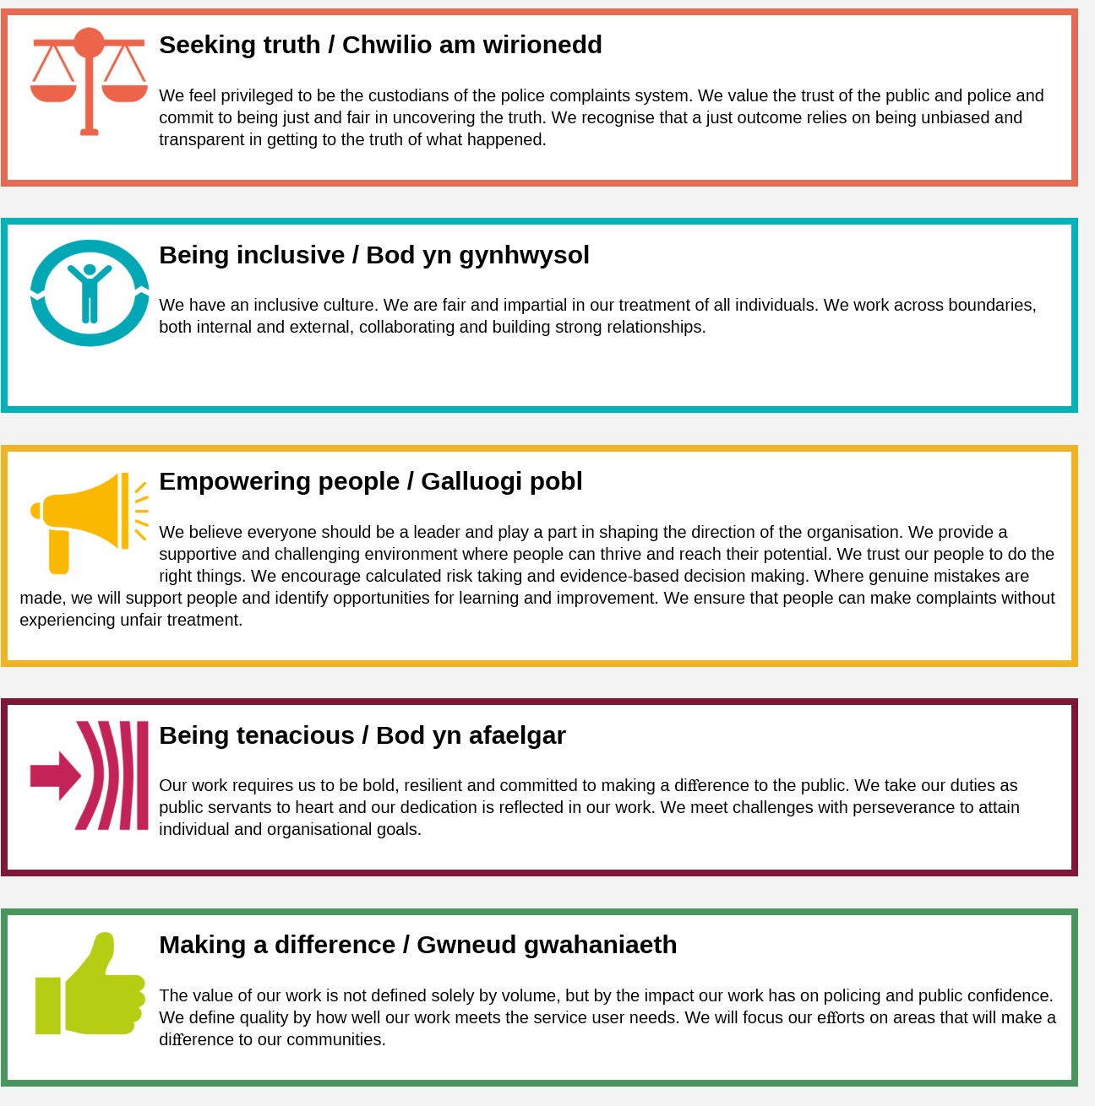

# ROLE DESCRIPTION

A multi-faceted L&D advisor role that provides opportunity to contribute to strategic work of the IOPC, influence a learning culture and make a difference to the people work here.

**MAIN DUTIES AND RESPONSIBILITIES**

**Engagement:**

* Advise stakeholders about L&D interventions which will effectively address learning needs and help solve business issues.
* provide advice and guidance to individuals on personal and professional development.
* Promote the work of the team and inspire others about learning and development through speaking in meetings, delivering presentations and networking at events and conferences.
* Design and deliver facilitated discussions, workshops and activities with multidisciplinary groups and colleagues.
* Identify skill gaps, learning needs and new opportunities for learning and improvement through continuous assessments and observations.
* Contribute to the development of the IOPC People Strategy through matrix working across the directorate, particularly with peers in the ODDT and PMW Teams
* Drive a learning culture during every conversation, using coaching conversation techniques.
* Manage and respond to relevant L&D queries received through the L&D inbox.

**Delivering L&D work:**

* Deliver defined L&D work packages (advice, research, design, delivering interventions & projects) through effective self-management, prioritisation and collaboration with others.
* Work closely with L&D consultants and peer L&D advisors to continuously re- evaluate and re-prioritise workloads to ensure a smooth delivery of L&D products to the business.
* Co-ordinate the successful delivery of the team’s activities, ensuring close working and consultation with the L&D support team
* Source and liaise with external providers, ensuring procurement and contracting guidance is followed.
* Develop, draft and present high-quality business reports outlining key L&D proposals and issues.
* Research, develop, draft and amend L&D strategies and policies at the direction of an L&D Business Partner.
* Lead and co-ordinate the management of the Learning at Work platform.
* Lead (or co-lead/support) the annual Learning at Work Week initiatives.
* Develop and produce L&D metrics.
* Team Work & Development
* Embrace opportunities for personal and professional growth on the team by having regular development conversations, giving and receiving constructive feedback.
* Deputise for L&D Consultants in their absence.
* Contribute to matrix teams brought together to deliver defined projects and outcomes.

**L&D Expertise:**

* Obtain and maintain a good understanding of the IOPC skill profile and existing L&D programmes, initiatives and products.
* Maintain credibility and professional expertise through driving own continuous professional development, keeping abreast of industry advances.
* Disseminate your learning, share good practice and ideas for improvement with the team and wider organisation.
* Ensure all L&D activities are underpinned by Equality (EIA) and Data Protection Impact Assessments (DPIA)
* Ensure L&D products add value and demonstrate impact and return on investment through effective evaluation.
* Engage with relevant external organisations to carry out benchmarking activities, access peer learning opportunities and seek out good practice.
* Horizon scan for innovations that can contribute to the teams/organisational goals.
* Design, develop and deliver effective and engaging learning & development solutions.
* Introduce a range of tools and techniques to encourage people to take responsibility for their own learning and development.
* Develop area (s) of L&D specialisms, dependent on business need and own development aspirations.

**PERSON SPECIFICATION**

**Essential Experience**

* A professional interest in Learning & Development
* Strong commitment to own personal and professional development.
* Confident communication and engagement skills in varied contexts.
* Experience of planning and co-ordinating programmes of work which have been successfully delivered.
* Experience of analysing and resolving problems or business issues.
* Creativity and innovation.
* Ability to write and produce professional and credible documents suitable for internal and external communications.
* Experience of managing multiple tasks within a rapidly changing environment.
* Organised, self-motivated and capable of working autonomously
* Intermediate or advanced use of IT such as excel, other MS office applications, including MS Teams.

**Desirable**

* Experience of Learning & Development in a professional context.
* CIPD Level 3 qualification or above in L&D or equivalent.

**Any move to the IOPC from another employer will mean you can no longer access childcare vouchers. This includes moves between government departments. You may however be eligible for other government schemes, including Tax-Free Childcare. Determine your eligibility at <https://www.childcarechoices.gov.uk/>.**

**Selection process**

This vacancy is using [**Success Profiles**](https://www.gov.uk/government/publications/success-profiles?_ga=2.156185915.1692943174.1578577916-319911383.1576576754). As part of the application process you will be asked to complete four sift questions.

The Behaviours being assessed are:

* Seeing the Big Picture
* Working Together
* Communicating and Influencing

For successful candidates who reach the assessment stage, we will provide further details of what will be assessed.

**What is Success Profiles?**

Success Profiles moves us to a tailored way of assessing, dependent on the requirements of the job. For each role we advertise, we consider what you will need to demonstrate in order to be successful. This gives us the best possible chance of finding the right person for the job, drives up performance and improves diversity and inclusivity so that we can truly reflect the communities that we serve.

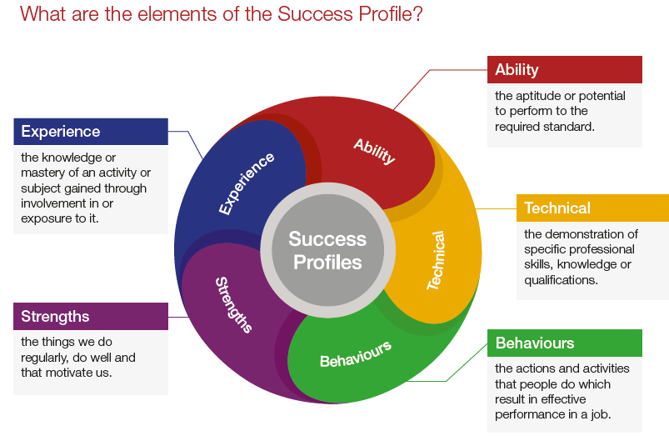Not all of the elements are relevant to every role, and will vary depending on the level and type of role. You should ensure you read the job description carefully to see what elements are required for the specific job you are applying for. There are separate guides to each of the elements, which will give you more information about what and how you can demonstrate specific requirements.

**How the elements are assessed**

You could be assessed in a number of different ways, depending on the type of role and level you are applying for. Using a range of assessment methods helps us to more accurately match people to the essential requirements of the job. For example, you may be asked to complete an application form; provide a CV and supporting statement; attend an assessment centre; or complete an online test. Often a combination of these approaches will be used and more than one element may be tested within the same assessment method.

Details of which elements will be assessed and how we will assess you against these, are included in the job description.

**Reasonable adjustments**

The IOPC is a diverse and inclusive workplace and we want to help you demonstrate your full potential whatever type of assessment is used. If you require any reasonable adjustments to our recruitment process please let the recruiting manager know.

**Preparation checklist**

Review the full job description ☐

Review the behaviours and the descriptors for each behaviour☐

Review the Strengths dictionary ☐

Review the IOPC values ☐

Consider your Strengths (if applicable) ☐

Consider drafting example answers that cover the specific elements ☐

Prepare some questions to ask the interviewers ☐