

**J**

**ob**

**D**

**escription**

**T**

**itle**

**Title:** Senior Executive Support

**Reports to:** Deputy Director General

|  |  |
| --- | --- |
| **Location:** | Canary Wharf or Sale |
| **Grade:** | Grade 13 |
| **Salary:** | £44,493(London weighting of £4968 if based in Canary Wharf) |
| **Contract:** | Fixed-term until 27/04/2026 |

# Purpose

The IOPC is on a transformation journey and this role offers an opportunity to be at the heart of it by joining a dynamic Executive Support Services Team (ESS). The Executive Support Services team delivers high quality executive support to the IOPC senior leadership team and has a key role in enabling the delivery of the IOPC strategic objectives.

This newly established team forms part of a matrix management structure which allows team members to thrive in a fast-paced, high performing and collaborative environment.

As the Senior Executive Support you will be work closely with and provide personal support to either the Deputy Director General of Strategy, Engagement & Comms or the Deputy Director General of Investigations, Oversight & Casework. You will develop deep insights into the work of the organisation at a strategic level and with this, provide a high level of support and advice to the Deputy Director Generals, enabling them to perform at the highest level.

You will provide direct line management to the Executive Assistant to the Deputy Director General and work together to ensure highly effective tailored and focused executive support for the individual.

You will quickly establish effective working relationships across the IOPC Senior team and specifically with the Director General’s Office and the Executive Support Services Team, delivering seamless executive support to the organisation.

# Organisational Context

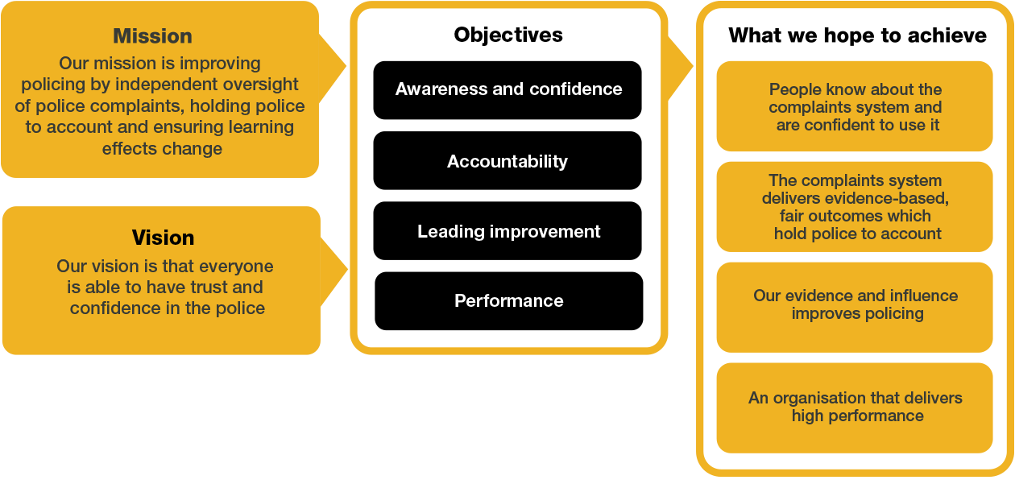

We work in the context of our agreed values which inform the way we do things at the IOPC. As Senior Executive Support you will need to be committed to managing in the context of these values.

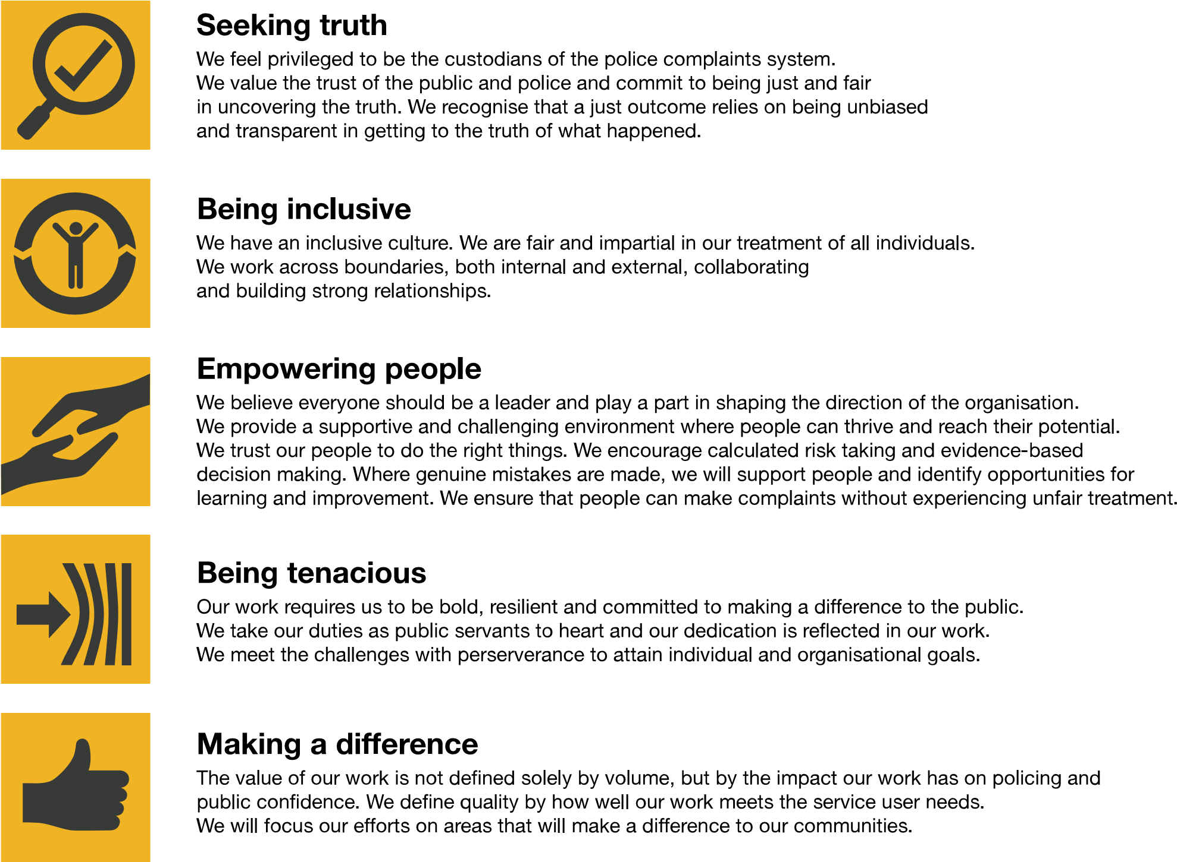

The IOPC is committed to **promoting equality and valuing diversity** in everything we do. Our vision is to be, and to be seen as, a leader in inclusive employment and services, demonstrating this ethos in everything that we do.

* As a silver standard Stonewall employer, we continue to commit ourselves to being a LGBTQ+ employer through the work of our Pride LGBTQ+ Staff Network, creating welcoming environments for lesbian, gay, bi and queer people.
* We are pleased to share we are a signatory of the Business in the Community Race at Work Charter. The Charter is composed of five [calls to action](https://race.bitc.org.uk/issues/racecharter) for leaders and organisations across all sectors.
* Being a Disability Confident employer, the IOPC is dedicated to removing the barrier for disabled people to thrive in the workplace.
* Our Staff Networks are constantly working to make the IOPC the leaders of inclusive employment, from our Allyship Programme to [Operation Hotton,](https://www.policeconduct.gov.uk/recommendations/operation-hotton-recommendations-metropolitan-police-service-september-2021) to [Welsh Language Standards](https://www.policeconduct.gov.uk/who-we-are/equality-and-diversity/welsh-language-standards) and Know the Line Policy, we are constantly seeking new ways to create an environment for all to develop and thrive.



# Main duties and responsibilities

* To act in a key advisory capacity to the Deputy Director General in matters across the business.
* Assisting in the development and implementation of business strategies, providing insights, and facilitating strategic meetings.
* Ensuring the Deputy Director General is fully prepared for meetings, providing briefings, action updates and stakeholder information to ensure they can achieve the meeting objectives.
* Preparing speeches, speaking notes and briefings using authentic application of voice and tone of the speaker.
* To draft reports, non-routine correspondence and communication material on behalf of the Deputy Directors Generals (for both internal and external stakeholders).
* Assisting in the creation and revision of IOPC policies, relevant to the Deputy Director General’s business area.

* To identify areas of potential organisational risk across the business and to demonstrate initiative to make judgements on appropriate mitigating actions, including an assessment of whether risks/issues require further escalation to the Deputy Director General and or Director General/Chief of Staff.
* To handle and lead discrete pieces of work on behalf of the Deputy Director General.
* Acting decisively in urgent situations, implementing contingency plans, and maintaining communication to ensure business continuity and mitigate risks.
* Lead on solutioning high priority issues that are escalated to Deputy Director Generals, collaborating with and influencing relevant colleagues to an effective resolution.
* To assist the Deputy Director General with preparing for delivering Drive and performance management of direct reports.
* Provide support with budget management, processing and interpreting finance reports, and conducting preliminary financial analysis to aid in decision-making.
* To provide direct line management to the Executive Assistant (G10) ensuring high quality and performance in the delivery executive support to the individual.
* Manage and protect the Deputy Director General’s time, through close working with the Executive Assistant.
* To work closely with the wider Director Generals office and Executive Support team ensuring that seamless executive support service is delivered.

**Cultural Competence, Equality, Diversity & Inclusion:**

* Be pro-active and committed to equity, diversity and inclusion.
* Demonstrate cultural competence when interacting with all stakeholders.

## Person specification

### Experience & Qualifications

* Knowledge of the work of the IOPC and the wider public sector environment.
* Previous experience of providing executive support to a senior leader.
* Experience of preparing high level professional reports and documents for both internal and external senior audiences.
* Experience of drafting speaking notes and speeches with authentic application of voice and tone of the speaker.
* Experience of working with diverse groups, networking and building professional productive relationships.
* Line management experience, focused on delivering high performance and quality.
* Proven track record of delivery, demonstrating an analytical approach to making judgements and decisions in a fast moving and fluctuating working environment.
* Experience of project managing cross directorate/ organisational initiatives.
* Evidence of having acted with discretion to deal appropriately with confidential matters.
* Able to be Security Cleared to the appropriate level.

### Skills and Abilities

* Demonstrable ability to communicate effectively, both verbally and in writing, with experience in building relationships with a diverse and challenging group of stakeholders.
* Proficiency in the use of ICT, including MS Office, Word, Excel, PowerPoint, SharePoint and MS Teams.
* Task management - ability to manage a fluctuating workload and adapt to fast moving demands.
* Trouble shooter with ability to quickly understand an issue and apply a fix.
* Demonstrable ability to quickly grasp new/complex concepts and assimilate information quickly.
* Comfortable taking decisions within a clear framework of delegation.

#### Reasonable adjustments

The IOPC is a diverse and inclusive workplace and we want to help you demonstrate your full potential whatever type of assessment is used. We are open to providing you with the tools you need to succeed, from extra time to formatting changes, to name a mere few. If you require any reasonable adjustments to our recruitment process, please email recruitment@policeconduct.gov.uk

#### Working conditions

Making the IOPC a great place to work is one of our key priorities. We are pleased to offer a unique hybrid working model based on business needs, balanced with the needs of our colleagues.

The IOPC hybrid working policy requires all staff to work 20% of their contractual hours at their office base (or another office for business reasons) 1 September 2024, increasing to 40% from April 2025. Office attendance time includes in-person training, meetings with stakeholders and families, and attending events.

#### Preparation checklist

|  |  |
| --- | --- |
|  |  |
| ☐ | Review the full job description |
| ☐ | Review the behaviours and the descriptors for each behaviour |
| ☐ | Review the Strengths dictionary |
| ☐ | Review the IOPC values |
| ☐ | Consider your Strengths |
| ☐ | Consider drafting example answers that cover the specific elements |
| ☐ | Prepare some questions to ask the interviewers |