Job description
Title: Digitisation Assistant – Hillsborough x 2
Reports to: Archive Manager
Location: Warrington
Grade: Grade 8
Salary: £28,665
Contract: 1 x Fixed Term position until 31st December 2025
1 x Fixed Term position until 31st March 2026

Purpose
As a Digitisation Assistant in the Hillsborough team you will be welcomed into a dynamic and inclusive directorate working to undertake digitisation of historical material, following appropriate preservation and digitisation standards, relating to the Hillsborough Stadium Disaster of 1989 and its aftermath. The IOPC is on a journey to develop its culture, perspectives and ethos to support the organisation’s core outcomes and this is your opportunity to enter into the varied world of IOPC digitisation, allowing you to develop your mindset and approaches to contribute to improving the police complaints system in England and Wales.
The post holder will undertake quality assurance of digitised records, searching a range of systems to assess duplication, also assist with the ongoing investigation.

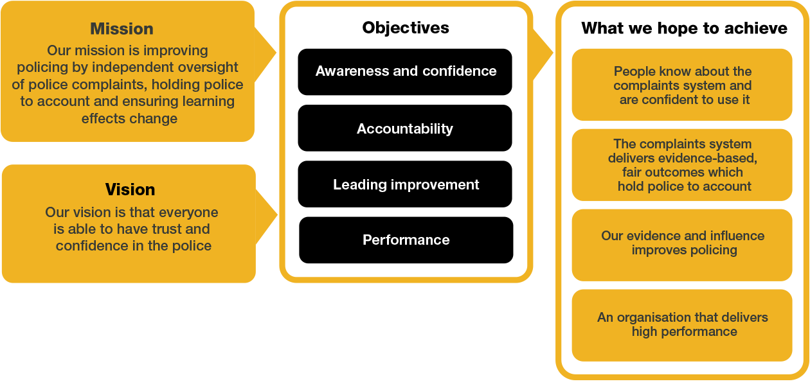
Organisational Context

We work in the context of our agreed values which inform the way we do things at the IOPC. The Digitisation Assistant – Hillsborough will need to be commited to managing in the context of these values.

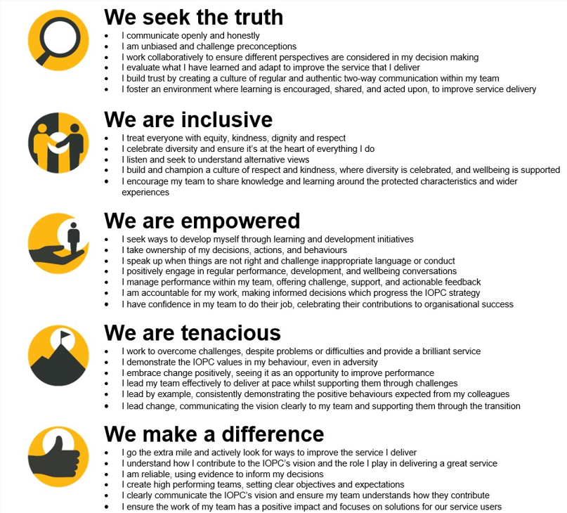

The IOPC is committed to promoting equality and valuing diversity in everything we do. Our vision is to be, and to be seen as, a leader in inclusive employment and services, demonstrating this ethos in everything that we do.
- As a silver standard Stonewall employer, we continue to commit ourselves to being a LGBTQ+ employer through the work of our Pride LGBTQ+ Staff Network, creating welcoming environments for lesbian, gay, bi and queer people.
- We are pleased to share we are a signatory of the Business in the Community Race at Work Charter. The Charter is composed of five calls to action for leaders and organisations across all sectors.
- Being a Disability Confident employer, the IOPC is dedicated to removing the barrier for disabled people to thrive in the workplace.
- Our Staff Networks are constantly working to make the IOPC the leaders of inclusive employment, from our Allyship Programme to Operation Hotton, to Welsh Language Standards and Know the Line Policy, we are constantly seeking new ways to create an environment for all to develop and thrive.




Main duties and responsibilities
- To undertake the digitisation of the Hillsborough archive material, for which the IOPC are custodians, ensuring appropriate digitisation and preservation standards are adhered to and the safety of and appropriate handling of the record at all times
- To ensure the integrity of the historic archive material relating to the Hillsborough Stadium Disaster and its aftermath is maintained by locating, retrieving and re-shelving records in a timely and accurate manner
- To quality assure all scanned records, through searching through a range of systems including databases and spreadsheets utilised by IOPC
- To ensure at all times that information contained within the collections is managed lawfully under the terms of the Data Protection and Freedom of Information Acts. To safeguard information and ensure it is not released unlawfully or restricted unnecessarily
- To perform audits of digitised material to ensure the completion of the digitisation project and to determine the quality of the records of this digitised material, providing suggestions for improvements and quality assurance. Including audio visual material held on removeable media, ensuring digital continuity and preservation is maintained for future posterity.
- To assess the risks of this content and assisting in the migration of this content to a secure format. At all times adhering to the IOPC Digital Continuity Police and Hillsborough Retention Schedule (in development)
- To quality assure the redactions work of Legacy Team Members, to ensure all file names and scan quality have remained of a high standard and nothing has been changed or altered in error

Person specification

Essential Experience
- Experience of handling and working with archive material, and document production
- Experience of digitisation of archival material
- Experience of quality assurance
- Understanding of archive cataloguing standards and principles, including ISAD(G)
- Ability to retrieve detailed information from sources accurately
- Experience of working with information within a Data Protection and Freedom of Information environment
- Experience of working with discretion, confidentiality and sensitivity
- Experience of working to tight deadlines and adjusting working practices accordingly
- Knowledge of relevant legislation, standards and procedures in relation to collections management
- Proven experience of working effectively in a team environment
- Ability to work independently with minimal supervision
- Experience of having worked with multiple time demands and deadlines, exercising judgement on time management

Desirable Experience
- Experience of researching the HOLMES 2 database for investigation material
- Experience of using Relativity
- Experience of digital preservation

Reasonable adjustments
The IOPC is a diverse and inclusive workplace and we want to help you demonstrate your full potential whatever type of assessment is used. We are open to providing you with the tools you need to succeed, from extra time to formatting changes, to name a mere few. If you require any reasonable adjustments to our recruitment process, please email recruitment@policeconduct.gov.uk

Working conditions
The IOPC are currently consulting with our consultative bodies about proposed changes to our hybrid working policy which will require all staff to work 20% of their contractual hours at their office base (or another office for business reasons) from 1 September 2024 and will be increased to 40% from April 2025. Office attendance time includes in-person training, meetings with stakeholders and families, and attending events.

Preparation checklist
☐ Review the full job description
☐ Review the behaviours and the descriptors for each behaviour
☐ Review the Strengths dictionary
☐ Review the IOPC values
☐ Consider your Strengths (if applicable)
☐ Consider drafting example answers that cover the specific elements
☐ Prepare some questions to ask the interviewers

