

**JOB DESCRIPTION**

**TITLE:** People Business Partner

**REPORTS TO:** Head of People Management and Wellbeing

**LOCATION:** Birmingham or London (Canary Wharf or Croydon offices)

**GRADE:** 13

**SALARY:** £44,340, plus London Weighting Allowance of £4527, if based in Canary Wharf or Croydon

**CONTRACT:** Permanent

**PURPOSE**

The role focuses on making the IOPC a great place to work by ensuring that all colleagues in the IOPC have access to effective modern people policies and timely advice and support. The People Business Partner service is focused on pre-empting issues and early problem solving by finding flexible person-centred solutions to problems and issues.

People Business Partners support managers to focus on effective business change. This includes using data insights, implementing corporate changes and working closely with managers on complex people management issues.

People Business Partners are the key point of contact between the People directorate and local functional or regional management teams enabling the wider business to input into draft policies, access services and influence the development of corporate strategy.

# ORGANISATIONAL CONTEXT

# 

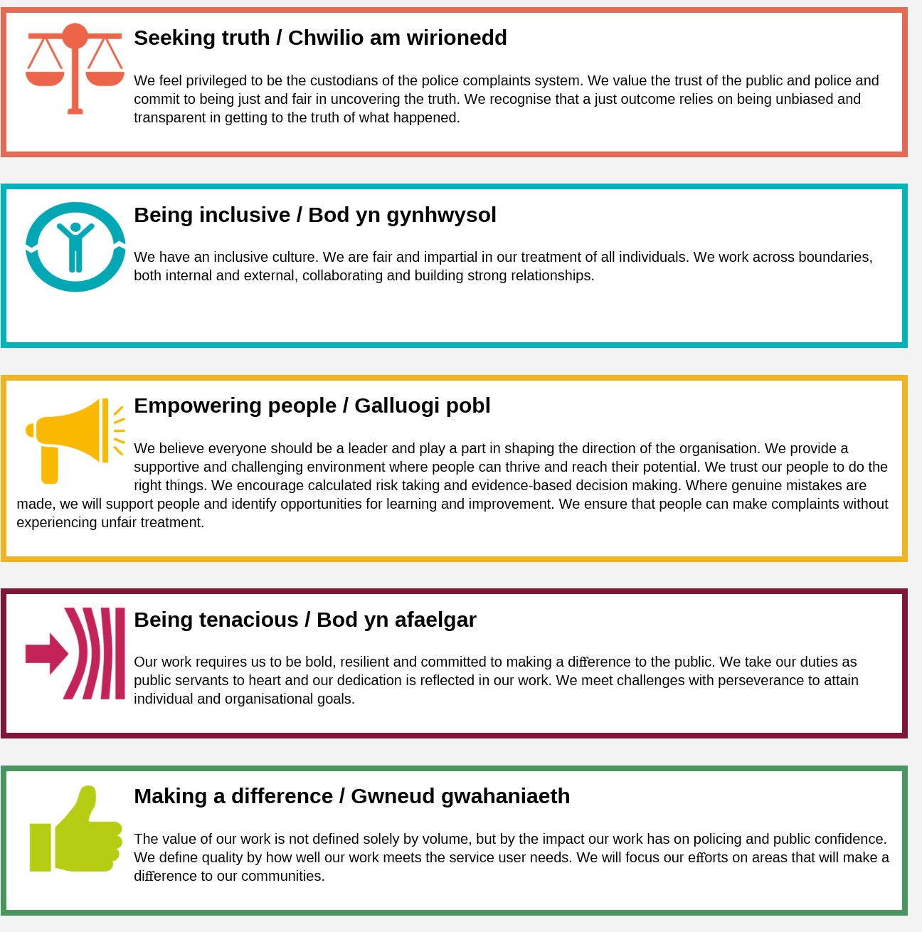We work in the context of our agreed values which inform the way we do things at the IOPC. The People Business Partner will need to be commited to managing in the context of these values.

**MAIN DUTIES AND RESPONSIBILITIES**

**Corporate and Managerial**

* Lead, manage, motivate and coach a small team and identify opportunities for improvement
* Contribute to the development and implementation of the IOPC People Strategy as a member of the People Directorate Management Team
* Recognise and implement changes to corporate policy and practice
* Maintain excellent relationships across the People directorate and collaborate on projects and initiatives, leading where necessary.
* Show strategic awareness and maintain an up to date knowledge of IOPC operational challenges
* Identify and challenge risk and escalate as needed
* Sign off FOI and subject access requests on behalf of the Information Asset Owner, escalating items where relevant
* Ensure that when issues are raised that are relevant to other parts of the Directorate or Corporate Services generally, these are passed to the relevant colleague for action
* Contribute to change initiatives within the People directorate
* Work collaboratively with the finance team and business planning team to understand the financial and planning constraints governing change programmes
* Provide suitable reports to the HR&R committee, Management Board and Non-executive Directors as necessary

**Strategic Business Partner**

* Understand the immediate issues and concerns in relevant customer departments and contribute to improvement plans
* Contribute to discussions about the core work of the customer department, working closely with senior managers to contribute to problem solving, providing challenge and appropriate support and guidance.
* Design a relevant balanced scorecard of data for customer department and present areas for action and focus
* Lead workforce planning and succession planning with customer departments, thinking ahead and anticipating possible outcomes and their impact
* Assist in the annual planning and budgeting process

**Policy**

* Take responsibility for the development of a policy area, acting as a source of expert guidance for others in the team
* Ensure that case law and good practice guidance relating to the specialist area is disseminated to colleagues
* Ensure that all managers in the customer department are aware of relevant policy and best practice.
* Assisting with the embedding of necessary people management and wellbeing processes and principles within customer departments
* Attend JNC and Staff Council as needed to discuss policy amendments
* Comment on policy and practice documents prepared by others ensuring that the suite of people policies are consistent

**Outreach / Staff Engagement**

* Ensure that HelpPoints happen regularly at every location for which responsible; personally contribute to the HelpPoint rota and ensure that learning is captured and followed up for the benefit of the whole team
* Ensure that a member of the team is available in person for a conversation with colleagues every day during core hours. In exceptional circumstances, they must be available for a telephone conversation if physical presence is not possible.
* Work with colleagues, employee representatives and STREAM practitioners to ensure that individual employee issues and concerns are solved speedily
* Work with internal communications to ensure that relevant news stories about customer departments are shared

**Employee Relations**

* Ensure that employee relations cases are run in an effective, pragmatic and timely manner
* Deploy mediation and problem-solving skills to resolve disputes within teams
* Provide expert advice, guidance and coaching to the Assistant Business partners and line managers about the application of the law and best practice in relation of ER matters
* Personally manage complex cases and those involving senior staff
* Act as Investigating Officer for complex casework as necessary
* Support ER Appeals
* Maintain an oversight of ET cases and liaise with our principal employment lawyers about complex matters and to build and maintain an excellent relationship with them.
* Consult with the Home Office Sponsor Unit and Cabinet office as needed, submitting suitable business cases to gain permission for severance schemes if needed
* Manage small scale change processes
* Contribute to the management of large scale change processes, including insourcing outsourcing and TUPE
* Ensure that best practice policies are followed to minimise the impact of change on individuals
* Consult about proposed changes with trades unions and staff representatives taking on board ideas and feedback to improve the case for change and implementation plans

**Recruitment**

* Plan workforce requirements with customer departments
* Provide advice and guidance on job design and evaluation
* Ensure that recruitment casework is managed effectively and time to hire targets are achieved.
* Advise on legal issues (e.g. positive action, discrimination)
* Ensure that recruited staff are processed efficiently and receive a friendly personal service during onboarding
* Make decisions about candidate suitability in collaboration with senior line managers
* Collaborate with colleagues in the payroll team to ensure that employee changes are processed efficiently
* Contribute to the development of best practice in recruitment and maintain close working links with the OD&TD team

**Customer Service**

* Collect and analyse customer feedback data about the quality and timeliness of advice and support
* Work with the team to identify key performance indicators and service improvements

**PERSON SPECIFICATION**

**Essential**

* CIPD level 7, or actively working towards.

**Experience**

* Significant experience in a senior HR role in a dynamic organisation
* Experience of complex employee relations, resourcing, change management and performance management
* Proven track record of proving credible, expert advice and services to managers in a complex environment.
* Proven track record of delivering significant and measurable business benefits
* Designing, delivering and implementing tailored solutions, business processes, policies and procedures in accordance to organisational and People strategic direction

**Skills and Abilities**

* Up to date and demonstrable comprehensive knowledge of HR practice, concepts and themes including employment law and employee relations issues
* Experience of managing a small HR team
* Up to date knowledge of employment legislation and best practice
* Promote and embed equality and diversity as an integral aspect of working
* Strong commercial awareness, with an understanding of the need to balance commercial success with organisational values
* Understanding of health and wellbeing practices that support a positive attendance culture
* Excellent interpersonal, consultancy, communication, negotiating and influencing understanding and skills
* Able to gain respect and confidence of professionals and management colleagues, sustain credibility and maintain strong working relationships

**Selection process**

This vacancy is using [**Success Profiles**](https://www.gov.uk/government/publications/success-profiles?_ga=2.156185915.1692943174.1578577916-319911383.1576576754). As part of the application process you will be asked to complete four sift questions.

The Level 3 Behaviours being assessed at application stage are:

* Communicating and Influencing
* Making Effective Decisions
* Changing and Improving

In addition, you will also be assessed against your experience.

If you are shortlisted for interview, we will provide further details of what will be assessed.

**What is Success Profiles?**

Success Profiles moves us to a tailored way of assessing, dependent on the requirements of the job. For each role we advertise, we consider what you will need to demonstrate in order to be successful. This gives us the best possible chance of finding the right person for the job, drives up performance and improves diversity and inclusivity so that we can truly reflect the communities that we serve.

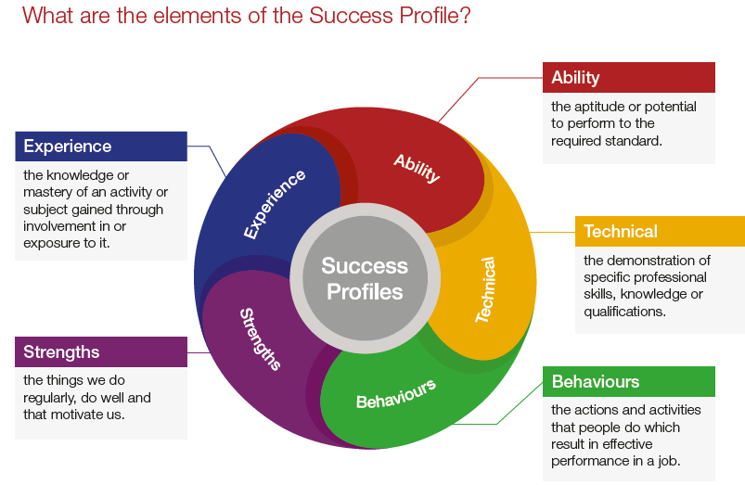Not all of the elements are relevant to every role, and will vary depending on the level and type of role. You should ensure you read the job description carefully to see what elements are required for the specific job you are applying for. There are separate guides to each of the elements, which will give you more information about what and how you can demonstrate specific requirements.

**How the elements are assessed**

You could be assessed in a number of different ways, depending on the type of role and level you are applying for. Using a range of assessment methods helps us to more accurately match people to the essential requirements of the job. For example, you may be asked to complete an application form; provide a CV and supporting statement; attend an assessment centre; or complete an online test. Often a combination of these approaches will be used and more than one element may be tested within the same assessment method.

Details of which elements will be assessed and how we will assess you against these, are included in the job description.

**Reasonable adjustments**

The IOPC is a diverse and inclusive workplace and we want to help you demonstrate your full potential whatever type of assessment is used. If you require any reasonable adjustments to our recruitment process please let the recruiting manager know.

**Preparation checklist**

Review the full job description ☐

Review the behaviours and the descriptors for each behaviour☐

Review the Strengths dictionary ☐

Review the IOPC values ☐

Consider your Strengths (if applicable) ☐

Consider drafting example answers that cover the specific elements ☐

Prepare some questions to ask the interviewers ☐