Job description
Title: Strategy and Planning Manager
Reports to: Strategy Unit Manager
Location: Any IOPC Office
Grade: 13
Salary: £47,493
Contract: Permanent

Purpose
As a Strategy and Planning Manager, you will be welcomed into a dynamic and inclusive Strategy team working on the IOPC’s business planning process. The IOPC is on a journey to develop its culture, perspectives and ethos to support the organisation’s core outcomes and this is your opportunity to enter into the varied world of IOPC Strategy allowing you to develop your mindset and approaches to contribute to improving the police complaints system in England and Wales.
The Strategy and Planning Manager is responsible for:
- Managing the IOPC’s annual business planning process, ensuring plans are affordable, deliverable and aligned to the organisation’s strategy
- Leading efficiency and investment planning across the organisation, ensuring the production of robust and deliverable plans for improving the efficiency of the organisation and identifying where the organisation wants to invest.
- Providing and maintaining a process for effectively managing in-year changes to agreed business plans
- Leading in the Strategy and Planning team and managing the Strategy and Planning Officer(s).
- Supporting the planning and delivery of elements to improve the strategic maturity of the organisation.
The Strategy and Planning Manager leads within the Strategy and Planning team and manages the staff within the team. The Strategy Unit leads on the development of the strategic direction for the organisation, ensuring we answer, “are we are doing the right things?” to deliver our mission through understanding the capabilities we need and planning how we deliver on the success we have stated. We ensure our strategic maturity improves and report on the progress of delivery against the Strategy to enable effective decision making to answer “are we doing them right?”

Organisational context
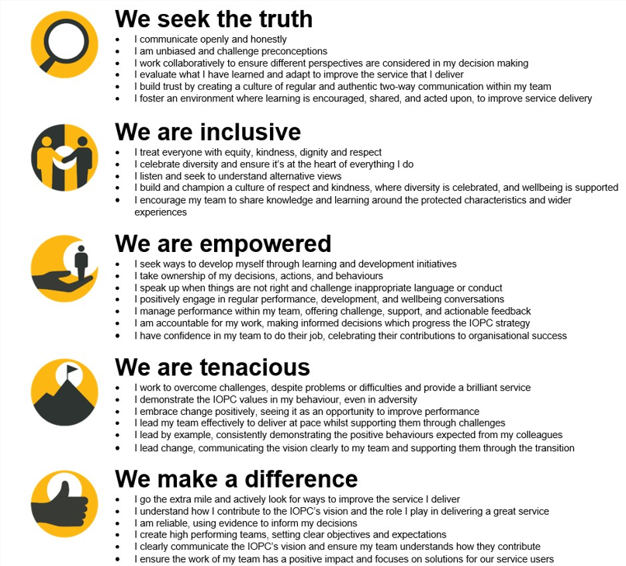

We work in the context of our agreed values which inform the way we do things at the IOPC. The Strategy and Planning Manager will need to be commited to managing in the context of these values.
The IOPC is committed to promoting equality and valuing diversity in everything we do. Our vision is to be, and to be seen as, a leader in inclusive employment and services, demonstrating this ethos in everything that we do.
- As a silver standard Stonewall employer, we continue to commit ourselves to being a LGBTQ+ employer through the work of our Pride LGBTQ+ Staff Network, creating welcoming environments for lesbian, gay, bi and queer people.
- We are pleased to share we are a signatory of the Business in the Community Race at Work Charter. The Charter is composed of five calls to action for leaders and organisations across all sectors.
- Being a Disability Confident employer, the IOPC is dedicated to removing the barrier for disabled people to thrive in the workplace.
- Our Staff Networks are constantly working to make the IOPC the leaders of inclusive employment, from our Allyship Programme to Operation Hotton, to Welsh Language Standards and Know the Line Policy, we are constantly seeking new ways to create an environment for all to develop and thrive.




Main duties and responsibilities
- Maintain a sound understanding of the context in which the IOPC operates and ensure intelligence from its own work and work across the police complaints system informs planning activity
- Manage the IOPC’s annual business planning process, ensuring plans are affordable, deliverable and aligned to the organisation’s strategy
- Interact with finance to
  - produce annual budgets to ensure that annual plans are deliverable and appropriately resourced
  - identify future financial pressures and investment opportunities that will affect our budget
  - ensure resources are dedicated where needed through the in year change process.
  - ensure there is a collaborative approach to strategic financial planning
- Work collaboratively with the Performance team to ensure that measures are agreed as part of the Business Plan.
- Produce the IOPC’s annual business plan documents, ensuring plans are effectively communicated to internal and external stakeholders in a timely manner
- Provide and maintain a process for effectively managing in-year changes to agreed business plans
- Lead efficiency and investment planning across the organisation, ensuring the production of robust deliverable plans for improving the efficiency of the organisation and developing plans that enable us to invest.
- Ensure good practice is adhered to in relation to the planning processes, liaising with other functions across the organisation to support delivery.
- Continuously improve the planning processes to increase the organisations strategic maturity, identifying innovative solutions to problems to ensure they continue to meet the needs of the business and follows best practice
- Develop and maintain good relationships with senior managers and Directors to provide advice, challenge and guidance across all planning activity.
- Analyse information to provide support and advice to the DG, Management Board and Unitary Board to ensure plans are robust, deliverable and strategically aligned to enable them to make effective decisions.
- Lead the Strategy and Planning team and manage, develop and oversee the work of the Strategy and Planning Officer(s) to ensure delivery of the team’s objectives and improve the organisation’s strategic maturity.
- Support the delivery of new strategic plans and other strategic planning activity, as required, influencing their development direction
- Deputise for the Strategy Unit Lead when necessary and provide support on the functioning of the Strategy Unit and the planning of activity to improve our strategic maturity.
- Work flexibly to support the work of the Strategy, Policy and Impact directorate to ensure it continues to meet its objectives
- Act as a representative of the Strategy, Policy and Impact directorate , providing leadership and supporting engagement activity across the organisation as required.

Person specification

Essential Experience
- Experience in leading business and financial planning processes
- Ability to think strategically to see the bigger picture
- Knowledge of strategic planning processes and models.
- Knowledge and experience of change control processes and ability to identify how to resources effectively.
- developing and drafting strategic plans
- developing and maintaining effective relationships with a variety of internal stakeholders including the DG, DDGs and Directors (Senior leaders) .
- Working collaboratively with key teams in these processes ie Finance, communications and the performance team.
- providing advice and challenge to and influencing more senior colleagues
- excellent administration and co-ordination skills
- using persuasion, negotiating and influencing skills to develop and maintain good relationships with senior customers / stakeholders
- analysing complex issues and problems and ability to clearly communicating them orally and in writing and make recommendations to get effect decisions to solve these.
- staff management and team building.

Desirable
- knowledge of project methodology (Prince 2) – desirable

Reasonable adjustments
The IOPC is a diverse and inclusive workplace and we want to help you demonstrate your full potential whatever type of assessment is used. We are open to providing you with the tools you need to succeed, from extra time to formatting changes, to name a mere few. If you require any reasonable adjustments to our recruitment process, please email recruitment@policeconduct.gov.uk

Working conditions
The IOPC are currently consulting with our consultative bodies about proposed changes to our hybrid working policy which will require all staff to work 20% of their contractual hours at their office base (or another office for business reasons) from 1 September and increased to 40% from April 2025. Office attendance time includes in-person training, meetings with stakeholders and families, and attending events.

Preparation checklist
☐ Review the full job description
☐ Review the behaviours and the descriptors for each behaviour
☐ Review the Strengths dictionary
☐ Review the IOPC values
☐ Consider your Strengths (if applicable)
☐ Consider drafting example answers that cover the specific elements
☐ Prepare some questions to ask the interviewers

