Job description
Title: Finance Business Partner
Reports to: Senior Finance Business Partner
Location: Birmingham, Cardiff, Sale, Wakefield
Grade: 13
Salary: £47,493
Contract: Permanent

Purpose
As a Finance Business Partner, you will be welcomed into a dynamic and inclusive Finance Team working across the organisation to influence decision making using financial insight and support operational improvements and resource allocation.
The IOPC is on a journey to develop its culture, perspectives and ethos to support the organisation’s core outcomes, and this is your opportunity to enter the varied world of IOPC Finance, allowing you to develop your mindset and approaches to contribute to improving the police complaints system in England and Wales.

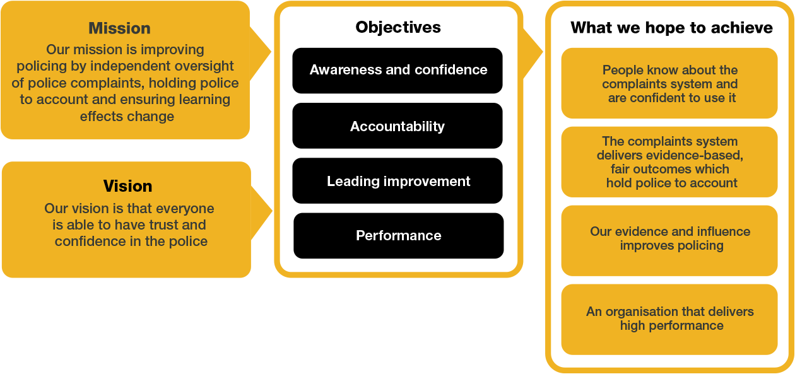
Organisational context

We work in the context of our agreed values which inform the way we do things at the IOPC. The Finance Business Partner will need to be commited to managing in the context of these values.

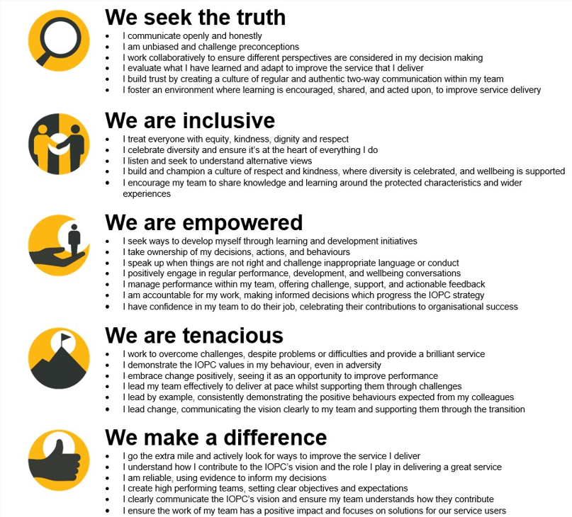
The IOPC is committed to promoting equality and valuing diversity in everything we do. Our vision is to be, and to be seen as, a leader in inclusive employment and services, demonstrating this ethos in everything that we do.
- As a silver standard Stonewall employer, we continue to commit ourselves to being a LGBTQ+ employer through the work of our Pride LGBTQ+ Staff Network, creating welcoming environments for lesbian, gay, bi and queer people.
- We are pleased to share we are a signatory of the Business in the Community Race at Work Charter. The Charter is composed of five calls to action for leaders and organisations across all sectors.
- Being a Disability Confident employer, the IOPC is dedicated to removing the barrier for disabled people to thrive in the workplace.
- Our Staff Networks are constantly working to make the IOPC the leaders of inclusive employment, from our Allyship Programme to Operation Hotton, to Welsh Language Standards and Know the Line Policy, we are constantly seeking new ways to create an environment for all to develop and thrive.




Main duties and responsibilities
- Develop a strong understanding of the business areas you support, including key issues and IOPC strategy.
- Act as the primary finance contact for IOPC business functions and internal stakeholders, building strong relationships.
- Recognise the importance and relevance of information and share relevant financial information with stakeholders.
- Collaborate with all relevant stakeholders in the annual budget setting process and with producing robust financial forecasts.
- Regularly report on the financial position for business functions and hold regular financial reviews with delegated budget holders to ensure financial performance is understood and actively managed.
- Attend project and other boards to provide financial insights and confidently contribute a finance perspective.
- Analyse and identify financial issues, risks and variances early, working with others to resolve and report them on a timely basis.
- Communicate complex financial data and other information clearly to non-financial colleagues, senior managers, and external stakeholders.
- Provide financial advice, challenge, support, insight and training to improve financial management, performance and capability.
- Ensure compliance with Managing Public Money principles, develop robust financial controls and adhere to financial delegations.
- Prepare and provide accurate data for management accounts, budgets, Spending Review, financial commissions and other ad-hoc reports.
- Lead finance change initiatives to improve systems, processes, and controls.
- Provide decision support for new activities, including business case development, cost modelling, constructive challenge and strategic analysis.
- Use knowledge and experience to apply professional judgment to financial matters.
- Support the wider finance team as necessary.

Person specification

Essential Experience
- Strong interpersonal skills for building relationships with stakeholders.
- Analytical expertise in translating financial data into meaningful insight to support decision making.
- Confident communicator, comfortable with effectively challenging and influencing senior leaders and decision-makers.
- Ability to adapt in dynamic environments to think strategically and work comfortably with risk and ambiguity.
- Extensive experience in management accounting within dynamic organisations.
- Experience in budget setting, forecasting, and financial planning.
- Experience designing and implementing tailored business solutions and processes aligned with strategic goals.
- Skilled in presenting complex reports and ideas to non-financial managers.

Essential Technical
Candidates must hold a CCAB, CIMA, or equivalent, accountancy qualification and hold membership of a professional accountancy institute.

Skills and Abilities
- Strong collaboration skills with the ability to work at pace.
- Ability to provide robust financial advice and challenge budget holders effectively.
- Excellent communicator, with the ability to explain complex financial issues clearly and concisely.

Reasonable adjustments
The IOPC is a diverse and inclusive workplace and we want to help you demonstrate your full potential whatever type of assessment is used. We are open to providing you with the tools you need to succeed, from extra time to formatting changes, to name a mere few. If you require any reasonable adjustments to our recruitment process, please email recruitment@policeconduct.gov.uk

Working conditions
The IOPC are currently consulting with our consultative bodies about proposed changes to our hybrid working policy which will require all staff to work 40% of their contractual hours at their office base (or another office for business reasons) from April 2025. Office attendance time includes in-person training, meetings with stakeholders and families, and attending events.

Preparation checklist
☐ Review the full job description
☐ Review the behaviours and the descriptors for each behaviour
☐ Review the Strengths dictionary
☐ Review the IOPC values
☐ Consider your Strengths (if applicable)
☐ Consider drafting example answers that cover the specific elements
☐ Prepare some questions to ask the interviewers

