Job description
Title: People Support Coordinator
Reports to: People Support Manager
Location: Birmingham, Cardiff, Canary Wharf, Croydon, Sale or Wakefield
Grade: 8
Salary: £28,665 plus London Weighting (£4,968) per annum if applicable
Contract: Fixed Term Contract until 31/03/2026

Purpose
As a People Support Coordinator, you will be welcomed into a dynamic and inclusive People and Change Team. The IOPC is on a journey to develop its culture, perspectives and ethos to support the organisation’s core outcomes and this is your opportunity to enter into the varied world of IOPC People allowing you to develop your mindset and approaches to contribute to improving the police complaints system in England and Wales.
As People Support Coordinator, you will provide excellent customer service focused administrative support to all teams (outlined below) in the People directorate, to ensure that they can meet organisational business needs:

- People Management & Wellbeing, including Recruitment and Resourcing
- Learning Talent & Development
- Equalities Diversity & Inclusion
- Health & Safety
- People, Pay & Systems

To be the first point of contact for all transactional queries and deliver a responsive service to all managers and staff, ensuring that it is right first time. To ensure that all aspects of administrative support services is delivered to and within the agreed standards and timescales.

Update and maintain a range of People directorate systems and records including producing appropriate and timely reports that meet business needs, as and when required.

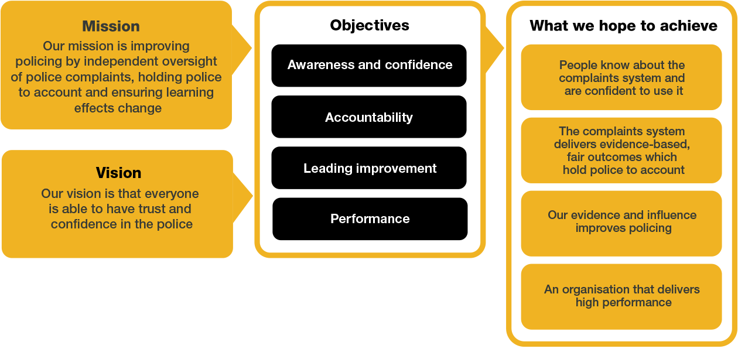
Organisational context

We work in the context of our agreed values which inform the way we do things at the IOPC. The People Services Co-ordinator will need to be commited to managing in the context of these values.

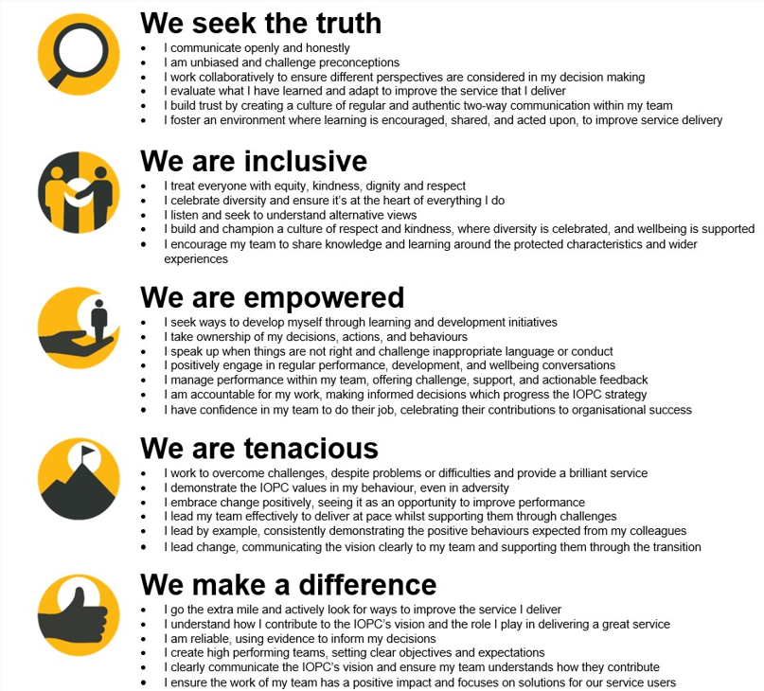
The IOPC is committed to promoting equality and valuing diversity in everything we do. Our vision is to be, and to be seen as, a leader in inclusive employment and services, demonstrating this ethos in everything that we do.
- As a silver standard Stonewall employer, we continue to commit ourselves to being a LGBTQ+ employer through the work of our Pride LGBTQ+ Staff Network, creating welcoming environments for lesbian, gay, bi and queer people.
- We are pleased to share we are a signatory of the Business in the Community Race at Work Charter. The Charter is composed of five calls to action for leaders and organisations across all sectors.
- Being a Disability Confident employer, the IOPC is dedicated to removing the barrier for disabled people to thrive in the workplace.
- Our Staff Networks are constantly working to make the IOPC the leaders of inclusive employment, from our Allyship Programme to Operation Hotton, to Welsh Language Standards and Know the Line Policy, we are constantly seeking new ways to create an environment for all to develop and thrive.




Main duties and responsibilities
- Respond to queries from the business to the People directorate email inbox and engaging the wider teams as necessary.
- Signpost managers and staff to relevant team members, and or policies and procedures.
- Support all teams in the People directorate with the effective delivery of activities, including:
- Arrange and organise meetings, including booking events and venues.
- Taking minutes at meetings, typing, and distributing to relevant parties as directed.
- Draft and issue template employee letters (such as probation completion notifications, reminders to complete required training, contractual variation confirmations, sickness absence meeting invites and family leave).
- Administer wellbeing activities such as issuing flu vouchers, eye test vouchers and wellbeing check-ins.
- Provide administrative support for People related projects, as directed.
- Assist in the development of articles to for the ‘Hub’, staff intranet to create awareness and or promote the services of the People directorate.
- Produce standard workforce and other reports as and when required.
- Work collaboratively with others and build up good working relationships with managers and staff.
- All post holders are required to undertake any duties which are commensurate with the role of a People Support Coordinator.

Finance:

- Raise purchase orders and undertake good receipting as directed.
- Any other finance administrative duties as directed.

People and recruitment:

- Complete pre-employment checks, including DBS and security clearances administration in an accurate and timely manner.
- Administer the onboarding processes, and follow-up to ensure it is effectively completed.
- Invite employees to complete and administer exit interviews.
- Issue contracts of employment.
- Administer DBS, SC, and DV renewals.

Learning and development:

- Support the set up and administration of learning events, including ‘live’ instance on Bridge, the online training platform.
- Administer staff required learning via use of the LMS, and support learning cohort intakes.
- Coordinate and distribute course material preparation, electronic and physical, within agreed timescales and assist the delivery of training by distributing learning materials as required.
- Upload staff data into the learning and development system – Bridge.
- Securely handle and store electronic and physical material, on and off site, including transportation and ensuring compliance with appropriate policies and procedures.

Reporting and data handling:

- Provide reporting using appropriate People systems as directed.
- Handle all People data and information confidentially and sensitively, storing and sharing it securely, following IOPC Data and information management policies.
- Use Sharepoint, People and all ICT systems effectively and in accordance with organisational policies and procedures.

Person specification

Essential Experience
- Knowledge of administration processes
- Experience of working in an administrative role in an office environment

Desirable
- CIPD Level 3 – qualified or prepared to study towards a relevant qualification
- Experience of working in the public, not for profit or charity sector

Skills and Abilities
- Excellent customer service skills.
- Ability to prioritise competing and changing work priorities.
- Effective and clear communications using a range of media.
- Experience of organising events and/or courses.
- Excellent organisational ability and attention to detail.
- Proficiency in the use of ICT, including MS Word and Excel.

Reasonable adjustments
The IOPC is a diverse and inclusive workplace and we want to help you demonstrate your full potential whatever type of assessment is used. We are open to providing you with the tools you need to succeed, from extra time to formatting changes, to name a mere few. If you require any reasonable adjustments to our recruitment process, please email recruitment@policeconduct.gov.uk

Working conditions
The IOPC are currently consulting with our consultative bodies about proposed changes to our hybrid working policy which will require all staff to work 20% of their contractual hours at their office base (or another office for business reasons) from 1 September 2024 and will be increased to 40% from April 2025. Office attendance time includes in-person training, meetings with stakeholders and families, and attending events.

Preparation checklist
☐ Review the full job description
☐ Review the behaviours and the descriptors for each behaviour
☐ Review the Strengths dictionary
☐ Review the IOPC values
☐ Consider your Strengths (if applicable)
☐ Consider drafting example answers that cover the specific elements
☐ Prepare some questions to ask the interviewers

