Job description
Title: Digital Investigation Unit Manager
Reports to: Operations Manager DMI
Location: Any IOPC office
Grade: 12
Salary: £37,120 (plus £4,438 London Weighting, if applicable)
Contract: Permanent

Purpose
As a Digital Investigation Unit Manager, you will be welcomed into a dynamic and inclusive DMI department. The IOPC is on a journey to develop its culture, perspectives and ethos to support the organisation’s core outcomes and this is your opportunity to enter into the varied world of IOPC Operations, allowing you to develop your mindset and approaches to contribute to improving the police complaints system in England and Wales.
The IOPC exists to investigate complaints fairly and thoroughly. The IOPC has the power to initiate, carry out and oversee investigations. It is also responsible for monitoring the way complaints are handled by local police forces.
The DIU manager is responsible for line managing and supporting the operational work delivered by a national dedicated digital team, using their digital expertise to deliver expert service to investigators which manages the collection, review and presentation of digital evidence.
The Digital Investigation Unit Manager will support the strategic and policy development of digital investigation in the IOPC, providing technical expertise and advice to the organisation, on digital investigation, tactics, relevant legislation, and identifying future threats and opportunity.

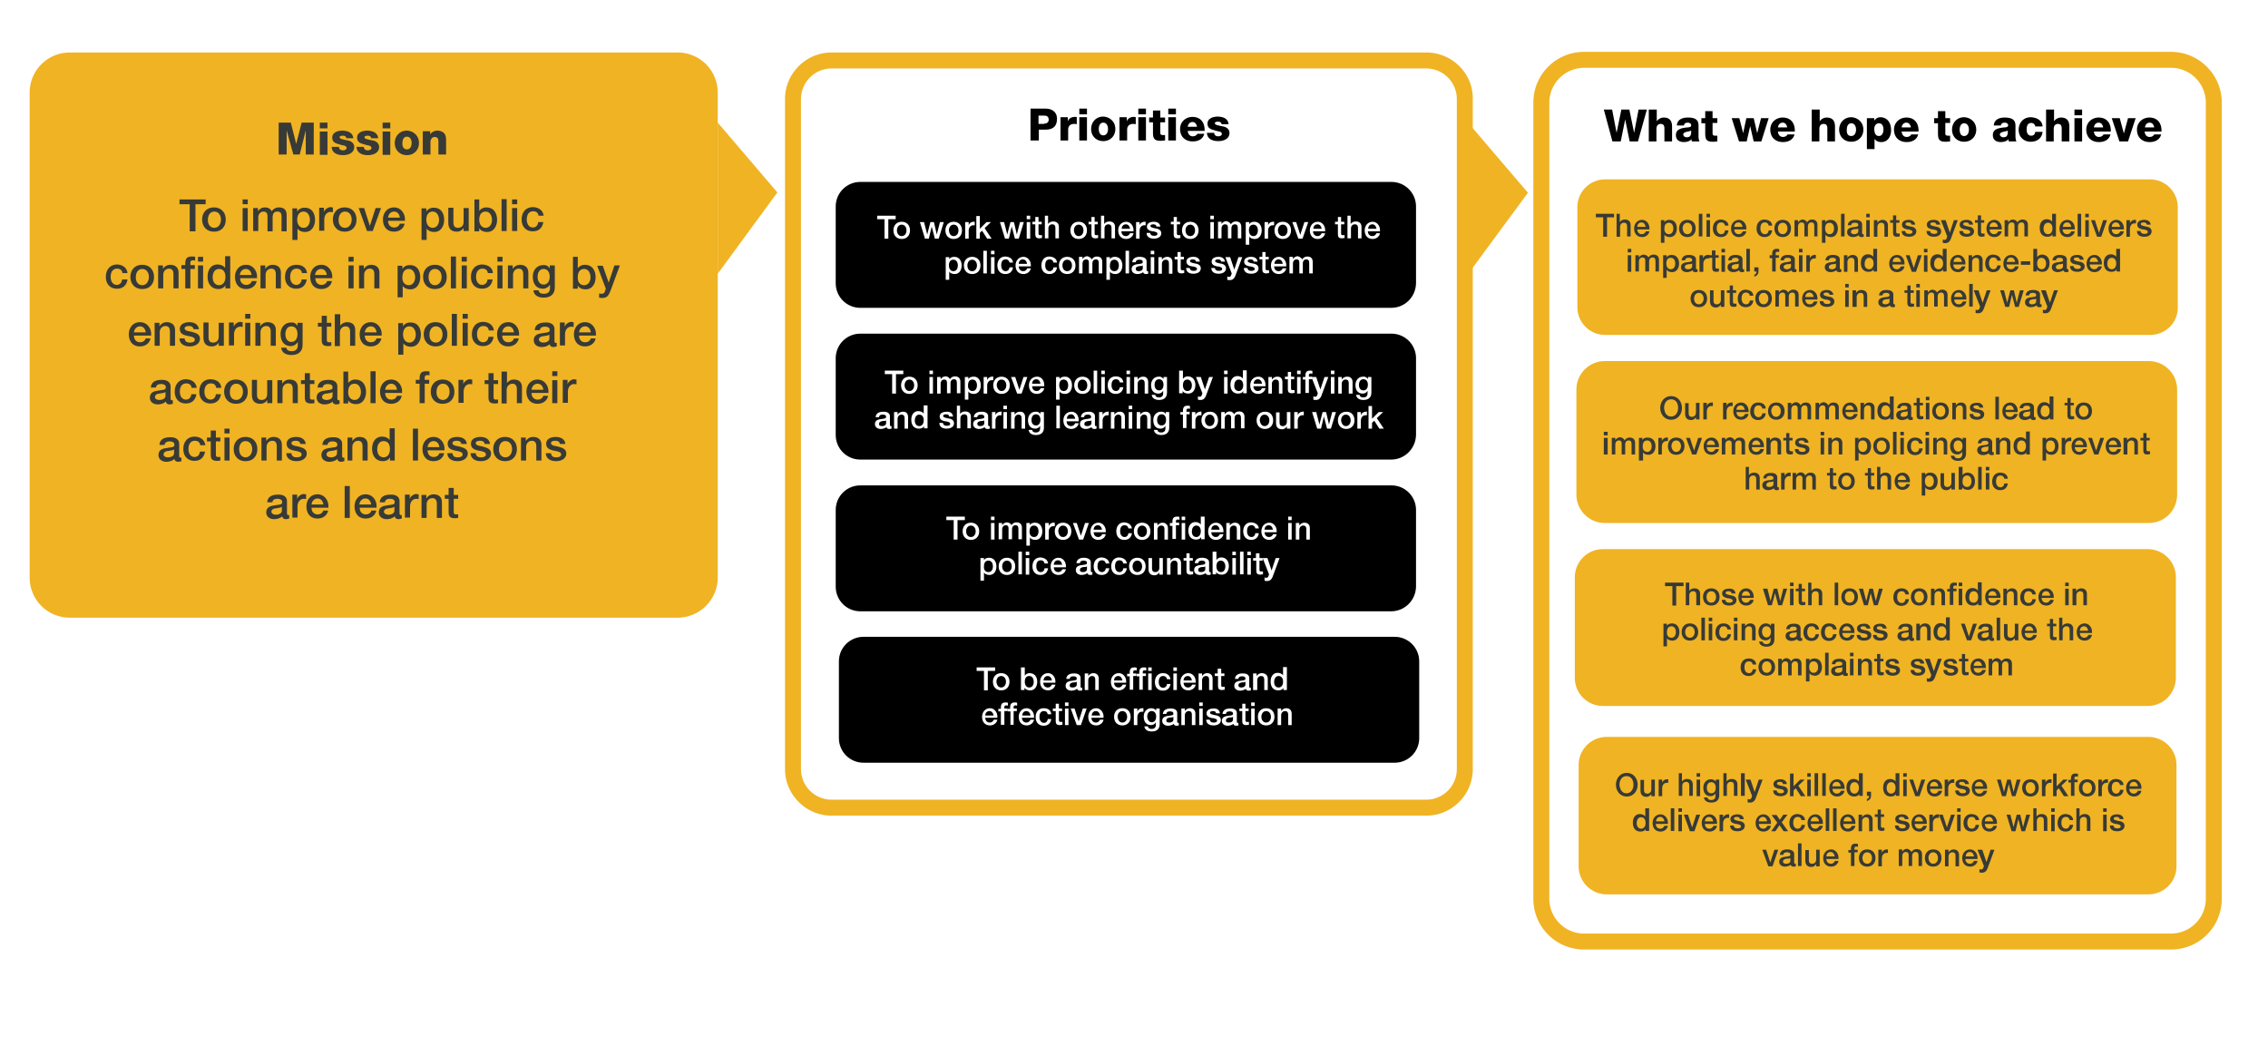
Organisational context

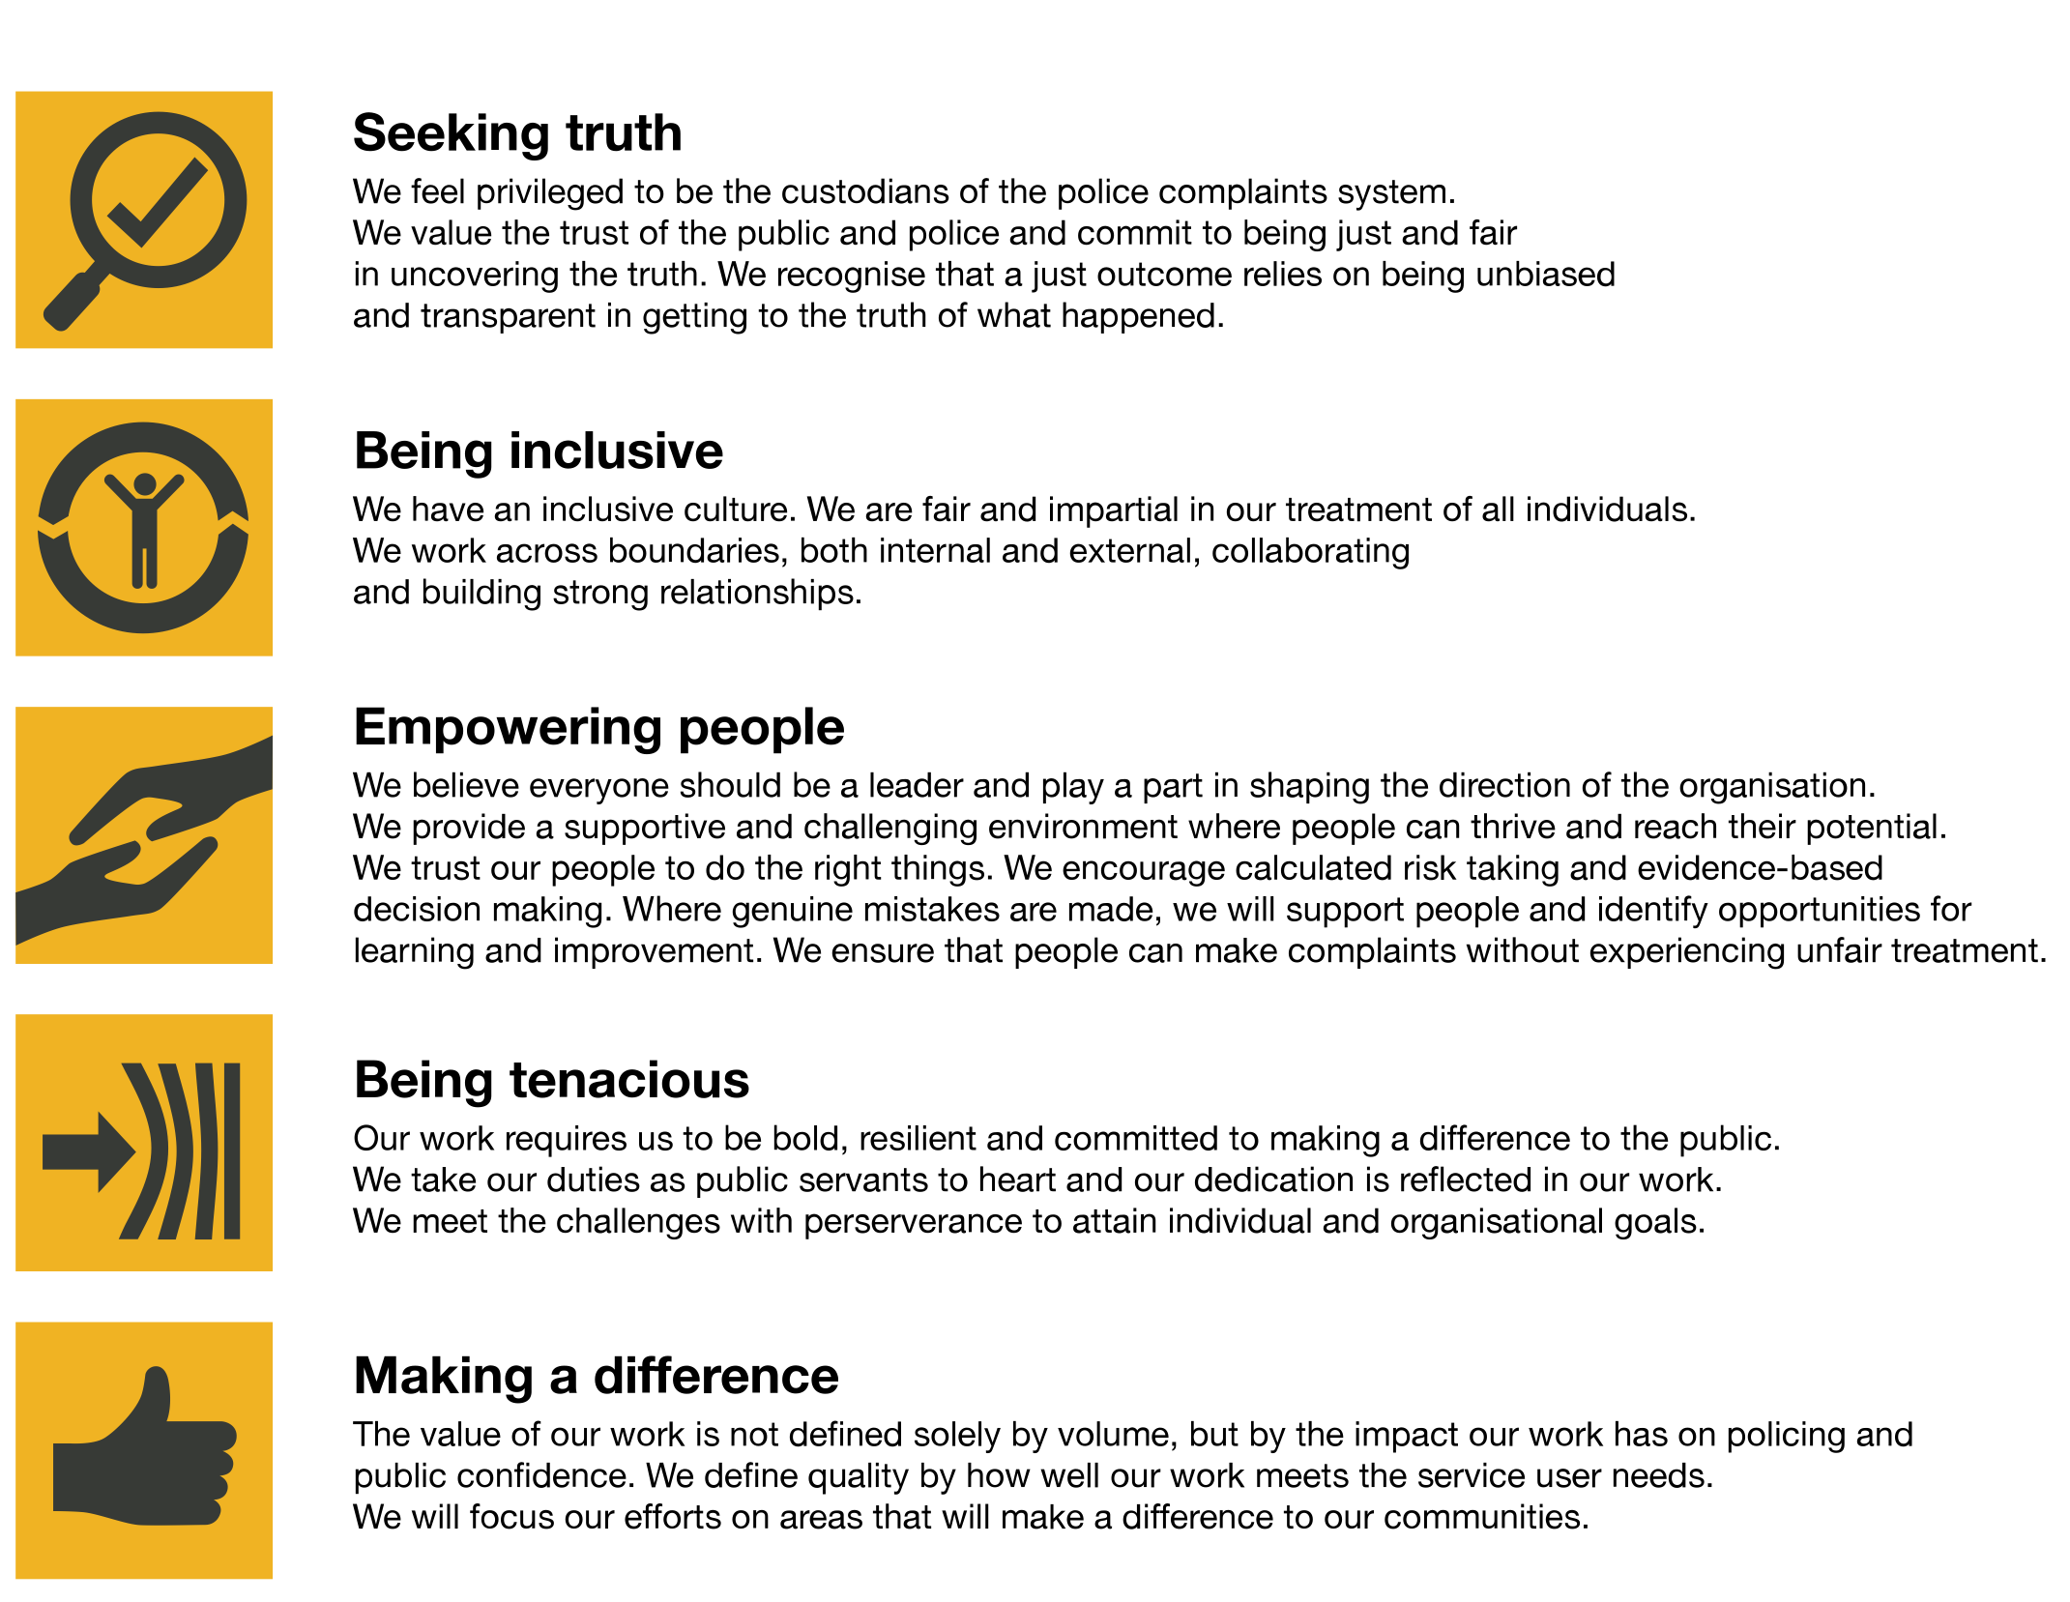
We work in the context of our agreed values which inform the way we do things at the IOPC. The Digital Investigation Unit Manager will need to be commited to managing in the context of these values.
The IOPC is committed to promoting equality and valuing diversity in everything we do. Our vision is to be, and to be seen as, a leader in inclusive employment and services, demonstrating this ethos in everything that we do.
- As a silver standard Stonewall employer, we continue to commit ourselves to being a LGBTQ+ employer through the work of our Pride LGBTQ+ Staff Network, creating welcoming environments for lesbian, gay, bi and queer people.
- We are pleased to share we are a signatory of the Business in the Community Race at Work Charter. The Charter is composed of five calls to action for leaders and organisations across all sectors.
- Being a Disability Confident employer, the IOPC is dedicated to removing the barrier for disabled people to thrive in the workplace.
- Our Staff Networks are constantly working to make the IOPC the leaders of inclusive employment, from our Allyship Programme to Operation Hotton, to Welsh Language Standards and Know the Line Policy, we are constantly seeking new ways to create an environment for all to develop and thrive.

Main duties and responsibilities
- Deliver a high quality, efficient and cost-effective service from specialist staff on high profile and contentious cases and empower them to offer evidence-based challenge, including to senior staff.
- Ensure that digital material provided to the IOPC is stored and managed in line with IOPC Policy and Security Standards.
- Encourage and promote innovative ideas and improvements, promoting a culture of learning to meet the needs of internal and external stakeholders.
- Set clear roles and responsibilities for service delivery considering available solutions, resources and cost. Maximise efficient use of specialist staff skills and time and escalate concerns where appropriate.
- Take responsibility for fostering team behaviours that align with IOPC Values and Behaviours.
- Lead on individual, team, and inter-team development, performance management and welfare in order to create a resilient workforce that can adapt to change and challenges.
- Actively engage in workforce and succession planning by participating in recruitment and identifying staff development opportunities.
- Contract Business owner for digital forensics
- Act as SPOC for s.49 RIPA applications
- Maintain relationships and professional networks with relevant external stakeholder groups to ensure the delivery of shared objectives, identifying and sharing good practice, and maintaining an awareness of all aspects of the business environment.
- Champion the effective use of digital technology in the police complaints system, representing the IOPC in appropriate forums.
- Take ownership for reporting on threats and opportunities to the IOPC digital investigation capability
- Support the development of digital investigation capability in the IOPC by providing expert advice and opinion to DMI management to support the development of organisational strategy.
- Develop and maintain an expert knowledge of technological, legislative, social and political developments to ensure the cyber-digital strategy is effective.
- Undertake specialist training and accreditation in line with the requirements of the role.
- Provide line management for a team of digital investigation and digital media specialists, including prioritising and overseeing the allocation of workstreams according to risk and impact.
- Establish and implement a quality assurance regime for the team, ensuring that processes and systems are effective, efficient and meet the quality standards for the IOPC.
- Establish and implement appropriate data processing controls to ensure that the team is compliant with IOPC policy and the requirements of legislation.
- To coach and mentor, the Digital Investigation Unit by promoting innovation and improvements to quality, creating and maintaining a framework for assuring standards and managing performance to maintain investigative excellence
- Assess and report on threat harm and risk posed to IOPC investigations nationally through changes in technology, legislation, policies, or social trends.
- Providing strategic support to the organisation, within the agreed sign off structure within DMI, to create and deliver effective policy solutions, safeguarding IOPC operational effectiveness in the cyber-digital arena.
- Work with stakeholders across private sector, government, intelligence, and law enforcement sectors to identify risk and opportunities, and share thematic learning to develop and safeguard the organisation’s effectiveness in cyber-digital investigations.
- Understand, develop and use the strategic and business intelligence we have, to enable the IOPC to be more proactive and demonstrate impact (including responding to emerging cyber-digital themes).
- Contract Business owner for digital forensics.
Any other tasks as deemed appropriate to the role enabling operational delivery:
- Act as the Operations Lead/interface for DEMS to ensure user needs are being met.
Your focus:
- Develop and maintain the IOPC cyber-digital investigation capability, driving continuous improvement to strategy, policy, and service delivery
- Provide leadership, acting as an agent of change, embed a consistent, effective and best practice approach to cyber-digital investigation, promoting innovation and the use of expertise
- Deliver a high quality, efficient and cost-effective service providing expertise and support to cyber-digital investigation workstreams, demonstrating IOPC core values in every aspect of the role.
- Develop yourself and your team to achieve personal and organisational objectives.

Person specification

Essential Experience
- Have investigative experience and where relevant, hold IOPC accreditation or an equivalent investigative accreditation.
- Experience of leading and managing a team.
- Experience of managing systems to facilitate effective allocation of tasks and resources to deliver quality outcomes within challenging timescales.
- Provide expertise and guidance in key technological, legislative and policy areas.
- Involvement in promoting a culture which values diversity of experience and background and embeds effective team behaviours.
- Recognise the development needs of yourself and members of your team and be proactive in addressing them.
- Demonstrable personal resilience in order to manage and implement change and work in an environment subject to scrutiny.
- Ability to convey information effectively and negotiate and influence others.
- Experience of carrying out dynamic risk assessments and manage operational and organisational risks.
- Stakeholder negotiation and influencing.

Skills and Abilities
- Relevant professional expertise in cyber-digital capability, sufficient provide technical leadership to the IOPC in developing policy, strategy and guidance and to advise and guide teams in the operational delivery of Digital Investigation Unit services
- Ability to communicate effectively both verbally and in writing and adapt communication styles as appropriate.
- Ability to analyse complex information, identify the key issues and make recommendations.
- Ability to identify and respond to the diverse needs of individual and stakeholder groups.

Technical Competence
- Have knowledge and understanding of the law and procedure in connection with the following areas:
  - Digital Forensics
  - Digital Exploitation
  - Cloud forensics and emerging technology
  - Network investigations
  - Wi-Fi Opportunities
  - Open-source research
  - Communications data
  - ANPR
  - CCTV
- Key legislative knowledge of:
  - PACE
  - CPIA including PII
  - ECHR
  - Data Protection
  - IP act 2016
  - RIPA 2000 part 3
  - Equality Act 2010 (Public Sector Equality Duty)
  - PRA 2002
  - Police, Crime, Sentencing and Courts Act (bill) 2022

Reasonable adjustments
The IOPC is a diverse and inclusive workplace and we want to help you demonstrate your full potential whatever type of assessment is used. We are open to providing you with the tools you need to succeed, from extra time to formatting changes, to name a mere few. If you require any reasonable adjustments to our recruitment process, please email humanresources@policeconduct.gov.uk

Working conditions
Making the IOPC a great place to work is one of our key priorities. We are pleased to offer a unique hybrid working model based on business needs, balanced with the needs of our colleagues. Our business need framework guides our decisions about when it is best to work onsite (in our offices or other appropriate locations) to complete tasks most effectively or when to work remotely, offering colleagues flexibility to work where they feel most productive and supporting work-life balance. The model also encourages staff to feel welcome at the IOPC by ensuring we have opportunities to work face-to-face as teams.

Preparation checklist
☐ Review the full job description
☐ Review the behaviours and the descriptors for each behaviour
☐ Review the Strengths dictionary
☐ Review the IOPC values
☐ Consider your Strengths (if applicable)
☐ Consider drafting example answers that cover the specific elements
☐ Prepare some questions to ask the interviewers

