**Title:** Media Officer

**Reports to:** Senior Media Officer

**Location:** Sale

**Grade:** 12

**Salary:** £41,878

**Contract:** 3 month Fixed-Term Contract with possibility of extension up to 6 months.

# Purpose

As a Media Officer, you will be welcomed into a dynamic and inclusive

Communications and Media team dealing with a number of high profile cases which often make the headlines so the environment can be fast paced and requires a quick-thinking, problem-solving approach. The IOPC is on a journey to develop its culture, perspectives and ethos to support the organisation’s core outcomes and this is your opportunity to enter into the varied world of IOPC Communications, allowing you to develop your mindset and approaches to contribute to improving the police complaints system in England and Wales.



**J**

**ob**

**d**

**escription**

The post holder reports to a Senior Media Officer and is responsible for providing advice on media and communications to IOPC senior managers and staff, implementing both proactive and reactive media plans. The post holder will be security cleared to at least BS level and the post is politically restricted.

You will have direct and frequent contact with operational, policy, stakeholder engagement teams and senior management, and with the media and various police force press offices. You will take part in the out-of-hours duty press officer rota.

# Organisational context

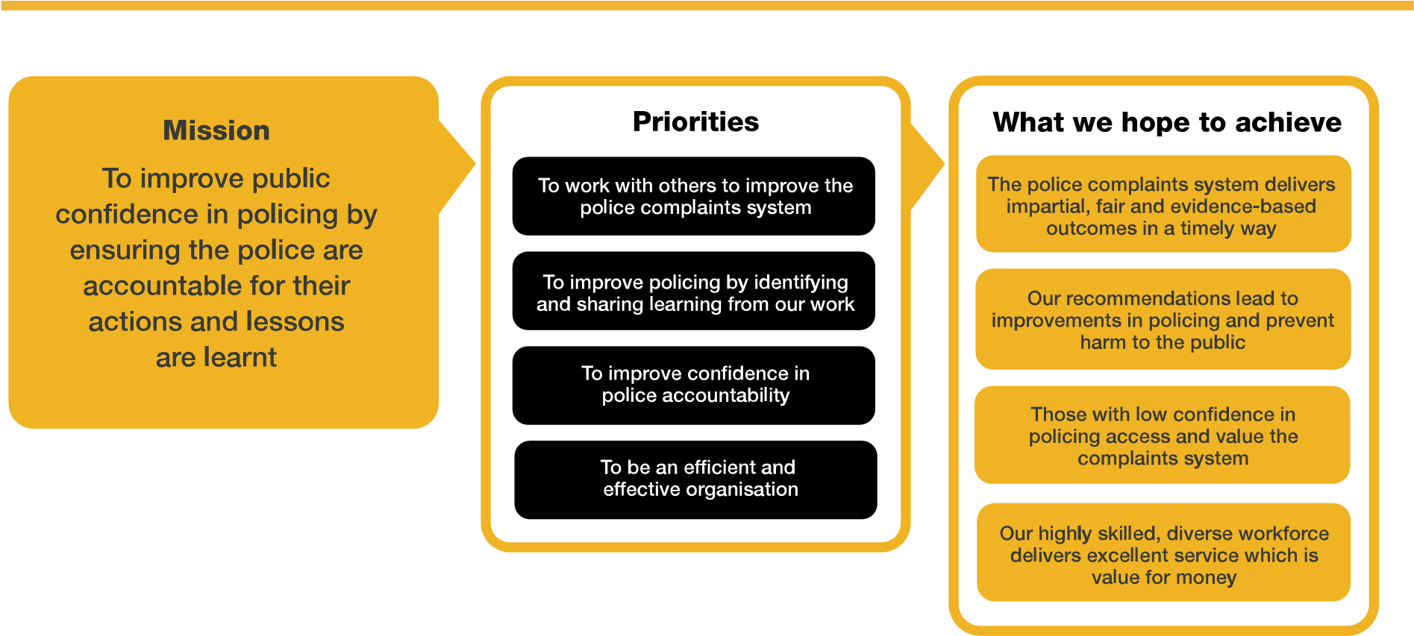

We work in the context of our agreed values which inform the way we do things at the IOPC. The Media Officer will need to be committed to managing in the context of these values.

The IOPC is committed to **promoting equality and valuing diversity** in everything we do. Our vision is to be, and to be seen as, a leader in inclusive employment and services, demonstrating this ethos in everything that we do.

* As a silver standard Stonewall employer, we continue to commit ourselves to being a LGBTQ+ employer through the work of our Pride LGBTQ+ Staff Network, creating welcoming environments for lesbian, gay, bi, trans and queer people.
* We are pleased to share we are a signatory of the Business in the Community Race at Work Charter. The Charter is composed of five [calls to action](https://race.bitc.org.uk/issues/racecharter) for leaders and organisations across all sectors.
* Being a Disability Confident employer, the IOPC is dedicated to removing the barrier for disabled people to thrive in the workplace.
* Our Staff Networks are constantly working to make the IOPC the leaders of inclusive employment, from our Allyship Programme to [Operation Hotton,](https://www.policeconduct.gov.uk/recommendations/operation-hotton-recommendations-metropolitan-police-service-september-2021) to [Welsh Language Standards](https://www.policeconduct.gov.uk/who-we-are/equality-and-diversity/welsh-language-standards) and Know the Line Policy, we are constantly seeking new ways to create an environment for all to develop and thrive.



# Main duties and responsibilities

* To provide a high quality proactive and reactive media relations service on IOPC investigations, including writing and distributing press releases, monitoring national and specialist media, taking the initiative to rebut inaccuracies and leading on relevant statements and briefings.
* To arrange interviews, press conferences and briefings, often at short notice
* To write and implement media handling plans for the publication of IOPC investigation and corporate reports.
* To liaise with Stakeholder Engagement colleagues to develop and implement communications and engagement plans for controversial or significant issues as outlined in our communications and engagement strategy.
* To provide a media relations service on investigations andcorporate issues, working closely with senior managers and other colleagues to support our work, including on national policy areas such as firearms, custody, stop and search.
* To contribute to the strategic diary and forward planning for the communications team
* To be a committed member of the national media team and support colleagues working in other regions
* To liaise with colleagues across regions and nationally to ensure accurate, consistent and coordinated messages are disseminated to IOPC staff, stakeholders and to the public
* To contribute to the IOPC’s social media strategy by making day to day use of social media platforms to engage new and existing audiences
* To take part in the national out-of-hours duty press office rota
* To undertake any other duties as may be assigned from time to time commensurate with the level and responsibilities of the post.

# Person specification

## Essential

* Considerable experience in media relations, including dealing, on a regular basis, with controversial issues and crisis management or commensurate experience as a journalist
* High level understanding of national and local media and their priorities
* Experience of working in a busy press office or newsroom
* Experience of being able to handle emotionally sensitive subjects within a press context
* Excellent communication, interpersonal and writing skills
* Proven ability to translate complex issues into clear, simple narratives
* Experience providing robust and appropriate advice to senior managers
* Good knowledge of current affairs

## Skills and Abilities

* Ability to build strong working relationships with a variety of stakeholders
* Ability to work as part of a team
* Strong customer and audience focus
* Strong communication skills – both written and oral
* Good negotiation and influencing skills
* Positive attitude and flexibility of approach

## Reasonable adjustments

The IOPC is a diverse and inclusive workplace and we want to help you demonstrate your full potential whatever type of assessment is used. We are open to providing you with the tools you need to succeed, from extra time to formatting changes, to name a mere few. If you require any reasonable adjustments to our recruitment process, please email recruitment@policeconduct.gov.uk

## Working conditions

The IOPC are currently consulting with our consultative bodies about proposed changes to our hybrid working policy which will require all staff to work 20% of their contractual hours at their office base (or another office for business reasons) from 1 September 2024 and will be increasing to 40% from April 2025. Office attendance time includes in-person training, meetings with stakeholders and families, and attending events.

## Preparation checklist

|  |  |
| --- | --- |
| ☐ | Review the full job description |
| ☐ | Review the behaviours and the descriptors for each behaviour |
| ☐ | Review the Strengths dictionary |
| ☐ | Review the IOPC values |
| ☐ | Consider your Strengths (if applicable) |
| ☐ | Consider drafting example answers that cover the specific elements |
| ☐ | Prepare some questions to ask the interviewers |