Job description
Title: Learning and Development Consultant
Reports to: L&D Business Partner (Learning and Development)
Location: Birmingham, Sale, Cardiff, Wakefield, Croydon or Canary Wharf
Grade: 12
Salary: £41,878 per annum (Plus London Weighting allowance of £4,968 if based in Croydon or Canary Wharf)
Contract: Fixed-Term until September 2026.

Purpose
The IOPC is on a journey to develop its culture, perspectives and ethos to support the organisation’s core outcomes and this is your opportunity to enter into the varied world of IOPC Learning and Development, allowing you to develop your mindset and approaches to contribute to improving the police complaints system in England and Wales.
The post holder is responsible for supporting the delivery of a comprehensive and high-quality programme of learning and development initiatives, including personal development, to ensure high standards of management practices and leadership behaviours within the IOPC.
The primary function of this post is to provide an in-house learning, education and consultancy service that includes research and development, learning delivery and facilitation, undertake/participate in workforce development projects, develop and manage the organisations learning and development quality assurance and evaluation processes and nurturing IOPC talent.
The post holder is required to undertake any duties that are commensurate with the role of a Learning and Development Consultant.

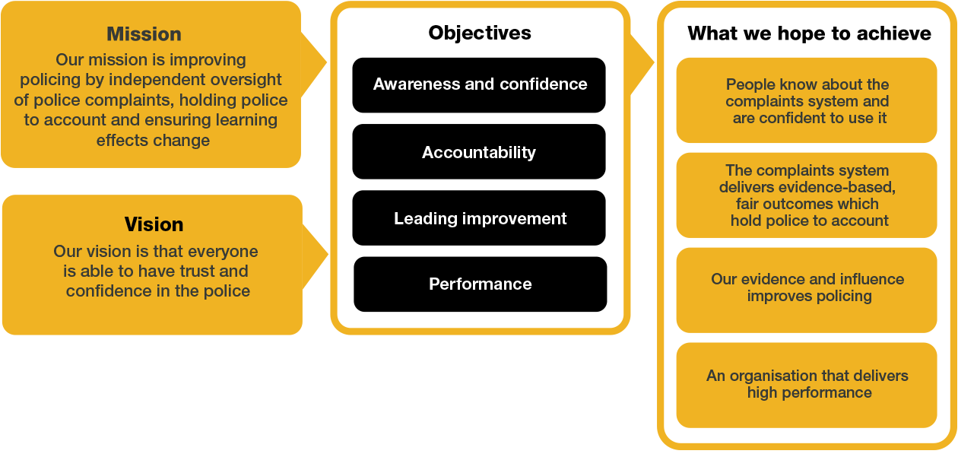
Organisational Context

We work in the context of our agreed values which inform the way we do things at the IOPC. The Learning and Development Consultant will need to be commited to managing in the context of these values.

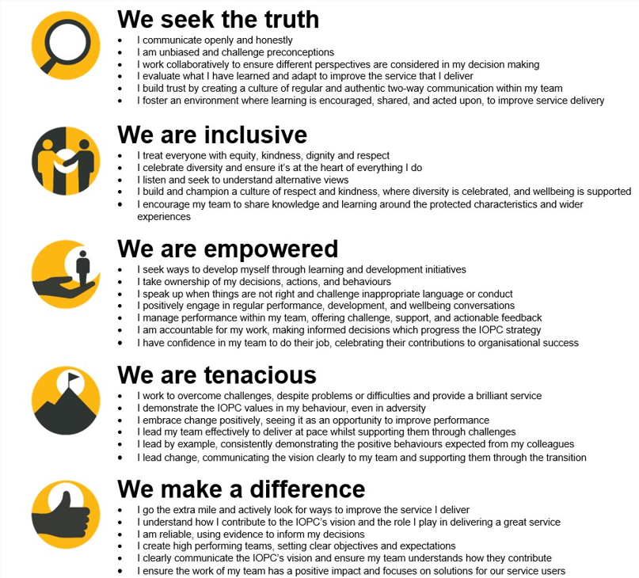

The IOPC is committed to promoting equality and valuing diversity in everything we do. Our vision is to be, and to be seen as, a leader in inclusive employment and services, demonstrating this ethos in everything that we do.
- As a silver standard Stonewall employer, we continue to commit ourselves to being a LGBTQ+ employer through the work of our Pride LGBTQ+ Staff Network, creating welcoming environments for lesbian, gay, bi and queer people.
- We are pleased to share we are a signatory of the Business in the Community Race at Work Charter. The Charter is composed of five calls to action for leaders and organisations across all sectors.
- Being a Disability Confident employer, the IOPC is dedicated to removing the barrier for disabled people to thrive in the workplace.
- Our Staff Networks are constantly working to make the IOPC the leaders of inclusive employment, from our Allyship Programme to Operation Hotton, to Welsh Language Standards and Know the Line Policy, we are constantly seeking new ways to create an environment for all to develop and thrive.




Main duties and responsibilities
Consultancy:
- Develop an excellent understanding of the organisation’s business priorities, structures, and skills profile.
- Work with key stakeholders to understand business issues and learning needs, diagnose problems and advise on L&D interventions which have measurable benefits and impact.
- Lead or contribute to the development and delivery of live training programmes and sessions on a variety of topics in line with the People strategy, at the direction of an L&D Business Partner.
- Contribute to the development and delivery of senior leadership development interventions and other Talent/OD projects as and when required.
- Champion and contribute to the delivery of organisational change/development in line with the corporate strategy.
- Design and lead facilitated discussions, workshops and activities with multidisciplinary groups and colleagues at all levels of the organisation, for example, ‘live’ LNA, root cause analysis, etc.
- Promote the work of the team and inspire others about learning and development through speaking in meetings, delivering presentations and networking at events and conferences.
- Drive a learning culture during every conversation, utilising the 70:20:10 model of development.
- Maintain and deliver the New Manager’s Programme.
- Form and nurture professional relationships and links with internal stakeholders, teams, and networks.
- Contribute to the delivery of the IOPC People Strategy through matrix working across the directorate.
- Participate in workforce planning exercises, ensuring development needs are identified.
- Devise plans to address development needs identified during workforce planning.
- Maintain the corporate induction.
- Work with stakeholders to develop digital storyboards.
Business & workflow management:
- Responsible for the delivery of L&D work packages/projects through effective self-management, prioritisation, and collaboration with others.
- Work closely with managers and peers across the team to continuously re-evaluate and re-prioritise workloads to ensure a smooth delivery of L&D products to the business.
- Contribute to the L&D business and budget planning process by providing stakeholder feedback, business analytics and LNA results amassed through consultancy work.
- Follow procurement and contracting guidance when working with external providers.
- Develop, draft and present high-quality L&D proposals.
- Research, develop, draft, and amend L&D strategies and policies at the direction of the L&D Business Partner.
- Deputise for the L&D Business Partner in their absence.
- Ensure all work undertaken aligns with and contributes towards to our business strategies and plans.
- Regular and consistent use of internal guidance, policies, systems and processes to input/access key information.
Teamwork & development:
- Coach and mentor L&D advisors, supporting their personal and professional development.
- Commit to a culture of high performance by embracing opportunities for personal and professional growth on the team by having regular development conversations, giving, and receiving constructive feedback.
- Actively contribute to team communication and collaboration platforms.

Learning and Development expertise:
- Maintain credibility and professional expertise through driving own continuous professional development, keeping abreast of industry advances.
- Disseminate your learning, share good practice and ideas for improvement with the team and wider organisation.
- Ensure all L&D activities are underpinned by Equality (EIA) and Data Protection Impact Assessments (DPIA)
- Ensure L&D products add value and demonstrate impact and return on investment through effective evaluation.
- Engage with relevant external organisations to carry out benchmarking activities, access peer learning opportunities and seek out good practice.
- Support and guide individuals through their professional qualifications, apprenticeships and CPD activities.
- Encourage and support staff to embrace and develop a learning culture across the business

Person specification

Essential Experience
- CIPD Level 5 qualification in L&D consultant or equivalent/higher qualification/experience.
- Knowledge of learning and development practices, and current theories.
- Knowledge of leadership and management development theories and practical application in the workplace.
- Knowledge of the learning methodologies.
- Experience of developing, delivering, and evaluating learning to a range of audiences with differing abilities.
- Good understanding of learning theories & practice and demonstrable experience of applying these concepts in a live environment.
- Proven experience of live training delivery
- Experience of identifying and solving problems through analysis and consultation.
- Experience of leading, facilitating, and motivating groups to achieve collaborative outcomes.
- Experience of managing a high workload within a rapidly changing environment.
- Experience of writing high quality and complex business documents.
- Experience of effectively collaborating with internal and external stakeholders.
- (Desirable) Professional experience of Learning & Development in a public sector, or legislative context.

Skills and Abilities
- Excellent communication skills, including oral, written and presentation.
- Excellent facilitation skills, and the ability to ‘read the room’ to pivot, if necessary.
- Excellent organisational and prioritisation skills.
- The ability to work in an environment with competing priorities and demands.
- The ability to motivate self and others.

Other Essential
- Travel is an essential part of the job role and successful candidates will be required to travel to various office locations on average of 2-3 times in a month.

Reasonable adjustments
The IOPC is a diverse and inclusive workplace and we want to help you demonstrate your full potential whatever type of assessment is used. We are open to providing you with the tools you need to succeed, from extra time to formatting changes, to name a mere few. If you require any reasonable adjustments to our recruitment process, please email recruitment@policeconduct.gov.uk

Working conditions
The IOPC are currently consulting with our consultative bodies about proposed changes to our hybrid working policy which will require all staff to work 20% of their contractual hours at their office base (or another office for business reasons) from 1 September 2024 and will be increased to 40% from April 2025. Office attendance time includes in-person training, meetings with stakeholders and families, and attending events.

Preparation checklist
☐ Review the full job description
☐ Review the behaviours and the descriptors for each behaviour
☐ Review the Strengths dictionary
☐ Review the IOPC values
☐ Consider your Strengths (if applicable)
☐ Consider drafting example answers that cover the specific elements
☐ Prepare some questions to ask the interviewers

