Job description
Title: Welsh Translator
Reports to: Welsh Language Development Manager
Location: Cardiff, Birmingham, Sale or Wakefield
Grade: 8
Salary: £28,665
Contract: Permanent

Purpose
The main purpose of the role is to provide an effective and high quality Welsh translation service to IOPC departments, maintaining the brand tone and using a translation memory. The postholder will work within the Communications and Engagement team and will report to the Welsh Language Development Manager. The role contributes directly to the work of the IOPC to raise awareness of and confidence in the police complaints system. The majority of the work will be written translation from English to Welsh.

Organisational context
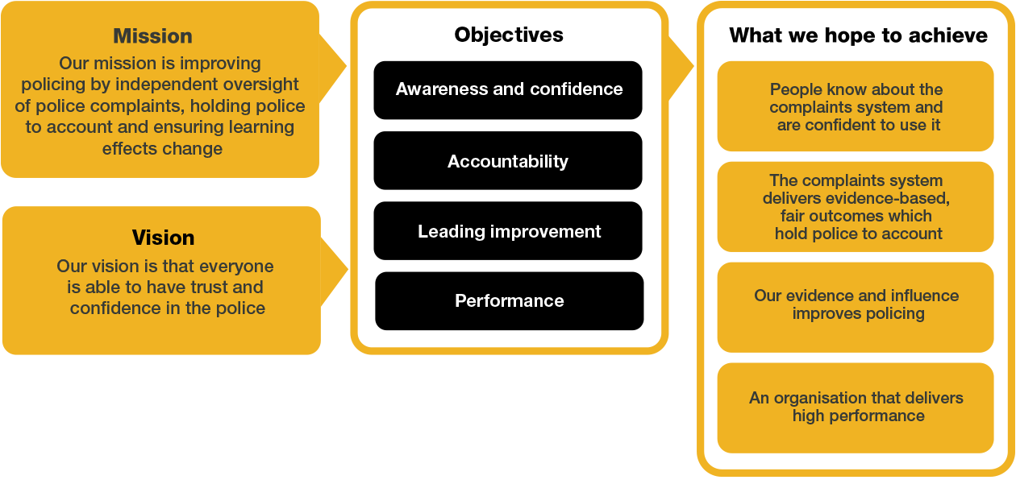
We work in the context of our agreed values which inform the way we do things at the IOPC. The Facilities Officer will need to be commited to managing in the context of these values.

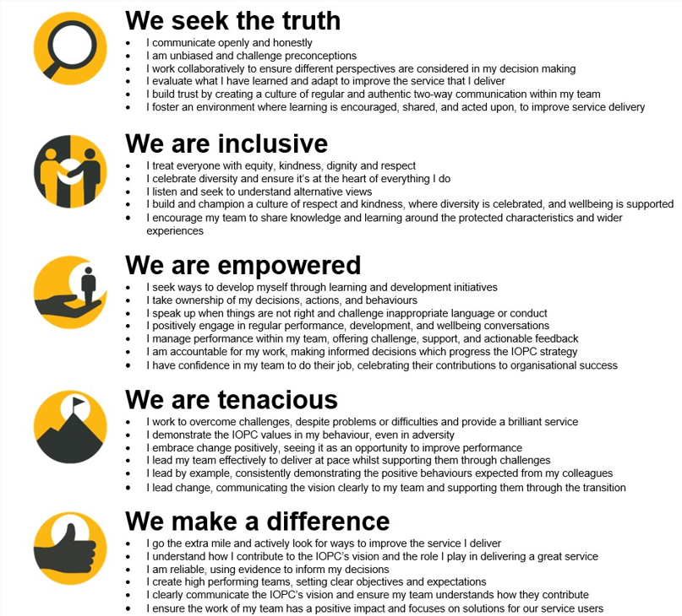
The IOPC is committed to promoting equality and valuing diversity in everything we do. Our vision is to be, and to be seen as, a leader in inclusive employment and services, demonstrating this ethos in everything that we do.
- As a bronze standard Stonewall employer, we continue to commit ourselves to being a LGBTQ+ employer through the work of our Pride LGBTQ+ Staff Network, creating welcoming environments for lesbian, gay, bi and queer people.
- We are pleased to share we are a signatory of the Business in the Community Race at Work Charter. The Charter is composed of five calls to action for leaders and organisations across all sectors.
- Being a Disability Confident employer, the IOPC is dedicated to removing the barrier for disabled people to thrive in the workplace.
- Our Staff Networks are constantly working to make the IOPC the leaders of inclusive employment, from our Allyship Programme to Operation Hotton, to Welsh Language Standards and Know the Line Policy, we are constantly seeking new ways to create an environment for all to develop and thrive.




Main duties and responsibilities
- Provide written copy of the highest standard, showing attention to detail and passion for producing excellent work.
- Translate content for and update IOPC webpages (Training will be provided on updating the website)
- Translate content and work very closely with Communications colleagues to produce creative content for IOPC social media channels.
- Offer an internal proof reading service for members of IOPC staff who work through the medium of Welsh.
- Translating video evidence and witness and police officer statements from Welsh to English
- Liaise with external translation suppliers when a back up translation service is required, e.e. holidays, training days etc.
- Liaise with other professional translators in the justice and policing sector in order to be aware of terminology and standardised language across the sector.
- The postholder is required to undertake any duties that are commensurate with the Welsh Translator role.

Person specification
Essential skills and abilities

- Experience in written translation from English to Welsh and Welsh to English
- Experience of working to tight deadlines and managing your own time
- Membership of Cymdeithas Cyfieithwyr Cymru (Basic or Full) or willingness to work towards membership; or a degree in translation
- Experience of using a translation memory
- Excellent customer service skills
- The ability to prioritise competing demands and change.
- Effective and clear communication in Welsh and English, orally and in writing, with a wide range of audiences and at every level
- Familiar with ICT programmes, e.g. Microsoft Office including PowerPoint and Excel, Adobe Acrobat etc
- Excellent organisational skills and attention to detail
- Can foster effective business relationships with colleagues at every level of the organisation and with external partners

Desirable

- Web editing experience

Reasonable adjustments
The IOPC is a diverse and inclusive workplace and we want to help you demonstrate your full potential whatever type of assessment is used. We are open to providing you with the tools you need to succeed, from extra time to formatting changes, to name a mere few. If you require any reasonable adjustments to our recruitment process, please email recruitment@policeconduct.gov.uk

Working conditions
The IOPC requires all staff to work 40% of their contractual hours at their office base (or another office for business reasons) as of April 2025. Office attendance time includes in-person training, meetings with stakeholders and families, and attending events.

Preparation checklist
☐ Review the full job description
☐ Review the behaviours and the descriptors for each behaviour
☐ Review the Strengths dictionary
☐ Review the IOPC values
☐ Consider your Strengths (if applicable)
☐ Consider drafting example answers that cover the specific elements
☐ Prepare some questions to ask the interviewers

