Job description
Title: Performance Analyst x 3
Reports to: Deputy Performance Manager
Location: Any IOPC office
Grade: 10
Salary: £31,110 (plus London Weighting, if applicable)
Contract: Fixed term contracts until 29th March 2024

Purpose
As a Performance Analyst, you will be welcomed into a dynamic and inclusive Knowledge and Performance team. The IOPC is on a journey to develop its culture, perspectives and ethos to support the organisation’s core outcomes and this is your opportunity to enter into the varied world of IOPC Strategy and Impact, allowing you to develop your mindset and approaches to contribute to improving the police complaints system in England and Wales.
The Performance Team are responsible for producing a wide range of reporting dashboards and analytics to support the delivery of our strategic objectives and the role of a Performance Analyst is vital in transforming raw data into information and insight, which the organisation can use to facilitate effective decision making

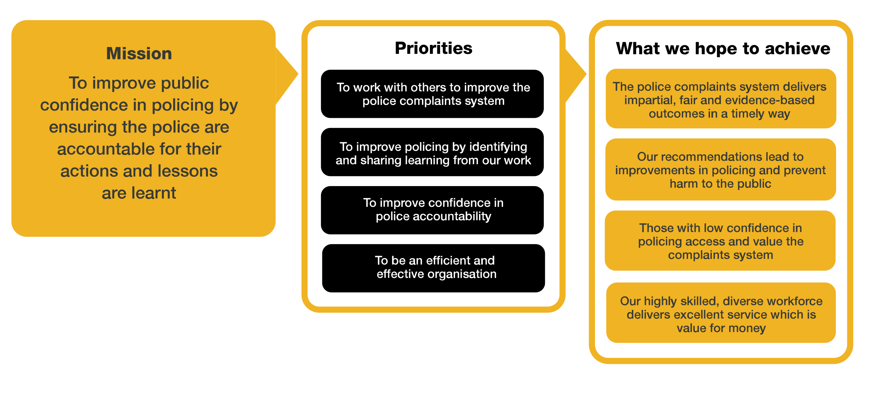
Organisational context

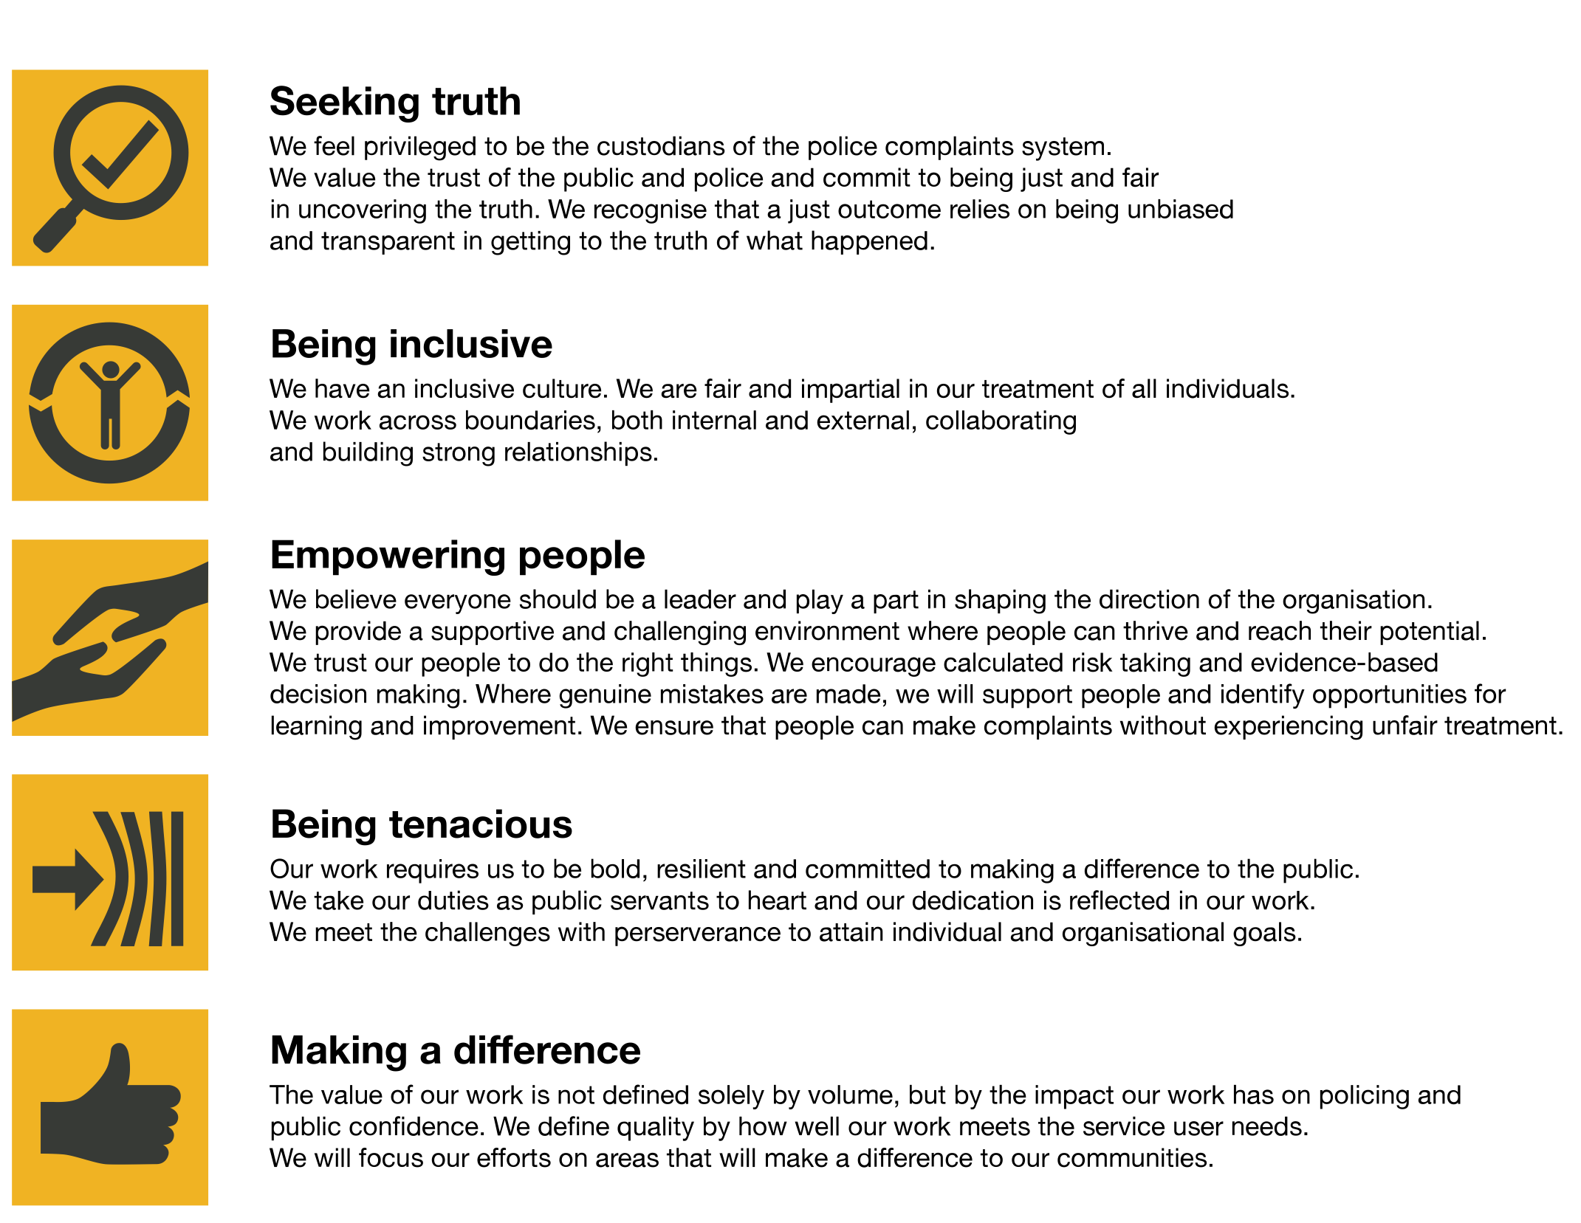
We work in the context of our agreed values which inform the way we do things at the IOPC. The Performance Analyst will need to be commited to managing in the context of these values.
The IOPC is committed to promoting equality and valuing diversity in everything we do. Our vision is to be, and to be seen as, a leader in inclusive employment and services, demonstrating this ethos in everything that we do.
- As a silver standard Stonewall employer, we continue to commit ourselves to being a LGBTQ+ employer through the work of our Pride LGBTQ+ Staff Network, creating welcoming environments for lesbian, gay, bi and queer people.
- We are pleased to share we are a signatory of the Business in the Community Race at Work Charter. The Charter is composed of five calls to action for leaders and organisations across all sectors.
- Being a Disability Confident employer, the IOPC is dedicated to removing the barrier for disabled people to thrive in the workplace.
- Our Staff Networks are constantly working to make the IOPC the leaders of inclusive employment, from our Allyship Programme to Welsh Language Standards and Know the Line Policy, we are constantly seeking new ways to create an environment for all to develop and thrive.

Main duties and responsibilities
The post holder will be responsible for:
- Producing high quality and timely data analysis and providing specialist support and advice to the organisation, whilst working as part of an innovative team
- Using data systems securely to meet requirements and in line with organisational procedures and legislation
- Implementing the stages of the data analysis lifecycle
- Identify and escalate quality risks in data analysis with suggested mitigation or resolutions as appropriate
- Collaborate and communicate with a range of stakeholders, using styles and behaviours to suit the audience, to support the development of reports
- Collate and interpret qualitative and quantitative data and convert into infographics, reports, tables, dashboards and graphs
- Respond to internal and external information requests and perform ad-hoc analysis as they arise
- Develop and improve reporting to meet the needs of the organisation through; gathering business requirements, testing and publishing

Person specification

Essential
- Working experience of Power BI and its capabilities
- Comfortable liaising with stakeholders at all levels and communicating the outputs of their analyses, using appropriate visuals to tell stories
- Data driven mind set with strong numerical, analytical and problem-solving skills
- Advanced experience using Microsoft Excel
- Experience using other Microsoft tools (SharePoint/OneNote)
- Excellent communication skills
- Ability to think critically and qualify assessments with strong presentation, documentation and organisational skills
Ability to work independently, navigate complex problem areas and work with cross-functional teams

Desirable
- BCS Data Analyst (level 4) certification
- Proven working experience as a Data Analyst or Business Data Analyst

Reasonable adjustments
The IOPC is a diverse and inclusive workplace and we want to help you demonstrate your full potential whatever type of assessment is used. We are open to providing you with the tools you need to succeed, from extra time to formatting changes, to name a mere few. If you require any reasonable adjustments to our recruitment process, please email humanresources@policeconduct.gov.uk

Working conditions
Making the IOPC a great place to work is one of our key priorities. We are pleased to offer a unique hybrid working model based on business needs, balanced with the needs of our colleagues. Our business need framework guides our decisions about when it is best to work onsite (in our offices or other appropriate locations) to complete tasks most effectively or when to work remotely, offering colleagues flexibility to work where they feel most productive and supporting work-life balance. The model also encourages staff to feel welcome at the IOPC by ensuring we have opportunities to work face-to-face as teams.

Preparation checklist
☐ Review the full job description
☐ Review the behaviours and the descriptors for each behaviour
☐ Review the Strengths dictionary
☐ Review the IOPC values
☐ Consider your Strengths (if applicable)
☐ Consider drafting example answers that cover the specific elements
☐ Prepare some questions to ask the interviewers

