Job description
Title: ICT Support Engineer
Reports to: Lead ICT Support Engineer
Location: Canary Wharf & Croydon
Grade: 10
Salary: £34,067 Plus £4,968 London Weighting allowance per annum
Contract: Permanent

Purpose
As an ICT Support Engineer, you will be welcomed into a dynamic and inclusive DDaT team responsible for providing support to the IOPC supporting prevailing BAU & project rollout work. In addition, you will support the administration of various processes including starters, movers & leavers, ICT service requests, IMACS, information asset management, document libraries, ICT system access control, digital media management, incident reporting and day to day support of tickets coming into the ICT Support Centre. The IOPC is on a journey to develop its culture, perspectives and ethos to support the organisation’s core outcomes and this is your opportunity to enter into the varied world of IOPC ICT Support Engineer, allowing you to develop your mindset and approaches to contribute to improving the police complaints system in England and Wales.

This role will need to work closely with internal stakeholders, including but not limited to HR, FM and Finance and Investigation Support Units, all of whom are also involved in key processes.

This role will require travel to the designated office (Canary Wharf & Croydon) and other offices based on hybrid working and business need policies. The need can come from escalations from the Service Desk team for hands on end-user support and project related activities.

The role also involves liaising with other members of the broader ICT team, and particularly IOPC outsourced suppliers.

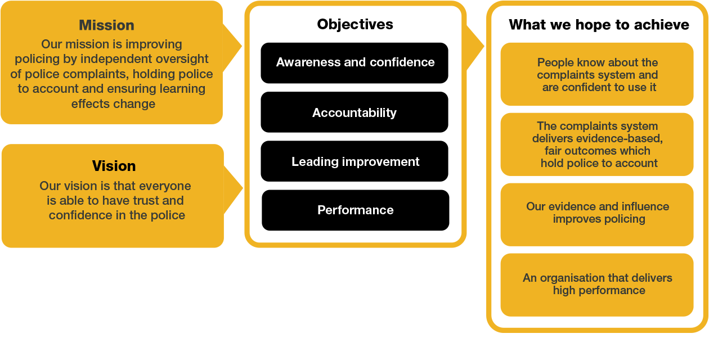
Organisational context

We work in the context of our agreed values which inform the way we do things at the IOPC. The ICT Support Engineer will need to be commited to supporting in the context of these values.

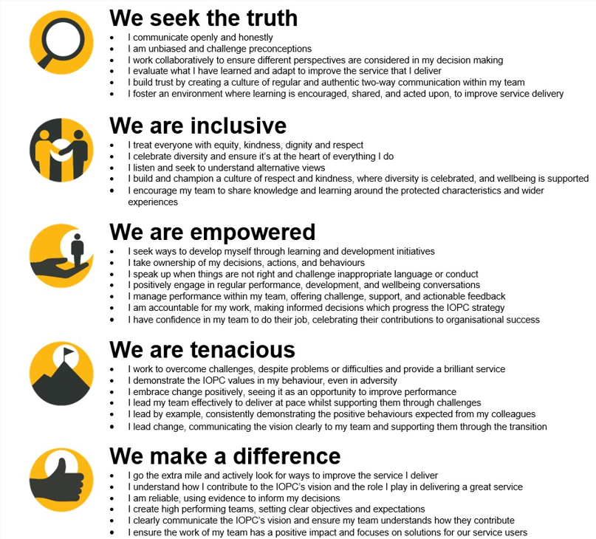

The IOPC is committed to promoting equality and valuing diversity in everything we do. Our vision is to be, and to be seen as, a leader in inclusive employment and services, demonstrating this ethos in everything that we do.
- As a silver standard Stonewall employer, we continue to commit ourselves to being a LGBTQ+ employer through the work of our Pride LGBTQ+ Staff Network, creating welcoming environments for lesbian, gay, bi and queer people.
- We are pleased to share we are a signatory of the Business in the Community Race at Work Charter. The Charter is composed of five calls to action for leaders and organisations across all sectors.
- Being a Disability Confident employer, the IOPC is dedicated to removing the barrier for disabled people to thrive in the workplace.
- Our Staff Networks are constantly working to make the IOPC the leaders of inclusive employment, from our Allyship Programme to Operation Hotton, to Welsh Language Standards and Know the Line Policy, we are constantly seeking new ways to create an environment for all to develop and thrive.




Main duties and responsibilities
- To be part of a team responsible for maintaining a rigorous service delivery management regime in relation to the IOPC’s ICT supplier(s), maintaining control over service demand, ICT provision and ensuring the supplier meets the required and contracted levels and standards.
- Analysing current processes and procedures and developing new procedures based on CSI (Continual Service Improvement).
- Contribute to policies, processes and procedures.
- Reporting faults within the ITSM tool.
- Undertaking Installations, Moves, and Changes (IMACS) related to desktop equipment. Action ICT service requests, ensuring compliance with agreed governance processes
- Work with IOPC’s outsourced ICT providers to ensure that incidents are resolved promptly, problems accurately reported and diagnosed and that ICT services are efficiently delivered. Managing local “break-fix arrangements” through swap-out and stock maintenance
- To support refresh and change projects related to the desktop environment including user acceptance testing and cutover activities
- Working with the IOPC’s outsourced ICT providers, their service desk and resolver groups, raising/approving requests on 3rd party supplier ITSM portals.

To administer service requests and starters leavers and mover process as it applies to providing access to corporate applications, file stores and mailboxes

To undertake other activities needed from time to time to provide resilience across the team and to provide data input and reporting to others in the wider ICT team

To be involved in ICT procurement – determining requirements for day-to-day ordering, requesting quotes, raising requisitions.

Negotiating with suppliers on costs, ensuring integrated and efficient services.

Negotiating with staff of all levels, planning for future activities, for themselves and for other members of the team.

Strong customer focus and experience of building good working relationships with stakeholders and end users

Managing service change, ensuring continuity whilst implementing complex key technical changes.

Providing hands-on support to local users in their use of the IOPC standard desktop/laptop and end devices such as scanners, plotters, printers, local telephony, Wi-Fi networking, fixed and soft-phone telephony and video conferencing as well as specialist equipment used for Major Investigations.

Being a SPOC for your designated office and taking ownership of incidents/requests/project work require at that site.

Be willing to travel for ICT projects.

Ensure new end user requirements or requests are captured and either escalated to the Business Relationship Managers or fed into the appropriate processes such as Service Improvement board / Technical Design Authority etc.

To work with outsourced ICT service providers to ensure that incidents are resolved promptly, recurring problems are escalated and that ICT services are efficiently delivered.

Ensure all support calls via phone/email/user walk-up are handled/triaged effectively.

React to alerts from monitoring systems within SLA.

Escalate/triage issues where necessary.

Contribute to policies, processes and procedures.

Reporting faults within the ITSM tool.

Administer all ICT user account profiles, application and system access. Ensuring all users only have authorised access to the relevant information & systems according to their role and responsibility, supporting security and system integrity of the starters and leavers processes and security groups.

Provide end user support for the ICT equipment & infrastructure in IOPC offices and key applications such as Outlook email & MS Office as well as line of business applications

Maintain the CMDB, ICT asset registers and Service Catalogue are current, status accounted and fit for purpose, with reporting available when required

Maintain and update a knowledge base, ensuring relevant information is available for all users when required

Support refresh and change projects related to the ICT infrastructure and end user device portfolio, including user acceptance testing and cutover activities

To undertake any other ICT administration duties as may be assigned from time to time commensurate with the level and responsibilities of the post.

Raise relevant Purchase Orders when required in line with ICT support requirements.

As an ICT Support Engineer there is a requirement to cover the hours of 08:00-16:00 when covering the telephones for the service desk, which will be assigned on a rota schedule.

Person specification

Essential Experience
- Demonstrable knowledge of Citrix XenApp thin client
- Microsoft Office 365 cloud services
- Microsoft Azure cloud services
- InTune/Endpoint management
- Experience supporting various end user devices utilising appropriate management tools such as Microsoft Active Directory & Mobile Device Management systems
- Willingness to work towards the principles of ITILV3/V4 and corresponding ICT service management
- IT Literate
- Experience of working with outsourced IT service delivery teams and awareness of ITIL incident and asset management principles
- Experience of working in a secure environment
- Knowledge of shared WiFi, VPN, LAN and WAN technologies
- Experience of managing a range of enquiries from internal stakeholders
- Demonstrable experience in the management of details records in relation to actions taken
- Good administration skills
- Ability to work as part of a team
- Excellent written and oral communication skills
- Positive can-do attitude and flexibility of approach

Desirable Experience
- Some familiarity with the ICT project lifecycle
- PM qualification or experience – PRINCE Foundation useful
- Experience of managing hardware related faults
- Experience of working with outsourced IT service delivery teams and awareness of ITIL incident and asset management principles
- Working knowledge of one or more of the IOPC’s corporate applications such as SharePoint or HP Records Manager
- Knowledge of ITSM tools such as Freshservice/Service Now
- Reporting and trending experience in ITSM tools
- Experience/knowledge of automating tasks/processes

Skills and Abilities
The post holder will report to the Lead ICT Support Engineer and be responsible for providing support for core ICT business activities.
- Support incident and problem resolution by undertaking first time fix and managing triage of tickets to other resolver groups.
- Support service request fulfilment adhering to SLA’s, team OLA’s and prioritising tickets.
- Support users on the broad range of ICT deployed at the IOPC, along with helping to maintain infrastructure in the IOPC’s offices.
This will include: fixed and flexible working devices, WiFi networking, printing services, fixed and softphone telephony, mobile telephony and video conferencing as well as specialist equipment used by specific teams within the organisation.
- Work with in house and 3rd party ICT providers in delivering ICT services
- Deal with first line user enquiries and provide end user support for all departments within the IOPC onsite or remotely.
- Ensure incidents/service requests are closed within SLA.
- Administer the access and security of all ICT user accounts, system and file access requests and user profiles
- Deal with support requests appropriately via the service desk workflow system

The post holder will be security cleared to SC level.

Reasonable adjustments
The IOPC is a diverse and inclusive workplace and we want to help you demonstrate your full potential whatever type of assessment is used. We are open to providing you with the tools you need to succeed, from extra time to formatting changes, to name a mere few. If you require any reasonable adjustments to our recruitment process, please email recruitment@policeconduct.gov.uk

Working conditions
The IOPC are currently consulting with our consultative bodies about proposed changes to our hybrid working policy which will require all staff to work 20% of their contractual hours at their office base (or another office for business reasons) from 1 September 2024 and will be increased to 40% from April 2025. Office attendance time includes in-person training, meetings with stakeholders and families, and attending events.

Preparation checklist
☐ Review the full job description
☐ Review the behaviours and the descriptors for each behaviour
☐ Review the Strengths dictionary
☐ Review the IOPC values
☐ Consider your Strengths (if applicable)
☐ Consider drafting example answers that cover the specific elements
☐ Prepare some questions to ask the interviewers

